What’s the story?

Increasing access to the arts

Arts Access Aotearoa: vision and purpose
Arts Access Aotearoa is a national organisation advocating for people in New Zealand who experience barriers to participation in the arts, as both creators and audience members. Key stakeholders are artists and arts organisations in the community and professional arts sectors; people with physical, sensory or intellectual impairments; and people with lived experience of mental ill health. Arts Access Aotearoa is also the key organisation in New Zealand facilitating the arts as a tool for rehabilitation in prisons.

In particular, it works with a network of creative spaces to provide professional development, capability building and leadership, advocacy and promotion, information-sharing and artistic opportunities.

Vision

All people in New Zealand are able to participate in the arts.

Purpose

Arts Access Aotearoa advocates for all people in New Zealand to have access to the arts by supporting people who experience barriers to participation or whose access is limited.

Values

Arts Access Aotearoa provides its service believing in these values:
- Accessibility and inclusion in the arts, respect and kindness in our undertakings for and with all people
- Arts Access Aotearoa recognises the importance of Te Tiriti o Waitangi to our kaupapa, with due regard for its articles and principles.
This recognition is reflected in the following values that underpin its work:
- Mōhiotanga - seeking understanding and awareness
- Rangatiratanga – respecting the mana of others
- Whanaungatanga – appreciating the value of relationships and partnerships
- Kotahitanga – working in harmony to achieve common purpose and shared vision
- Kaitiakitanga – service to others and nurturing leadership within others.
Contents

1. Arts Access Aotearoa: vision and purpose

2. From grassroots to galleries:
the Chair and Executive Director’s report on 2016

3. People in 2016

4. Achievements in 2016

Access and Participation
Community Development
Advocacy and Profile
Arts in Corrections
Information Centre

5. Funders, sponsors and supporters

6. Supporting what we do
Performance review 2017
Arts Access Aotearoa’s independent Auditor Report for the year ended 31 December 2016 is published in its Performance review 2016. This document includes its Statement of Service Performance, Statement of Financial Performance, Statement of Financial Position, Statement of Cash Flows, Statement of Accounting Policies and Notes to the Performance Report.
You can download the Performance review 2016 from the Arts Access Aotearoa website: www.arts.access.org.nz/about+us

Large print and online

Arts Access Aotearoa’s Performance Review 2016 and What’s the story? can be downloaded as an accessible Word document at www.artsaccess.org.nz/about-us

Large-print copies of the report are available on request.

Arts Access Aotearoa thanks all its stakeholders, funders and supporters for their contributions to its work in 2016.

Contact us:
Level 3, Toi Pōneke Arts Centre
61–63 Abel Smith St
PO Box 9828
Wellington 6141
T: 04 802 4349
E: info@artsaccess.org.nz
W: www.artsaccess.org.nz
From grassroots to galleries
The Chair and Executive Director’s report on 2016
From grassroot creative spaces to arts programmes in prisons and access to performing arts companies, museums and galleries … Arts Access Aotearoa is a small, national organisation with a big vision of a society where everyone in New Zealand is able to participate in the arts as both creators and audience members.
To help us achieve this vision, we encourage and advocate for increased access to the arts – particularly for people who, for reasons of disadvantage, disability or isolation, face challenges in getting the access that many of us take for granted.
Working with others, Arts Access Aotearoa achieved a great deal in 2016. What’s the story? outlines the key achievements under our five programmes, and includes stories about some of the artists and organisations who work with us to increase access to the arts and culture.
Arts Access Aotearoa has always acknowledged the importance of the Treaty of Waitangi. Building on this commitment, the board and staff have set up a programme to increase the organisation's cultural competency and the positive impact we can have on outcomes for Māori.
In this report, we highlight three of the projects undertaken in 2016: a conference we organised for creative space workers and artists, the Arts Access Awards 2017 and a theatre project in Arohata Prison.
Creative spaces around the country play an important role in building more inclusive, healthier and happier communities. They provide a space, a sense of belonging, and resources for people to create and participate in arts programmes and activities. The first of these spaces, founded in 1985 in downtown Wellington, was Vincents Art Workshop.
Thanks to additional funding from Creative New Zealand, we organised a national two-day conference called Creative Spaces 2020: building a strong future for the sector. Among the many positive comments, one delegate described it as “a valuable networking, skill-sharing and unifying event for creative spaces”.
Themes to emerge from the conference include the need for effective tools to evaluate and measure what we do; professional development for creative space staff; and a more equitable funding environment for creative spaces. Arts Access Aotearoa and creative space representatives will work on these areas of concern over 2017.
Recognising the outstanding contribution of a leader in the sector, we were very pleased to present the Arts Access Accolade 2016 to Glen Macdonald, co-ordinator of Vincents Art Workshop. Glen’s contribution to Vincents over 23 years and to the Wellington community is huge. She has been an important sounding board to Arts Access Aotearoa and a mentor to other creative spaces around the country. Thank you, Glen, for your life-long commitment to creativity, community and inclusion. You can read more about Glen in What’s the story?
Also profiled is the recipient of the Arts Access Artistic Achievement Award 2017. Gisborne artist David Cameron was recognised for his outstanding achievements and contribution to traditional and contemporary Māori arts.
Arts Access Aotearoa firmly believes that arts programmes in prisons can contribute to prisoner rehabilitation and help them lead more productive lives when they are released. They have the capacity to create artistic pathways; play a therapeutic role; and provide a sense of achievement, self-worth and confidence.
An example of this in 2016 was the ongoing theatre and creativity project in Arohata Prison, starting with a one-week workshop led by German theatre practitioner Uta Plate in February. Thanks to a partnership with Goethe-Institut New Zealand, Arts Access Aotearoa facilitated and co-ordinated this workshop, along with Creativity in Corrections forums in Auckland, Wellington and Christchurch.
The workshop culminated in a devised, 45-minute performance by 16 women in Arohata Prison’s Drug Treatment Unit. It was inspiring to see the confidence and pride shining on the women’s faces as they sang, moved, acted and then responded to the audience’s questions after the performance.
We would like to acknowledge the generosity of the 11 volunteer artists who worked alongside Uta during the workshop. Following the February workshop, several of the artists continued to work with the women throughout the year.
Fundraising has become an increasingly important and challenging role for arts organisations in New Zealand. Along with core funding from Creative New Zealand and a contract with the Department of Corrections, we would also like to thank all those who support us with grants and donations. All this support is vital to enhancing Arts Access Aotearoa’s sustainability and the work we do across the country.
Despite the November earthquake, we held a very successful fourth Awesome Arts Access Auction in CQ Hotels Wellington on 1 December. The result of our fundraising efforts and careful management of funds means we can report a surplus for 2016.
Finally, we are very fortunate to have a great team at Arts Access Aotearoa: staff, volunteers, trustees, Kaumātua Bill Kaua, and Patrons Mel Smith, Miranda Harcourt and Dame Rosie Horton. This year, we farewelled trustees Kendall Akhurst and Jeremy Smith, and welcomed Kim Morton to the board.
We look forward to another rewarding year in 2017.
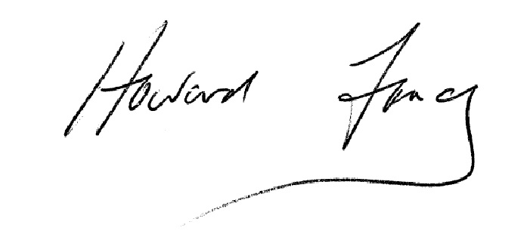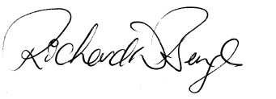
Howard Fancy Richard Benge
Trust Chair Executive Director
13 May 2017 13 May 2017
People in 2016
as at 31 December 2016

Kaumātua
Bill Kaua (Ngāti Porou, Ngāti Kahungunu, Ngāti Horowai, Rongowhakaata, Rakaipaaka, Te Aitanga a Hauiti)

Founding patron
Mel Smith CNZM

Patron
Miranda Harcourt ONZM

Patron, Arts Access Accolade
Dame Rosemary Horton DNZM, QSO, QSM

Trustees
Howard Fancy, Chair – Chair from August 2015
Kendall Akhurst – retired from board in April 2016
Kim Morton – joined board in February 2016
Awhimai Reynolds – joined board in August 2015, on leave of absence as of November 2016
Jeremy Smith – retired from board in November 2016
Karen Webster – joined board in April 2012
Josie Whipps – joined board in May 2014

Staff
Richard Benge, Executive Director
Dawa Devereux, Business Administrator and Personal Assistant
Iona McNaughton, Communications Manager
Jacqui Moyes, Arts in Corrections Advisor (part-time)
Claire Noble, Community Development Co-ordinator
Dev Singh, Finance Manager (part-time)

Volunteers
Thanks to all the volunteers, who did so much to support Arts Access Aotearoa and its work in 2016.
Eliecer Reverol, Daniela Pavez, Mayke Blom, Nikoo Namini, Sylvie McCreanor
Arts Access Awards 2016: Sarah Benge, William Thompson, Mayke Blom, Dipti Jivan, Eliecer Reverol, Judith Jones, Kate Leslie, Daniela Pavez, Lize Immelman, Ania Upstill, Rajeev Mishra, Leroy Lakamu, Dave Wilson

Awesome Arts Access Auction 2016: Mayke Blom, Ania Upstill, Lize Immelman, Eliecer Reverol, Leroy Lakamu, Sarah Benge, William Thompson, Dave Wilson, Katie Fallows, Mollie Hobley, Nikoo Namini, Aidan Heffernan, Duncan Armstrong, Nick Smith , France Aziz
Achievements in 2016

Arts Access Aotearoa fulfils its strategic goals through five key programmes:
- Access and Participation
- Community Development
- Advocacy and Profile
- Arts in Corrections
- Information Centre

This section highlights the key activities in 2016 under each programme.

1. Access and Participation
This programme is about supporting arts organisations, companies, festivals, producers and venues to be accessible. It includes the Arts For All partnership programme with Creative New Zealand.

Key achievements
Under this programme, Arts Access Aotearoa:
- promoted and encouraged access to the arts by producing Connecting Through Music, a video about relaxed performances in partnership with Chamber Music New Zealand and funded by the Ministry of Social Development.
- raised awareness of arts, inclusion and disability in New Zealand at the Arts Activated Conference in Sydney, where performance artist Rodney Bell and Claire Noble, Arts Access Aotearoa, highlighted successful collaborations and accessibility initiatives.
- encouraged and promoted the accessible events and services of Arts For All Network members. We documented a record 73 accessible services at arts and cultural events around New Zealand. This includes 18 audio described events, 39 sign interpreted events, four relaxed performances and two dementia-friendly gallery tours.
- inspired accessibility projects and increased knowledge by facilitating nine Arts For All Network meetings in Auckland, Taranaki, Wellington, Canterbury and Otago. At these meetings, members shared information and challenges, found solutions and learned about best practice in accessibility.
- strengthened the capability of 12 Arts For All Network member organisations to deliver accessible services at arts and cultural events by consulting with them on their accessibility policies and plans.

“What can we do that’s the easiest thing for us to all feel connected? Make some music together. So simple.” – Community musician Julian Raphael, featured in the video Connecting Through Music

Building bridges

Rodney Bell (Ngāti Maniapoto) has performed in prestigious companies with respected choreographers, and is internationally recognised for his physically integrated dance – a contemporary dance style that combines people with and without physical disabilities.

For 12 years, he lived in the United States and says he always felt he was building a bridge. “From a cultural perspective, it was great for people to experience my culture. I kind of felt like an ambassador of Māori culture.”

Following his dreams wasn’t always easy and he was homeless in San Francisco for three years after losing his job. Now back in New Zealand, Rodney’s overseas journey became the subject of Meremere, an hour-long autobiographical performance that premiered at the Tempo Dance Festival in Auckland in October 2016.

Rodney Bell wants to make the most of his experience to support and encourage others. “After being away for such a long time, I feel I owe a debt to New Zealand. I want to use my knowledge with our local disabled community, and support people to feel empowered. But I also want to learn from other people’s experiences.”

Rodney Bell is a member of the Arts For All Auckland Network. He co-presented with Arts Access Aotearoa at the Arts Activated Conference in Sydney.

Chamber music for all
Music is a universal language that can bring joy to everyone and yet the traditional concert hall is not an environment that suits everyone.

Chamber Music New Zealand has been presenting relaxed (or accessible) performances and workshops for people with intellectual disabilities since 2012. And in 2014, the organisation expanded its programme to include audio described concerts for blind and partially sighted patrons.

During relaxed performances, audience members can move around the space, make sounds, interact and play along with the musicians.

Its commitment to building new audiences and removing barriers to accessing classical music made Chamber Music New Zealand a worthy recipient of the Arts Access Creative New Zealand Arts for All Award 2016.

In a video, produced by Arts Access Aotearoa, Trio Amistad saxophonist Simon Brew talks about the rare and “special feeling” he gained during workshops with the students of Mahinawa Specialist School.

“It was a reminder to me of the importance of music. Years ago, chamber music and concerts were social outings. By doing concerts that are more accessible, I think everyone could enjoy classical music more.”

Called Connecting Through Music, the video also features community musician Julian Raphael as the workshop and concert facilitator for Chamber Music New Zealand.

Chamber Music New Zealand is a member of the Arts For All Wellington Network. Arts Access Aotearoa offered advice on accessibility, wrote new stories and promoted its accessibility.

2. Community Development

This programme is about building the capacity of community-based arts organisations, in particular creative spaces, to deliver high-quality arts programmes for people with limited access.

For more information about creative spaces, including a directory of creative spaces throughout New Zealand, visit Arts Access Aotearoa’s website.
Key achievements
Under this programme, Arts Access Aotearoa:
- strengthened the capability of creative spaces by organising a national conference called Creative Spaces 2020: building a strong future. Held in Wellington in May, it was a chance to network, share challenges and strengthen the sector.
- supported and promoted the Creative Spaces Capsule Project. This innovative, touring exhibition was inspired by a creative conversation between Menno Huibers, art tutor at Pablos Art Studios, and Benton Glassey, art tutor at Studio2/Margaret Freeman Gallery, at Creative Spaces 2020.
- enhanced the capability of three creative spaces by working with them to develop Flightdec community websites and providing online resources.
- supported creative spaces around the country through regular contact (e.g. meetings, visits, phone calls, emails) and by providing advice, opportunities, information, research and networking.
“Hugely valuable for networking. As a start-up facility, having so much expertise in the room is amazing. I’m in awe of all these wonderful people.” – Creative Spaces 2020 conference delegate
Celebrating inclusion

Fun, friendships and physical challenges are all part of the daily routine at Circability Central in Auckland. It’s developing opportunities and removing barriers by providing a creative space for all ages and abilities.

Circability Central is the recipient of the Arts Access Creative Space Award 2016. The judging panel commended its inclusion and celebration of difference. “Circability Central is a model of inclusive practice, offering a diverse range of activities across the community and building exciting partnerships.”

Circability Central runs programmes aimed at changing attitudes towards disabled people and enhancing their participation. More than 100 people participate in the classes with half of the participants having a physical or intellectual impairment.

Nathan Child, for example, has been an enthusiastic participant of the Circability Central community for the past four years. “Being part of the circus is what I like the most. It is a big thing for me. I like all my friends there and I like our circus instructors too. We are a big happy family, living happily ever after.”

Nathan, the bass player in the rock band called the Mutes from Mars, combines his musical talents, painting and acting with his circus classes. At Circability Central, he learns acrobatics, hula hoops and juggling.

Circability Central is a member of the Arts For All Auckland Network. Arts Access Aotearoa has written news stories and promoted it online.
The power of creativity
“My mental health was suffering severely but with this process, and the support of Ōtautahi Creative Spaces, I’m creating. Not just on canvas but in my world and my daily life. It’s a very powerful way of healing.”

These are the words of Narelle, a former counsellor, who says the Christchurch earthquakes made her question a lot. “Trauma was the experience: it changed my living, my work, my mental health.”
Narelle is one of several artists speaking in a video about the health and social benefits of attending Room 5, a project run by Ōtautahi Creative Spaces in the Phillipstown Community Hub in Christchurch.

The video is part of a series called Christchurch Dilemmas, directed by filmmaker Gerard Smyth.

Room 5 artist Sue says: “I love Mondays. I can’t wait for Mondays. It’s changed my life for the positive. I was quite a negative person. I didn’t think I could do art until I came here and now I’m doing a certificate in art.”

In May 2016, Sue gained a scholarship and started a distance delivery course through The Learning Connexion in Wellington. “If I get upset I sit down and do art, and after five minutes I’m back to being on a level basis. My life’s amazing now.”

Kim Morton, Manager of Ōtautahi Creative Spaces, says: “Being creative alongside others is a powerful tool for resilience and recovery. It’s as much about the social connection as it is about the art. Combined, they are a force for transformation.”

Ōtautahi Creative Spaces is a member of the Arts For All Canterbury Network. Arts Access Aotearoa has written news stories and promoted it online.

3. Advocacy and Profile
This programme is about raising public awareness and advocating for access to the arts for everyone in New Zealand. We do this by profiling, celebrating and advocating for the individuals, organisations and communities with whom we work.
Key achievements

Under this programme, Arts Access Aotearoa:

- profiled and celebrated the artists, creative spaces, producers and venues who lead the way in providing access to the arts at the Arts Access Awards 2016. A feature this year was acknowledging the contribution of the Deaf community in New Zealand and celebrating the tenth anniversary of New Zealand Sign Language as an official language. Awards co-presenter was Victoria Manning, Deaf Aotearoa, with Richard Benge, Arts Access Aotearoa. A performance featured an excerpt from Here At the End of My Hands, presented by Equal Voices Arts – recipient with partners University of Waikato, Deaf Aotearoa and Bill Hopkinson, of the Arts Access CQ Hotels Wellington Community Partnership Award 2016.
- provided a voice for disabled people through the Arts Access Advocates website, funded through the Ministry of Social Development. This included a section promoting Disability Pride Week in Wellington from 27 November to 3 December. We worked with convenors to write, develop and promote its art events online and in mainstream media.
- increased awareness and advocated for inclusion by writing more than 100 stories, blogs and profiles about accessibility and the arts, promoting them in digital and mainstream media.

Artistic achievements shine

Gisborne artist David Cameron (Ngatapa, Gisborne, Kati Mamoe, Ngai Tahu, Te Whānau a Kai, Te Aitanga-a-Mahaki, Ngati Porou) is proof there are no limitations for a creative soul.

At the age of 19, David fell from a balcony and was paralysed. During his rehabilitation in 1977, his passion for art was rekindled. He taught himself to carve leather and today, he is a recognised leather worker, painter, ceramicist, and tutor in his preferred artform, uku (clay ceramics).

Guided in uku by ceramic artists Baye Riddell, Wi Taepa, and the late Manos Nathan and Colleen Waata-Urlich, David is acknowledged nationally as a senior ceramic artist and a mentor for emerging ceramicists.

He is also a member of Kaihanga Uku (Māori Clay Artists Collective), a network engaging with indigenous artists in the Pacific Rim and globally.

“I love the immediacy of uku – taking a lump of clay and modelling it into a living, beautiful form. I also enjoy the challenges and delights of this malleable material, which sometimes has a mind of its own.”

In 1995, David was asked to paint the kowhaiwhai in the newly constructed wharenui (whare-tipuna) Te Poho o Hiraina at Pakowhai Marae, Waituhi, in Gisborne. From September 1997 and over the next 12 years, David worked on this assignment. It’s this work on the wharenui that he’s most proud of.

“It was a lot of work over 12 years but the opportunity I was given to work on a project that represents the pinnacle of Māori artistic expression has been an honour and a privilege.”

David Cameron is the recipient of the Arts Access Artistic Achievement Award 2016.

“My heart is here”
Anyone who knows Glen McDonald, Co-ordinator of Vincents Art Workshop in Wellington, will tell you about her commitment to creativity, inclusion and community. She’s happy to talk all day about Vincents but uncomfortable when the attention focuses on her.

However, she can’t avoid a fuss this time. Glen is the recipient of the Arts Access Accolade 2016, which recognises the lifetime achievements of someone who has played a significant role in working with Arts Access Aotearoa to achieve its vision of a society where all people in New Zealand can participate in the arts.

Glen has been working at Vincents Art Workshop for 23 years and says, “My heart is here.” Her commitment to the arts and inclusion dates back to when she was aged six or seven and she found herself wondering why some people were excluded from society because of their differences.

“I’m a dreamer,” Glen says, “and even though I don’t really focus on the past or the future, my vision is for a world where places like Vincents are not needed because all people are included. A world where everyone is accepted, respected and valued.”

“Well done, Tom and the Arts Access Aotearoa team, for helping us make our accessibility programme such a huge success.” – Megan Duffy, New Zealand Festival 2016

4. Arts in Corrections

This programme is about working with the Department of Corrections and the wider community through Arts Access Aotearoa’s Arts in Corrections Advisory Service. We provide information and advice about arts activities and programmes that support the rehabilitation process of offenders and their re-integration into the community on release.

Under this programme, Arts Access Aotearoa:

- enhanced its capacity to deliver Arts in Corrections projects by building and strengthening community partnerships. For example, we organised three Creativity in Corrections forums in Auckland, Wellington and Christchurch, which increased knowledge and highlighted the role of theatre and creativity in prisons. Each forum included a training workshop delivered by Uta Plate.
- developed the skills of Corrections’ staff, local artists and 16 prisoners in the Drug Treatment Unit of Arohata Prison by facilitating a one-week workshop called Through the Looking Glass Prison Theatre Project, led by Uta Plate. The workshop culminated in a 45-minute devised performance presented to an audience of invited guests, prisoners, and clinical and Corrections staff. The project was evaluated and documented in a 24-page report and short video.
- built further on the skills and confidence developed in the Through the Looking Glass Prison Theatre Project by continuing to work with several local artists and prisoners in the Drug Treatment Unit of Arohata Prison. The result were two further performance opportunities in 2016: a performance at the graduation of women from the six-month Drug Treatment Unit programme and performances in the Arohata Christmas Concert in December.
- supported the ongoing development of performing arts projects at Northland Region Corrections Facility, informed by facilitated conversations between Facility staff, prisoner participants and providers. In addition, Arts Access Aotearoa worked with art tutor and education facilitator Beth Hill to deliver a performing arts workshop celebrating the first-year anniversary of the Shakespeare Behind Bars group. Over two days, participants workshopped scripts written by women at Arohata Prison during The Looking Glass Prison Theatre Project, and created their own movement-based performances in response to discussions around re-integration and rehabilitation.

Shared vision of the arts

“We have an amazing team of Corrections officers, educators, interventions staff and management team. We all believe the arts are a valuable tool to add to the kete when it comes to rehabilitating and reintegrating men from the prison into the community.”

Beth Hill of Redemption Arts and Education Services is the arts tutor and education facilitator at Northland Region Corrections Facility. She plays a pivotal role in developing the prison’s arts programmes and partnerships.

Recipient of the Arts Access Corrections Leadership Award 2016, Northland Region Corrections Facility’s shared vision across the prison is to support prisoners on a well-structured pathway; reduce re-offending; be mindful of victims of crime; and use creativity in its many forms to achieve these goals with dignity and integrity.

The Facility offers theatre, music, creative writing, painting and carving classes, where prisoners find support and gain new skills on their pathway to rehabilitation. They can also study NZQA courses and gain qualifications through Te Aho o Te Kura Pounamu – The Correspondence School and North Tec.

The prison also has a network of expert practitioners regularly visiting the site; contributes to the community through donations of prisoners’ artwork, exhibitions and open performances; and engages with local iwi for advice on cultural protocol.

Seeds of creativity grow

Continuity. That’s the word Wellington artist and musician Dan James uses to describe why he volunteered to work with prisoners in Arohata Prison from February through to December last year, culminating in the Arohata Christmas Concert.

His first experience of working in a prison environment was when he and seven other local arts practitioners (actors, musicians and a visual artist) took part in the Looking Glass Prison Theatre Project. Led by German theatre practitioner Uta Plate, the workshop was held over one week in Arohata Prison in February 2016.
At the end of the workshop, Dan could have walked away and got on with his own busy life. So what inspired him to carry on working with the prisoners over 2016?

“For me, it was about continuity. In Uta’s workshop, we built a rapport with the women and I saw how much confidence they gained. A sustained approach is much more poignant and valuable than doing something as a one-off.”

Key aims of the Looking Glass Prison Theatre Project were for all of the participants to work collaboratively and also create ongoing opportunities for artistic expression in the prison and the wider community, says Jacqui Moyes, Arts in Corrections Advisor, Arts Access Aotearoa.

“After the February workshop, several artists and I continued working with the Arohata women, supporting them to create their own version of the Looking Glass for a graduation in June. We were then invited to work together on the Christmas concert.”

The women in the prison’s Drug Treatment Unit based their Christmas performances on five pieces of creative writing they had developed in a ten-week creative writing course, run by Wellington writers and teachers Pip Adam and William Brandt of Write Where You Are.

These performances addressed child abuse and abandonment in state care, domestic violence, drug addiction, the journey to prison and having to leave their children.

For Jacqui, the ongoing interaction in 2016 between the artists and women shows what is possible. “For me, it’s highlighted the role of the arts to motivate and inspire change, boost self-esteem and increase confidence. It’s allowed the women’s creative voices to be heard and to shine.”

Arts Access Aotearoa thanks Uta Plate, Anita Grafton, Jo Randerson, Sandra Schmidt, Chantelle Brader, Batanai Mashingaidze, Waylon Edwards, Dan James, Rosie Howells, Alice Ralston and Aimee Martin.

“What I want for my future is to live a crime-free, drug-free life, to be there for family and my children and my children's children. I am an expressive person and very creative in many forms and so many levels, so I found the whole experience very uplifting and enjoyable. I'm keen to pursue more of these workshops or anything to do with the arts, given the chance.” – Participant in the Through the Looking Glass Prison Theatre Project

“These workshops are invaluable for those using theatre as a means for social change, whether it be in prisons or whether it be in the openings and growth of connection in our communities. Thank you.” – Arts in Corrections Northern Region Network member

5. Information Centre

This programme is about providing a national information service on access to and participation in the arts, and advising on best practice.

Key achievements

Under this programme, Arts Access Aotearoa:
- increased traffic and engagement to its two websites (Arts Access Aotearoa and Arts Access Advocates). In 2016, the websites attracted 20,041 unique visitors and 59,833 page views.
- built the capacity of its stakeholders and networks by providing accurate and relevant answers to a record 175 requests for information and advice from individuals and organisations.
“Oh wow, you rock! Amazing help and fab ideas! You are always brilliant at communication, much appreciated.” – Kayte Shaw, Deaf Aotearoa
Funders, sponsors and supporters
Arts Access Aotearoa would like to thank the following organisations and individuals who have supported its work in make a difference in New Zealand by increasing access to the arts in 2016. We look forward to your ongoing support.

Core funder   | Major contract   | Local government  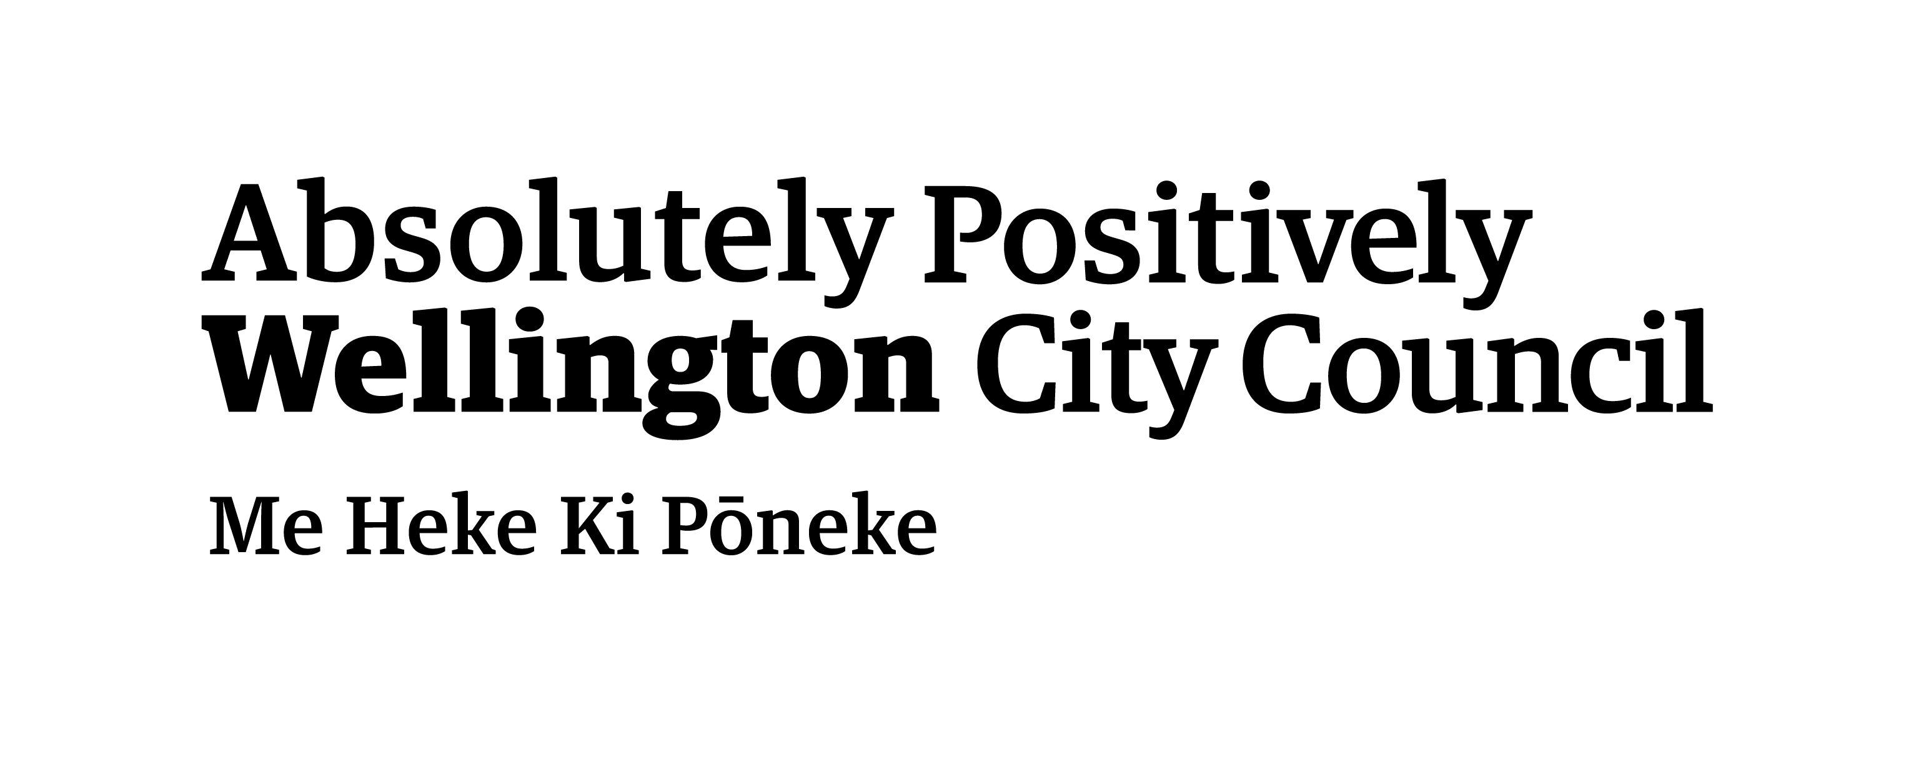
Project partners  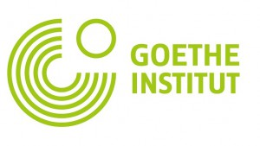   | Major grant  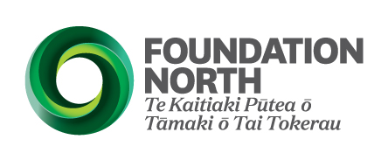 | Arts Access Awards sponsors  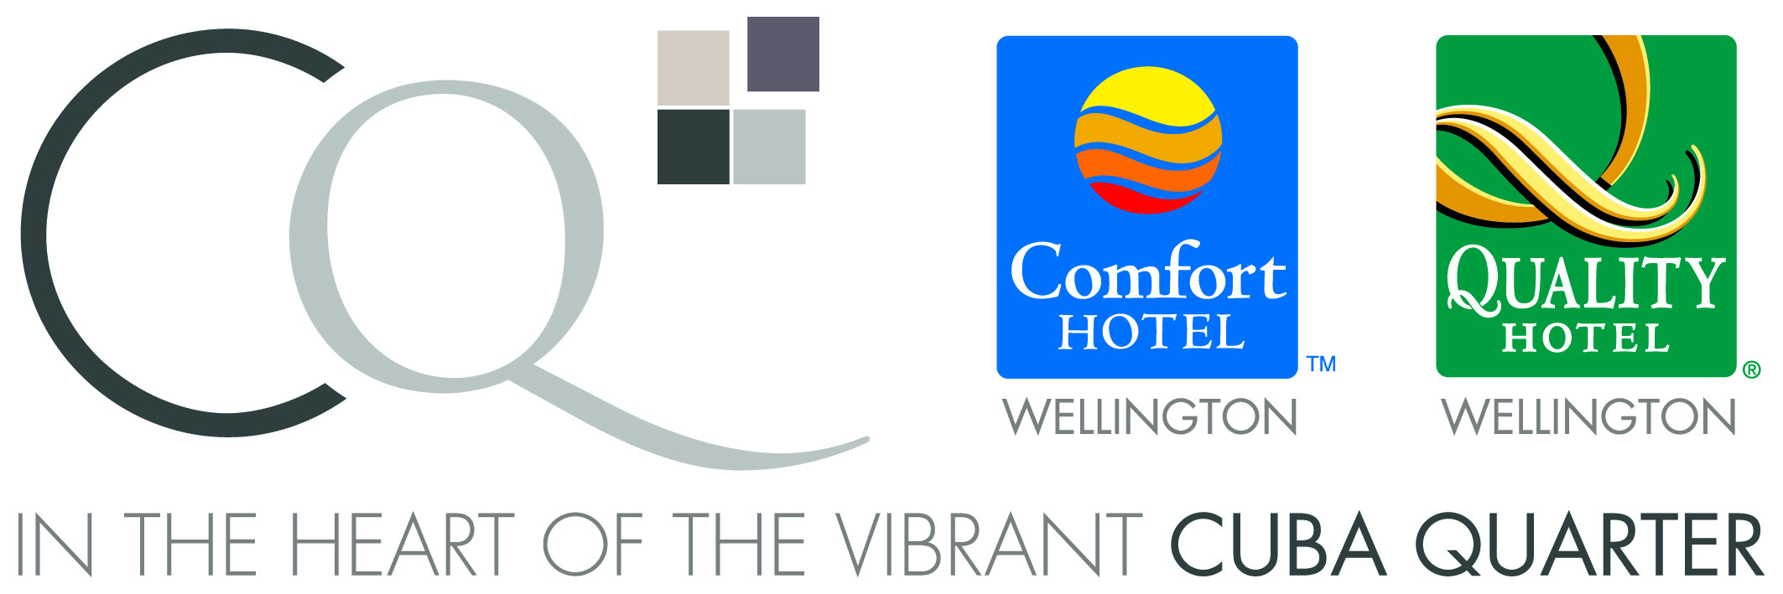
Awesome Arts Access Auction event partner | Legal services  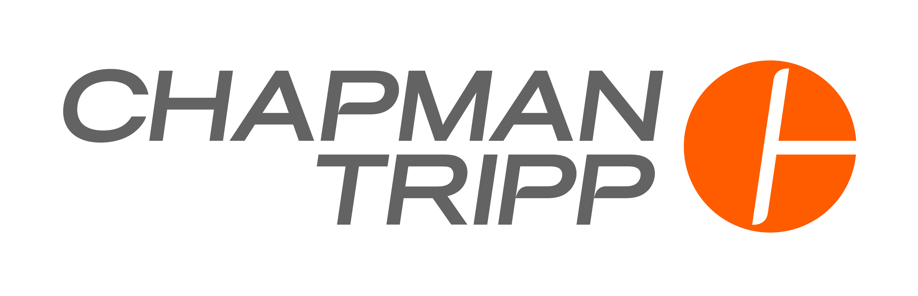 | Grants and donations  - Infinity Foundation  - Mazda Foundation  - National Foundation for the Deaf  - Nikau Foundation  - Thomas George Macarthy Trust  - Wellington Community Trust  - Winton and Margaret Bear Charitable Trust

Organisational supporters in 2016
Many thanks to the following people and organisations for their support of Arts Access Aotearoa’s activities, including the Arts Access Awards 2016 and Awesome Arts Access Auction 2016.

Abbott Kavanagh Rolle Ltd, Alex van Heeren and Worldwide Leisure, Alexandria Tasker, Alpha Gallery and Art Studio, Anita Grafton, Ann Byford, Anton Carter, ART+OBJECT, Auckland Art Gallery, Auckland Theatre Company, Awhimai Reynolds, Beach Babylon, Beauté on Willis St, Beth Hill, Bettina Senff, Bev Lowen, Bidvest, Bill Kaua, Briar Munro, Capital E, CareNZ, Catherine, Chamber Music New Zealand, Chapman Tripp, Christine Winbush, Cin Cin, Circa Theatre, Commonsense Organics, Cordon Bleu, CQ Hotels Wellington, Daniel Phillips, Darcy Nicholas, Denise Dennehy, Eliecer Reverol, Ellmers, Emporio Coffee, Erwin Van Asbeck, Ethni-city, Experience Wellington - Hannah Play House, Experience Wellington - Nairn Cottage, Experience Wellington - Space Place, Fly My Pretties, Fraser Carson and Flightdec, Fraser Hoffe, Gazley Motors, Goethe-Institut New Zealand, Gordon Harris, Graphic Solutions, Hon Maggie Barry, Hon Nikki Wagner, Hotel Pullman Auckland, Huka Lodge, Jacinda Ardern MP, Judith Jones, Julian Raphael, Juliet Nally, Karamia Lee, Karen Boyes, Karen Ross, Kerry Tilby-Price, Kim Morton, Kirsten Mason, Langdons on the Bay, Langdons Retreat, Len Lye Centre Govett Brewster Art Gallery, Les Mills Extreme, Lido Café & Bar , Lize Immelman, LOT EIGHT, Lotto NZ, Lyn Cotton, Mark Newdick, Martinborough Hotel, Martine Abel, Mary Ama, Mayke Blom, Metro, Michael Cox, Mihailo Ladjevac, MIX, Molly Mullen, Murray Wylie, Museums Wellington, Nice Hotel, Nikau Café, Olivier Lacoua, On Yer Bike, Orchestra Wellingon, Out of the Box, Pablos Art Studio, Pacifica Arts Centre, Park Hotel, Parliamentary Service, Pati Umaga, Paula Comerford, Pauline Johns, Peter O'Connor, Peter Wedde, Pip Adam, Pony Lane, Quilt Stitch Volunteers, Rachel Leota, Rajeev Mishra, Ray Smith, Reece Tong, Rimutaka Prison Printshop, Rodger Fox and members of the Wellington Jazz Orchestra, Royal New Zealand Ballet, Sable Fine Hair, Schustrings, Roger That, Sexual Abuse Prevention Network, Shaun Fahey, SkillWise and The White Room, Smartpay, Southern Cross Bar and Restaurant, Spyglass, Stephen Wainwright, Sterling Woodfire Eatery & Bar, Stew Sexton, Streamliner, Sue Jane, Tactical Survival Academy, Te Ara Korowai, Te Papa Press, Te Papa Tongarewa, The Front Room Café, Timothy Leatigaga, Tirohana Estate Vineyard, Tony Kuepfer, Tory Urban Retreat, Ulrike Rosenfeld, Unichem Cuba Mall, Volunteer Wellington, Victor Bright, Victoria Manning, Vincents Art Workshop, Wellington Jazz Festival, Wellington Phoenix Football Club, Wellington Potters Association, Weta Workshop, William Brandt

Supporting what we do

You can help Arts Access Aotearoa reduce barriers and increase access to the arts for everyone in New Zealand.

Make a donation

Help us ensure all people can participate in the arts either as creators or audience members. An easy and effective way to make a monthly donation and be kept up to date with events and activities throughout the year is to join Friends of Arts Access Aotearoa.

Arts Access Aotearoa is a registered charitable trust and donations of any size are gratefully received. You can claim a tax credit on donations of $5 or more.

Sponsorship and corporate support

By sponsoring Arts Access Aotearoa, your business can be strategically aligned with a national arts charity that increases access to the arts for everyone in New Zealand.

Leave a gift in your will

Your bequest will help us build a more inclusive society to ensure that future generations will experience art and creativity, without barriers.

Options to support

Every dollar you donate will benefit artists, people and communities throughout New Zealand. Projects needing support include:

1. Arts For All: increasing access to arts and cultural events for everyone

“People who are sighted can look at pictures to see what something looks like. When you can’t see, you can’t do that. For me, touching the harpsichord transported me back in time to seventeeth-century France.” Student Renee Patete, who is blind, enjoys a touch tour and audio described concert of Les Talens Lyriques, presented in Wellington by Chamber Music New Zealand.

2. Creative spaces: building the sustainability of community-based creative spaces throughout New Zealand

Auckland artist and writer Anita Mary lives with chronic pain. She says Toi Ora Live Art Trust provides a supportive community of creative people. “Toi Ora, my faith, art and creativity have been crucial in my journey of self-discovery and healing.”

3. Arts Access Awards: celebrating artistic achievement, and the individuals, groups and organisations providing access to the arts

“My main goal is to continue working with clay and explore the kowhaiwhai patterns in my work. Every day I get new ideas and I want to keep challenging myself so that my work evolves,” says David Cameron, recipient of the Arts Access Artistic Achievement Award 2016. The Gisborne artist was presented his award by senior Māori artist Darcy Nicholas.

4. Arts in Corrections: using the arts as a tool supporting the rehabilitation and re-integration of prisoners

After six days participating in a theatre workshop, the 16 prisoners in the Drug Treatment Unit of Arohata Prison in Wellington perform Come Listen to my Story of Wonderland, a work they created and rehearsed with German director Uta Plate and eight Wellington actors, musicians and a visual artist. Arts Access Aotearoa worked in partnership with Goethe-Institut New Zealand to develop and implement this project.

Making your donation

Arts Access Aotearoa needs your support to ensure everyone in New Zealand, now and in the future, can engage in the arts. With your help, we can all experience art and creativity, without barriers.

Title: ________________________________________________________
First name: __________________________________________________
Surname: ____________________________________________________
Address: _____________________________________________________
____________________________________________________________
Phone: ___________________________ Mobile: ___________________
Email: __________________________________________________________

Please supply your email address so we can send you a receipt and keep you up to date with news and events. You can unsubscribe at any time.

I wish to support:
€ Arts For All
€ Creative spaces
€ Arts Access Awards
€ Arts in Corrections
€ Area of most need

With a donation of $________

Or:

€ I wish to make a regular monthly donation as a Friend of Arts Access Aotearoa of $________ .

€ Please send me information about leaving a gift in my will so that more people in New Zealand will have access to the arts for years to come.

Please choose a payment option below or give online at www.artsaccess.org.nz/donate-to-arts-access-aotearoa

€ I enclose my cheque payable to Arts Access Aotearoa

or

€ Please charge my credit card

Visa / Mastercard number: _______________________________
Expiry date: __/__
Name of cardholder: _____________________________________
Signature: ____________________________

€ I would like to give online with an Internet banking payment.

Account name: Arts Access Aotearoa
Account number: 03-0502-0040862-00
Please include your full name as reference.

To arrange for your tax deductable receipt please call us on 04 802 4349 or email info@artsaccess.org.nz

Please return this completed tear-off slip with your payment to Arts Access Aotearoa, PO Box 9828, Wellington 6141.

Thank you for your support.

If you would like more information about how you can support Arts Access Aotearoa, please contact Richard Benge, Executive Director (T: 04 802 4349 or 021 217 1002 E: richard.benge@artsaccess.org.nz).

