**Show me the money**

**Fundraising tips from Creative Spaces 2020 delegates**

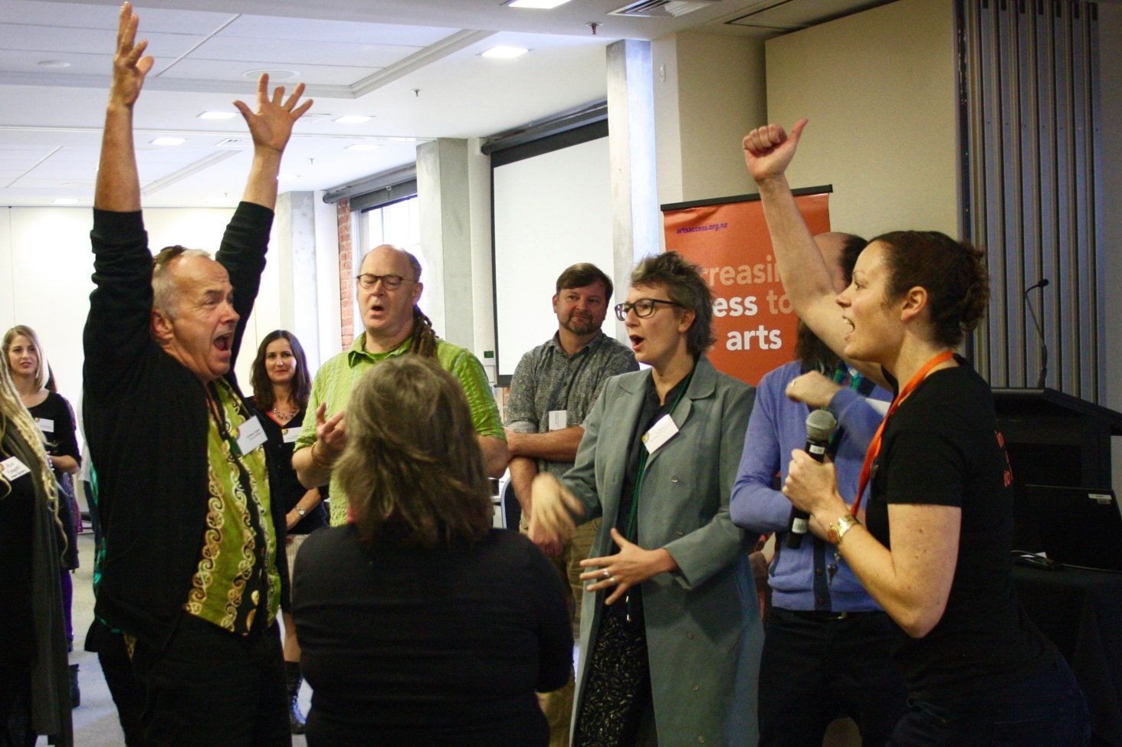



**What are your best ideas for strengthening relationships with donors, sponsors and supporters?**



**You both**

**benefit**



* COLLABORATION
* Thank them, show appreciation and follow up
* Grow projects together
* Encourage them to become advocates for your organisation
* Get to know them, make it personal
* Ensure they know why you exist – tell your story
* Demonstrate what difference their contribution makes to the service
* Keep them in the loop with what you’re doing
* Send them a photobook of the project
* Communication pre, post and during
* Feedback – ask what worked, what didn’t?
* Take a polaroid of staff/artists saying “thanks”
* Advertising
* Workplace wellbeing creative workshops in return
* Promote their contributions
* Everyone loves art – we have heaps in common!
* Establish mutual connections to develop a relationship
* Get them invested in the artists you/they support
* Manaakitanga
* Building up communications with them once you’ve had a meeting by keeping relationships fresh through social media and letting them know what your creative space is up to
* Food and wine
* Tell succinct stories about transformation – difference their investment makes
* Mention them/ thank them in annual reports/ newsletters/ website/ social media, if they consent
* Tell your story clearly and briefly
* Send them a company calendar or cards
* Give them small gifts

**Stay connected**



* Give them artwork to hang

**Establish relationships**

* Reciprocal – promote them as well
* GET THEM INVOLVED. Invite them to your event/space/exhibition opening/ workshops etc
* Invite them to get creative in your space
* Showcase your mahi

**What’s the best piece of fundraising advice you’ve received?**



* Re-apply
* Say thank you



* “No” just means no today,

rephrase and ask again later

* Do your accountability reports well
* “If you had to close down there would be so many people that would say – why didn’t you tell me!” HUMAN IMPACT
* Show in-kind support as expenses and income in your budget
* Research and talk to people within the sector as to what they did
* Build a budget, be specific
* Be realistic in what you are asking for – don’t be greedy
* Build relationships
* Get creative
* Keep asking
* Develop a funding calendar
* Explore the many aspects of social media available that you can tap into



* You must let people know the value of what you do
* Tell your story using human impact, photos and a well-written storyline
* Be clear about what you want before you ask for it
* What’s in it for everyone else
* Try to directly address as many points of the criteria as possible (but don’t bullshit too)
* Read the specifications on each grant clearly, so you know what they will/won’t fund
* Match the funding request to the funder. Make each funding application fit the funds available – no generic “copy and paste” applications
* Give them what they ask for: e.g. don’t write a book if they ask for a paragraph
* If you don’t ask, you don’t get
* Don’t waffle
* Have stories that help make it real
* Reflect the language of the funder
* Photos and testimonies from people you affect
* Keep your application on point
* Make it fun
* Outcomes
* Get feedback whether you are successful or not

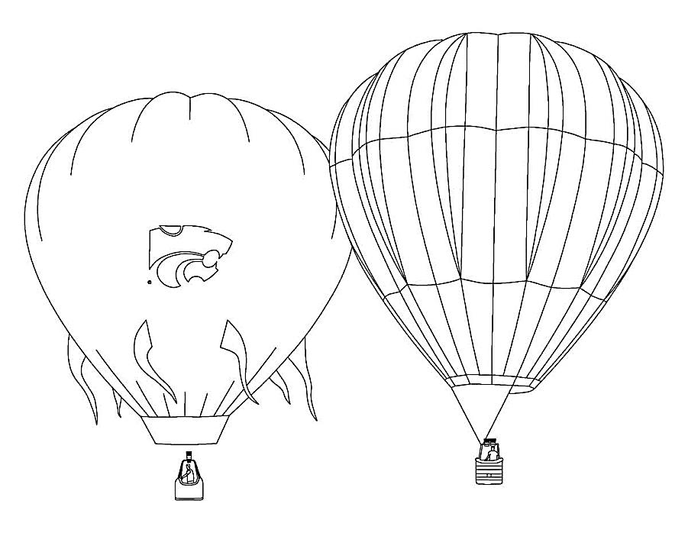**What successful grants have you applied to for your creative space?**

* ASB Bank NZ
* Infinity Foundation
* Lion Foundation
* Sky City
* J.R. McKenzie Trust



* TODD Foundation
* John Illot Charitable Trust (Rotary Club of Light)





* Masonic Lodge
* Rata Foundation
* Fund: Think Differently

# Te Puni Kōkiri (Ministry of Maori Development)

* Hawkes Bay Foundation
* Lottery Community
* Invercargill Licensing Trust



* Rotary
* City and Regional Councils
* Community Organisation Grants Scheme (COGS)
* Strengthening Communities
* Chocolate Fundraising Ideas NZ
* WEL Energy Trust Grants (Waikato)
* Pub Charities
* Whittakers

Foundation North (Auckland & Northland)

* Freemasons NZ
* ANZ staff
* District Health Board
* Creative communities (Local Council)
* CNZ (individual development) Earthquake Recovery CNZ Community Arts Development Fund CNZ/Christchurch City Council
* Community board funding
* Asking foundation (with Rotary)
* Making a Difference
* Ministry of Social Development
* Winton and Margaret Bear Trust (Youth & Wgtn)
* James Gibb Fund
* North South Foundation (Education)
* The Funding Network
* IHC Foundation, IHC legacies
* The Southern Trust (national)
* Blue Sky Communities Trust
* Ara Taiohi: Youth Week Trust
* Frozen Funds Trust
* Philanthropic Trusts
* Local business support (for cheap rent)
* Nikau Foundation: Nikau Community Fund
* Rehabilitation Trust
* Box Trust
* Community Trusts
* Lotteries
* CH Izard Trust
* Trust Waikato
* Community Trust of Southland

**How could you access resources that would typically cost, without spending money?**

* Sharing resources through creative spaces
* Collaboration – bartering/trade services
* Creative Junk – low cost material resource centre ($5 a bag)
* Exchange labour
* Recycled materials
* Tech Soup
* “End of line” stuff from industry – paper, cardboard, etc
* M.O.W. recipients – relationship building = free knitting wool/pears
* Printing companies – paper offcuts



* Paint companies – paint test pots
* Christchurch City Council gave us free computers
* For sale signposts
* Borrow or share
* Our website calls for donations of paint, paper or anything that can be made into art, also equipment.
* Ask for seconds/offcuts/bad runs etc
* Plywood from Placemakers/Bunnings/etc. (cover sheets)
* Freecycle
* Professional expertise of committee members

volunteers

* Know what you need
* Library where you borrow skills/equipment
* Community spaces – gardens, malls, libraries
* Use Facebook to advertise free resources, so have a specific page
* Asking people
* Target the right people
* Op shops etc
* Call out/ask local community, rich people, strategic partners
* Find the supplier and tell them the vision or plan



* Sponsorship
* Loan artwork in exchange for services
* One man’s trash, another man’s treasure
* Koha
* Time banking
* Green currency
* Social corporate responsibility
* Ask – articulate the impact it would make
* Corporate challenge groups from volunteer Wellington
* NZ Post giving free postage – Community Post
* Local community social media sites
* Interns – university/arts school/polytechnic
* Mutual exchanges with other services
* Access to international internship programme

**What are innovative ways of accessing financial support you have used or know of?**

* One Percent Collective – getting others to run fundraisers for you

* Have a “friends” programme to attract regular donations
* Community groups and/or corporates to do traditional fundraising – sausage sizzle/bake sale/fun run/walkathon
* Give a talk at your local Rotary/Lions/Lodge to possibly gain support
* Host dinner events
* Mardigras
* Holding market events, charge per stall
* Performances
* Product sale
* “Time banking”
* Allow people to use space – venue hire: e.g. Fringe Festival
* Being a “charity of the month” for large business
* Crowdfunding – Boosted (arts specific), PledgeMe (NZ wide), Kickstarter (International), Give a Little (free)
* Sell on commission – widgets
* Non-monetary donations
* Art auction with work from well-known artists (also building support from them)
* Selling hugs with a dog or cat
* Rent a desk
* Renting materials
* Renting what you already have
* Event where the door charge goes to the best idea from a handful of people pitching
* Garage sale
* Gate sales at collaborative event
* Movie fundraising nights – functions supported by cinema
* Do what you do well and be proud
* Collaborate with other organisations who get funding for you
* Relationships – not going straight for the cash … shared purpose



