Annual Report 2014

Increasing access to the arts

Contents

1. Arts Access Aotearoa: vision and purpose

2. Investing in Arts Access Aotearoa’s work:
the Chair and Executive Director’s report on 2014

3. People in 2014

4. Achievements in 2014

Access and Participation
Community Development
Advocacy and Profile
Information Centre
Prison Arts

5. Performance report 2014

6. Funders, sponsors and supporters

7. Supporting what we do

Large print and online

Arts Access Aotearoa’s Annual Report 2014 can be downloaded as an accessible Word document at www.artsaccess.org.nz/about-us

Large-print copies of the report are available on request.

Arts Access Aotearoa thanks all its stakeholders, funders and supporters for their contributions to its work in 2014.

Contact us:

Level 3, Toi Pōneke Arts Centre
61–63 Abel Smith St
PO Box 9828
Wellington 6141
T: 04 802 4349
E: info@artsaccess.org.nz
W: www.artsaccess.org.nz
Arts Access Aotearoa: vision and purpose
Arts Access Aotearoa is a national organisation advocating for people in New Zealand who experience barriers to participation in the arts, as both creators and audience members. Key stakeholders are artists and arts organisations in the community and professional arts sectors; people with physical, sensory or intellectual impairments; and people with lived experience of mental ill health. Arts Access Aotearoa is also the key organisation in New Zealand facilitating the arts as a tool for rehabilitation in prisons.

In particular, it works with a network of creative spaces to provide professional development, capability building and leadership, advocacy and promotion, information-sharing and artistic opportunities.

Vision

All people in New Zealand are able to participate in the arts.

Purpose

Arts Access Aotearoa advocates for all people in New Zealand to have access to the arts by supporting people who experience barriers to participation or whose access is limited.

Values

Arts Access Aotearoa believes that all people have a right to access artistic opportunities as both creators and audience members.

In all aspects of its work, Arts Access Aotearoa will respect and honour the Treaty of Waitangi with due regard for its articles and principles.

Strategic goals

Arts Access Aotearoa is committed to working in partnership with others to achieve its purpose. Its goals are to:
- Support arts organisations and venues to be accessible.

- Build the capacity and sustainability of community-based arts organisations to deliver quality arts programmes for people with limited access.

- Raise public awareness and advocate for access to the arts.

- Provide a national information service about access to and participation in the arts, and advise on best practice.

- Support and promote the use of the arts as a tool of rehabilitation and reintegration for prisoners.
Investing in Arts Access Aotearoa’s work

The Chair and Executive Director’s report on 2014

Everyone has the right to be creative. This is Arts Access Aotearoa’s central belief – a belief that has guided it since its inception in 1995.

Arts Access Aotearoa is a small national organisation with a big vision of a society where all people are able to participate in the arts. In particular, we focus on people who, for reasons of disadvantage, disability or isolation, have limited access to the arts as creators, audience members and gallery/museum visitors.

This year, we have achieved a great deal as we work towards attaining this vision. We have increased public understanding and promoted the creative talents of New Zealanders who face barriers to access; we have connected people and organisations so they can share their knowledge and innovative practice; and we have added value to the social and community goals of central and local government agencies.

Funding through the Ministry of Social Development’s Making a Difference Fund certainly made a difference to what Arts Access Aotearoa was able to achieve in 2014. This vital support enabled us to undertake two significant initiatives.

Firstly, we held a series of workshops with a group of 15 disabled artists and arts enthusiasts in Christchurch. These workshops were aimed at building leadership skills and providing effective ways for disabled people to advocate for improved access to the arts. As in Auckland, where we held similar workshops the previous year, an arts advocacy group was formed to provide an ongoing, effective voice for access to the arts.

Secondly, Christchurch was one of five cities featured in Arts Access Aotearoa’s national I’m an Artist Campaign, held over October and November. This exciting advocacy campaign was launched at events in Wellington, Dunedin, Auckland, Christchurch and Hamilton.

The overall aim of the campaign was to change attitudes and behaviour towards people with a disability, sensory impairment or lived experience of mental ill-health. In this campaign, the artists (who have a disability or experience of mental illness) were promoted along with the community-based creative spaces that support their creative achievements.

The campaign was built around huge, eye-catching posters featuring a photo of a local artist with their work, accompanied by the text “I’m an artist”. The posters were pasted up on city streets and billboards. In Christchurch, for example, the poster featured Michael Krammer, a dancer and tutor at Jolt Dance.

Thank you to the artists and creative spaces who worked with us on this campaign.

We are grateful to core funder Creative New Zealand for additional funding to rewrite a second edition of Arts For All: Ngā mō te katoa, printed with support from Wellington City Council.

This practical, how-to guide is aimed at artists and art marketers, companies, producers, festivals, galleries and museums. It provides a framework to guide and inspire members of the Arts For All networks we’ve established in Wellington, Auckland, Taranaki, Dunedin and Christchurch.

The publication was launched by Her Worship the Mayor of Wellington Celia Wade-Brown with Stephen Wainwright, Chief Executive of Creative New Zealand, in April 2014. At this event, the Mayor also presented nine newly trained audio describers with certificates for completing a three-day audio describing course, facilitated by Arts Access Aotearoa and funded by Wellington City Council.

Wellington City Council recognises the work we do to ensure access to the arts for its citizens and funds us accordingly. We are grateful for this support and that of other local councils.

The Arts Access Awards in July celebrated the achievements and commitment of the people who work to provide access and inclusion in the arts. A new award called the Arts Access Accolade was introduced. This is presented to a person who has played a significant role in assisting Arts Access Aotearoa to achieve its vision. Everyone at the event and beyond was delighted to learn the inaugural recipient was Philip Patston. We are honoured that Dame Rosie Horton has agreed to be Patron of the Arts Access Accolade, which she presented to Philip.

Arts Access Aotearoa has a contract with the Department of Corrections to provide an advisory service to Corrections’ staff and volunteers. This year we conducted a pilot project, connecting prisoners who had responded well to arts activities with community art spaces and mentors up to and following their release date. This project assists the Department of Corrections with its goal to reduce re-offending by 25 per cent by 2017.

Fundraising has become an increasingly important role for Arts Access Aotearoa to enable us to build on the work we do across the country. The second Awesome Arts Access Auction, held at CQ Hotels Wellington in October 2014, was a huge success. Guests from businesses and the community enjoyed a delightful function and participated in an exciting charity auction. It was their chance to contribute to Arts Access Aotearoa’s work.

In addition, Arts Access Aotearoa increased the level of funds raised through donations, grants and other fundraising activity on the previous year. We are pleased to report a small surplus, which takes us into 2015 in a strong position.

Finally, we are very fortunate to have a great team at Arts Access Aotearoa. Without the commitment of staff and trustees, we would not have achieved what we did in 2014. We are also grateful to the many wonderful volunteers who joined us over the year, bringing additional skills and enhancing our capacity to increase access to the arts for everyone in New Zealand.

Richard Cunliffe Richard Benge
Trust Chair Executive Director
22 May 2015 22 May 2015

People in 2014
(as at 31 December 2014)

Kaumātua
Bill Kaua (Ngāti Porou, Ngāti Kahungunu, Ngāti Horowai, Rongowhakaata, Rakaipaaka, Te Aitanga a Hauiti)

Founding patron

Mel Smith CNZM

Patron

Miranda Harcourt ONZM

Patron, Arts Access Accolade

Dame Rosemary Horton DNZM, QSO, QSM

Trustees

Richard Cunliffe, Chair
Howard Fancy, Deputy Chair
Kendall Akhurst, Glen McDonald, Karen Webster, Josie Whipps

Staff
Richard Benge, Executive Director
Gemma Williamson, Business Administrator and Personal Assistant
Iona McNaughton, Communications Manager
Jacqui Moyes, Prison Arts Advisor
Claire Noble, Community Development Co-ordinator

The contribution of trustees

Arts Access Aotearoa’s trustees volunteer their skills and time. In their governance role, they meet five times a year to set the organisation’s strategic direction. They also attend events related to Arts Access Aotearoa’s work.

Volunteer programme
Thanks to all the volunteers, who did so much to support Arts Access Aotearoa and its work in 2014.
Nhan Luu, Shane Eccleshall, Ben Jones, Rashika Keshwan, Terri Rosenstock, Andrea Moxham, Hoang An Liu, Jackson Mulder, Radhika Goyat, Caitlin McNaughton
Arts Access Awards 2014:
Jackson Mulder, Teresa Heinz Housel, Caitlin McNaughton, Judith Jones, Rashika Keshwan, Radhika Goyat, Matt Sims, Sarah Benge, Nhan Luu, Kate Schrader, Harriet Hughes, Shane Eccleshall, Michelle Baker, Jessica Ducey, Tim Herbert, Kelly Kiwha, Alice Pardoe, Meg Melvin, Joanne Ridley
Awesome Arts Access Auction 2014:
Susie McShane, Matt Sims, Teresa Heinz Housel, Terri Rosenstock, Nhan Luu, Shane Eccleshall, Leroy Lakamu, Zane Te Wiremu Jarvis, Dave Wilson, Rashika Keshwan, Georgie Keyes, Radhika Goyat
Thanks also to Georgie Keyes, a Victoria University student who did an internship with us during the I’m an Artist Campaign.
Achievements in 2014

Arts Access Aotearoa fulfils its strategic goals through five key programmes:
- Access and Participation
- Community Development
- Advocacy and Profile
- Information Centre
- Prison Arts
This section highlights the key activities in 2014 under each programme.

1. Access and Participation
This programme is about supporting arts organisations, companies, festivals, producers and venues to be accessible. It includes the Arts For All partnership programme with Creative New Zealand.

Key achievements
Under this programme, Arts Access Aotearoa:
- developed leadership skills and provided effective ways for disabled people to advocate for improved access to the arts through the Making A Difference Arts Advocacy Programme in Christchurch. Three workshops were held and a group was formed to continue advocating for access to the arts.
- facilitated 12 meetings and supported Arts For All networks in Otago, Christchurch, Wellington, Taranaki and Auckland. At the meetings, members shared information, found solutions, and discussed their accessibility plans and ideas.
- profiled the visit of leading American audio description pioneer Joel Snyder, organised his presentation on audio description in Wellington and facilitated his visit to Auckland.
- built a team of audio describers in Wellington by organising a three-day audio describing training course for nine participants.

“The experience of becoming an audio describer was intense but also intensely fun … I really do think that having this trained crew will change accessibility to the arts in Wellington.” – Bruce Roberts, participant in the audio describing training course

2. Community Development

This programme is about building the capacity of community-based arts organisations, in particular creative spaces, to deliver high-quality arts programmes for people with limited access.

For more information about creative spaces, including a directory of creative spaces throughout New Zealand, visit www.artsaccess.org.nz
Key achievements
Under this programme, Arts Access Aotearoa:
- developed the leadership skills of creative spaces through a year-long Creative Spaces Mentor Programme, where mentors from both the community and business sectors worked with mentees from creative spaces to help them meet agreed goals. The 2013/2014 project concluded with a digital conference with American artist and community arts leader Bert Crenca, held in the US Embassy in Wellington. The 2014/2015 project got underway in September 2014 with a training day for mentors and mentees, led by Aly McNicoll, Director of the New Zealand Coaching and Mentoring Centre.

- supported creative spaces around the country by providing information, opportunities, connections and advice through regular contact, including face-to-face meetings and visits.

- designed and implemented a survey of creative spaces to identify their goals, challenges and concerns, and how Arts Access Aotearoa can best support the development of their capability.

3. Advocacy and Profile
This programme is about raising public awareness and advocating for access to the arts for everyone in New Zealand. We do this by profiling, celebrating and advocating for the individuals, organisations and communities with whom we work.
Key achievements

Under this programme, Arts Access Aotearoa:

- raised the profile of artists and creative spaces in a national I’m an Artist Campaign, launched with events in Wellington, Dunedin, Auckland, Christchurch and Hamilton. The campaign aimed to change attitudes and behaviour towards people with a disability, sensory impairment or lived experience of mental ill-health. Significant media coverage, including opinion pieces in five major dailies, spread the message of inclusion.
- introduced a new award called the Arts Access Accolade. This award recognises the life-time achievements of an individual who has played a significant role in working with Arts Access Aotearoa to achieve its vision. Philip Patston, a former comedian committed to social change, was presented the Arts Access Accolade by award Patron Dame Rosie Horton. Held in Parliament every year, the Arts Access Awards 2014 were attended by 288 guests.

- increased awareness about the importance of access to the arts and culture for everyone in New Zealand through its website, social media, mainstream media and the monthly Arts Access Aotearoa In Touch e-newsletter.

“It was an amazing night. I left with the biggest smile on my face and have reflected on the stories told, sharing them with friends. We have a rich community, made up of those who are often unacknowledged, at times unseen. The Arts Access Awards are another avenue to celebrate and honour – and have fun!” – Kate Hiatt, Wellington Community Trust

4. Information Centre

This programme is about providing a national information service on access to and participation in the arts, and advising on best practice.

Key achievements

Under this programme, Arts Access Aotearoa:
- built the capacity of its stakeholders and networks by providing accurate and relevant information about access to the arts to 132 organisations or individuals.

- published and disseminated copies of the second edition of Arts For All, a practical guide about increasing access to the arts for disabled people. Along with updated information, there’s an additional chapter on the accessibility opportunities offered by digital media; and profiles of disabled artists and arts enthusiasts.

- continued to build new content and information on the website. In 2014, the website received 15,230 unique visits, 78,435 page views and an average time of 3.35 minutes per visit.

“Check out Jared Flitcroft interview and other awesome stuff from Arts Access. They rock.” – Jared Flitcroft, Deaf filmmaker

5. Prison Arts

This programme is about working with the Department of Corrections through Arts Access Aotearoa’s Prison Arts Advisory Service. We provide information and advice about arts activities and programmes that support the rehabilitation process of offenders and their re-integration into the community on release.
Key achievements

Under this programme, Arts Access Aotearoa:
- established a relationship with Michael Crowley, UK writer and youth worker; facilitated his professional development creative writing workshop in Wellington for writers and Corrections staff interested in creative writing as a tool supporting rehabilitation. Michael also ran a creative writing session with prisoners in Arohata Prison. As a result of the workshop, four writers set up the Prison Writing Collective and one member worked as a volunteer to run a 16-week creative writing pilot project at Arohata Prison.
- facilitated new community engagement between the Department of Corrections, prisoners and the arts community through a pilot project called Navigating Creative Pathways. The project was developed to connect prisoners who had responded well to arts activities with community art spaces and mentors up to and following their release date.
- recognised leadership, commitment and achievement in two prison arts award categories at the Arts Access Awards 2014. The Arts Access Prison Arts Leadership Award 2014 was presented to Sandra Harvey, art tutor and education facilitator, Northland Region Corrections Facility. The Arts Access Prison Arts Community Award 2014 was presented to Hibiscus and Bays Local Board, which sponsors community projects involving the gifting of prisoners’ carvings and artworks to schools, civic buildings and parks.
- presented a paper about the use of performing arts in New Zealand prisons and learned about international practice at a conference in Brisbane called Creative Innovations in Corrections: using the performing arts in service delivery.
- provided an advisory service to 17 prisons, resulting in increased arts activities in several prisons: for example, a permanent art tutor at Otago Corrections Facility.
“One thing that seems apparent to me already is that those who manage arts work in prisons in the UK should look to Arts Access Aotearoa as a model organisation in this field.” – Michael Crowley, writer and youth worker, who conducted creative writing workshops in Wellington
Performance report 2014
For the year end 31 December 2014

Arts Access Aotearoa Whakahauhau Katoa o
Hanga

Entity information
31 December 2014
Legal name of entity: | Arts Access Aotearoa Whakahauhau Katoa o Hanga
Other name of entity (if any): | Arts Access Aotearoa
Type of entity and legal basis (if any): | Incorporated society and registered charity
Registration number: | CC33533
Registration date: | 30 June 2008
Entity's purpose or mission:
Arts Access Aotearoa advocates for all people in New Zealand to have access to the arts by supporting people with barriers or whose access is limited.
Entity structure:
Arts Access Aotearoa is a national organisation with a team of four full-time staff members and one part-time staff member. Arts Access Aotearoa is governed by a board of six experienced trustees. The trustees represent different areas of expertise and geographic allocations.
Main sources of the entity's cash and resources:
Arts Access Aotearoa receives core contract funding from Creative New Zealand to deliver national services to increase access to the arts. Arts Access Aotearoa also receives contract funding from the Department of Corrections to deliver a national prison arts advisory service. Arts Access Aotearoa receives additional income from local government; revenue from grants; corporate sponsorship; and individual donations to support its programmes and projects to increase access to the arts in New Zealand.
Main methods used by the entity to raise funds:
Arts Access Aotearoa primarily seeks funding support through grants from philanthropic, family and gaming trusts. The organisation also raises funds to support programmes and projects through fundraising events and an individual giving programme.
Entity's reliance on volunteers and donated goods or services:
Arts Access Aotearoa is supported by many businesses and organisations that provide donations of goods and services. The estimated value of the donated goods and services provided in 2014 is more than $44,500. Arts Access Aotearoa also receives valuable support from individuals through its volunteer programme, prison arts re-integration project and Creative Spaces Mentor Programme. The number of hours that volunteers supported Arts Access Aotearoa in 2014 was more than 1,500 hours.
Additional information:
Arts Access Aotearoa is a national organisation advocating for people in New Zealand who experience barriers to participation in the arts, as both creators and audience members. Key stakeholders are artists and arts organisations in the community and professional arts sectors; people with physical, sensory or intellectual impairments; and people with lived experience of mental ill-health. Arts Access Aotearoa is also the key organisation in New Zealand facilitating the arts as a tool for rehabilitation in prisons.
Contact details
Physical address: |  |  | 61-63 Abel Smith Street, Te Aro,  Wellington 6012
Postal address: |  |  | PO Box 9828, Wellington 6141
Phone/Fax: |  |  | 04 802 4349
Email/website: |  |  | info@artsaccess.org.nz  www.artsaccess.org.nz
 |  |  | www.facebook.com/ArtsAccessAotearoa

 |  |  | www.twitter.com/ArtsAccessNZ

Arts Access Aotearoa Whakahauhau Katoa o Hanga

Statement of Service Performance

For the year ended
31 December 2014

Description of the entity's outcomes:
Arts Access Aotearoa works to achieve the following goals and outcomes: - Support arts organisations and venues to be accessible - Build the capacity and sustainability of community-based arts organisations to deliver quality arts programmes for people with limited access - Raise public awareness and advocate for access to the arts - Provide a national information service about access to and participation in the arts, and advise on best practice - Support and promote the use of the arts as a tool in the rehabilitation process and re-integration for prisoners.
 | Actual* |  |  | Budget |  |  | Actual*
Description and quantification (to the extent practicable) of the entity's outputs: | This Year |  |  | This Year |  |  | Last Year
Making a Difference Arts Advocates project that builds leadership skills and provides effective ways for disabled people to advocate for improved access to the arts | 21 advocates |  |  | 16 advocates |  |  | 12 advocates
Participants attending Arts For All networking forums, focus groups and development meetings in Wellington, Auckland, New Plymouth, Dunedin and Christchurch | 199 participants |  |  | 112 participants |  |  | 265 participants
Number of emerging creative space leaders that who received mentoring through the Creative Spaces Mentor Programme in 2014 | 11 leaders |  |  | 9 leaders |  |  | 6 leaders
Number of visits to Arts Access Aotearoa's website in 2014 | 15,230 unique visits |  |  | 13,000 unique visits |  |  | 14,478 unique visits
Responses to direct information requests | 132 requests |  |  | 120 requests |  |  | 136 requests
Additional output measures:
Other additional output measures for Arts Access Aotearoa include: - Delivering a national poster campaign in five cities around New Zealand, raising awareness of the work of creative spaces and their artists
- Designing and delivering a re-integration project, creating community networks for six offenders to support their re-integration into the community. - Writing and publishing a second edition of the Arts For All publication, which supports arts organisations to improve their accessibility. More than 550 copies of this resource were distributed or downloaded in 2014.
- Arts Access Aotearoa facilitated professional development opportunities with a visiting UK prison arts leader for 15 writers and Corrections staff interested in delivering creative writing projects in prisons
- Nine Wellington-based audio describers were trained to audio describe live performance - Facilitated professional development opportunities for Arts For All network members in Wellington and Auckland with a visiting American audio description expert.
Additional Information:
- In 2014, the number of accessible services delivered in the centres where there is an Arts For All network increased by 68% percent. - Arts Access Aotearoa also acted as the umbrella organisation for an award-winning education project providing a performing arts course for 12 young disabled people to continue their performing arts learning after high school.

Arts Access Aotearoa Whakahauhau Katoa o Hanga

Statement of Financial Performance

For the year ended
31 December 2014

 |  | Note |  | Actual* |  | Budget |  | Actual*
 |  |  |  | This Year |  | This Year |  | Last Year
 |  |  |  | $ |  | $ |  | $
Revenue
Donations, fundraising and other similar revenue |  | 1 | N1 Rev'!G40 | 82,361 |  | 68,092 |  | 60,797
Fees, subscriptions of other revenue from members |  | 1 | N1 Rev'!G52 | - |  | - |  | -
Revenue from providing goods or services |  | 1 | N1 Rev'!G64 | 506,003 |  | 441,715 |  | 437,094
Interest, dividends and other investment revenue |  | 1 | N1 Rev'!G76 | 5,600 |  | 2,769 |  | 3,195
Other revenue |  | 1 | N1 Rev'!G88 | 10,164 |  | 17,500 |  | 15,521
Total revenue |  |  |  | 604,128 |  | 530,076 |  | 516,607
Expenses
Expenses related to public fundraising |  | 2 | N2 Exp'!G26 | 5,042 |  | 3,746 |  | 1,726
Volunteer and employee related costs |  | 2 | N2 Exp'!G39 | 376,245 |  | 347,031 |  | 357,394
Costs related to providing goods or services |  | 2 | N2 Exp'!G52 | 185,663 |  | 149,434 |  | 123,528
Grants and donations made |  | 2 | N2 Exp'!G64 | - |  | 1,000 |  | -
Other expenses |  | 2 | N2 Exp'!G83 | 16,544 |  | 15,179 |  | 10,909
Total expenses |  |  |  | 583,494 |  | 516,390 |  | 493,557
Surplus/(Deficit) for the year |  |  |  | 20,634 |  | 13,686 |  | 23,050

The financial statements are to be read in conjunction with the Notes to the Financial Statements and the accompanying Auditor’s Report.

Arts Access Aotearoa Whakahauhau Katoa o Hanga

Statement of Financial Position

As at
31 December 2014
 |  | Note |  | Actual* |  | Budget |  | Actual*
 |  |  |  | This Year |  | This Year |  | Last Year
 |  |  |  | $ |  | $ |  | $
Assets
Current assets
Bank accounts and cash |  | 3 | N3A_L!G24 | 192,267 |  | 90,479 |  | 145,794
Debtors and prepayments |  | 3 | N3A_L!G34 | 18,949 |  | 23,805 |  | 30,774
Inventory |  | 3 | N3A_L!G44 | - |  | - |  | -
Other current assets |  | 3 | N3A_L!G54 | - |  | - |  | -
Total current assets |  |  |  | 211,216 |  | 114,284 |  | 176,568
Non-current assets
Property, plant and equipment |  | 4 | N4Assets!J26 | 25,159 |  | 28,279 |  | 22,288
Investments |  | 3 | N3A_L!G64 | - |  | - |  | -
Other non-current assets |  | 3 | N3A_L!G74 | - |  | - |  | -
Total non-current assets |  |  |  | 25,159 |  | 28,279 |  | 22,288
Total assets |  |  |  | 236,375 |  | 142,563 |  | 198,856
Liabilities
Current liabilities
Bank overdraft |  | 3 |  | - |  | - |  | -
Creditors and accrued expenses |  | 3 | N3A_L!G84 | 23,532 |  | 17,500 |  | 23,089
Employee costs payable |  | 3 | N3A_L!G94 | 17,938 |  | 12,000 |  | 16,280
Unused donations and grants with conditions |  | 3 | N3A_L!G104 | 62,111 |  | 10,000 |  | 51,299
Other current liabilities |  | 3 | N3A_L!G114 | 13,224 |  | 2,000 |  | 9,252
Total current liabilities |  |  |  | 116,805 |  | 41,500 |  | 99,920
The financial statements are to be read in conjunction with the Notes to the Financial Statements and the accompanying Auditor’s Report.

Non-current liabilities
Loans |  | 3 | N3A_L!G124 | - |  | - |  | -
Other non-current liabilities |  | 3 | N3A_L!G134 | - |  | - |  | -
Total non-current liabilities |  |  |  | - |  | - |  | -
Total liabilities |  |  |  | 116,805 |  | 41,500 |  | 99,920
Total assets less total liabilities (net assets) |  |  |  | 119,570 |  | 101,063 |  | 98,936
Accumulated funds
Capital contributed by owners or members |  | 5 | N5Equity!F26 | - |  | - |  | -
Accumulated surpluses or (deficits) |  | 5 | N5Equity!G26 | 20,634 |  | 14,056 |  | 23,050
Reserves |  | 5 | N5Equity!H26 | 98,936 |  | 87,007 |  | 75,886
Total accumulated funds |  |  |  | 119,570 |  | 101,063 |  | 98,936
Adopted as true and correct by the governance board on 05/03/2015
Chairperson |  |  |  |  |  |  |  | Date
Executive Director |  |  |  |  |  |  |  | Date

The financial statements are to be read in conjunction with the Notes to the Financial Statements and the accompanying Auditor’s Report.
Arts Access Aotearoa Whakahauhau Katoa o Hanga
Statement of Cash Flows
"How the entity has received and used cash"
For the year ended
31 December 2014
 |  | Actual* |  | Budget |  | Actual*
 |  | This Year |  | This Year |  | Last Year
 |  | $ |  | $ |  | $
Cash flows from operating activities
Cash was received from:
Donations, fundraising and other similar receipts |  | 82,361 |  | 68,092 |  | 61,742
Fees, subscriptions and other receipts from members |  | - |  | - |  | -
Receipts from providing goods or services |  | 506,003 |  | 441,715 |  | 436,149
Interest, dividends and other investment receipts |  | 5,600 |  | 2,769 |  | 3,195
Other revenue |  | 10,164 |  | 17,500 |  | 15,521
Net GST |  | (1,052) |  | 8,000 |  | 1,075
Movement on debtors |  | 11,825 |  | 6,974 |  | 6,109
Cash was applied to:
Payments to suppliers and employees |  | 549,012 |  | 516,390 |  | 493,557
Donations or grants paid |  | - |  | - |  | -
Net cash Flows from operating activities |  | 65,889 |  | 11,010 |  | 81,772
Cash flows from investing and financing activities
Cash was received from:
Receipts from the sale of property, plant and equipment |  | - |  | - |  | -
Receipts from the sale of investments |  | - |  | - |  | -
Proceeds from loans borrowed from other parties |  | - |  | - |  | -
Capital contributed from owners or members |  | - |  | - |  | -
The financial statements are to be read in conjunction with the Notes to the Financial Statements and the accompanying Auditor’s Report.
Cash was applied to:
Payments to acquire property, plant and equipment |  | 19,416 |  | 23,909 |  | 9,468
Payments to purchase investments |  | - |  | - |  | -
Repayments of loans borrowed from other parties |  | - |  | - |  | -
Capital repaid to owners or members |  | - |  | - |  | -
Net cash flows from investing and financing activities |  | (19,416) |  | (23,909) |  | (9,468)
Net increase / (Decrease) in cash |  | 46,473 |  | (12,899) |  | 72,304
Opening cash |  | 145,794 |  | 103,413 |  | 73,490
Closing cash |  | 192,267 |  | 90,514 |  | 145,794
This is represented by:
Bank accounts and cash |  | 192,267 |  | 90,514 |  | 145,794

The financial statements are to be read in conjunction with the Notes to the Financial Statements and the accompanying Auditor’s Report.

Arts Access Aotearoa Whakahauhau Katoa o Hanga
Statement of Accounting Policies
For the year ended
31 December 2014

Basis of preparation
Arts Access Aotearoa Whakahauhau Katoa o Hanga has elected to apply PBE SFR-A (NFP) Public Benefit Entity Simple Format Reporting - Accrual (Not-For-Profit) on the basis that it does not have public accountability and has total annual expenses of equal to or less than $2,000,000. All transactions in the Performance Report are reported using the accrual basis of accounting. The Performance Report is prepared under the assumption that the entity will continue to operate in the foreseeable future.
Goods and Services Tax (GST)
All amounts are recorded exclusive of GST, except for debtors and creditors, which are stated inclusive of GST.
Income tax
Arts Access Aotearoa Whakahauhau Katoa o Hanga is wholly exempt from New Zealand income tax having fully complied with all statutory conditions for these exemptions.
Bank accounts and cash
Bank accounts and cash in the Statement of Cash Flows comprise cash balances and bank balances (including short-term deposits) with original maturities of 90 days or less.
Changes in accounting policies
There have been no changes in accounting policies during the financial year. (last year - nil)
Fixed assets
Fixed assets, other than land, are recorded at cost less accumulated depreciation.
Depreciation
Depreciation has been calculated on a straight line basis over the estimated useful life of the assets.
Debtors
Debtors have been recorded at their net realisable value.
Revenue recognition
Income is recognised when invoiced, or receipted, except where income is received in advance. Income in Advance is stated as a current liability where the funds have not yet been expended, according to the authorised purpose, and those funds would be required to be repaid to the funder.
Income tax exemption
Section CW41 & 42 of the Income Tax Act 2007 exempt income tax, on an organisation registered with the Charities Commission, and applying income to its charitable purposes. The Trust has income tax exemption and charitable status through its registration with the Charities Commission on 30 June 2008. [CC33533]
Arts Access Aotearoa Whakahauhau Katoa o Hanga

Notes to the Performance Report

For the year ended
31 December 2014

Note 1 : Analysis of Revenue

 |  | This Year |  | Last Year
Revenue item | Analysis | $ |  | $
Fundraising revenue | ASB Community Trust | 30,000 |  | 20,000
Fundraising revenue | Thomas George Macarthy Trust | 5,000 |  | 5,000
Fundraising revenue | Fundraising events | 10,042 |  | 8,869
Fundraising revenue | Rehabilitation Welfare Trust | - |  | 1,961
Fundraising revenue | Wellington Community Trust | 6,667 |  | 1,333
Fundraising revenue | Infinity Foundation | 3,297 |  | 1,128
Fundraising revenue | Mazda Foundation | 217 |  | 1,865
Fundraising revenue | Entrepreneurial activities | 810 |  | -
 | Total | 56,033 |  | 40,156
 |  | This Year |  | Last Year
Revenue item | Analysis | $ |  | $
Donations and other similar revenue | Volunteer support | 20,988 |  | 19,656
Donations and other similar revenue | Donations | 5,340 |  | 985
 | Total | 26,328 |  | 20,642
 | Total fundraising and donations | 82,361 |  | 60,797
 |  | SoFPer!I19
 |  | This Year |  | Last Year
Revenue item | Analysis | $ |  | $
Revenue from providing goods or services | Creative New Zealand - core | 280,000 |  | 280,000
Revenue from providing goods or services | Department of Corrections | 112,000 |  | 107,564
Revenue from providing goods or services | Ministry of Social Development | 53,429 |  | 20,116
Revenue from providing goods or services | Wellington City Council - core | 20,564 |  | 20,180
Revenue from providing goods or services | Creative New Zealand - projects | 17,110 |  | 3,290
Revenue from providing goods or services | National Foundation for the Deaf | 1,640 |  | 945
Revenue from providing goods or services | Wellington City Council - projects | 15,470 |  | -
Revenue from providing goods or services | Pub Charity | 3,200 |  | -
Revenue from providing goods or services | Christchurch City Council | 1,000 |  | -
Revenue from providing goods or services | New Plymouth District Council | 1,000 |  | -
Revenue from providing goods or services | Other revenue from providing services | 590 |  | 5,000
 | Total | 506,003 |  | 437,095
 |  | SoFPer!I21
 |  | This Year |  | Last Year
Revenue item | Analysis | $ |  | $
Interest, dividends and other investment revenue | Interest received | 5,600 |  | 3,195
 | Total | 5,600 |  | 3,195
 |  | SoFPer!I22
 |  | This Year |  | Last Year
Revenue item | Analysis | $ |  | $
Other revenue | Arts Access Awards | 7,500 |  | 15,500
Other revenue | Sales of the Arts For All publication | 2,651 |  | -
Other revenue | Other income | 13 |  | 21
 | Total | 10,164 |  | 15,521

Arts Access Aotearoa Whakahauhau Katoa o Hanga

Notes to the Performance Report

For the year ended
31 December 2014

Note 2 : Analysis of Expenses

 |  | This Year |  | Last Year
Expense item | Analysis | $ |  | $
Expenses related to public fundraising | Fundraising events | 2,044 |  | 623
Expenses related to public fundraising | Travel and hospitality | 598 |  | 483
Expenses related to public fundraising | Memberships | - |  | 620
Expenses related to public fundraising | Fundraising database | 2,400 |  | -
 | Total | 5,042 |  | 1,726
 |  | This Year |  | Last Year
Expense item | Analysis | $ |  | $
Volunteer and employee related costs | Professsional development | 2,858 |  | 3,204
Volunteer and employee related costs | Salary and employment costs | 351,296 |  | 333,543
Volunteer and employee related costs | Volunteer programme | 22,091 |  | 20,647
 | Total | 376,245 |  | 357,394
 |  | This Year |  | Last Year
Expense item | Analysis | $ |  | $
Costs related to providing goods or services | Administration expenses | 16,439 |  | 13,427
Costs related to providing goods or services | Audit | 2,185 |  | 1,861
Costs related to providing goods or services | Communications | 6,264 |  | 5,205
Costs related to providing goods or services | Community development | 6,288 |  | 8,147
Costs related to providing goods or services | Information technology | 2,907 |  | 2,126
Costs related to providing goods or services | Insurance | 3,827 |  | 3,721
Costs related to providing goods or services | Premises | 23,006 |  | 22,734
Costs related to providing goods or services | Projects | 115,757 |  | 58,904
Costs related to providing goods or services | Trustee expenses | 8,990 |  | 7,402
 | Total | 185,663 |  | 123,527
 |  | This Year |  | Last Year
Expense item | Analysis | $ |  | $
Other expenses | Depreciation | 16,544 |  | 10,909
 | Total | 16,544 |  | 10,909
 |  | SoFPer!I36

Arts Access Aotearoa Whakahauhau Katoa o Hanga

Notes to the Performance Report

For the year ended
31 December 2014

Note 3 : Analysis of Assets and Liabilities

 |  | This Year |  | Last Year
Asset item | Analysis | $ |  | $
Bank accounts and cash | Cash on hand | 231 |  | 200
Bank accounts and cash | Current account | 49,986 |  | 33,981
Bank accounts and cash | Deposit account | 142,050 |  | 111,613
 | Total | 192,267 |  | 145,794
 |  | SoFPos!I22
 |  | This Year |  | Last Year
Asset item | Analysis | $ |  | $
Debtors and prepayments | Accounts receivable | 13,734 |  | 23,261
Debtors and prepayments | Prepayments | 5,215 |  | 7,513
 | Total | 18,949 |  | 30,774
 |  | SoFPos!I23
 |  | This Year |  | Last Year
Liability item | Analysis | $ |  | $
Creditors and accrued expenses | Accounts payable | 13,596 |  | 12,101
Creditors and accrued expenses | GST payable | 9,936 |  | 10,988
 | Total | 23,532 |  | 23,089
 |  | This Year |  | Last Year
Liability item | Analysis | $ |  | $
Employee costs payable | Employee entitlements | 17,938 |  | 16,280
 | Total | 17,938 |  | 16,280
 |  | SoFPos!I41
 |  | This Year |  | Last Year
Liability item | Analysis | $ |  | $
Unused donations and grants with conditions | Wellington City Council | 10,384 |  | 25,650
Unused donations and grants with conditions | National Foundation for the Deaf | 414 |  | 2,055
Unused donations and grants with conditions | Creative New Zealand | 24,100 |  | 14,710
Unused donations and grants with conditions | ASB Community Trust/Creative New Zealand grant | 19,882 |  | -
Unused donations and grants with conditions | Ministry of Social Development | 6,571 |  | -
Unused donations and grants with conditions | Lion Foundation | 760 |  | -
 | Christchurch City Council | - |  | 1,000
 | New Plymouth District Council | - |  | 1,000
 | Mazda Foundation | - |  | 217
 | Wellington Community Trust | - |  | 6,667
 | Total | 62,111 |  | 51,299
 |  | SoFPos!I42
 |  | This Year |  | Last Year
Liability item | Analysis | $ |  | $
Funds held in trust | Andrew Blythe | 650 |  | 650
Funds held in trust | Eko Theatre | 3,627 |  | 3,628
Funds held in trust | Winton and Margaret Bear | 1,221 |  | 1,221
Funds held in trust | Quilt-Stitch group | 101 |  | 753
Funds held in trust | Arts Integrated | 7,626 |  | 3,000
 | Total | 13,225 |  | 9,252
 |  | SoFPos!I43

Arts Access Aotearoa Whakahauhau Katoa o Hanga

Notes to the Performance Report

For the year ended
31 December 2014

Note 4 : Property, Plant and Equipment

This Year
Asset class | Opening Carrying Amount* |  | Purchases | Sales/ Disposals |  |  |  | Current Year Depreciation and Impairment* |  |  | Closing Carrying Amount*
Land | - |  | - | - |  |  |  | - |  |  | -
Buildings | - |  | - | - |  |  |  | - |  |  | -
Motor vehicles | - |  | - | - |  |  |  | - |  |  | -
Furniture and fixtures | 3,260 |  | - | - |  |  |  | 1,441 |  |  | 1,819
Office equipment | 1,513 |  | 630 | - |  |  |  | 382 |  |  | 1,761
Computers (including software) | 17,515 |  | 18,786 | - |  |  |  | 14,722 |  |  | 21,579
Machinery | - |  | - | - |  |  |  | - |  |  | -
Heritage assets | - |  | - | - |  |  |  | - |  |  | -
Total | 22,288 |  | 19,416 | - |  |  |  | 16,545 |  |  | 25,159
 |  |  |  |  |  |  |  |  |  |  | SoFPos!I29
Asset class | Current Valuation* |  | Source and Date of Valuation*
Land | - |  | Not applicable
Buildings | - |  | Not applicable
Heritage assets | - |  | Not applicable
Last Year
Asset class | Opening Carrying Amount* |  | Purchases |  |  | Sales/ Disposals |  |  | Current Year Depreciation and Impairment* |  |  | Closing Carrying Amount*
Land | - |  | - |  |  | - |  |  | - |  |  | -
Buildings | - |  | - |  |  | - |  |  | - |  |  | -
Motor vehicles | - |  | - |  |  | - |  |  | - |  |  | -
Furniture and fixtures | 4,702 |  | - |  |  | - |  |  | 1,441 |  |  | 3,261
Office equipment | 544 |  | 1,161 |  |  | - |  |  | 192 |  |  | 1,513
Computers (including software) | 18,483 |  | 8,308 |  |  | - |  |  | 9,277 |  |  | 17,514
Machinery | - |  | - |  |  | - |  |  | - |  |  | -
Heritage assets | - |  | - |  |  | - |  |  | - |  |  | -
Total | 23,729 |  | 9,469 |  |  | - |  |  | 10,910 |  |  | 22,288
Significant donated assets recorded - source and date of valuation*
There were no significant donated assets in 2014.
Significant donated assets - not recorded*
There were no significant donated assets in 2014.

Arts Access Aotearoa Whakahauhau Katoa o Hanga

Notes to the Performance Report

For the year ended
31 December 2014

Note 5: Accumulated Funds
This Year
Description | Capital Contributed by Owners or Members* | Accumulated Surpluses or Deficits* |  | Reserves* | Total*
Opening balance | - | - |  | 98,936 | 98,936
Capital contributed by owners or members | - | - |  | - | -
Capital returned to owners or members | - | - |  | - | -
Surplus/(Deficit) | - | - |  | 19,570 | 19,570
Distributions paid to owners or members | - | - |  | - | -
Transfer to reserves | - | - |  | 1,064 | 1,064
Transfer from reserves | - | - |  | - | -
Closing balance | - | - |  | 119,570 | 119,570
Last Year
Description | Capital Contributed by Owners or Members* | Accumulated Surpluses or Deficits* |  | Reserves* | Total*
Opening balance | - | - |  | 75,886 | 75,886
Capital contributed by owners or members | - | - |  | - | -
Capital returned to owners or members | - | - |  | - | -
Surplus/(Deficit) | - | - |  | - | -
Distributions paid to owners or members | - | - |  | - | -
Transfer to reserves | - | - |  | 23,050 | 23,050
Transfer from reserves | - | - |  | - | -
Closing balance | - | - |  | 98,936 | 98,936
Breakdown of reserves |  |  |  | Actual* | Actual*
 |  |  |  | This Year | Last Year
Name | Nature and purpose* |  |  | $ | $
Funds tagged to support Arts Access Aotearoa in the event of an unanticipated funding shortfall. This would provide Arts Access Aotearoa time to seek replacement funding or to wind down | Reserves |  |  | 100,000 | 98,936
 |  |  | Total | 100,000 | 98,936

Arts Access Aotearoa Whakahauhau Katoa o Hanga

Notes to the Performance Report

For the year ended
31 December 2014

Notes 6 - 12

Note 6: Commitments
There are no commitments as at balance date (Last Year - nil )
Contingent liabilities and guarantees
There are no contingent liabilities or guarantees as at balance date (Last Year - nil )
Note 7: Other
*
Goods or services provided to the entity in kind*
Description* |  |  |  | Amount* $
Joel Snyder - estimated value of travel costs |  |  |  | 2,000
Michael Crowley - estimated value of travel |  |  |  | 2,000
Phantom Billstickers - donated support for the poster campaign |  |  |  | 7,868
Various suppliers – estimated value of items donated for the Awesome Arts Access Auction |  |  |  | 10,193
CQ Hotels Wellington - Venue and support for the Awesome Arts Access Auction |  |  |  | 4,000
Various suppliers - Services donated for the Awesome Arts Access Auction |  |  |  | 6,080
Other donations of goods or services received |  |  |  | 12,643
 | Total |  |  | 44,784
Arts Access Aotearoa has recognised the estimated value of the goods and services provided to Arts Access Aotearoa in kind. Where individual donations have the confirmed estimated value of $2,000 or more these have been acknowledged. Where the donations have the confirmed estimated value of $2,000 or less, these have been grouped with other donees.
Note 8: Related party disclosures:
There were no transactions involving related parties during the financial year. (Last Year - Nil)
Note 9: Events after the balance date:
There were no events that have occurred after the balance date that would have a material impact on the Performance Report. (Last Year Nil)
Note 10: Ability to continue operating*
The governance has considered the going concern principle and believes to the best of its knowledge that the organisation has resources to continue operating for the foreseeable future.
Note 11: Correction of errors*
The governance is not aware of any material errors requiring correction in the financial statements.
Note 12: Volunteer support
The Trust has recognised in its statement of financial performance an expense line item for volunteer expenses that relates to volunteer time and value in kind support, based on the monetary value of the services donated. These volunteer expenses have been offset as a credit against donations income.

Audit report

S&I Associates Limited

Independent Auditor report to the Trustees of Arts Access Aotearoa Whakahauhau Katoa o Hanga Charitable Trust for the year ended 31 December 2014.

Report on the financial statements
We have audited the financial statements on pages 24 to 34 being the statements of financial performance, movements in equity, financial position, notes and accounting policies. The financial statements provide information about the past financial performance of Arts Access Aotearoa Whakahauhau Katoa o Hanga Charitable Trust, and its financial position as at 31 December 2014. This information is stated in accordance with the accounting policies set out on page 22.

Trust board’s responsibilities for the financial statements
The management board are responsible for the preparation and fair presentation of these financial statements, in accordance with generally accepted accounting practice in New Zealand and for such internal control as the trustees determine is necessary to enable the preparation of financial statements that are free from material misstatement, whether due to fraud or error of Arts Access Aotearoa Whakahauhau Katoa o Hanga.

Auditor’s responsibilities
It is our responsibility to express an independent opinion on the financial statements presented by the management committee, and to report our opinion to you. We conducted our audit in accordance with international standards on auditing (New Zealand). Those standards require that we comply with ethical requirements and plan and perform the audit to obtain reasonable assurance about whether his financial statements are free from material misstatement.

An audit involves performing procedures to obtain audit evidence about the amounts and disclosures in the financial statements. The procedures selected depend on the auditor's judgment, including the assessment of the risks of material misstatement of the financial statements, whether due to fraud or error. In making the risk assessments, the auditor considers internal controls relevant to the organisation’s preparation and fair presentation of the financial statements in order to design audit procedures that are appropriate in the circumstances, but not for the purpose of expressing an opinion on the effectiveness of the entity's internal control. An audit also includes evaluating the appropriateness of accounting policies used and the reasonableness of accounting estimates, as well as evaluating the overall presentation of the financial statements.

We believe that the audit evidence we have obtained is sufficient and appropriate to provide a basis for our audit opinion.

Other than in our capacity as auditors, we have no other relationship with or interests in Arts Access Aotearoa Whakahauhau Katoa o Hanga Charitable Trust.

Opinion
In our opinion, the financial statements on pages 6 to 23 present fairly, in all material respects, give a true and fair view of the financial position of Arts Access Aotearoa Whakahauhau Katoa o Hanga Charitable Trust as at 31 December 2014, and of its financial performance and its cash flows for the year then ended in accordance with generally accepted accounting practice in New Zealand.

Our audit was completed on 12 April 2015, and our unqualified opinion is expressed as at that date.

Sholan Ivaiti CA PP
Chartered Accountant
Manukau
Funders, sponsors and supporters
Arts Access Aotearoa would like to thank the following organisations and individuals that have supported its work in make a difference in New Zealand by increasing access to the arts in 2014. We look forward to your ongoing support.

Core funder   | Major contract   | Local government  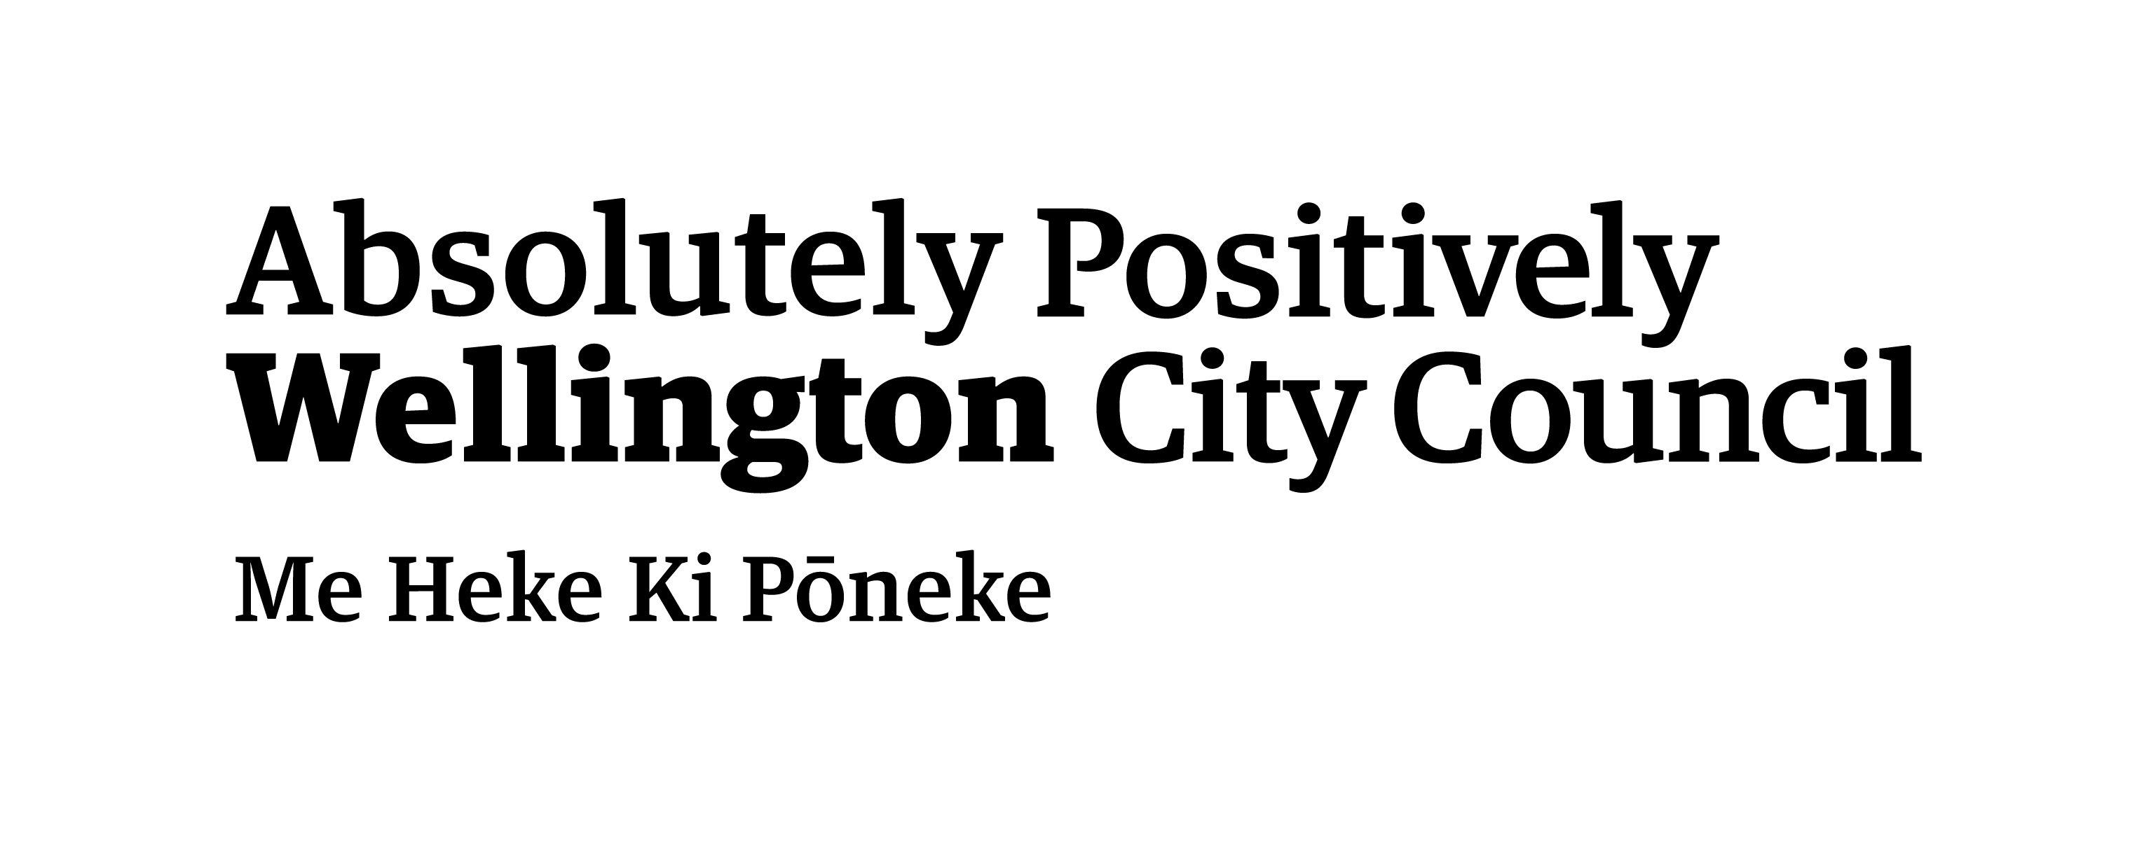  
Programme partners  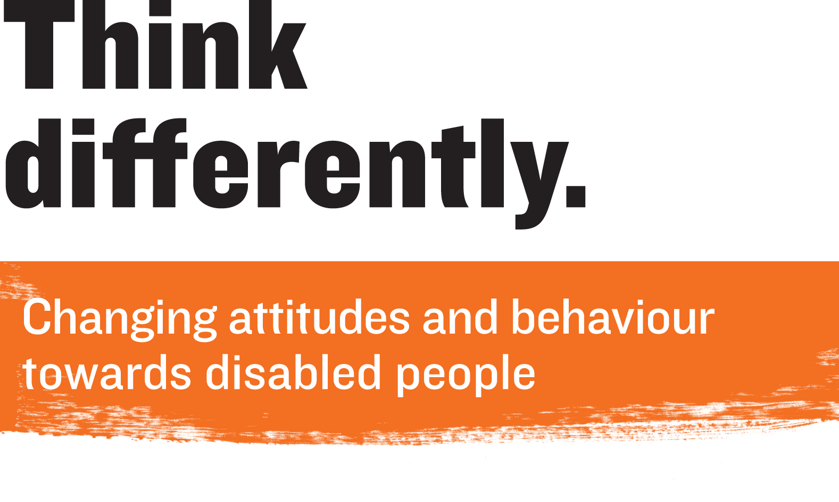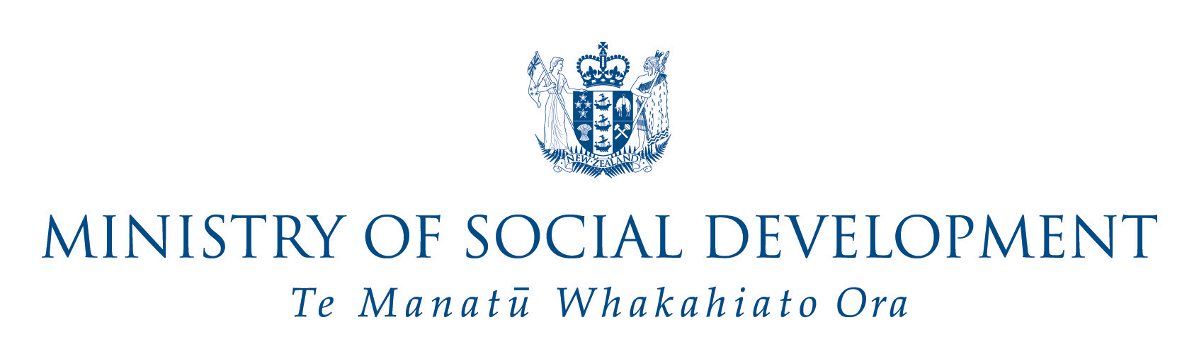 | Major grant  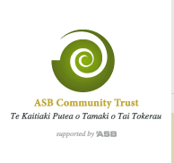 | Arts Access Awards sponsors  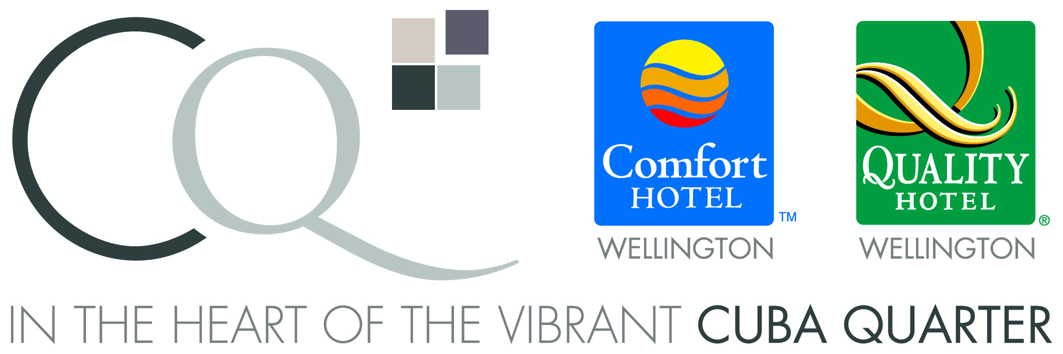
Awesome Arts Access Auction event partner | Legal services  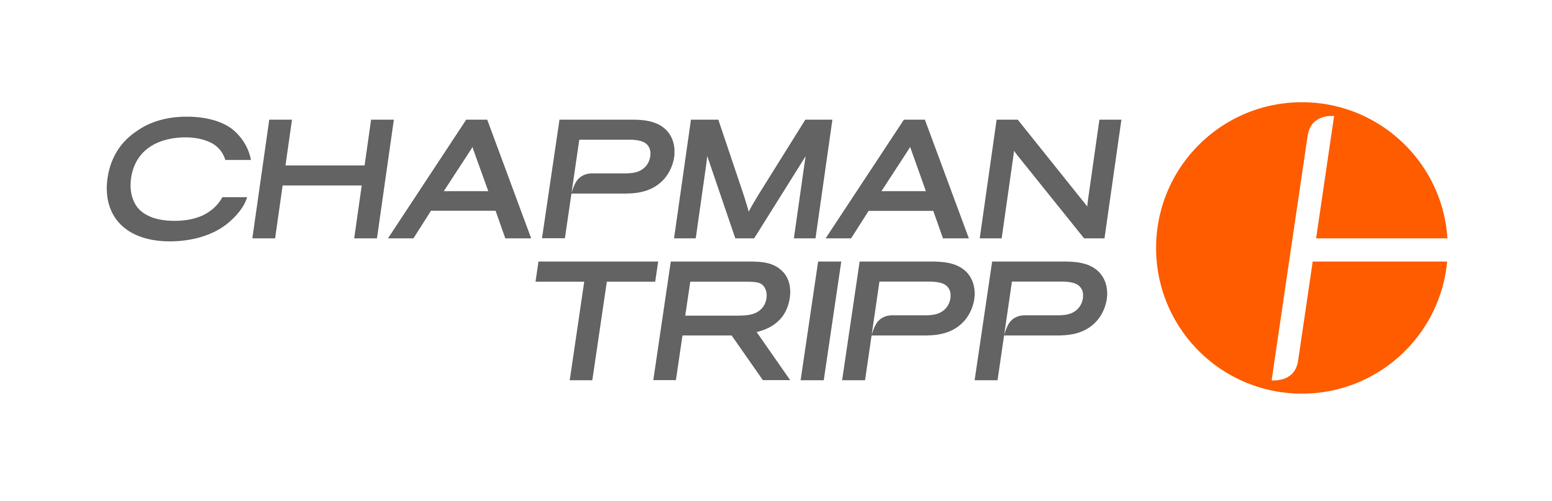 | Grants and donations  - Christchurch City Council  - Infinity Foundation  - Lion Foundation  - Mazda Foundation  - National Foundation for the Deaf  - Pub Charity  - Thomas George Macarthy Trust  - Wellington Community Trust  - Winton and Margaret Bear Charitable Trust

Organisational supporters in 2014

Many thanks to the following people and organisations for their support:

Alpha Art Studio, Auckland Art Gallery, Auckland Theatre Company, Base.IT, Canterbury Museum, Christchurch City Council, Commonsense Organics, CQ Hotels Wellington, Dunedin City Council, Dunedin Public Art Gallery, Fresco, Graphic Solutions, Isaac Theatre Royal, Joel Snyder, Kiwi Karma, Leadership New Zealand, Museum of Wellington City & Sea, Michael Crowley, New Zealand Opera, Oddsocks Productions, Out of the Box, Phantom Billstickers, Positively Wellington Venues, Puke Ariki, Resene Paints Ltd, TAPAC, Te Papa, The Court Theatre, Toi Whakaari, Volunteer Wellington and our volunteers.

Event supporters in 2014

Alpha Art Studio, Animates, Ashok Bava, Auckland Live, Auckland Zoo, Barnaby Weir, Beauté, Bidvest, Capital E, Chamber Music New Zealand, Charles Cunningham, Circa Theatre, Encore Restaurant, Commonsense Organics, Daniel Phillips, Emporio, Exodus, Fleur Wickes, Fraser Hoffe, French Imports, Gordon Harris, Graphic Solutions – Craig Christensen, Grill Meats Beer, James Cook Grand Chancellor, James Toki, Joy Cowley and Gecko Press, Kingsgate Hotel Wellington, Lion Nathan, Mix, Murray Wylie, My Food Bag, Out of the Box, Pablos Art Studios, PAK’nSAVE, Paul Hayes, Peter Wedde Antiques, Pippa Sanderson, Prefab, Pony Lane, Quality Hotel Parnell Gladstones Restaurant, Reece Tong, Robert Rapson, Rodger Fox and members of the Wellington Jazz Orchestra, Route 66 Newmarket, Roxy Cinema, Shafiq Sos, Smartpay, Southern Cross bar and restaurant, Streamliner, Te Papa Press, Te Papa Tongarewa, Tuatara, The Kapiti Company, Trilogy, Unichem Cuba Mall Pharmacy, Vanessa Rushton, Victor Bright, Vincents Art Workshop, Xtend Barre Wellington

Supporting what we do

You can help Arts Access Aotearoa reduce barriers and increase access to the arts for everyone in New Zealand.

Make a donation

Help us ensure all people can participate in the arts either as creators or audience members. An easy and effective way to make a monthly donation and be kept up to date with events and activities throughout the year is to join Friends of Arts Access Aotearoa.

As Arts Access Aotearoa is a registered charitable trust, donations of any size are gratefully received. You can claim a tax credit on donations of $5 or more.

Sponsorship and corporate support

By sponsoring Arts Access Aotearoa, your business can be strategically aligned with a national arts charity that increases access to the arts for everyone in New Zealand.

Leave a gift in your will

Your bequest will help us build a more inclusive society to ensure that future generations will experience art and creativity, without barriers.

Options to support

Every dollar you donate will benefit artists, people and communities throughout New Zealand. Projects needing support include:

1. Arts For All: increasing access to arts and cultural events for everyone

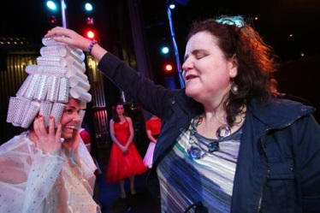
“Now, with the increased availability of audio described theatre performances and television programmes, I finally feel more included.” Martine Abel, who is blind, gets up close to the cast in a touch tour before Tauranga Musical Theatre’s audio described performance of the musical Grease. Photo: Bay of Plenty Times

2. Creative spaces: building the sustainability of community-based creative spaces throughout New Zealand

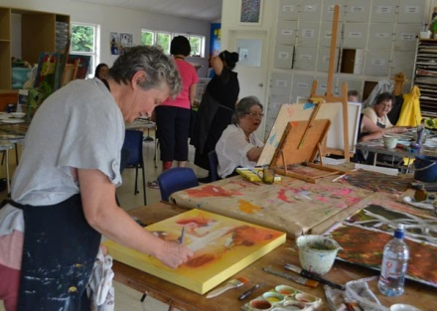
In 2010, Thonia Brooks had a stroke. It left her with some impaired brain functioning, a weakened left side and fatigue. “Learning to develop my own art practice and attending an art therapy group for stroke survivors at Spark Centre in Auckland has made a critical difference to my quality of life and hence my recovery.”

3. Arts Access Awards: celebrating individuals, groups and organisations providing access to the arts

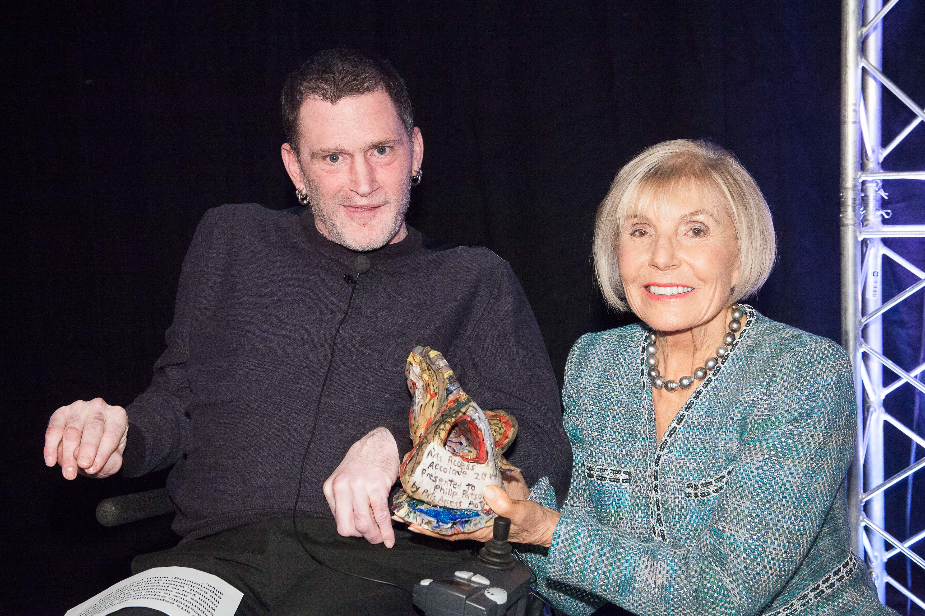
Philip Patston was presented the inaugural Arts Access Accolade by award patron Dame Rosie Horton at the Arts Access Awards 2014. “Philip is an inspiration to people who work with him. Rather than retreat from challenges, he has faced them. Rather than ignore bigotry, he has educated. And rather than increase tension, he has used humour and generosity to change attitudes.”

4. Arts in Corrections: using the arts as a tool supporting the rehabilitation and re-integration of prisoners

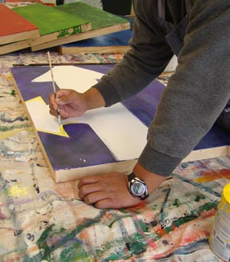
Messages of hope, of breaking the chains with the past and beginning a new journey are included in a series of 12 paintings, created by prisoners at Waikeria Prison in the Waikato. Large images of the paintings are hung in facilities such as Police cells, Community Corrections offices and Court foyers to ensure there are positive messages for offenders and their families to read.

Making your donation

Arts Access Aotearoa needs your support to ensure everyone in New Zealand, now and in the future, can engage in the arts. With your help, we can all experience art and creativity, without barriers.

Title: ________________________________________________________
First name: __________________________________________________
Surname: ____________________________________________________
Address: _____________________________________________________
____________________________________________________________
Phone: ___________________________ Mobile: ___________________
Email: __________________________________________________________

Please supply your email address so we can send you a receipt and keep you up to date with news and events. You can unsubscribe at any time.

I wish to support:
€ Arts For All
€ Creative spaces
€ Arts Access Awards
€ Arts in Corrections
€ Area of most need

With a donation of $________

Or:

I wish to make a regular monthly donation as a Friend of Arts Access Aotearoa of $________ .

€ Please send me information about leaving a gift in my will so that more people in New Zealand will have access to the arts for years to come.

Please choose a payment option below or give online at www.artsaccess.org.nz/donate-to-arts-access-aotearoa

€ I enclose my cheque payable to Arts Access Aotearoa

or

€ Please charge my credit card

Visa / Mastercard number: _______________________________
Expiry date: __/__
Name of cardholder: _____________________________________
Signature: ____________________________

€ I would like to give online with an Internet banking payment.

Account name: Arts Access Aotearoa
Account number: 03-0502-0040862-00
Please include your full name as reference.

To arrange for your tax deductable receipt please call us on 04 802 4349 or email info@artsaccess.org.nz

Please return this completed tear-off slip with your payment to Arts Access Aotearoa, PO Box 9828, Wellington 6141.

Thank you for your support.

If you would like more information about how you can support Arts Access Aotearoa, please contact Richard Benge, Executive Director (T: 04 802 4349 or 021 217 1002 E: richard.benge@artsaccess.org.nz).

“Disabled people want to share in the beauty of this world and also help create beauty as artists.” – Lisette Wesseling, soprano and braille music teacher

