Q & A: Creative spaces
Exult, helping you reach your potential
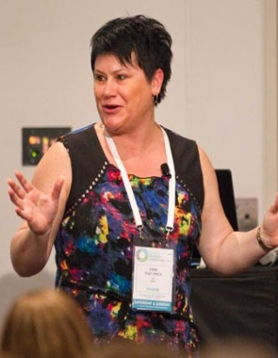
Kerri Tilby-Price is the Chief Executive of Exult, a training provider for the community sector. She talks to Arts Access Aotearoa about what drives the organisation and why creative spaces would benefit from connecting with Exult.
1. Exult: a background
Exult started by accident, back in 2007. I was managing a community-based arts organisation in Tauranga called The Art Room. I had a series of seizures, all stress-related, so I threw it in and took six months off. In that time, I wrote a book called The Seriously Good Guide to Fundraising. People kept asking me to do workshops and so Exult was born.

Our name means “to celebrate” and we chose it because that’s what we do. We celebrate passionate people, strong communities, and the change that can occur when one person decides to make a difference.
We specialise in the business end of running an organisation and over the past seven years, more than 5000 people have taken part in our workshops and seminars. We’re regularly asked to contribute to conferences and expos throughout Australasia, and we also hold an annual Tonic conference.
Something we stress is the importance of self-care. When I tell my story about the seizures I had, there’s almost always someone in the workshop who says “That’s what happened to me”. There are a lot of people working so hard in the community sector that their bodies can simply shut down – like mine did. So looking after yourself and your team is a priority.

2. Your vision is “Every non-profit working at their full potential”. How do you work to achieve this?

We believe that people (and organisations) thrive when they are given practical support, without all the fluff and jargon. So that’s what we give them. Our workshops and resources are full of practical, how-to advice that groups can easily put into action, and we cover all the aspects of running a successful non-profit.
For us it’s a bit like a jigsaw. Fundraising, marketing and communications, volunteer management, governance, project planning – they’re all intertwined. If you want your organisation to thrive, you need to be able to put all the pieces together.

3. What are three reasons why you think creative spaces should connect with Exult?
- You’ve got nothing to lose. Even if your organisation is doing really well, you don’t know what you don’t know. Sometimes it’s just one little tweak that can make all the difference to how your organisation runs.

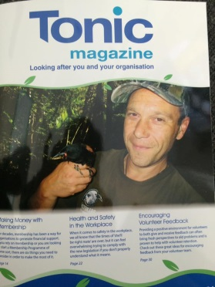
- We know the sector. Before heading up Exult, I managed a community-based arts centre in Tauranga. I know what it’s like to run an organisation with multiple stakeholders, stretched resources and a big vision. People working in creative spaces can learn directly from my mistakes and successes. And I’ve had plenty of both!
- We make it easy. There’s lots of information available about running successful organisations but it takes time and energy to hunt it all out and sift through the rubbish. Our resources include only the best, most useful and most up-to-date information, so you’ve always got your finger on the pulse.

The easiest way to connect with Exult is to sign up to our e-newsletter and “like” us on Facebook. You can also give us a call or email us any time.
Another good idea is to subscribe to Exult’s quarterly magazine called Tonic. For a 12-month subscription of $99, you’ll receive a copy of each issue, plus a weekly update of the latest information about upcoming funding rounds, awards, online tools, links to articles, innovative ideas and so on.
If anyone wants a free copy of Tonic to see what it’s about, email rosie@exult.co.nz and mention Arts Access Aotearoa, and we’ll send you a copy.

4. Fundraising is usually a big challenge for creative spaces. What advice do you have on the subject?

I’d love to say there’s a silver bullet to solve all your funding issues but there’s not. Developing sustainable streams of funding takes planning, persistence and people – lots of people.
My biggest piece of advice is to focus on building relationships both inside and outside your organisation. Every person you meet is a potential donor, sponsor or supporter, so take time to meet new people and tell your story as often as you can. The more relationships you have, the easier it is to raise money.
My second piece of advice is to look at fundraising as a multi-sport event, and do more than simply apply for grants. Set up a supporters club, run regular fundraising events, develop a donor base, partner with a local business – be creative! If you want to develop financial sustainability you need to think outside the square and be prepared to try a few different things.
5. Tell us about your different workshops.
We do about 40 public workshops a year on a range of topics: for example, sustainable funding, sponsorship, marketing, creative thinking and enterprise, and using volunteers.
We take the workshops to all the main cities and towns around New Zealand so you can check out the Exult website () for a calendar of workshops – or better still, sign up to our e-newsletter to find out when one is coming your way.

We also do customised workshops for specific groups: so for example, we’ve done one about sustainable funding tailored to arts organisations.
We’ve also recorded our popular one-day Sustainable Funding workshop so you can watch it on DVD in your own place when it best suits you and your team. You could set aside a professional development day and go through the whole DVD at once, or work through it in bite-sized pieces, concentrating on one aspect at a time.
There’s loads of practical ideas for raising more funds more often and develop real action steps for increasing your fundraising revenue. There’s no fluff, no jargon – just real ideas that will work for you. It costs $95 + $6.50 p & p, incl. GST. You can order via email (rosie@exult.co.nz) or order online.
Here are some comments from workshop participants:
“Possibly the most useful seminar I have been to in recent years. Really practical, relevant information delivered extremely well.” – Susan Warren, COMET Auckland

“Totally worth it! Great value and an enjoyable and inspiring experience.” – Micheal Hermen, Prisoner Aid and Rehabilitation Trust

“A great package – everything flowed so well, perfect for building on ideas. In summary brilliant, inspiring and realistic.” – Catherine de Monchy, Tauranga Waldorf School

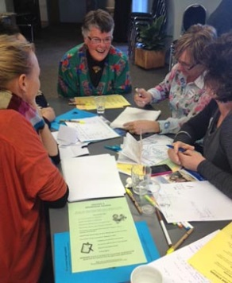
6. What about governance? How important is it to have a good board – and what does that look like?
I think there are two kinds of non-profit organisations in New Zealand. The type that really understands how important good governance is and what that looks like – and the type that doesn’t.
For me a good board starts with commitment. It’s not just about showing up for meetings. It’s about being totally committed to the cause. For a board to work well, every trustee needs to buy into the heartbeat of the organisation and genuinely care about its future success. They need to bring their best self to the table every time.
It’s also important that boards have a good mix of skills and experience, and are representative of the people they serve. The strength of a board is not in the individuals but in how well those individuals complement each other.
Just as you need singers, dancers and actors to make up a musical, you need people with different strengths to make up a board: for example, money skills, human resources, marketing, strategic planning and a genuine understanding of how the sector works.
In issue 25 of the Tonic magazine, I wrote an article called The right governance model for you. Basically, it’s saying that a one-size-fits-all model doesn’t work. Non-profit organisations need to find a governance model that suits their size, purpose and stage of development. They also need to be willing to adapt their model as they grow.

Five things creative spaces can do now to take them closer to working at their full potential
- Get really clear about why your organisation exists. Stop focusing so much on what you do, and start describing why you do it. Try answering this question: If your organisation was doing everything 100% right, what would your community look like as a result?

- Build relationships. Build relationships. Build relationships. You can achieve almost anything when you know the right people.

- Get into the habit of questioning every aspect of your organisation
and be prepared to adapt, adjust or completely change the way you operate. Keep asking yourself: Is this still the most relevant, appropriate, effective way to make this happen?

- Stop using “lack of money” as an excuse for not being all you can be. There will never be enough funding - it’s your job to work out how to be AMAZING in spite of those things.

- Get good staff. Get good volunteers. Get good trustees. Your people are your organisation. Choose them wisely and then look after them well.

For more information
Kerri Tilby-Price
Chief Executive, Exult
PO Box 1187, Tauranga
T: 07 571 8819 E: kerri@exult.co.nz
W: www.exult.co.nz

