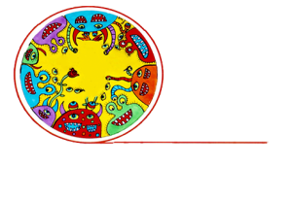
Q & A: Creative spaces
Vincents Art Workshop: putting inclusion into practice
Glen McDonald, Coordinator of Vincents Art Workshop in Wellington, talks to Arts Access Aotearoa about the philosophy of inclusion, why it’s important, and how to establish and maintain an inclusive creative space.

1. Background: about Vincents Art Workshop
Vincents Art Workshop was established in 1985 in response to a pressing need in the community. During the early 1980s, institutions were going through a process of de-institutionalisation, with more and more people in institutions being sent into the community.
At that time, community worker Pam Whittington was working for Wellington's Inner City Mission, which later became known as the Downtown Community Ministry. People would visit her and do their artwork on her kitchen table. Pam and another social worker, Helen Walch, saw the need for a creative space and from this, Vincents was born.
A year later, Vincents became an incorporated society. Now, an average of 30 people a day use the workshop. The activities are free, and artists are provided with art materials, skilled tuition and a supportive environment.
From the beginning, there were no restrictions on who could use Vincents. People who were homeless, unwaged, lonely, had disabilities or mental ill-health and anyone from the wider community were all welcome. This philosophy of inclusion continues to be integral to everything that Vincents does.
When I first visited Vincents in 1993, I saw this philosophy in practice. It was light years ahead of other organisations that were providing services to specific groups of people.
Our artists have received national and international recognition and we celebrate their achievements. Vincents has also been recognised with numerous awards over the years, including the Arts Access Creative Space Award 2012.
2. What do you mean by a “philosophy of inclusion”?
It means that the focus on the people who come to Vincents is a positive one: they come here to express themselves creatively. Within this philosophy, people aren’t labelled or stigmatised. They’re seen in a holistic way – not just as a “disabled” person.
We believe that categorising or labelling people excludes them from feeling they're a valued part of the wider community. That’s why our doors are open to everyone, including tourists, arts students, lecturers, mums, dads and retired people.

When this philosophy is taken on board, it makes the world more equitable. It honours people's basic human rights. It's about not wanting to waste people’s potential; everyone has something of value to offer.
Inclusiveness underpins our governance too. Half of Vincents’ governing committee is made up of Vincents’ artists. Artists are also involved in planning and in the hiring of art tutors.
3. Why do you think a philosophy of inclusion is important in a creative space?
One of the benefits of an inclusive environment is that it fosters a climate of mutual acceptance and understanding. It reduces the social stigma around mental illness or being an ex-prisoner or having a disability. It helps people feel less isolated in their community.
It encourages all people to go to a creative space, where they can feel that they’re valued members of the wider community. That’s good for everyone.
4. Let’s say you’re setting up a creative space. How do you establish a philosophy of inclusion?
There's no magic bullet. Anyone embarking on this journey needs to see it as a way of life. Here’s a list of things to think about if you want to embed a philosophy of inclusion in both your personal life and the life of your creative space.
- Wanting to be inclusive should be a passion. If it isn't, you should read, research and learn about it until it is.
- Don't try to set up a creative space with a philosophy of inclusion unless you understand and value the benefits.
- Think about it as a human rights issue. Why would you want to isolate different groups of people? What are the benefits when you include everyone?
- Respond to people’s needs. Always ask them from the outset what they want and need instead of assuming that you know.
- Research the issues, think about them and discuss them with people who are also setting up a creative space or are already running one.
5. Your inclusive creative space is up and running. How do you ensure it remains inclusive?
- Inclusiveness must be the foundation of how your creative space operates across your governance, staff induction and training, and policy development.
- Ongoing discussions about inclusion are essential.
- Celebrate and promote anything that highlights the philosophy of inclusion.
- Keep working on it, developing it, thinking about it.
- Keep returning to the basic question: Is this an inclusive way of working?
6. What do you mean by “accessibility” and how does it work at Vincents Art Workshop?
Accessibility is about each person’s individual needs; about awareness and respect. At Vincents, we work very hard to be as accessible as we can.
The workshop is physically accessible for people who use wheelchairs or have other mobility issues. But accessibility means more than physical access. It’s about people feeling welcomed and comfortable in the environment. You can create that atmosphere by showing you’re truly pleased to see the person or people. A smile from the heart is the most important thing you can do – and it doesn’t cost a thing.
You can also create an inclusive atmosphere by being sensitive to body language, always being respectful and really listening to people.
Language and the words we use are also important. Make sure you know what’s okay for people and if in doubt, ask.
7. Why do you think creative spaces should be a part of the wider community? And how can they achieve this?
When creative spaces are part of the wider community, it helps reduce stigma and isolation, and all artists feel valued. At Vincents, we make connections with the wider community whenever we can – through our policy of open access and community integration; displays of art in public spaces; and collaborations with other organisations.
For example, our artists’ works have featured in Newtown Festivals, Cuba Street Carnivals, community parades and Wellington City Council's summer city programmes. We also have a close connection with Wellington Zoo and collaborate with the zoo several times a year.
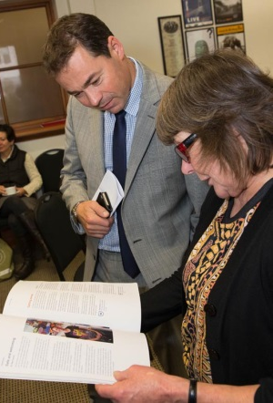
Our outreach programmes include weekly workshops in Te Whare o Matairangi, the psychiatric unit of Wellington Hospital. We’re also facilitating a mural project at Arohata Women’s Prison. This provides an important creative outlet for prisoners and we hope that when they’re released, they'll feel comfortable coming to Vincents as part of their reintegration back to the community.
Our philosophy of inclusion means that the wider community is always welcome to come and participate at Vincents. From my experience, the best ways to make your creative space a vital part of the wider community are to:
- emphasise your philosophy of inclusiveness and welcome everyone into your creative space
- display your art in the wider community: for example, at community spaces, events and exhibitions
- collaborate with other organisations and develop meaningful partnerships
- take part in expos, forums and conferences, which all provide excellent networking opportunities.

Glen’s five key ways to help maintain a philosophy of inclusion in a creative space
- Make a philosophy of inclusion your passion. It's not a box-ticking exercise; it's a way of life.
- Do your research and understand that inclusion and accessibility are human rights issues.
- Inclusion isn't one size fits all: if you want to connect with a person, find out what that person needs to feel included.
- Question yourself constantly. Is there anything that can be done to make your creative space more inclusive?
- Listen and respond to feedback.

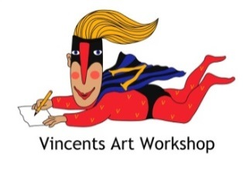

For more information
Glen McDonald
Coordinator of Vincents Art Workshop
Willis St Village, 5 /148 Willis Street, Wellington.
T: 04 499 1030 E: vincentsartworkshop@xtra.co.nz
W: www.vincents.co.nz

