Q & A: Creative spaces
Artists Alliance and the market
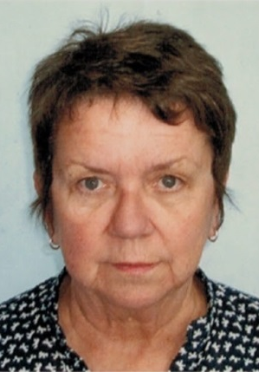
Maggie Gresson is Executive Director of Artists Alliance and a board member of Toi Ora Live Art Trust. She talks to Arts Access Aotearoa about creative space artists; how to market and price their work; and what resources Artists Alliance can provide.
1. What do you see as the key issues about professionalism and the artists working in creative spaces?
Firstly, are we assuming that all artists working in creative spaces have a “professional” intention regarding the work they produce? Do they all intend to show their work and in what context? It is one thing to make work and show it to family and supporters at creative space exhibitions. If you want to show work in the so-called mainstream market then that’s a different matter. Different rules apply.
I see the key issue as understanding how that market works – in particular, how the money moves from purchaser to artist via the dealer. There will be commissions and costs that will come out of the sale price before it gets to the artist. These need to be understood and agreed on upfront to avoid disappointment and confusion.
2. What are some of the issues for creative space artists regarding the art market?
It’s important to know about the art market – or have an advisor who can negotiate the territory for the artist. If, for example, an artist gets taken up by a dealer then there are certain services the artist can expect from the dealer. A dealer can be expected to provide scheduled opportunities for both solo and group shows; maintain in-house portfolios to publicise the artist; and to cultivate collectors and corporate clients with a view to fostering sales. And the artist has an obligation to the dealer to produce work of a suitable standard and to make that work exclusively available to the dealer. Both the artist and the dealer have obligations to each other.
3. What about issues for creative space artists in the wider professional art world (e.g. media, collectors, art writers, curators)?
The professional art world is big and complex. All of those people – media, collectors, art writers, curators – have a different focus of interest in an artist. It’s up to the artist or their advisor to recognise that, and learn how to make all of those relationships work.
The media may be interested in the artist’s personal story while the art writer might be more concerned with putting the artist’s work in a more theoretical context, as might be a curator. A collector would be interested in all of the above but would probably also have an eye on the dollar value. There are no hard and fast rules. That’s what makes the sector so fascinating and so frustrating at times.

4. What are the key things creative spaces could consider when pricing their artists’ work?
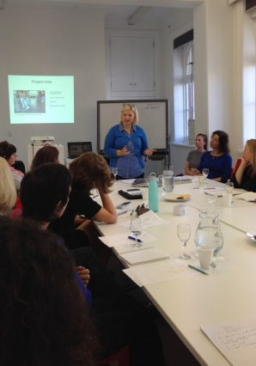
In short, be realistic. It’s always difficult to decide on a price for a work. Price can be dependent on any recognised training, a previous sales record, what other artists at a similar stage of career are getting for their work etc. Don’t over-price it because that inhibits sales. On the other hand, don’t sell it too cheaply. If the work is being sold through a creative space then the key question to ask is: Who is your buyer and what have they paid before?
5. What resources do Artists Alliance have that would be useful to creative spaces in supporting their artists?
Artists Alliance is the national organisation for visual artists. Established in 1991, Artists Alliance has represented and advanced the professional interests of Aotearoa New Zealand’s visual artists for more than 25 years.
Our website has information about a wealth of topics: law and copyright; industry insights; exhibiting, media and promotion; and awards, grants and funding. We also publish the following resources:
- The Dr Paynt resource answers questions about technical issues, mainly concerning painters.
- Initiate offers advice about running artist-run initiatives
- The Oily Rag Project profiles case studies of events and exhibitions, all held on “the smell of an oily rag”: i.e. little or no money. Each case study profiled includes information on its aims, those involved, venue, timeframe, costs, funding, promotion, audience, post exhibition/event reflections and contact details.

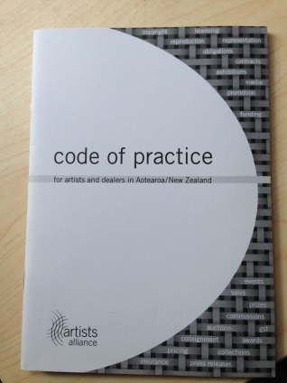
Artists Alliance has also published a Code of Practice for Artists and Dealers, which talks about the relationship between artists and dealers and the various obligations and expectations for both parties. This is a hardcover resource available for sale on our website.
You can also read articles on the Artists Alliance blog; and follow us on Facebook, Twitter and Instagram.
6. How would creative spaces benefit by belonging to Artists Alliance? Is there a special rate for not-for-profits?
Creative spaces would pay $165 a year and have access to all of our online resources. I see Artists Alliance as a good sounding board for creative spaces seeking to get their artists’ work into the mainstream arena. We also have resources that could support creative spaces to do their own thing when showing their artists’ work.
For a nominal fee, Artists Alliance could also hold workshops on specific topics for creative spaces staff and artists by arrangement.

Maggie’s five tips for creative spaces marketing their artists’ work
- Know your audience/buyers.

- Set realistic prices.

- Remember that the artists’ stories are part of the work.

- Think carefully about any commission the creative space may think of taking. Why do it and is it fair?

- Take good care of your artists and their expectations.

For more information
Maggie Gresson
Executive Director
Artists Alliance
1 Ponsonby Road, Newton, Auckland
T: 09 376 7285 E: maggie@artistsalliance.org.nz
W: www.artistsalliance.org.nz

