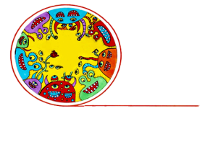
Q & A: Creative spaces
King Street Artworks and its art tutors

Linda Tilyard, Studio Manager at King Street Artworks, talks to Arts Access Aotearoa about its art tutors, and how they find, train, support and manage them. She also talks about some of the key skills and qualities she looks for in an art tutor.

1. Background: about King Street Artworks

King Street Artworks was established in the mid 1990s by a steering group made up of Vincents Art Workshop committee members, staff and artists. Based in Masterton, this creative space caters for people who use or have used mental health services, their whānau, friends and the community.

Between 40 and 50 people attend King Street Artworks every day, along with three tutors. Funded mainly through the Wairarapa District Health Board with additional funding from charitable trusts, the space is open six days a week.

All of the tutors are artists, and art classes, the use of the art workshop and most art materials are free. As Studio Manager, Linda is responsible for all daily operations of the workshop and is involved in employing art tutors at King Street Artworks. In 2011, King Street Artworks received the Arts Access Creative Space Award.

2. What are the main qualities and skills you look for in an art tutor?

- An all-round basic art understanding: to specialise is fine but art tutors must have the ability to translate their skills across many different areas and be familiar with more than one artform.

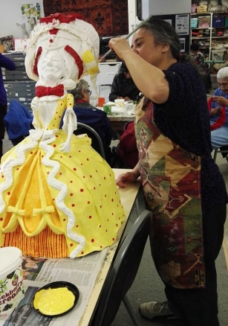
- People skills: art tutors must be able to connect with all kinds of personalities. They need to have respect and empathy, be able to understand the artists at King Street Artworks, and treat them as equals.

- Multi-tasking: art tutors need to be able to juggle all kinds of tasks. For example, working with three or four artists doing printmaking, carving and painting while getting photocopies for others and filling up coffee tea cannisters, mopping up a spillage and settling in another artist in a wheelchair who has just arrived.

- Self-awareness skills: art tutors are put in new situations each day. Having a good personal self-awareness and self-evaluation system in place helps tutors to remain professional and know exactly where their role begins and ends.

- A sense of humour: art tutors must be able to laugh at themselves, and not take things to heart.

3. Where do your art tutors come from?

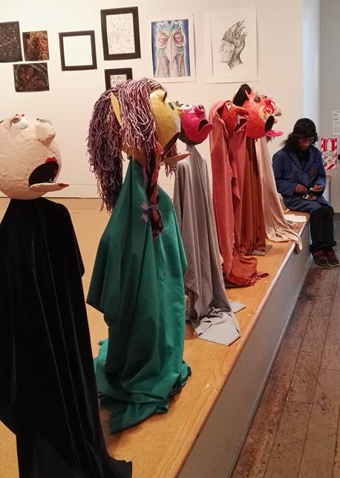
We don’t have a very high turnover of staff because they are mostly all working artists. Some of our staff have formal qualifications in art while others are self-taught. We tend to hire our staff for their ability to understand and communicate with people. A candidate may have attended the most prestigious art schools and received the best grades but their ability to connect with our artists is the most important quality.

At King Street Artworks, 80% of our current relieving art tutors are artists from the workshop whom we think connect exceedingly well with others and we have asked to work for us.

4. How do you train your art tutors?

We have an induction day where the new tutor is brought in and introduced to everyone. We buddy them up with an experienced King Street Artworks tutor, giving them a chance to watch and learn from them. We gradually build up the responsibility and don’t expect our new tutors to take on a large workload immediately.

We create opportunities for learning, if necessary, usually at King Street. If we come across a possible tutor who ticks all the boxes in relation to people skills but they have limited experience with art, we can provide art training for them through art courses and workshops.

5. What are some of the things that new art tutors may experience?

The most common issue for our art tutors is learning to be supportive without being too involved. Our staff need to know how to empower and support our artists without being drawn into some of the issues that can be very intense for the artists. Tutors must reaffirm their boundaries, and let their artists know that they are their tutor and their relationship is professional.

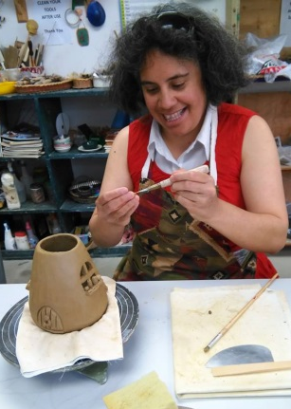
New art tutors need to pay close attention to their energy levels. Up to 50 people come to the studio per day, and art tutors are there to guide them, sometimes individually, for an extended period of time. They can also find themselves having intense conversations, which can be repeated 20 to 30 times a day with different artists. Art tutors must learn not to let this affect their mood and energy levels throughout the day.

6. What ongoing support do you offer your art tutors?

We have daily 15-minute meetings before and after work, which act as our briefing and debriefing sessions. At these meetings, we share any difficulties we’re experiencing and any basic issues at the time. We also have one long staff meeting each week for approximately and hour and a half, where we discuss issues in more detail and find solutions. These meetings act as supportive get-togethers but we also offer our staff supervision support if required.

7. Do you offer structured teaching sessions or programmes for your artists? If so, do your artists respond best to structured or unstructured art sessions?

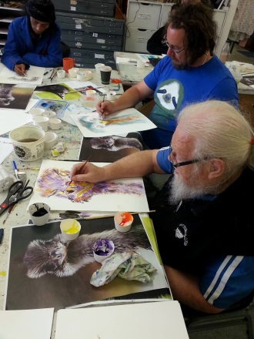
Our classes are not structured in the traditional sense. We work with each artist, starting from where they are at before deciding on their next step. This works well because it’s about working with each person’s different timeframes. The classes become more task-orientated because they are personally tailored to each individual, and I think people thrive on that.

We offer structured workshops, which run for set periods and contain a small number of clear goals and tasks. However, these structured workshops feed into the unstructured classes because they provide specific skills for the artist to then take into the classes and experiment with.

8. How directive are your tutors when working with artists?

This depends entirely on circumstance. Sometimes there is a need to be directive but it’s only implemented when there’s an established relationship between the tutor and the artist. We tend to guide our artists rather than tell them how to do something. We don’t expect them to do art in a specific way but if we don’t give them any direction, that isn’t really teaching. We want to push people to be excellent – but to be excellent the way they want to be.

9. Linda’s five tips on making the most of art tutors:
- Communication: always be honest and upfront with your staff.
- Allow creativity: encourage the tutor to have creative input into the creative space environment.
- Be supportive: allow for regular get-togethers with other staff and discuss issues.
- Have passion: let staff know that you believe in what you’re doing and encourage them to vocalise their enthusiasm for their work.
- Have fun: always keep a fun and friendly environment.

For more information
Linda Tilyard
Studio Manager
King Street Artworks
16 Queen Street, Masterton
T: 06 378 9777 E: kingst@wise.net.nz
W: www.kingstreetartworks.co.nz

