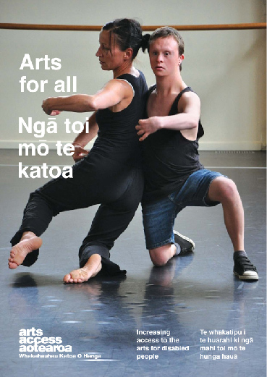
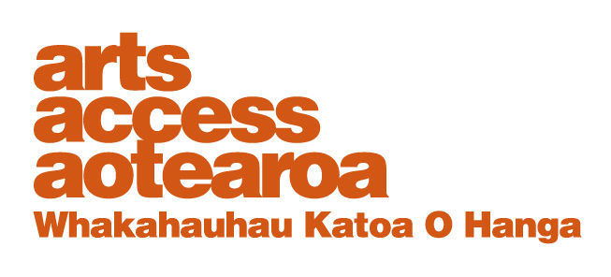
Q & A: ARTS FOR ALL
Gallery’s Insightful Tours for blind visitors

Lynda Cullen, Visitor Programmes Officer, Dunedin Public Art Gallery, talks to Arts Access Aotearoa about the gallery’s commitment to accessibility and its Insightful Tours for blind and vision impaired visitors.

1. Background: about us
The Dunedin Public Art Gallery is the oldest public art gallery in New Zealand and the only gallery in the country with a painting by Claude Monet in its collection. We also have some of the earliest religious works in a public collection as well as paintings by many European old masters.
Inclusion is a focus of our strategic plan and so a key function of the gallery is making the world of art accessible to the widest possible range of people. One way we do this is through events and activities that interpret and complement our exhibitions programme, providing insight into artworks and artists’ practice. We’re also a member of the Arts For All Otago Network, facilitated by Arts Access Aotearoa.

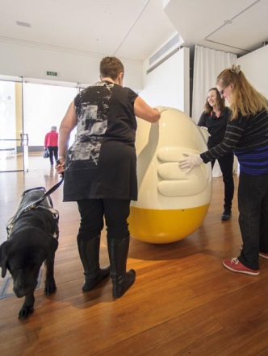
Educational and school holiday programmes, guided tours, floor talks, lectures, film and video presentations, seminars and workshops all help to achieve this aim. My role is to implement these various programmes and events.
Visitors can choose to extend their knowledge and experience by taking part in the various visitor programmes. My aim is to empower both the regular and new visitors, enriching their learning experience. I also want to encourage non-visitors to start coming into the gallery.

2. What does access mean to the gallery?
Access is about being physically, psychologically and virtually (via the internet) accessible to everyone in the local community and beyond – people of all ages, ethnicities and backgrounds, including people with intellectual, physical and sensory impairments.

The gallery aims to make access easy for everyone. All areas of the gallery are wheelchair accessible, and we’re continuing to increase our services to disabled visitors. One of the key ways we do this is through our visitor programmes. There is also front-of-house awareness about the importance of welcoming everyone into the gallery.

3. What motivated the gallery to develop its tours for blind and vision impaired people, and where did you start?
The gallery has a public programmes strategy and part of this is about being accessible to all groups. Our tours for people with sensory impairments began with hesitant steps on Deaf Awareness Week 2010 after a meeting with John Kena, a member of the Deaf Association in Dunedin.
We undertook a signed tour of our exhibition Beloved: works from the Dunedin Public Art Gallery collection, using sign language interpreter Bridget Brown to conduct the tour. John suggested that the signed tour could be advertised on the Deaf Association website, which we did. Around ten people took part in the tour and for most of them, it was the first time they’d been to the gallery. I remember there was a middle-aged woman who asked a lot of questions and had a lovely sense of humour. It made the group feel more relaxed.

In 2011, Beloved still had a freshness to it and so for Deaf Awareness Week 2011, we used another of our tour guides who had theatre training to look at some of the more modern works in the exhibition. Bridget Brown wasn’t available this time and so we used Brydee Jenkin Strang’s expertise as an interpreter.

These two tours were a stepping stone to the notion that we could offer tours to people with other sensory impairments. The idea of offering tours for blind and vision impaired visitors had been sitting in my mind for some time. Then I discovered Online Accessibility Training, an online programme from Art Education for the Blind (www.artbeyondsight.org) and connected this up with programmes for blind people at the Museum of Modern Art (www.moma.org) in New York – particularly the descriptions on their audio.

I approached the team at the gallery, knowing that it was always part of our strategic plan to be inclusive, and that the project would be supported.

4. Outline the steps you took from the beginning through to the introduction of the tours.
Once I had the gallery’s confirmed support to proceed, I set about developing tours for blind and vision impaired visitors. Here are some of the key steps I took in implementing tours as a regular inclusion in our public programmes.

- Research was vital and included online sites such as Art Education for the Blind and Museum of Modern Art, New York
- I spent several weeks considering how to tailor some of these programmes and ideas to the Dunedin Public Art Gallery
- I built a relationship with the Dunedin branch of the Blind Foundation and asked advice on the text for our first tour.
- Our first planned tour for 24 July 2010, the Dane Mitchell: Radiant Matter II exhibition, had a “perfume” component. Unfortunately, the tour had to be cancelled because of snow. I had spent a lot of time putting the tour together but it couldn’t be rescheduled because the exhibition was due to close. However, it still provided a valuable learning experience.
- The first tour to go ahead was in November 2011 – this time it was a tour of Gymnauseum, a hands-on, tongue-in-cheek look at gymnasiums. The Blind Foundation’s Tuesday Walking Group came and there was also a young blind student and his guide dog. We had excellent feedback.
- In the same month, we advertised a weekend tour of Beloved. I now call these “insightful tours” because the term “touch tours” doesn’t really apply: people can’t touch the artworks. I had a brainwave – to use samples that could be touched. For example, samples of tempera or acrylic or oil paint on small boards; or vinyl adhered to Perspex to emulate a particular artwork. Two guide dogs were in attendance.

- In March 2012, I ran an insightful tour as part of the Haunts of Dickens exhibition. I provided samples of watercolour paper the same size as the exhibition watercolours, plus a sample mat board with a rectangle cut into it to receive the print. The tour finished off with a reading from Bleak House in Braille by Dave Allen, who is blind. There was great support for the gallery and for Louis Braille! In feedback about the tour, one blind participant wrote: “Thank you for the tour of Dickens. It was brailliant.”
- I’ve made a practice of sending the text for the tours to the Blind Foundation to look over, and also to the gallery team for their information.

5. What were key challenges and how did you overcome them?
A key challenge was working out how to explain size to the tour participants. I overcame this by comparing the artwork or object to everyday household objects: for example, the Machiavelli painting is the size of a pillowcase.

Other challenges:
- How to engage blind/visually impaired people when they can’t
touch the works.
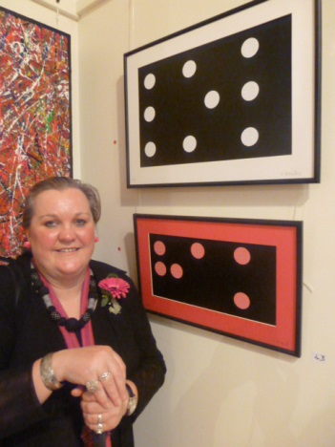
Where possible, we make samples available. I take time to hand a sample to each person and wait until they’ve finished touching it before taking it to the next person and placing their hands on the item. Other ideas are to ask people to put their bodies into particular poses: for example, “arms akimbo”, as in the Robin White painting Sam Hunt at the Portobello Pub; or running their fingers over their face when describing the tattoos on the Goldie painting of Te Aho.
- How to describe buildings:
Describing people is much easier than describing something structural that’s made of fairly inert material. Haunts of Dickens was a difficult show to describe as it was almost solely buildings and one or two small figures in shadow. I still feel unsure about how to best describe buildings. One of the tour participants told me to be bold and not to be hesitant: in other words, fake it until you make it! I will keep experimenting with varying degrees of uncertainty/certainty until I have a mix that feels right.

6. What are your three top tips for galleries and museums wishing to introduce tours for blind and low vision patrons?
- The first thing you should do is get in touch with your local branch of the Blind Foundation and/or other local vision impaired groups for support and advice. It’s important to start with the people you’re offering the service to. What do they want? It’s also good for marketing your tours: they have the networks.
- Always be welcoming. Sometimes, a group can be hesitant but each time they come, they bring more confidence with them
- Take your time. Describe two or three works rather than ten – and always ask the tour group for constructive criticism. This is really helpful.

7. How important is staff commitment to accessibility initiatives such as the tours?
Staff commitment is absolutely top of the list – from the Director through to the visitor host, who welcomes the group, to the tour guide and the marketing and events team. And for our samples, our conservator and designer have been involved.
We work as a team, supporting and drawing on each other’s areas of expertise. Without that, the insightful tours would be less enriching for the guide – and therefore for the participants.

For more information
Lynda Cullen
Visitor Programmes Officer, Dunedin Public Art Gallery
T: 03 474 3249 E: lynda.cullen@dcc.govt.nz

