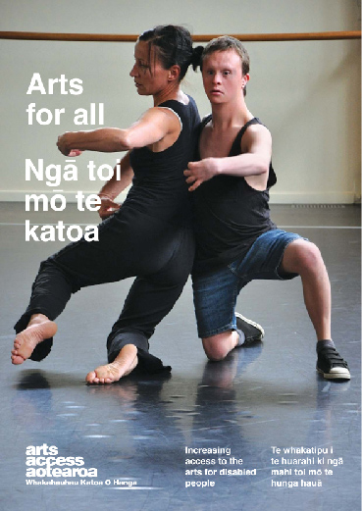
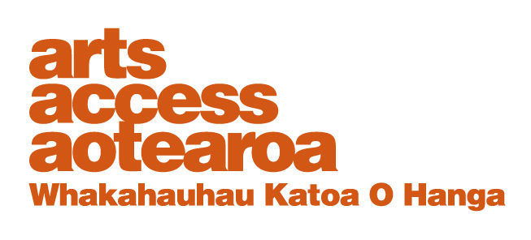
Q & A: ARTS FOR ALL
Making sense of sensory tours
Judith Jones is a trained audio describer and Visitor Services Tour Host at Museum of New Zealand Te Papa Tongarewa. She talks to Arts Access Aotearoa about the 2015 pilot tour of selected works in Ngā Toi │Arts Te Papa and how the GLAM sector (galleries, libraries, archives, museums) can provide more meaningful experiences for people who are blind or have low vision.

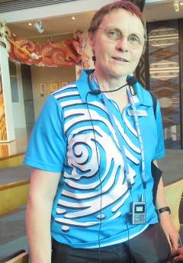
1. Background: about Judith Jones
I took part in the 2014 Wellington audio describer training, offered by Arts Access Aotearoa in partnership with Wellington City Council and Toi Whakaari: New Zealand Drama School. Audio description brings a powerful new dimension to all my work as a host at Te Papa, supporting our visitors to make their own meaning from what they encounter.
I joined the host team at Te Papa in 2012. My working career before this was as a journalist, performance storyteller and early childhood educator.
2. What are sensory tours?
Sensory tours are often intended for blind or low vision participants. However, they can be a meaningful experience for everyone.
You can define sensory tours however you want: the important thing is to clarify what you mean to the people who will be taking part. “Sensory” may mean that the guide’s description refers to senses other than visual: for example, sound, smell or tactile interaction.
The tour may include audio description of the spaces you move through and the things you’re discussing. Audio description, in its purest form, describes a place and tells a picture. This enables listeners to create their own images and to make their own meaning from these.
Overall, ”sensory” generally signals that your tour will offer more than the guide standing in front of something and talking about it as if everyone can see it clearly. And that your physical progress through the spaces will be supported to meet your needs.

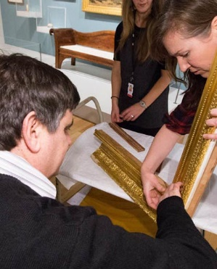
3. What were the key steps you took to prepare for your first audio described tour in Ngā Toi?
I was part of a team of Te Papa staff who established a pilot reference group of people from across our target community. Together, we discussed the gallery spaces and current works on display. We heard from the group about what they’d like to experience, and discussed the most effective ways to deliver this.
We agreed we would:
- develop and deliver a pilot tour of Ngā Toi │Arts Te Papa for art-interested sight impaired visitors. The tour would be a mix of information from our art curators, audio description and props
- evaluate all aspects of the tour, with the intention to establish a successful model for future tours.
Curator Rebecca Rice talks about our pilot tour in her blog A Picture in 1000 Words.
4. What are the main challenges you faced presenting a sensory tour of Ngā Toi and how did you overcome them?
Getting everyone together to develop a clear and common goal and approach was a key challenge. It really made a difference to have members of our team, including curators and conservators, meet with our reference group at the start. Our evaluation showed that participants enjoyed the mix of description and touchable objects, background, ideas and voices.
Finishing my script was another challenge! Audio description is an exacting discipline: every word has to work effectively.
5. What are some everyday actions front-of-house staff can do to enhance the sensory experience of blind and low vision visitors?
Familiarise yourself with everything you have available to support your visitors’ engagement: audio guides and/or audio description, braille or larger print signage, and how to use relevant apps.
Don’t assume their richest experience will happen if you send them from one thing they can touch to something else they can touch. Think about where they can hear narrative or other sound effects. How about a smell or taste components?
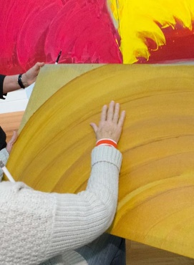
Be an advocate. If you hear visitors comment on a way your organisation could do things better for this group, pass it on to someone who can make change. If you’re aware of a potential hazard, bring it up through your appropriate channels. If you find out about a neat approach somewhere else, pass it on. Put your hand up for audio describer training if it appeals to you.
6. How can people in the GLAM sector get training in preparing and leading sensory tours?
Firstly, make contact with others who are doing this work: for example, through the Arts For All networks in Wellington, Otago, Taranaki, Auckland and Canterbury. For more information about the networks, visit the Arts For All Network section of Arts Access Aotearoa’s website.
If you’re a museum, art gallery or iwi tribal organisation, you can apply to be part of an Expert Knowledge Exchange He whakawhitiwhiti mātauranga. Contact National Services Te Paerangi for more information about the Expert Knowledge Exchange (T: 0508 678 743 E: natserv@tepapa.govt.nz).
7. Describe five key things the GLAM sector can do to ensure their venues are accessible for blind or low vision visitors.
- Read Arts For All: Ngā toi mō te katoa, published by Arts Access Aotearoa, and discuss it with colleagues. It’s a guide that includes both practical and longer-term steps you can take to provide access. One of the chapters looks at ways that museums and galleries can enhance their accessibility, including the use of technology, making connections with the disabled community and thinking outside the box. You can download Arts For All from the website.
- Experience what others are doing. Tune into the audio description on DVDs that have this option; go to an audio described play or concert; take part in a sensory tour.
- Make connections with your local blind or low vision community. Ask them to share their experiences and discuss what could support them to have a richer encounter with your exhibitions or events.
- Agree on a project – and make it happen! Develop a cross-functional team, and ensure collaboration with and feedback from your target audience are part of the process. Share your learning, challenges and successes with the rest of your organisation.
- Build what you’ve learned into your everyday programming and planning. Don’t let focus on this access area be dependent on individual advocates. Make it “The Way We Do Things Round Here”.
8. What are some great examples of accessibility in museums?
These are some sources that have especially helped me consider and develop my practice:
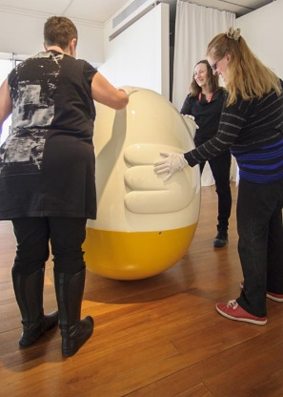
- First would have to be the Dunedin Public Art Gallery’s Insightful Tours. Lynda Cullen was incredibly generous with her time in talking me through her process for developing and delivering these. She’s been able to think about each tour and engage her wider gallery team as the exhibition is developed: for example, asking an artist if some things can be touched. One artist even created work just for that purpose. Read the Q & A Insight on Arts Access Aotearoa’s website, called Gallery’s Insightful Tours for blind visitors (pdf).
- As I’ve delved deep into understanding and extending my own practice, I’ve really enjoyed reading Telling Pictures, a blog by Lara Torr. Lara is a visual artist and theatre worker who trained as an audio describer in 2011. Her blog talks about her audio describer journey, with lots of examples of her work and feedback.
- I follow current practice and its development, and was excited to be able to listen into Bridging the Gaps: Exploring the link between art & audio description. This was a symposium held by Shape Arts at Tate Modern as part of its Tate Exchange programme, Ways of Seeing Art, in February 2017.
- Shape Arts provides opportunities and support for disabled artists and cultural organisations to build a more inclusive and representative cultural sector.
“We gathered a panel of advocates and practitioners of audio description in conversation with curators and museum professionals to examine the gaps between access and artists, galleries and audiences. How can we work together to bridge these gaps through creative and innovative means? This event was for those interested in applying audio description to contemporary art. With a focus on how blind and partially sighted people connect with art, we explored how creativity, innovation, technology, knowledge of art and the user experience enhances the current offer.”

9. What do you enjoy most about presenting sensory tours?
Here's what Robyn Hunt of AccEase, one of our pilot participants, said about her experience in her Low Visionary blog.

"At Te Papa the well-audio described works revealed intriguing hidden detail and depth that hooked and stimulated my imagination. Without audio description I must wade through tiring, confusing and seemingly meaningless visual clutter and I can’t read the guiding printed labels and information on gallery walls. Audio description means I can focus and connect at a deeper, more satisfying level and begin to have a similar experience to that of fully-sighted people."

This is what audio described tours are all about for me. To be an advocate, and an enabler.

Also, it seems to me that looking at an object or a space – really looking – is a sort of mindfulness. I allow room only for what I see. And then shift into thinking how I can put that into words. It’s a powerful moment and a powerful challenge.
For more information
Judith Jones
Te Papa Tongarewa
E: Judith.Jones@tepapa.govt.nz
Credit: Pilot tour photographs by Norm Heke, Te Papa

