Q & A: Arts in Corrections
How theatre can change lives
UK’s Dr Selina Busy spoke at an Arts in Corrections Northern Region Network meeting in 2017 about innovative theatre and arts projects, and how they contribute to reintegration. The event was organised by the Critical Research Unit in Applied Theatre at the University of Auckland and Arts Access Aotearoa. Here, she provides insights into the role of theatre to transform the lives of people in the criminal justice system.

1. An introduction: my background
I am an academic and a theatre practitioner who makes performances with community groups. I am a principal lecturer in applied theatre at the Royal Central, University of London.
Applied theatre is largely about using drama in non-traditional settings and/or with marginalised communities. It encompasses theatre practices that tackle areas of social and cultural policy such as public health, education, housing, social welfare, and juvenile and criminal justice.
My research and practice focus on theatre that invites the possibility of change, both in contemporary plays and in participatory performance. As a practitioner, I work in prison settings, youth theatres, and with young people living in adverse conditions both in the UK and internationally.
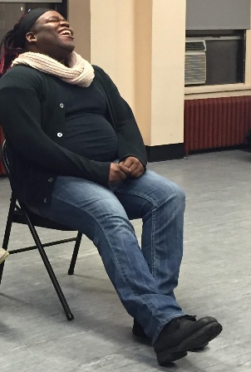
I’ve been involved with the arts and the criminal justice system for more than 20 years. Before working in a university context, I taught drama in a variety of settings. This included young offender institutions, prisons, pupil referral units, and with young people deemed to be at risk of offending.
Since working at Royal Central as the MA Applied Theatre course leader, I’ve developed a specialist MA programme in theatre and the criminal justice system. I’ve overseen student drama/arts projects in prisons, both in the UK and overseas.
Current projects include work with communities who have experienced homelessness in India and New York, and also people in the prison system in England and in Malta.
In 2014, I was awarded funding from Creative Works London to work with Clean Break on a research project investigating and evaluating the success of its work with women who have experience of the criminal justice system.
2. What’s the role of theatre as a tool to support people on probation?
I believe the arts have an important role to play in changing society’s views about offending and offending management systems, and also in the rehabilitation process.
But more than anything, the arts are vital to our wellbeing and quality of life, and should be available to everyone. Fullstop.
.

Within the criminal justice system, the arts provide a creative outlet in some very bleak settings. I also think they can play an important role in continued educational development, confidence building and self-esteem, and transferable life skills.
Through-the-gate provision of the arts and creativity is necessary for people on probation. Often, once they are back in society, there is little on offer for them. They are released into communities with difficult routes to housing, training and employment, and it’s all too easy to slip back into pre-prison habits and lifestyles.
Theatre has a role to play here to provide a sense of belonging and continued personal development. I also think there is a crucial role for people on probation to facilitate drama programmes for those at risk of offending. As well as providing a means of income, it can provide inspiration to young people.
The criminal justice system is failing in almost every country in the world. Prisons are over-crowded; self-harm and violent abuse is on the rise within prison walls; and re-offending rates are high.
We need to find alternative and more productive ways to work with people at risk of offending so we can reduce prison populations and address the social issues that create a school-to-prison pipeline for many young people today.
3. You worked with Clean Break Theatre Company and wrote a research paper. What were some of the key findings?
Clean Break is a theatre company specifically for women who have experience of the criminal justice system. It also has an independent education programme. Both strands of its work (theatre and education) are based on the belief that it is possible for theatre to change lives.
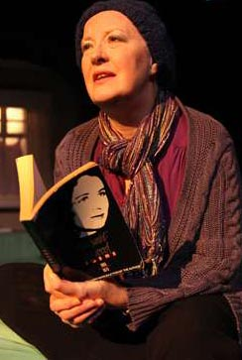
The project aimed to better understand, celebrate and share the diverse contributions and value that Clean Break participants bring to the cultural landscape and to their communities. It was a longitudinal research project, gathering quantitative and qualitative data from the women. It culminated in both a written report that told the women’s stories and provided some evidence of their cultural value, and also a digital and photographic record of their successes.
A total of 63 women were involved in the project through qualitative questionnaires, interviews and focus group workshops. The research focused on women’s involvement with the arts since leaving Clean Break, and the contribution of Clean Break to their interest in theatre and performance in both professional and community settings.
We discovered that 95% of Clean Break participants felt the company had helped them develop a new or existing interest in the theatre and/or the arts, which had continued since graduating from the programmes.

The report identifies a clear link between the women’s current involvement in the cultural landscape (e.g. higher education, voluntary projects/placements, professional practice) and their experience with theatre through Clean Break. Throughout the research it was apparent that Clean Break has had a profound impact on the lives of many vulnerable women.
4. How does practical work complement your research?
I don’t separate my practical work and my research. I start with an issue that frustrates or annoys me, and where I think drama might usefully intervene or inform the issue.
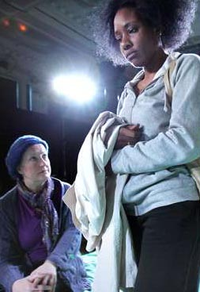
For example, in the UK there are some statistics that demonstrate re-offending can be linked to housing and employment issues, and that if male offenders have maintained links with their families they are more likely to have housing on release, and therefore more job opportunities. They are therefore less likely to re-offend.
Maintaining contact with their children is often difficult for adults in prison. So creating a drama project where fathers in prison devise and perform children’s theatre for their own families to see on a visit gives them access to creativity; may help maintain contact; and can enable the parents to give something to their families. In the process, this can help maintain links and reduce re-offending.
So the making of children’s theatre is my practice while my research analyses the results of the practice on the participants’ self-esteem, education goals, aspirational thinking and re-offending rates.
5. Why is research and project evaluation important?
If we want something to change, we have to prove there is a better way of doing things. The criminal justice system is broken but arts practitioners need to provide evidence that there is a different way to do things – a way that works, reduces offending, keep communities safe and values human beings.
Anyone who works using the arts with communities knows it makes a difference to the quality of people’s lives. But we have to prove that. And not just with a questionnaire and a tick-box evaluation.
Evaluation methods need to be deeply embedded into our practices in a meaningful way. It means our participants should be our co-researchers and co-creators from the beginning of the planning stage through until the end of the evaluation process.
It also means that we use the artform – theatre, visual art, creative writing, dance, music – as a means of evidence collection and dissemination. Theatre becomes the practice, the research method and the communication method for the findings, supported by the data. With the Clean Break project, the exhibition was as important as the written report to celebrate the success of the individuals and the company.

6. What’s the one most inspiring thing you’ve uncovered in your research?
The inspiring moments are always in the practice. It’s always the participants.
- The group of fathers working to get the pirate dance right and perform like a boy band when none of them danced before.
- The young man who wrote a rap that became the narration for the play on the back of envelopes in his cell unprompted one night.
- One inmate teaching another to play the guitar.
- The man whose children couldn’t come to the show, but who performed his best for the children of others so as not to let down the team.
- The youth who didn’t want to perform but slid across the stage in a crab costume.
- The look on a child’s face when he saw his father was the pirate captain.
- The mother who came to see her son in prison for the first time in 15 years because he had sent her an invite to a play that he was in.
- Fifteen men playing grandmother’s footsteps, laughing together, painting leaves for a set together, taking a bow together.
Most inspiring? People’s ability to create, play, perform and support one another no matter what or where.
Now, the challenge is to open that out for the policymakers and the public to see what a difference the arts can make.
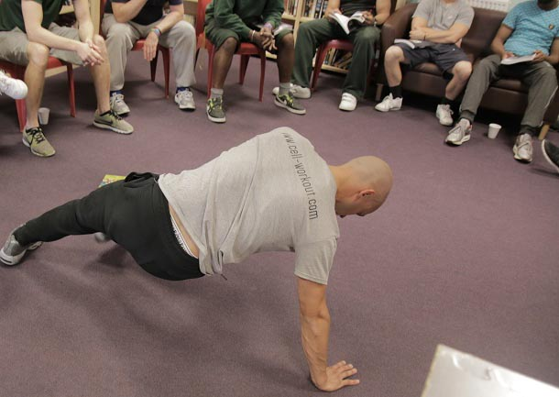

For more information
Dr Selina Busby
Principal Lecturer, Applied Theatre
Royal Central, University of London
E: selina.busby@cssd.ac.uk
W: www.cssd.ac.uk/staff/dr-selina-busby-ba-pgce-ma-phd

