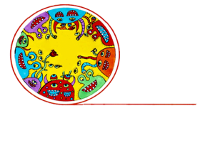
Q & A: Creative spaces
Arts therapy goes beyond words
What is arts therapy and what are the benefits? Amanda Levey, Arts Therapy Programme Director at Whitecliffe College of Arts & Design in Auckland, discusses arts therapy and the value of integrating it into creative space programmes.

1. Background: about Amanda Levey
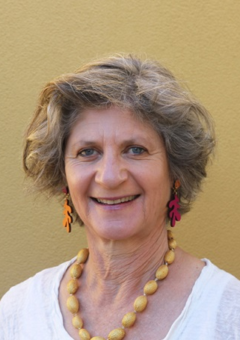
After I completed an honours degree in psychology at the University of Melbourne, I felt disillusioned with the cerebral nature of the field. So I decided to travel and while I was in India, I met an amazing yoga teacher and spent several months studying yoga in Cochin.

This was in 1980 and yoga was fairly new in the West. Yoga was an introduction to the physical element of life for me, as I had never been sporty. It was incredible to find a type of movement that suited my nature and body. I could see the benefits so I continued to practise regularly on my travels.

By chance, I was invited to a movement class when I was in Germany, which introduced me to movement as therapy. From this, I discovered Anna Halprin and went to the United States to study movement-based expressive therapies with her. It was life-changing to learn how we can explore our feelings through the body rather than only through the mind.

When I moved to New Zealand, I began practising as a psychologist but incorporated movement therapy into my work with clients. I met with Maureen Woodcock, one of the founders of the Whitecliffe College arts therapy programme, because she was interested in incorporating a movement-based therapist on to the faculty of the college’s arts therapy programme. I completed a Masters in Arts Therapy at Whitecliffe and have been a member of the faculty since 2007.

As well as my current role as Director of the arts therapy programme, I am also involved with ANZATA, the Asia-Pacific professional body for arts therapists. I’ve been involved with several creative spaces.

I co-founded the MARCO Trust, which operated for a few years in Auckland, and as part of that was involved in the development of CAN (Creative Arts Network). I was also on the board of what is now Māpura Studios for a couple of years.

2. What is art therapy?
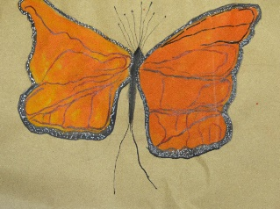
Arts therapy is about using a creative method to get beyond words. It’s a form of non-verbal communication, which can be through visual art, movement, poetry etc. Arts therapy can provide a greater sense of wellbeing to anyone who chooses to participate. The practice really comes into its own with people who have limited abilities to communicate, such as children and disabled people, and also at the other end of the spectrum for people who tend to over-think or over-talk.

3. What does arts therapy offer that is different from other forms of therapy?
Some of the benefits of arts therapy over traditional “talking” therapy:
- Through speech we can only say what we already know but by using our imagination, we can discover fresh ideas about ourselves and the world.
- Feelings are often multi-dimensional. The arts can be used to express multiple things simultaneously while words tend to be one-dimensional.
- The creative arts can access material that may be hidden from our conscious mind.
- The arts can clarify emotions and release feelings, such as those of anger or sadness, in a safe and acceptable way.
- Playfulness can be rediscovered by adults. Breaking out of the confines of thinking and talking can help us explore and find new opportunities to be positive.
- The creative process can offer a concrete object to look at and, over time, understand more from. This could be visual art, writing, or video of movement.
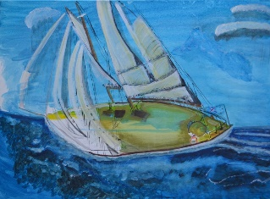
- It offers a triangular relationship, with the creative product as a third element, along with participant and therapist. This can be a less threatening experience for participants. Conversation while making art can also be a vehicle for deeper sharing, as seen in Pasifika cultures through the concept of Talanoa (the sharing of ideas, skills and experience through storytelling).

4. How does the experience of an arts therapy session differ from making art for pleasure?
Arts therapy can be seen on a spectrum. At one end is the use of the arts “in” therapy, where the therapist helps participants to reveal and understand themselves better. At the other end of the spectrum is the use of the arts “as” therapy: a calming or therapeutic experience more similar to creating art for pleasure or for its own sake. Arts therapists are able to adapt their practices along this spectrum, depending on the needs of their participants.

In addition, the focus of arts therapy is on the process, not the artistic product. The value of the work is what it reveals for the participant and often the resulting art is not kept. This can often be a freeing experience for participants. The removal of pressure to produce an artwork or product can unblock artists, and help them be more experimental and playful with their work.
5. Is arts therapy being used in creative spaces?
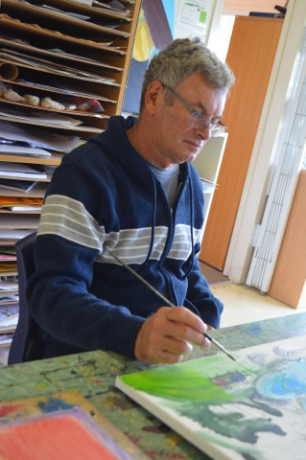
Arts therapy has been used in some creative spaces from time to time but there are two creative spaces using arts therapy: Māpura Studios and Raukatauri Music Therapy Centre, both based in Auckland.

Since 2010, Māpura Studios has provided an art therapy programme for people who have experienced the trauma of stroke. This is an intensive 12-week group programme, offered annually and recognised in University of Auckland research as having “significant benefit” to participants.

Other programmes delivered by Māpura Studios for the particular needs of children, youth and adults with diverse needs and abilities are an innovative synthesis of creative art-making and art therapy, supported by an exhibition programme in public galleries.
Raukatauri Music Therapy Centre uses some of our innate capacities – recognising rhythm and pitch – to work with disabled and disadvantaged individuals. Through the work of its music therapists, it becomes possible for clients to express themselves, engage with their community and develop meaningful relationships.
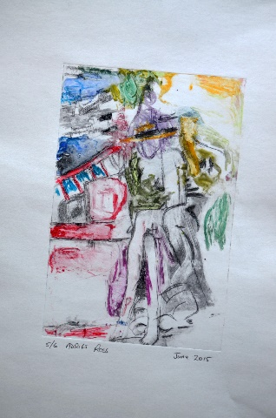
Raukatauri’s work is in high demand from education, health and disability organisations. It has responded to this demand by increasing the number of its centres and therefore the number of people it can support. At the same time, it has met the challenges of raising the necessary funds to continue expanding and keeping the cost of fees at levels that families can afford. This means that those who need the help of its music therapists are able to access it.
6. What value do you see in using arts therapy in creative spaces?
Arts therapy works really well in established groups and communities, so it could be a great fit with many creative spaces.
Some organisations hesitate to introduce arts therapy, as the word “therapy” can have negative connotations for many consumers. This is understandable but the concern is based on how arts therapy might have been practised in the past, where there was a focus on pathology and “fixing” people through therapy.
Contemporary practice of arts therapy is to open up conversations and enhance wellbeing, and I believe arts therapy can bring value to people in creative spaces.
Artists at creative spaces may get more value from arts therapy compared with other forms of psychotherapy because they can express themselves creatively rather than verbally.
7. Five things you can do to bring a therapeutic approach to the creative process.
- Be playful and experimental and try to let go of control; focus your attention on the process rather than the product.
- Help reduce the self-censoring and judgement of the outcomes of your creative process by trying to work with your non-preferred hand/side, and/or your eyes closed.
- Try working in different modalities and materials to those you are most familiar with.
- Try exploring one creative output through another medium. For example, if you have made a visual image, express that in movement or as a poetic response; or if you have done some movement, you can do an image or some writing in response. Cycle through the creative modalities as many times as you want to.
- Do some art-making and written reflections in a creative journal, and see what new understandings or insights occur to you.

8. Useful links
- Arts therapy a growing industry in New Zealand
- Australia New Zealand Arts Therapy Association
- Creative Therapies Association Aotearoa
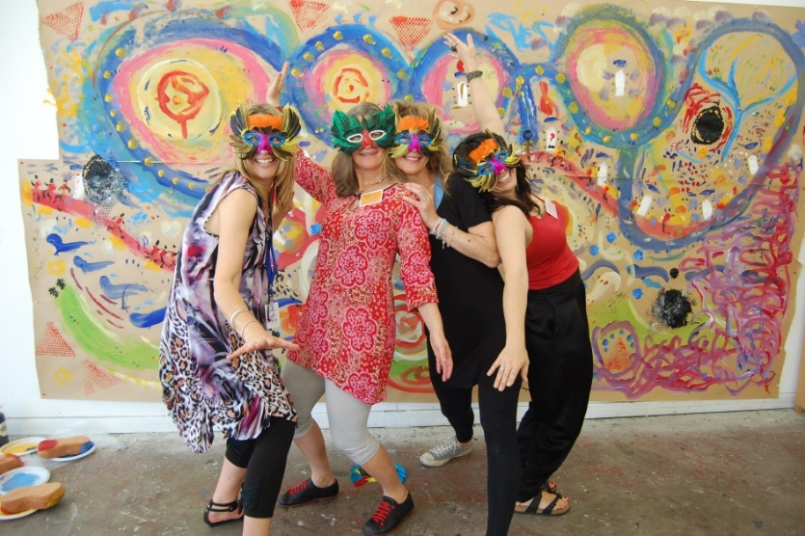

For more information
Amanda Levey
Programme Director
Arts Therapy, Whitecliffe College of Arts & Design
T: 09 601 8944 E: amandal@whitecliffe.ac.nz W: www.whitecliffe.ac.nz

