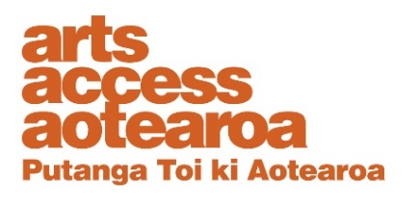

Te Putanga Toi Arts Access Awards 2021:

Arts Access Corrections Māui Tikitiki a Taranga Award 2021

1. Things to know before you start
About the Arts Access Corrections Māui Tikitiki a Taranga Award 2021
This award recognises an individual who works or volunteers for Ara Poutama Aotearoa Department of Corrections, demonstrates the qualities of Māui (innovation, creativity and leadership) and enables the provision of arts programmes in a New Zealand prison that reflect cultural inclusion and diversity. These programmes support and encourage pathways into rehabilitation and reintegration.

Māui is a name synonymous with this geographical part of the world and is featured in all of the indigenous traditions throughout the Pacific. Although sometimes portrayed as a mischievous prankster, Māui was also an innovator, a creator and a leader who looked for ways to produce better outcomes for others.

2. Eligibility criteria
To be eligible, the nominee must:
- be an employee, contractor or volunteer working in a New Zealand prison or Community Corrections site, managed by the Department of Corrections
- have been directly involved in the delivery of the arts as a rehabilitative/reintegration tool between January 2020 and the nomination closing date of 26 March 2021
- not be a previous recipient of the Māui Tikitiki a Taranga Award.

If you need any clarification or wish to discuss your nomination, please contact Chris Ulutupu, Arts in Corrections Advisor (T: 04 802 4349 E: chris.ulutupu@artsaccess.org.nz).

3. Nomination details

Nominations close: 5pm Friday 26 March 2021
Self-nomination is accepted.

Arts Access Aotearoa staff will shortlist the nominations. An industry judging panel will make the final decisions.

Late or incomplete nominations will not be accepted. We will confirm we have received your nomination and that it meets the award criteria within one week of receiving it.

If your nominee is shortlisted
Shortlisted nominees will be asked to provide the following supporting information for the judging panel:
- two support letters
- two items of support material (e.g. video, publicity material, images of work)
- evaluation data, providing evidence of its impact (e.g. feedback, statistics).

Complete the nomination form below and email it to chris.ulutupu@artsaccess.org.nz or post it to Arts Access Aotearoa, PO Box 9828, Wellington, 6141, New Zealand.

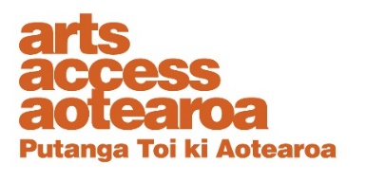
Nomination form
Arts Access Corrections Māui Tikitiki a Taranga Award 2021
Please enter the name of the nominated individual below

Contact details

Please ensure your nominee knows they are being nominated.

Nominee (the individual being nominated)

Name:

Physical address:

Postal address:

Phone/mobile: Email:

Website/online profile:

Your details (i.e. the person making the nomination)

Name:

Job title/organisation:

Postal address:

Phone/mobile: Email:

What the judges want to know

Please use the word length as a guide and use bullet points where suitable. Below are some bullet points to guide your answer.

1. Why do you think your nominee should receive this award?
(Between 300–500 words)
Write your answer below.

Think about:

- what makes their work outstanding: how they reflect the three qualities of Māui (innovation, creativity and leadership)
- what they have achieved in using the arts and culture as a rehabilitative tool
- what they have achieved in using the arts and culture as a tool to support reintegration and partner with the community/local iwi/Pacific communities
- the impact of their work

Nomination checklist
Before submitting your nomination, please type an X in the boxes below to ensure all information is supplied correctly.
The nominee meets the eligibility criteria, listed on the front page of this

document.

The nominee knows they are being nominated.

Every section of this nomination form is completed.

