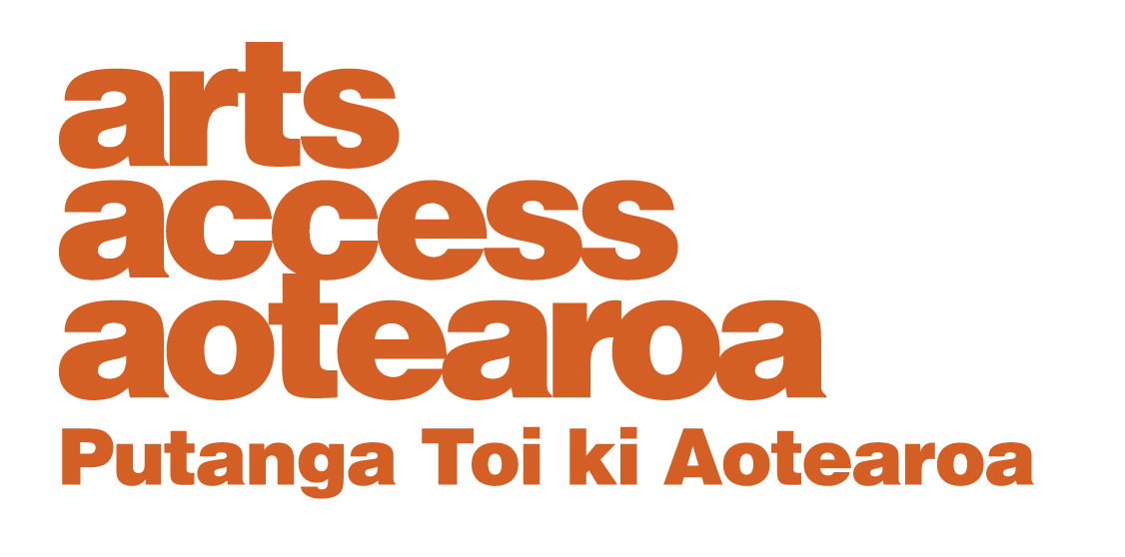

Te Putanga Toi Arts Access Awards 2021:

Arts Access Corrections Whai Tikanga Award 2021

1. Things to know before you start
About the Arts Access Corrections Whai Tikanga Award
This award recognises the outstanding contribution of a community group, organisation or individual working in a prison (e.g. in Te Tirohanga or Te Mana Wahine) or Community Corrections setting, and using tikanga and the arts to encourage a strong cultural identity and support pro-social living.

2. Eligibility criteria
To be eligible, the nominee must:
- be a community group, organisation or individual working with offenders and the Department of Corrections

- have been directly involved in the delivery of a programme or initiative incorporating tikanga and the arts between January 2020 and the nomination closing date of 26 March 2021

- not be a previous recipient of the Whai Tikanga Award.

If you need any clarification or wish to discuss your nomination, please contact Chris Ulutupu, Arts in Corrections Advisor (T: 04 802 4349 E: chris.ulutupu@artsaccess.org.nz).

3. Nomination details

Nominations close: 5pm Friday 26 March 2021
Self-nomination is accepted.

Arts Access Aotearoa staff will shortlist the nominations. An industry judging panel will make the final decisions.

Late or incomplete nominations will not be accepted. We will confirm we have received your nomination and that it meets the award criteria within one week of receiving it.

If your nominee is shortlisted
Shortlisted nominees will be asked to provide the following supporting information for the judging panel:
- two support letters
- two items of support material (e.g. video, publicity material, images of work)
- evaluation data, providing evidence of its impact (e.g. feedback, statistics).

Complete the nomination form below and email it to chris.ulutupu@artsaccess.org.nz or post it to Arts Access Aotearoa, PO Box 9828, Wellington, 6141, New Zealand.

Nomination form

Arts Access Corrections Whai Tikanga Award 2021

Please enter the name of the nominated individual/group/organisation below

Contact details:

Please ensure your nominee knows they are being nominated.

Nominee (the individual/organisation/group being nominated)

Group/organisation/individual:

Contact person:
Physical address:
Postal address:

Phone/mobile: Email:

Website:
Your details (the person making the nomination)

Name:

Job title/organisation:

Phone/mobile: Email:

What the judges want to know

Please answer the following question. Use the word length as a guide and use bullet points where suitable. Below are some bullet points to guide your answer.

1. Why do you think your nominee should receive this award?
(Between 300–400 words)

Write your answer below.

Think about:
- what makes their contribution outstanding
- their key activities and achievements in enabling/using tikanga and the arts to support the participants’ strong cultural identity and encourage pro-social living

Nomination checklist

Before submitting your nomination, please type an X in the boxes below to ensure all information is supplied correctly.

The nominee meets the eligibility criteria, listed in this

document.
The nominee knows they are being nominated.

Every section of this nomination form is completed.

You agree to supply the required support material if your nominee is shortlisted.

