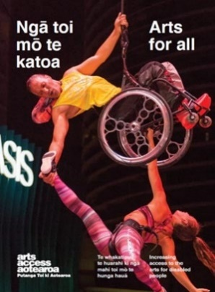
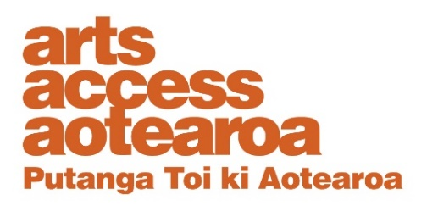
Q & A INSIGHT: ARTS FOR ALL
Integrating audio description into
a dance performance
What does integrated audio description mean and what’s involved? Judith Jones, audio describer and member of WIDance (Wellington Integrated Dance) discusses this new concept and what was involved in audio describing The Art of Observation.
1. Background: about the project
WIDance’s The Art of Observation was inspired by the architecture of the Academy of Fine Arts and selected artworks in the 28th Annual Wallace Art Awards NZAFA exhibition. It was performed during the New Zealand Fringe Festival in Wellington in March 2020.
This was the first major public performance season for WIDance, with five shows over a weekend. Sumara Fraser, Artistic Director, and the rest of the WIDance crew wanted these shows to be free and fully accessible for both the performers and the audience.
There were two daytime performances while the gallery was open to the public and three evening shows. The gallery space was accessible, all the performances were relaxed and included integrated audio description, and two evening performances were sign interpreted.
Sumara applied for, and received funding for an audio describer and a New Zealand Sign Language interpreter as part of her funding applications to Creative New Zealand and the Wellington Community Trust.

2. What’s audio description?
Audio description is translating the visual into the verbal. The audio describer uses expressive language to describe spaces, people, objects and actions so others can create their own pictures in their mind and develop their own meaning from that. It’s primarily created for blind and low vision audience members.
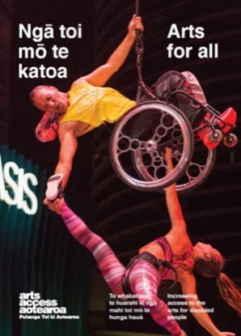
Audio description is usually delivered by the audio describer talking into a microphone with the audience receiving it via a headset. That way, they can listen to the audio aspects of the performance too.
Audio description is usually written to be said aloud. It takes time and thought to prepare, it’s a bit of an artform in itself. And for live performance it has a life of its own in the moment too.

3. What’s integrated audio description?
Integrated audio description is still quite a new concept, taking audio description into the DNA of a performance. It’s a really exciting extension of this artform and one I’ve been exploring.
I’ve been following performers around the world who are creating work that has audio description as part of the performance rather than an add-on for one segment of the audience. Let me introduce you to a couple of people who are pushing the boundaries with this:
- Kinetic Light: In the video Kinetic Light and the Disability Arts Movement the company’s Alice Sheppard and interviewer Liz Weintraub from Association of University Centres on Disabilities discuss cultural equity and turning the dance into “a soundscape”. They also model integrated audio description. Watch the video
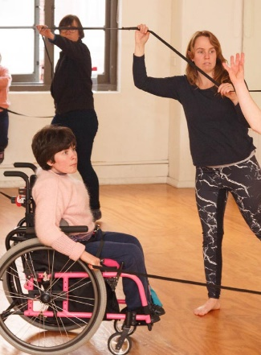
- Tito Bone: this multi-disciplinary performer subverts the traditional model of audio description. The article Unsightly Drag: taking one small step for quips (queer crips) and one giant leap for queer kind from Disability Arts Online, gives a sense of Tito’s performances, and discusses the audio description aspect.
- The audio and article The politics and power of audio-description from the Wellcome Collection refers to Tito Bone aka Amelia Cavallo, and is a terrific backgrounder exploring “the potential, power and politics of assistive technology for blind and visually impaired artists and audiences”. You can find Kinetic Light and King Tito Bone on Facebook, and other social media channels.

4. How did audio description work within the performance?
The Art of Observation had a very short rehearsal period and the performers had to concentrate on creating and refining individual movements and collaborative pieces. Fully integrated audio description was not an option this time but we started to frame the bones of this in the way we approached the work.
Sumara and I decided to thread audio description into the dance performance, using my voice as describer, once the pieces were established.
I created an audio description for each artwork the dancers would respond to, and for the themes, forms and movements they’d created, to voice ahead of each dance segment. Everyone would hear this: it would be part of the performance.
The music was a key part of the overall experience and so I spoke only in the silent moments or over a soft intro or outro.
However, one piece had a strong narrative flow. We decided to extend the experiment and create an audio description “story” that threaded through this work. I described the action in brief phrases, sometimes ahead of what happened, sometimes as it happened. You can read this script at the end of this Q & A insight.
We agreed it made sense that I’d also act as MC to welcome the audience and frame the experience they were about to have. I explained I’d be audio describing “the artworks that the dancers are responding to, and talk about the themes, forms and movements they’ve created for each piece”.

5. How did you prepare the description?
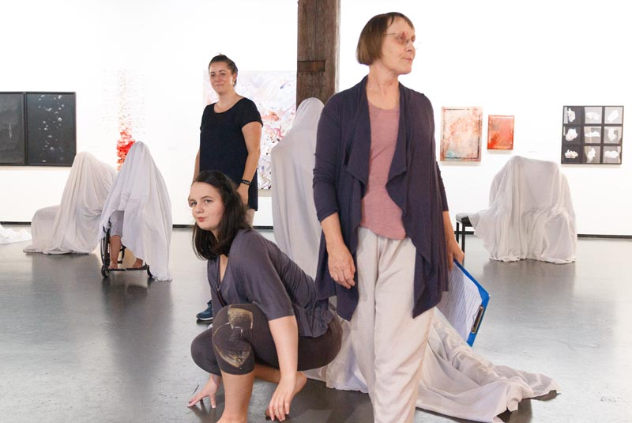
Judith Jones, audio describer, and Shoshanna Cleary, sign interpreter, integrated into the performance
There were two parts: the artworks in the gallery and the performance.
My intention was to describe the artworks in ways that reflected their role as inspiration for the choreography. If I’d been creating descriptions for an art tour, the writing would have been different. I wanted to support the listeners to create connections between the colour, form and movement of the artworks and the colour, form and movement of the dance.
I spent time with the artworks in the gallery space. I read what the artists wrote about their work, their methods, their intentions. I talked with Sumara about why she’d chosen these works. And I looked at the works slowly to find effective ways to translate them into a verbal form, aligned to the context of this contemporary dance.
The performance had a very short development time. I watched and listened as often as I could, in person and to rehearsal videos. I paid special attention to the words used in the choreography, and how the dancers talked about their movements, expressed their connections, and how it felt from inside the dance.
I watched the costumes in action on the performers, their colour and form, and how they responded to the dancers’ movements in the gallery space.
Aligning my description
I needed to align my description with the recorded music and with the time between pieces. I talked with Sumara about why she’d chosen the works she did, listening for key words she used in her explanations. I discussed with the sound technician the spirit and form of the tracks, their beginnings and endings, how loud they would be, and how to smooth the talk/music transitions.
I also built into the script a short description of the tone, pace and instruments for each piece of music so our Deaf audience members could get a sense of the soundscape when the NZSL interpreter interpreted the audio description.
During rehearsals in the gallery, we tested the transitions, and how loudly I could talk and still be expressive, and also make use of silence.
I wrote a draft script and shared it with Sumara.
Testing the script at rehearsals
We then tested this script at the rehearsals in the gallery space. I was conscious that the dancers hadn’t heard the script before and it had to work for them and support their creation, not intrude nor distract. They’d experienced me as a fellow dancer but hadn’t heard this aspect of verbal performance from me before. Their responses were really helpful. I refined the script in length and changed some ways of expressing things once I saw the dancers move in the space and light, in their costumes, and how they transitioned between the artworks.
I created a fresh MC/audio description script for the first show with the music cues, and shared that with the sound tech, and with the NZSL interpreter.
I didn’t stick to it exactly though. Some things changed on the day – as they do.
I knew the visual and verbal aspects of the artworks, the dance works and the dancers. I understood their intentions. My job was to integrate the words, to weave my audio description through the performance in real time. I also needed to respond to the varied audiences and their responses. I committed to hold the space and script lightly and ad-lib in the moment. No two performances were exactly alike and no two audio descriptions were exactly the same either.
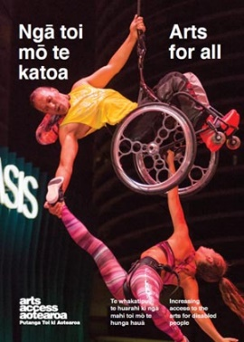
6. What was the response?
We had some very positive and thoughtful responses to the audio description from audience members. People told me they experienced the audio description as an integral and rich part of the whole. No one told me it had taken anything away for them or questioned why it was included.
Sumara commented that the audio description became an integral part of the performance, providing context and continuity. “It helped make all the connections – between the gallery, the artworks, the music, the dancers and their movements, and our audiences – stronger. It had an artistry of its own that the audiences and the dancers responded to.”
7. This was an experiment: what next?
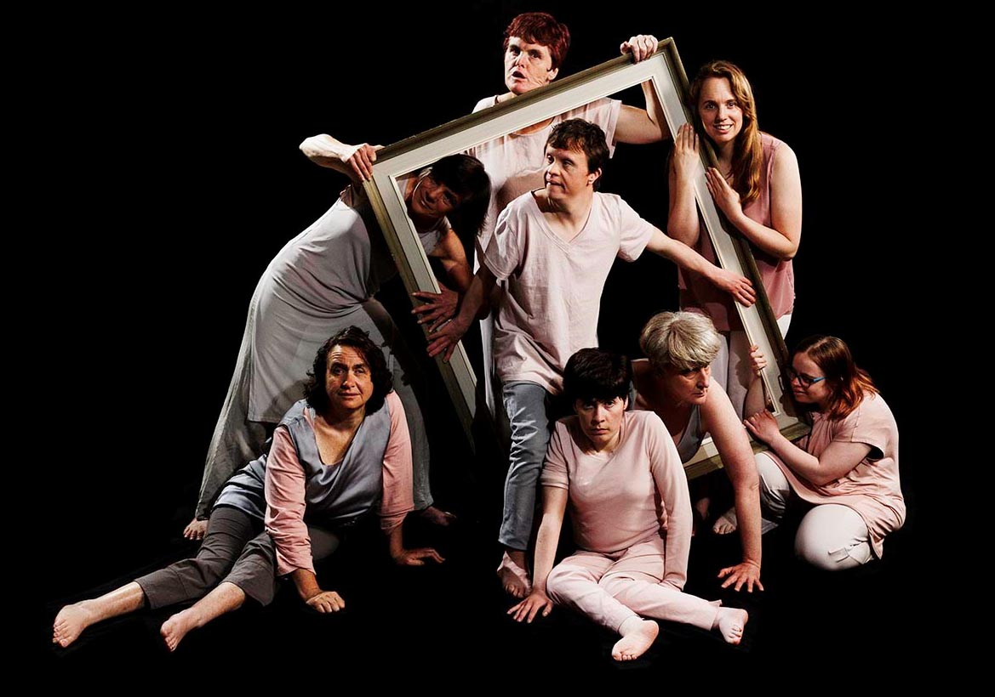
Overall, we were really happy with how the integrated audio description helped create a meaningful experience for our audiences. Holding both the space as MC and connecting with the music helped the audio description pieces sit within the work rather than as an add-on.
As an audio describer, I was pleased to bring this artform to a wider audience and to push what is possible for making the visual verbal with dance. Sumara and I are keen to take this experiment further. We plan to build on the framework we developed, and on the experience the dancers have now had of audio description within their performance.
Our idea for the next step is to give the dancers more ownership of this aspect from the start, as much as they individually wish. Perhaps, for example, they would voice descriptions themselves, live or recoded, or maybe not. We plan to workshop with the WIDance crew to explore how audio description could be an integral and meaningful part of the original creation of the work itself.

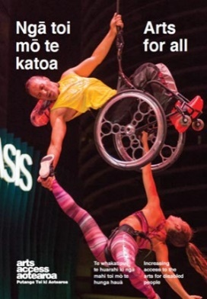
8. A script example
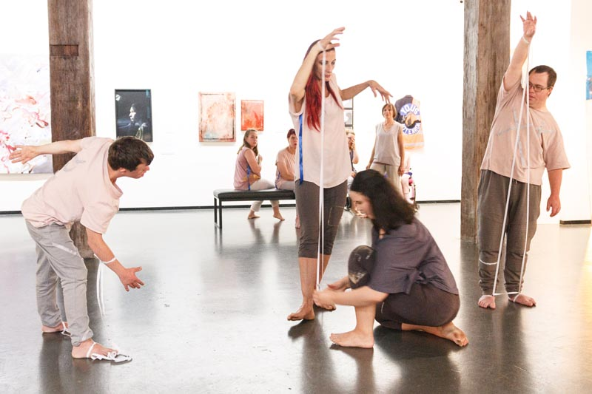
The following sample is part of the script for Elastics, pictured above, the one work in The Art of Observation where I spoke through the dance. This changed a little each time, responding to the dancers’ timing, forms and expressions. It’s a piece of writing written to be read, with pauses and expression.
Most of our dancers have moved to the edges of the space – three are left in a line. They each hold a long loop of finger-wide, white elastic band, with smaller loops set along it at intervals.
Dash goes to each dancer in turn, attaching them to their elastic band by giving them a smaller loop to hold in each hand, and slipping one around each foot. She poses them like puppets, framing them within stretched lines of elastic as she manoeuvres their limbs and bodies into angular shapes.
Puppeteer Dash scoots around the dancers, resetting their poses and positions in the space, stretching and plucking the elastics. They’re trapped, but each frame is fluid. She conducts their moves until they’re close together.
The dancers shift to the floor around her, wriggling inside their frames and tangling. Dash becomes ensnared in the elastics, as the dancers move these from their limbs to hers… and roll away. She’s dancing inside the fluid frame.
For more information about audio description
Judith Jones
Arts For All Wellington Network E: judith.jones@tepapa.govt.nz
Arts For All is an Arts Access Aotearoa/Creative New Zealand partnership programme. It aims to encourage arts organisations, venues and producers to improve access to Deaf and disabled audiences. Download the guide at artsaccess.org.nz or call 04 802 4349 for more information.

