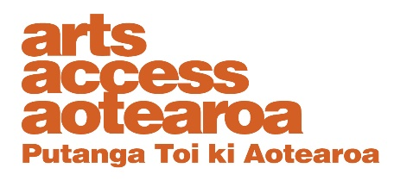

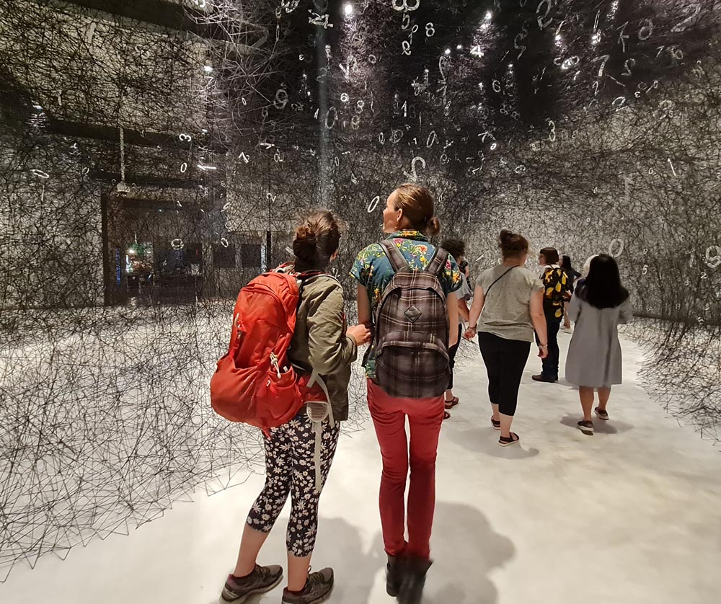
How to develop and write
an accessibility policy:
a guide for arts organisations

March 2021

Contents
Foreword 3
What is accessibility? 4
Why have an accessibility policy? 4
Developing an accessibility policy 6
What is policy? 6
The ten stages of the Policy Cycle 7
Process decisions 8
Paying disabled participants in your policy process 8
Stage one: the status quo, issues analysis, problem definition 9
Stage two: background, context, constraints 9
Stage three: goals, objectives, outcomes 10
Stage four: policy options 11
Stage five: options assessment 11
Stage six: write up your policy 12
Stage seven: consultation 13
Stage eight: revise your policy, get it approved, make it public 13
Stage nine: implementation 14
Stage ten: monitoring and evaluation 14
Back to the beginning of the Policy Cycle 14
Other matters 15
Checklist 16
Appendix1: Example of an accessibility policy 17
Appendix 2: Example of analysis during the development of an accessibility policy 20
Appendix 3: Some general ideas about possible accessibility options 22

Cover image: Visitors enjoy Te Papa’s Sense Art tour of the Web of Time installation by Japanese artist Chiharu Shiota, 2021
Photo: Stace Robertson

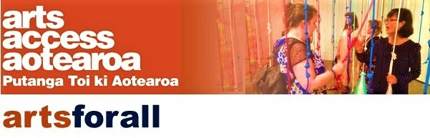

Foreword
Arts Access Aotearoa has advocated for accessibility in the arts for 25 years.
We know the arts can enrich our lives. They make us laugh and think, and can be challenging. They give voice to our cultural expression and can make us feel better about ourselves and the world.
Many people, however, experience barriers to participating in the arts and so are excluded from their benefits.
This guide for arts organisations on how to develop and write an accessibility policy is designed to move us towards a better, more connected society where more people can be included in the arts and experience its benefits.
Over time, we will respond to feedback, refresh the information and let members of the Arts For All Network know about updates.
Many arts organisations, local councils and others in the Arts For All Network are already working towards increased accessibility. Thank you for your commitment to making a difference.
I trust this guide will be another step in our dialogue on how Arts Access Aotearoa can support members of the Arts For All Network to develop and implement accessibility policies.
Please let us know your questions and comments so we can continue to support you in your work to make the arts accessible for everyone in Aotearoa.
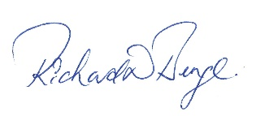
Richard Benge
Executive Director| Kaiwhakahaere Matua
Arts Access Aotearoa
For more information, please contact Stace Robertson, Access, Inclusion and Participation Advisor at Arts Access Aotearoa.
E: stace.robertson@artsaccess.org.nz T: 04 802 4349

What is accessibility?
Accessibility can be described as the ability for all people regardless of disability or impairment to be able – independently, with dignity, and without restriction or barrier – to:
- use a service or product
- participate in society
- access our built environments and communities.
This definition is consistent with that used by the United Nations and by government agencies in New Zealand such as the Office for Disability Issues.

Why have an accessibility policy?
This guide is intended to help arts organisations think about how they might benefit from having an accessibility policy, and how they might go about developing and writing such a policy or enhancing the ones they already have.
- Ethical, diversity-focused and accessible behaviour is good for business.
Being seen to be serious about human rights, and ethical and diversity imperatives can foster a sense of public goodwill toward your organisation.
A company’s reputation for ethical, diversity-focused and accessible behaviour can help it create a more positive image in the marketplace, which can bring in new customers through word-of-mouth referrals and benefit your bottom line. This behaviour can serve to differentiate your brand from those of your competitors, thereby offering you a competitive edge.
The advantages of ethical, diversity-focused and accessible behaviour can include helping your organisation build customer loyalty, avoid legal problems associated with human rights violations, and attract and retain talented employees.
- An accessibility policy may help your organisation be more effective.
Taking a policy approach will guide you to: (a) be clear about where your organisation is now and (b) help you compare where you are now with what your organisation wants to achieve. It can:
- require you to gather evidence and data to reveal how well your organisation is doing to respond to the needs of disabled artists, audiences and staff. This may uncover issues and problems you had not previously recognised.
- help you to think through the range of options for starting from where you are to get to where you want to go and assess those options against sensible criteria.
- be a tool to ensure everyone in the organisation is using the same plan to achieve the same goals and objectives. This should help your organisation reach those goals more effectively.
- An accessibility policy may help your organisation be more efficient.
By developing a plan of action for getting from where you are to where you want to go, use of a robust policy approach and assessment criteria may help your organisation avoid wasting precious time, money and resource on actions that are not helping you achieve your goals and objectives.
- One-quarter of our population has a disability. Your organisation may not want to overlook this number of people, which includes artists, audiences and staff.
In your environmental scanning for your organisation planning, you may have come across this data from the 2013 Disability Survey:
- About 24% of our population is disabled (26% of Māori).
- The rate of disability for people aged 65 and over is 59% compared with 21% for the working age population (aged 15 to 64 years).
- Of the people in New Zealand with a disability: 57% have a physical disability; 44% a sensory disability; 8% a learning disability; and 22% a psychiatric or psychological disability (some people have more than one type of disability).
This is a significant component of our society which your organisation may not want to ignore. Your ability to draw on diverse artistic talent, for example, could be a strength for your organisation.
- An accessibility policy may help your organisation demonstrate best practice.
The United Nations Convention on the Rights of Persons with Disabilities (CRPD), together with New Zealand’s Disability Strategy 2016-2026 and Action Plan 2019-2023, promote best practice. In the cultural sector, this could include:
- Deaf and disabled people being able to take part in the arts on an equal basis with others
- venues and services designed to meet the needs of people who are Deaf and disabled – also likely to be good for everyone else (universal design).
Compliance with the Human Rights Act 1993 could also help reduce the risk of a complaint to the Disability Rights Commissioner at the Human Rights Commission under section 21(1)(h) of the Act (discrimination on the grounds of disability).

- An accessibility policy may help your funding applications be more successful.
Analysing problems or issues requires a methodical, evidence-based approach. Collecting evidence and data can help you track investment in an action and its impacts by:
- Being clear about the “starting position” of your company as you develop your accessibility policy (your “baseline”), and
- Monitoring how that picture changes over time as you implement your accessibility policy’s plan of action.
This type of evidence is critical to support funding applications and may mean you are more likely to be successful with those applications.

Developing an accessibility policy

What is policy?
A policy is a framework or set of guidelines, and an agreed basis for action. It is developed knowingly, ahead of time.
Policies should focus on achievements and outcomes, and they should be able to be evaluated for their effectiveness.
Think of a policy as a raft to navigate a raging river and help you get from one side of the river to the other.

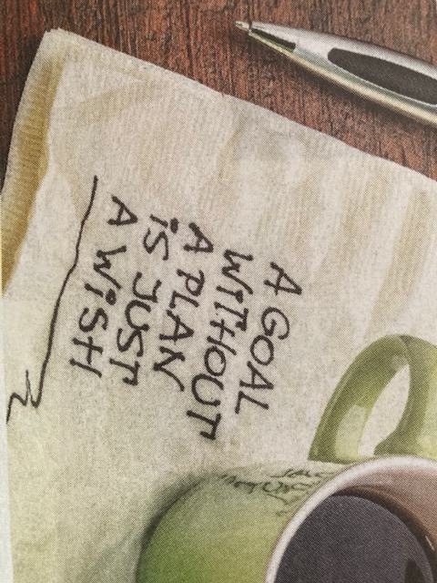

The ten stages of the Policy Cycle
The Policy Cycle will influence what you do, in what order, and how you do it, as you are developing your accessibility policy. There are ten broad stages in the Policy Cycle, but these can be modified to fit your situation.
- Appendices 1 and 2 to this Guide include an example of how to develop and write up an accessibility policy for a fictitious company called Rope Line Theatre Inc. The ten stages of the Policy Cycle are applied to this entity.

Process decisions
- Before we even think about the stages of the Policy Cycle, however, it is useful to consider how to run a policy development process that will operate alongside the ten stages of the Policy Cycle.
- How will disabled people and the disability sector, which some non-disabled people, contribute to the development of your accessibility policy? The effectiveness of your policy will heavily depend on the extent to which the voice of disabled people is heard and addressed in your policy. Your decisions about this may depend on how large an organisation you are and extent to which a disability voice is already embedded in your oganisation.
- Involvement of disabled people – as artists, audience members and staff – is particularly critical in stage one of the Policy Cycle, where you will describe the status quo and identify issues and problems.
- Do you want to engage or workshop with disabled people and the disability sector at this early stage?
- Or do you want to form a small working group of stakeholders from outside your organisation to help you throughout the entire project? You could also include some staff from within your organisation.
- Do you want to contract a disabled person to lead stage one, or all, of your policy process?
- What would help you get the best results? And how will you make the process accessible to the disabled people who are participating (such as using sign language interpreters)?
Stace Robertson, Access, Inclusion and Participation Advisor at Arts Access Aotearoa can help you think about what might work best in your context and can connect you to Deaf and disabled artists and their communities.

Paying disabled participants in your policy process
- It is usual to recompense Deaf and disabled people for their expertise and experience. It is this expertise and experience that will inform the contents of your policy and ensure that it will support you to make effective change for the inclusion of Deaf and disabled people.
- It is best to speak with the members of your focus group about what method of recompense will work best for them. You should also factor into your budget the cost of accessibility requirements such as New Zealand Sign Language interpreters.

Stage one: the status quo, issues analysis, problem definition
Stage one of the Policy Cycle goes by different names but is essentially about where you are right now. It is the launching-off place for your raft. It is the things you might want to change. For example:
- Do you want to address accessibility barriers – for audiences, artists and staff - that are a thorn in your side as an arts organisation? Have people been complaining?
- Does your data show that disabled people are simply not attending your venue or events, or are not putting on shows at your venue? Do you want to change that?
- Evidence can be very helpful in the problem definition stage but maybe you don’t collect data about your audiences, artists and staff that includes disability. In that case you might not even be sure if there are problems and issues you need to address. Maybe lack of data is the problem.
- What are some of the issues you are responding to?

Stage two: background, context, constraints
- In this stage of the Policy Cycle, you will consider what is going to influence the shape and contents of your accessibility policy.
- This consideration is important because it will help determine the amount of time and effort you need to devote to each stage on the cycle and, also, the processes you need to factor into your work to make each stage on the Policy Cycle happen.
  - You might already have an accessibility policy but it may need updating because the laws referred to in it have been amended or because social expectations have changed.
This might mean that little work is required and so your timeframes can be quick, your internal and external consultation procedures smooth.
  - Or you might know that you need to develop a policy because you are receiving complaints that your venue, or your website, or something else, is creating difficulties for audiences, or artists, or trustees and so on.
This is a great place to be because you know you have a mandate for change from disabled people and the disability sector.
  - Alternatively, your organisation might already have decided to align its business with international and national human rights law, as well as prepare for accessibility legislation expected to be introduced in Aotearoa New Zealand.
This is also a great place to be because you know that you have a mandate to develop an accessibility policy from your senior leadership and board.
  - The mandate you have from your senior leadership and your board is critical.
- Do you have total buy-in?
- Or do you only have the mandate to do a “once over lightly” this time rather than a comprehensive exercise with a more comprehensive policy developed in, say, three years” time?
- Or is there nervousness about what an accessibility policy might mean for the budget, and so your mandate to develop one is uncertain?
  - Some tips for getting buy-in to develop an accessibility policy are listed below.
- Develop a theoretical mock-up of a policy, maybe on an A3, including all the stages of the Policy Cycle that we cover here. The aim is to use this theoretical policy to demystify what a policy might look like. It could show how some actions in the policy could be straightforward while others could be prioritised, depending on the budget or additional fundraising.
- Propose that at the end of each policy development stage of the cycle you will check in with senior leadership to make sure they are still onboard. This way they can influence the pace and contents of the work. Ideally, you will be able to bring them along with you.
- If the idea of an accessibility policy is daunting, another route can be to introduce accessibility as a section into every memo, paper or proposal you write so that the issue starts to build visibility, acceptability and its own momentum. When it becomes obvious to all that an accessibility policy raft is needed, then you will be ready to build one.

Stage three: goals, objectives, outcomes
  - In stage one we talked about where you are, the launching off place, your problem definition. In stage two we covered the context and constraints within which you operate. Stage three is all about where you want to be. It is the other side of the river.
  - The goals, objectives and outcomes important to your organisation are the things that describe where you want to be. They are generally contained in your strategic and business plans. For some organisations, they can also be found in underpinning legislation.
  - What do we mean when we use the terms goals, objectives and outcomes?
    - Goals are the aims of your organisation at the most strategic level, such as: we want to be a sustainable arts company.
    - Objectives are the detailed business and marketing aims of your organisation, which should relate back to your strategic goals, such as: we want to be accessible so we can accommodate Deaf and disabled audiences and artists, and this will help our company be sustainable.
    - Outcomes refer to changes in people’s lives that your policies and actions influence, such as: providing opportunities for all people to participate fully in society.

Stage four: policy options
    - Policy options are the logs you will choose in making your raft. You want a raft robust enough to push off from the riverbank (where you are; your problem definition), navigate that scary river, and reach the riverbank on the other side (where you want to be; your goals, objectives, and outcomes).
    - There will be several ways your organisation can move from one side of the river to the other, and each of these ways – or options – will depend both on the specific issue you want to address, and the objective or goal towards which you are aiming.
    - Example: let”s assume that the key issues you have identified are that your organisation, firstly, does not collect data to say whether Deaf and disabled people are attending your shows and, secondly, has not asked Deaf and disabled people what the problems are for them with respect to your venues or shows.
    - Given this, jumping straight to an option of, say, building a ramp, might be premature. More sensible options for your policy in this example, to address the issues you have identified, might be to collect data and develop and implement a sector consultation strategy.
    - This approach should help your organisation avoid wasting precious time, money and resource on actions that may not actually help you achieve your goals and objectives.
    - The results of implementing these measures can then be used as evidence in, say, three years’ time when you review your policy and develop a new set of policies and actions.
  - Refer to Appendix 3 to this Guide for ideas about possible policy options.

Stage five: options assessment
  - Once you have a list of possible policy options, you will want to assess each option against a list of sensible criteria. Some options could fall off at this stage or could start to reveal themselves as longer-term options.
  - Some ideas for possible assessment criteria are:
    - Effectiveness: how effective is an option likely to be in: (a) addressing the problems identified; (b) achieving your objectives and goals?
    - How much support from disabled people and the disability sector is likely?
    - How much support is likely from your senior leadership/board?
    - Cost: how much will each option cost?
    - Efficiency/Value for money: in comparing options, are there any that look similar in terms of effectiveness but some that could be achieved in a shorter timeframe or for less cost than others (and so are more value for money)?
    - Implementation: how easy will it be to implement an option? How long will it take? Are there legislative barriers that will slow down an option or even discount it?

Stage six: write up your policy
This is the point at which all your analysis and ideas should be coming together in a written document, as below. Appendix 1 applies this template, using an example.
Introduction | State the reason for your organisation having an accessibility policy.
Background | Could include:  - a brief overview of your organisation and what it does  - regulation/best practice that governs or guides your industry. Other contextual matters (e.g. a global pandemic, the health of the economy, planning permission requirements etc).  - definitions of any terms used in the policy document  - the name and title of the person with responsibility for and oversight of the policy document and action plan.
Goals and objectives | Include a list or table of the strategic, business and marketing goals important to this policy.
Accessibility issues you want to address and why | Succinctly summarise the accessibility problems/issues you discovered while developing your policy approach. You will need to include evidence or data to support claims of the existence of each separate problem or issue.  You could table the problems/issues to show how they are reducing your ability to achieve your organisation”s objectives and goals and why you want to address them.
Accessibility policy | Once you have possible options, use your assessment criteria to help you weigh up the trade-offs between options. Choose which options to progress to address each of the issues identified. These options are the things that your organisation will use to move it from where it is to where it wants to be.
Action plan: KPIs, dates, milestones resources, funding | Against each intended policy action, note short, medium and longer-term timeframes with expected achievements by each. These are your Key Performance Indicators (KPIs). Be clear about who is responsible for each action point.  If an action point needs to be funded, the first milestone against that action might be to estimate the cost or to secure the required funding.  Subsequent milestones against that action point could then be dependent on achieving approval for funding.
Evidence, progress and review | You will need to include actions to gather evidence to show that your actions are addressing the problems identified and are helping you achieve your objectives and goals (or not).  Regular progress reporting and reviews of achievements is important. If something is not working, there is an opportunity to revise your approach.

Stage seven: consultation
- Now you have an accessibility policy drafted, consultation comes next.
- A very important point: before you begin consulting, get approval from your organisation for the product you are consulting on, as well as who you are consulting with, and how you intend to consult.
- If you have not consulted before now or used a working group approach, this is the very latest point at which you will want to consult both within your organisation and, when ready, with external stakeholders.
- Stakeholders will differ between your organisations but all should include the different groups within the disability sector, including types of disability, artists, audiences and so on. This will help ensure the feedback captures the needs and issues of as many different groups as possible.
- You will want to consult in accessible ways that work for different groups.

Stage eight: revise your policy, get it approved, make it public
- Once you receive feedback following your consultation, you will review submissions and revise your policy before beginning your approval process.
- Be prepared to make amendments to your policy many times as more eyes focus on it.
- The length and shape of your approval process will depend on the size and nature of your organisation. It will also depend on how successful:
  - stage two was in getting a mandate from senior leadership
  - your process has been in keeping the leadership informed after each of the policy development stages. Did they come on the journey with you?
- Once approved, publish your accessibility policy, including in large print, as a word document and as an Easy Read version.

Stage nine: implementation
- Implement your accessibility policy according to your policy document and its plan of action.
- If everyone in the organisation uses the same plan to achieve the same goals and objectives, this should help the organisation reach its aims more effectively and pull its raft up on to the opposite shore.

Stage ten: monitoring and evaluation
- Monitoring and evaluation are critical. They are, essentially, a warrant of fitness for your policy raft and a review of whether you landed in the right spot on that opposite bank. Ideally:
  - Data is gathered on the effectiveness of the measures you implement to achieve your goals, objectives and so on.
  - This monitoring is put in place from day one of implementing a policy activity so that the data can later feed into an evaluation and future review.
  - The data is gathered in ways that are accessible.
- This data you gather (such as feedback, house sizes, demographics, number of shows using NZSL and so on) should be able to show the extent to which you are achieving your KPIs, your objectives and your goals.
- To discover whether you are achieving your desired outcomes usually requires something a bit extra. You might want to know, for example, if your activities to improve accessibility are:
  - helping more people to feel more included in the community and society
  - or whether they are more likely to support your organisation because it is ethical.
- You could seek this type of information through feedback questionnaires or surveys. These do not have to be complex. They could be as simple as encouraging people to press a smiley, or a neutral, or a sad-faced button on the way out of a show, above which is pinned a banner stating your question.

Back to the beginning of the Policy Cycle
- You have now come full circle. Once you have data from your monitoring and evaluation, you are likely to find that you have a new or modified problem definition and we are back to stage one of the Policy Cycle, either:
  - fixing issues with your raft that were identified at your warrant of fitness
  - building a new raft
  - or re-floating the raft so that you can move up it the bank a bit.

Other matters
Policies that work together
- Arts Access Aotearoa is aware that the interface between accessibility, diversity and Te Tiriti o Waitangi policies is not always clear. When these policies are designed to work together (for example, when your Te Tiriti policy includes access for disabled Māori and your accessibility policy activities reference obligations under Te Tiriti) then people who have multiple marginalised identities are more likely to see impactful change that enables their participation.
- We welcome conversations about this interface, acknowledging this requires multiple groups working collaboratively within an organisation and a more nuanced approach to policy and intersectional change.
Accessibility legislation
- If you would like to know more about the government”s intention to introduce accessibility legislation, please talk to Stace Robertson at Arts Access Aotearoa. He will be able to direct you to the right place or person.

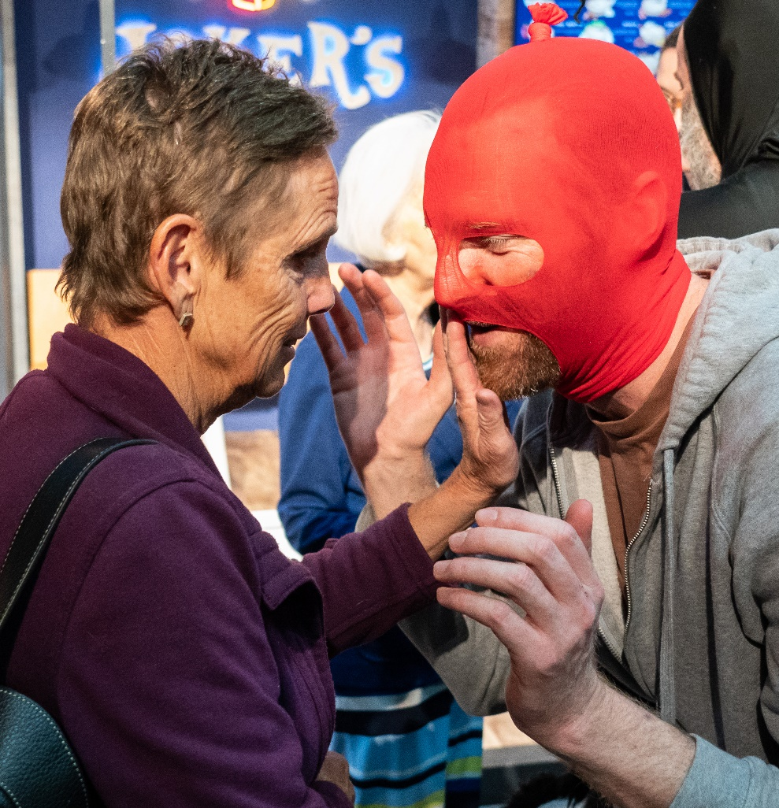
A touch tour before an audio described performance of Mr Red Light at the New Zealand Festival of the Arts 2020 Photo: Matt Grace, New Zealand Festival of the Arts 2020

Checklist
- Has your process of developing an accessibility policy actively sought and considered the voice and views of Deaf and disabled audiences, artists and staff?
- Did you recompense the Deaf and disabled people who contributed to the development of your accessibility policy, for their expertise, experience and time?
- Stage one: have you accurately determined what the accessibility problems or issues are for your organisation, based on the views of Deaf and disabled people and evidence?
- Stage two: have you identified the context and constraints within which your accessibility policy is developed and will operate?
- Did senior leadership and your board come on the journey with you as you developed your accessibility policy?
- Stage three: is your policy clear about its goals, objectives and outcomes?
- Stage four: did you identify a range of options for both addressing your problem definition (stage one) and moving closer towards your goals, objectives and outcomes (stage three)?
- Stage five: did you assess your policy options against a list of sensible criteria to determine which of your options would become policy activities?
- Stage six: did you draft your policy in a way that is helpful for staff, artists and audiences?
- Stage seven: did you receive permission to consult on your draft policy, and then consult widely?
- Stage eight: did you revise your policy based on feedback, have it approved and publish it in several accessible formats?
- Stage nine: have you implemented your accessibility policy and its activities; are you regularly reporting on progress?
- Stage ten: have you put monitoring and evaluation processes in place, to gather evidence of the effectiveness of your accessibility policy?

Appendix1: Example of an accessibility policy
Introduction | Name of organisation: Rope Line Theatre Inc  Our accessibility policy aligns with and supports our mission.  It will help us achieve our strategic goals and accompanying objectives.
Background | Rope Line Theatre Inc is:  - A small theatre space for emerging artists. Our mission is to offer a “hand up” and the potential for emerging artists to build their experience and profile.  - Based in Hamilton and we lease a heritage building.  - A registered charitable trust. We have a constitution, are not-for-profit, are run by a collective of performers, and employ a General Manager (GM). Stage managers and lighting/sound crew are contracted on a casual basis.  - A member of NZ Theatre Federation Inc. aka Theatre NZ Today, which advocates for community theatre.  - A Trust that operates from a basis of equal rights and non-discrimination; we aim to comply with all relevant legislation; we make information available to performers about the union Equity NZ.  - Clear about the usefulness of evidence; one of our operating principles is to collate (non-personal) data on audiences, artists and shows at our Theatre, to ensure we have evidence for funding applications and business planning.  The GM of Rope Line Theatre Inc. is responsible to the Chair of the Trust for implementing the accessibility policy and action plan.  These will be reviewed and updated in three years from the date of approval.
Goals and objectives | We have two strategic goals; each of which are supported by two objectives.  - Provide opportunities and reduce barriers for emerging, under-represented, and marginalised theatre artists.  - We operate on a curation basis with the aim that this process will result in even representation across all identities.  - Equality of outcome is important to us, not just equality of opportunity.  - Sustainability.  - We price theatre tickets to be as accessible as possible while covering our costs and paying artists.  - We maximise fundraising opportunities.
Accessibility issues to address and why | Analysis of “where we are at” compared with “where we want to be” in relation to our strategic goals and our accompanying objectives, shows that we have room to improve regarding accessibility.  This analysis is attached in Appendix 2: Example of analysis supporting the developing of an accessibility policy.
Accessibility policy | From the attached analysis, we have determined our accessibility policy, considering our goals and objective, to be:  - The views of the disability sector will input into the development of our Accessibility Policy.  - NZSL and AD will be integrated into our shows (note that captioning is already in place).  - We will find additional resource to support shows to be relaxed and accessible.  - Heavily subsidised accessible parking options will be made available.  - The Trust will be adequately represented by all population groups.  - A back-of-house accessible bathroom will be provided, if possible.  - Our curation criteria will be amended to ensure we consider the interests and needs of all types of performers, crew, and audiences.  - The Theatre”s accessibility features, and policy, will be advertised.
Action Plan: KPIs, dates, milestones, resources, funding | The action plan to implement our accessibility policy is:  Policy Activity Year 1 Year 2 Year 3  1. Sector consultation. Develop & implement consultation strategy. Revise draft AP.  2. NZSL & AD integration. Draft and implement fundraising/sponsorship plan. 33% of shows with NZSL/AD. 66% of shows with NZSL/AD. 90%+ of shows with NZSL/AD.  3. Relaxed and accessible shows. Seek support (Workbridge) for a neurodiverse consultant. Shows relaxed: 25%. Shows relaxed: 50%. Shows relaxed: 75%+.  4. Accessible parking Develop proposal and meet with Council. Consider if fundraising & sponsorship alternatives if Council is not willing to subsidise. 10 fully subsidised accessible parks. 20 fully subsidised accessible parks.  5. Representative Trust [Chair responsible] As positions become vacant, fill with Trustees that represent all population groups in the community. By year 3, aim to feel confident that this is the case.  6. Back-of-house accessible bathroom Scope costs and planning permission constraints. Open discussions with landlord. Include in fundraising & sponsorship plan (item 2). Progress as funds and planning allow. Progress as funds and planning allow.  7. Curation criteria that reflect our values Revise, agree on, and implement curation criteria. Gather data on: (a) the diversity of performers, crew and audiences including disability and age; (b) ticket sales and house sizes. Continuous improvement to ensure shows and audiences reflect all population groups.  Ave of 75% of each House full. Ave of 90% of each House full.  8. Enhanced advertising Develop and implement diverse advertising plan. Evaluate before/after sales by population group.
Evidence, progress and review | We will continue to gather:  (a) In an anonymised manner, data on the demographics of our performers, crew, and audiences, by type of show.  (b) Feedback/evaluations of our shows, venue, and accessibility from performers, crew, and audiences.  We will provide the board with quarterly updates on progress with our action plan. As part of these quarterly updates, we will include details of revenue and additional revenue by source, and expenditure on each policy activity.  We will evaluate the costs and cost-benefits (linking inputs, outputs, and outcomes) of each policy activity.

Appendix 2: Example of analysis during the development of an accessibility policy
Where we are | Our objectives | What we could do to address the gap between “where we are” and “our objectives”
Strategic Goal One: Provide opportunities and reduce barriers for emerging, under-represented and marginalised theatre artists. |  | - Ensure there is adequate representation on the Trust of all population groups.  Not an immediate option; need to wait for natural rotation of Trust membership.  - Develop a fundraising plan that includes the aim of NZLS and AD to be available at all shows.  Are a few options including ODI, Sign Language Board, National Foundation for the Deaf, CNZ, Hamilton Council, local DHB, local philanthropic trusts etc. Multi-year, sustainable funding may be difficult.  - Work with nearby Council-owned car park to agree on subsidised or free 24-hr accessible parking options.  Council may not be receptive; may take some time; may require the theatre to fundraise or increase ticket prices to cover even a subsidised cost.  - Work with landlord on a proposal to have a back-of-house assessable bathroom built; fundraise to pay for this.  Landlord may not be receptive; planning issues to consider; fundraising for a bathroom may take some time.  - Approach Workbridge for assistance to employ a part-time expert from the disability sector to advise on accessible and relaxed shows.  - Ask the disabled sector for its views on what more could be done.  Nothing about us without us.  - When curating our shows for the year, consider the interests and needs of all types of performers, crew, and audiences including older people.  There is a higher proportion of physically disabled people in the older population.  - Advertising the Theatre”s accessibility features, and its policy, could help attract new audiences.
Issues identified:  - Data reveals that the proportion of our shows that are - written, produced, directed, acted in, and crewed - by the population groups noted:  - Are comparable with their proportions in the Hamilton population: women, gay men, lesbian, Māori, culturally diverse, and Pasifika.  - Fall well below their proportions in the Hamilton population: disabled, trans, and refugees.  - The proportion of our audiences which identify as disabled is lower than the proportion in the Hamilton population.  - Disabled audiences are accommodated to some extent (see “positives” below).  - If the disabled sector is not made welcome as audience members, this reduces the likelihood that disabled writers, producers, directors, actors, and crew will be attracted to working in our theatre.  - Our shows may not always appeal to older audiences (whether disabled or non-disabled) and this may be skewing our data. We may also be missing out on ticket sales from an older population with leisure dollars.  Positives: flat access to theatre and inside theatre; front of house has an accessible bathroom; accessible front row of seating with re-configuration available; TV screens available on stage for captioning; our theatre encourages all performances to operate on “relaxed” principles, but this advocacy work is taking up a disproportionate amount of the GM”s time; manage ticket in-house so have a website that is screen reader accessible and user-friendly; demographic data is requested when tickets are purchased.  Barriers still in place: no capacity to afford audio description (AD) and NZSL; lack of accessible parking nearby; no back-of-house accessible bathroom; no disabled Trust member; our curation criteria are not comprehensive and so not all groups are catered for (performers, crew, audiences). | We operate on a curation basis with the aim that this process will result in even representation across all identities.  Equality of outcome is important, not just equality of opportunity.
Strategic Goal Two: Sustainability
Issues identified:  - Ticket prices – are already staggered (waged and unwaged); we cannot afford to reduce these further.  - House sizes – our shows, on average, are only 2/3rd full.  It may be advantageous to advertise not only our shows but also our accessibility features and policy, to attract bigger audiences.  Our curation criteria to date have not included the interests and needs of disabled performers, crew, and audiences.  - Fundraising and sponsorship – there are untapped fundraising and sponsorship options including for disability-focused policies and proposals. | Price theatre tickets to be as accessible as possible while covering our costs.  Fundraising opportunities to be maximised.

Appendix 3: Some general ideas about possible accessibility options | Audi-ences | Artists | Staff | Analysis
Seek advice through focus groups or other research of disabled people. Or a community advisory group, which would also build connections in the community. | Y | Y | Y | Reimbursement costs (participant time and travel costs, food etc). Signalling effects. Word of mouth benefits.
Venues and spaces e.g. For more ideas download Arts Council England’s Building Access: A good practice guide for arts and cultural organisations
Improvements to venues: e.g. emergency exits, narrow doorways, heavy doors, inaccessible toilets, inappropriate lighting. | Y | Y | Y | Range of costs and timeframes depending on structural modifications required. Building Code constraints and building consent requirements in some cases.
Modifications to workstations (also refer “recruitment”, below). |  |  | Y | Often inexpensive modifications and accommodations necessary. Could implement immediately.
External seating. Safe, level drop off points near entrances. Level/ramped access into the building | Y | Y | Y | Not costly. Could implement in stages (some may require planning permission). Potential benefits. Universal design.
Transport e.g.
Increase number of parking spaces for disabled/ seniors/families with young children etc | Y | Y | Y | Not costly. Could implement immediately. Potential benefits. Universal design.
Offer subsidised shuttles (in addition to Total Mobility subsidies) to transport disabled people to shows. | Y |  |  | Costs may not be significant. Could implement immediately. Potential benefits.

(continued) | Audi-ences | Artists | Staff | Analysis
Information and communication e.g.
Advertising that is targeted to Deaf and disabled audiences about what your organisation can offer | Y |  |  | Not costly. May take some time to bear fruit.
Improved website and digital access | Y |  |  | Incorporate as part of doing good business and normal upgrading. Absorb costs. May take a while.
Services e.g.
Recruitment to actively welcome Deaf and disabled applicants; will accommodate needs. |  |  | Y | Often inexpensive modifications and accommodations necessary. Could implement immediately.
Increase proportion of shows offering C/AD/NZSL | Y | Y |  | Some shows may not want to do this and so may go elsewhere. Could be slow to implement but potentially significant benefits. Could be expensive but there is the option to upskill staff to produce captions or deliver AD. Some funding available.
Subsidised or free tickets for companions of disabled audience members who require support to attend. | Y |  |  | Costly per person, but expect a small uptake, so not a big cost overall. Positive word of mouth benefits. Could implement quickly.

Disability is something that happens when people with impairments face barriers in society that limit their movements, senses or activities (New Zealand Disability Strategy 2016-2026, p49).
Impairment is a problem with the functioning of, or the structure of someone’s body (New Zealand Disability Strategy 2016-2026, p49).
Equality of opportunity = fairness, unhampered by barriers or prejudices. Equality of outcome = results that indicate that the opportunities provided, and the barriers that are dissolved, are having results.

