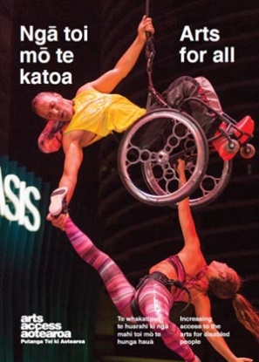
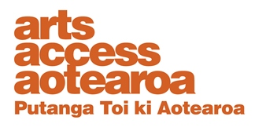
Q & A INSIGHT: ARTS FOR ALL
Audio Described Aotearoa
Putting blind people in the picture is what Auckland audio describer Nicola Owen does for a living. She talks to Arts Access Aotearoa about touch tours and audio description of arts and cultural events, and what happened when New Zealand went into lockdown in March 2020 because of COVID-19.
1. Background: about Audio Described Aotearoa

My own audio description training was via Auckland Live’s SIGNAL programme back in 2011. I set up Audio Described Aotearoa in 2014 with my partner, Paul Brown, who is blind. This was in response to the growing demand for audio description in New Zealand. We wanted to make it easier for organisations and venues to provide audio description for blind and low vision people.
Along with audio description services, we provide training for staff, advice on applying for funding, and how to market to the blind community about audio description and touch tours. We’re passionate about quality control and ensuring that blind and low vision people across New Zealand can access a wide variety of arts and cultural events.
We contract up to ten audio describers around the country to provide high-quality audio description for a range of events and tours.
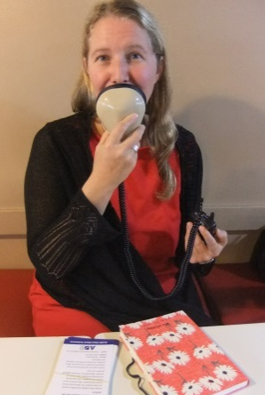
In April 2020, in response to COVID-19, we joined forces with the Royal New Zealand Ballet by providing audio description to accompany its livestream videos of previous productions and making them available to a global online audience. You can read Audio Described Aotearoa goes online for more about this process and what we achieved.
We were very pleased when Audio Described Aotearoa was presented the Extra Touch Award by Blind Citizens New Zealand and the 2020 Special Recognition Achievement Award – International by the American Council of the Blind for our collaboration with RNZB, which resulted in more than 1500 people around the world tuning into the four audio described online ballets: Hansel and Gretel, Passchendale, Dear Horizon, and Romeo and Juliet.
You can watch Arts Access Aotearoa’s audio described video called Access For All, where Paul and I talk about the benefits of audio description.
2. What are the arts and cultural events you audio describe?
The range of arts and cultural events that are audio described is increasing rapidly as awareness of audio description grows. So far, we’ve used it in theatres, chamber music, award ceremonies, opera, contemporary dance, ballet, photography and art exhibitions, conference presentations, local festivals and events, children’s theatre, museums and galleries, sculpture and botanical gardens. The latest addition in 2020 was a tour of street art as part of the Bradley Lane Festival in Auckland’s Glen Innes, which included tactile graffiti and a chance for participants to have a go at spray painting.
3. Does each artform bring its own set of challenges?
Each artform is different, and we adapt our audio description accordingly to make sure it flows with the piece we are describing. However, the principles are the same. The most important thing is to describe what is seen in an objective way so that patrons can draw their own conclusions and opinions about the performance, exhibition or presentation.
For some events such as tours, patrons can ask questions along the way and so audio description needs to allow time for this to happen.
For other events, audio description needs to be sensitively developed. With theatre productions, it’s important not to give away too much of the plot: for example, when a character is “in disguise” and the disguise is removed later on during the show. This sensitivity to the essence of each production is crucial.
The audience listens to the description of a production through individual headsets, usually transmitted live. The whole process of preparing an audio description script – from marking up the script and allowing silence where there’s dialogue or important noises or music on stage to finding the right words to describe the visuals – takes about 25 hours of preparation for each hour of the show.
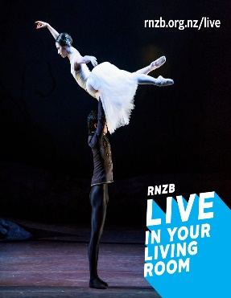
Audio describing dance
Dance is an area we have been developing over the past few years and it’s got particular challenges. Blind or vision impaired people may not have had previous access to dance and so dance vocabulary also needs to be made accessible.
This is where touch tours and workshops can be particularly useful: for example, an acrobat might allow a blind person to feel the position their body will be in during a contortion, or a blind person could be shown how to move their arm in a particular way so they can physically experience the meaning of dance terminology.
For dance, the combination of audio descriptions, workshops and touch tours can mediate people’s understanding and make a very visual artform come to life for a blind audience.
In audio describing children’s theatre shows, an age-appropriate vocabulary needs to be used and the tone of voice needs to vary. Lots of the children’s shows we audio describe include comedy and it’s great when you hear the blind children laughing at the same time as the rest of the audience. It means you’ve managed to describe the visual joke in a way that made sense to them, and timed it just right.
It’s hugely important that blind and vision impaired children are able to access the arts, so they can experience creativity as fully as possible and also continue to expect to be able to participate in the arts.

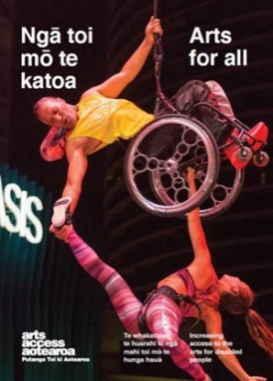
4. Why do you audio describe music? Isn’t it about listening?
We don’t usually talk over the music but there are lots of visual elements to music that help a sighted audience make sense of it that a blind audience might otherwise miss. There’s a huge range of musical instruments involved in musical performances and some of them are historic or from other cultures. Touch tours can illuminate the difference between, say, a cello and a rare baroque viol with seven strings.
Some music performances involve the performers interacting with the audience or each another in a variety of ways. For blind or vision impaired patrons, these connections and interplay are missed without audio description. If a violinist steps away from a music stand and plays without reading the music, showing their mastery of their instrument, the whole audience needs to experience that moment.
5. When do touch tours add value to audio described events?
Touch tours add great value whenever there’s visual or sensory material included as part of the event. With opera productions or ballet, for example, touch tours are a particularly important part of the experience. These companies invest huge energy and resources into costumes, set design, props and so on. During touch tours, the set, props and costumes can be experienced using touch. Some opera productions have hugely elaborate costumes made of velvet or lace; others have masks and head-dresses made from cardboard and all kinds of materials.
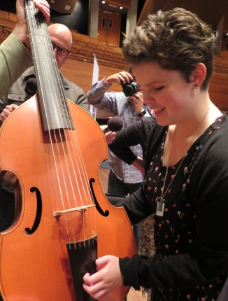
Touch tours are particularly effective when the actors, musicians or singers participate. If their voices can be heard in advance of the show, patrons can identify who is speaking or singing.
Touch tours also work well for art and sculpture exhibitions, garden tours and gallery visits – really, anything that involves tactile objects or materials being part of the whole experience. Even if you can’t touch the actual artifacts in an exhibition, you can often create a touch collection with offcuts, similar items, 3D-printed resources or tactile diagrams to enhance understanding.

6. Is there a growing demand for audio described arts and cultural events?
Definitely. Blind people are starting to ask for audio description and expect it to be available. More arts organisations than ever before are incorporating audio descriptions and touch tours into their programmes. This means greater accessibility and participation, as well as more diverse audiences at arts events.
A lot of people in the disabled community are used to not getting out much. COVID-19 showed us what was possible in the online world to increase access to the arts. After things go back to normal, it would be great if we all remember what we’ve learned through this crisis and continue to make our online presence accessible.

7. Looking ahead, what do you see as key challenges in developing audio description and its audiences?
A big challenge is where the ongoing funding will come from to maintain and develop accessibility opportunities, both online and live.
We’ve still got a lot of work to do developing new audiences. We particularly need to reach out to older people who are losing their sight and feeling isolated to let them know audio description is available so they can continue to enjoy the arts.
We’re continuing to reach out to children and their teachers, and engage with communities to find out what blind and partially sighted people want. It’s great when arts organisations build their own relationships with communities and have an ongoing dialogue about what people want. I’m thrilled that organisations like Auckland Theatre Company are following the examples of Tim Bray Theatre Company and are providing accessible performances for all of their productions in 2021.
We’ve done a huge amount of training over the years but there’s still much to be done. It’s important to continue training staff in accessible venues so that other organisations will see their confidence and consider the many benefits of increasing their own accessibility.
8. Where do you want Audio Described Aotearoa to be in 2030?
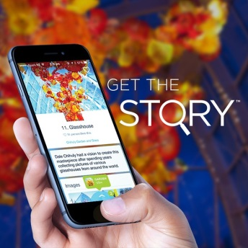
It would be great to see a strong network of audio describers all around New Zealand, making it possible for blind and partially sighted people to go anywhere and at any time, and have equal access to arts and cultural events.
We’d like there to be a “democratisation of description” so cultural event organisers can confidently produce high-quality audio descriptions for themselves, using tools like the STQRY app, a mobile storytelling platform that helps visitors engage with museums and galleries in their own time and at their own pace. We’d like to see audio description become this flexible.
It’s time that New Zealand audio description better reflected the cultural diversity of our New Zealand population, and was available in a variety of languages. I’d love to see more Māori performance described bilingually and have our rich Pacific cultures described by competent practitioners.
For more information
Nicola Owen
Audio Described Aotearoa
T: 09 636 0316 / 0210 358 513
E: audiodescribedaotearoa@gmail.com
Arts For All is an Arts Access Aotearoa/Creative New Zealand partnership programme. It aims to encourage arts organisations, venues and producers to improve access to Deaf and disabled audiences. Download the guide at artsaccess.org.nz or call 04 802 4349 for more information.

