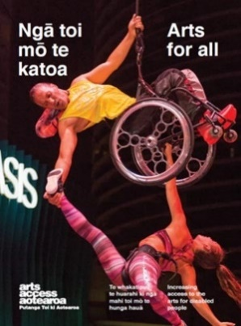
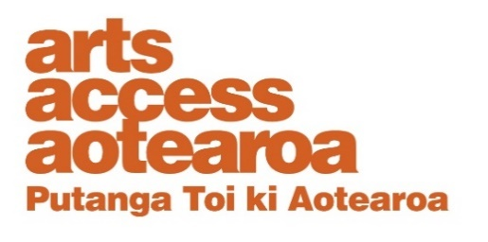
Q & A INSIGHT: ARTS FOR ALL
Relaxed performances at The Court Theatre
What are relaxed performances and what are the benefits to a theatre company in providing them? Rachel Tully, Programmes Manager at The Court Theatre in Christchurch, talks about the challenges but also the opportunities
to connect with new audiences.
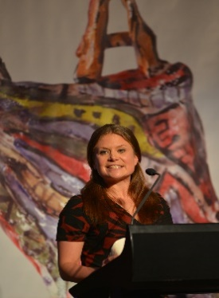
1. Background: about us
We’re tucked aware in the Christchurch suburb of Addington and are New Zealand’s largest theatre company. Currently we live in our post-earthquake refuge – an old grain shed – finding ways to share the magic of theatre with the people of Canterbury.
The company is made up of 60 permanent staff, plus hundreds of artists and artisans who produce 19 productions each year. More than 150,000 ticket buyers enter The Court each year to feast on the varied offerings of theatrical works, all created and produced onsite.
The Court has matched the ever-diversifying Christchurch population, and creates and supports work for everyone in our community. This includes children and families, tangata whenua and Christchurch’s growing Pasifika communities.
A strong education programme at The Court fosters and nurtures the future of theatre in New Zealand. People involved in our education programmes find a safe space to play and explore free of judgement, where everyone’s individuality is celebrated.
In 2017, The Court was presented the Arts Access Creative New Zealand Arts For All Award. This acknowledged our commitment to developing new audiences and making theatre accessible to diverse audiences – from front-of-house and discounted tickets through to programming and community outreach. Read more
2. What are relaxed performances?
A “relaxed performance” is a dedicated performance of a show designed to welcome people who will benefit from a more relaxed performance environment. This includes people with an Autism Spectrum Condition, sensory and communication disorders or a learning difficulty.
This means there’s a relaxed attitude to noise and movement during the performance, and some minor changes made to the light and sound effects. The auditorium has a smaller than usual capacity so patrons can move around more easily. There is also a chill-out area available in the foyer.
It’s a good idea to use the symbol for relaxed performances on your website and publicity material as it is becoming an increasingly recognised symbol for access.
We mainly offer relaxed performances for our family-friendly school holiday shows but all ages are welcome.
After they’ve booked, all patrons receive a show-specific resource pack by email. This pack provides a social story for parents and caregivers to use to prepare for their trip to the theatre. These are also available to download from our website if you want to take a look.
3. How did relaxed performances at The Court Theatre start?
We were looking for ways to grow our accessibility, and were inspired and excited by the work our international peers were doing with relaxed performances. We wanted to give it a try.
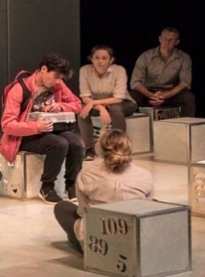
We presented our first relaxed performance of The Little Mermaid in July 2016 and have run one during every school holidays since then. We also presented a relaxed performance of The Curious Incident of the Dog in the Night-time in April 2017, a play told through the eyes of 15-year-old boy with autism.
We felt it was important to offer a relaxed performance of this award-winning show (and novel), where the central character has a disability. However, the show included so much sound, lighting and AV, we found it hard to meet the balance between being true to the vision of the director and creating an accessible version of the show.
4. What are some key challenges in providing relaxed theatre performances?

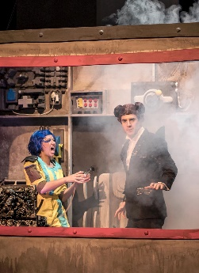
- Timeframe: There’s quite a tight timeframe between the show being ready to watch and the relaxed performance happening. In this time, we must make assessments and judgements about technical or artistic changes needed for the relaxed performance and create the resource pack that goes out to all patrons in advance of attending the show.
- Finding an audience: We are slowly fostering a committed audience for our relaxed performances and discovering new partners who can help us connect with new communities. It’s felt important to make the commitment to offering these shows every school holidays because it means that people are now more aware of this offer and know what to expect.
- Learning the language and the meaning: A “relaxed performance” is an international theatre term and we were the first organisation to offer one in the South Island of New Zealand. This means we have had to educate our audience at the same time as our staff team to understand what we are talking about.

5. What are some key benefits of relaxed performances?
- We get to connect with new audiences who otherwise might not come to the theatre. We love storytelling and we love finding new people to share stories with. It’s what we do!
- Our actors get a unique and meaningful experience. Performing for a relaxed performance has become a favourite moment for many of our kid-show performers. During a relaxed performance of Snow White last year, the audience got heavily invested in the journey of a character who was struggling to feel brave enough to talk on stage. The audience reaction so honest and real, the performers found it hugely emotional and affecting to be part of.
- It helps us focus on the story. Without flashy lights or loud noises, we can still tell a great story and sometimes it can be good to be reminded of that.
- We have built new relationships and partnerships with community organisations (e.g. Autism NZ), who are really supportive of our relaxed performances.
- We get great feedback from our community about this work. Even those who don’t want to attend our relaxed performances are glad we’re offering them.
6. How do you evaluate the impact of relaxed performances?
Because our audiences are small we can communicate directly with the patrons. We ask all patrons to let us know how they found the experience and make it clear that we are open to learning and developing our relaxed performance offer further. Most importantly, we have a dedicated team of ushers who staff our relaxed performances, which means they can develop relationships with our audiences and build an understanding of what works and what doesn’t for these shows.
7. Five key tips for anyone wanting to present a relaxed theatre performance
- Ask for advice: find partners to work with, local charities, parent groups, Arts Access Aotearoa, Autism NZ etc. These organisations will help you create the most accessible performance you can.
- Be willing to learn along the way: each relaxed performance we do is part of our learning and helps us develop the next one.
- Choose the right show: choose a show that you think will appeal to a wide audience and that isn’t hugely reliant on sensory elements.
- Get the team on board: spend the time and energy getting the performing and production team on board. It will help make the project a success.
- Go and watch a relaxed performance or check out videos online about relaxed performances that have been run overseas. You can also get in touch with me and come along to one of our relaxed performances. We’d love to help in any way we can to support other theatres to try this out.
For more information
Rachel Tully
Programmes Manager, The Court Theatre
T: 03 963 0901 E: rachel.tully@courttheatre.org.nz
Arts For All is an Arts Access Aotearoa/Creative New Zealand partnership programme. It aims to encourage arts organisations, venues and producers to improve access to Deaf and disabled audiences. Download the guide at artsaccess.org.nz or call 04 802 4349 for more information.

