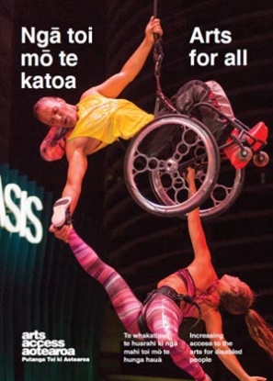
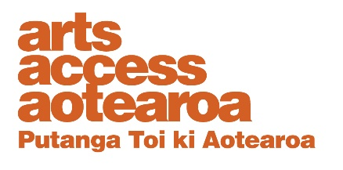
Q & A INSIGHT: ARTS FOR ALL
Developing an accessibility policy
Sue Jane, former Education and Outreach Co-ordinator, Chamber Music New Zealand, talks to Arts Access Aotearoa about what was involved in developing the organisation’s accessibility policy.
1. Background: about Chamber Music New Zealand
Chamber Music New Zealand is the country’s largest presenter of top-quality, nationally performed chamber music concerts. Our activities are divided into three strands:
- Kaleidoscopes Concert Season, showcasing top international and New Zealand artists
- Encompass Regional Concerts, focusing on New Zealand performers and emerging artists
- Encounter, which incorporates all of our life-long learning activities such as the annual secondary schools NZCT Chamber Music Contest, regular free pre-concert talks and music workshops, masterclasses and open rehearsals. Also included in this strand are our outreach projects such as relaxed performances, and special events like our Matariki and family concerts.
Binding together these strands is a strong commitment to New Zealand music and musicians. This has led to many specially commissioned works from New Zealand composers, and to the promotion of New Zealand performers.
The Education and Outreach role at Chamber Music New Zealand encompasses youth development, audience diversity and accessibility for all.
We’re a not-for-profit organisation and receive major funding from Creative New Zealand. We received the Arts Access Creative New Zealand Arts For All Award 2016 for our Accessible Concerts Programme. Our accessibility policy was a key part of the nomination and is the foundation on which we’ve built this programme.

2. What motivated Chamber Music New Zealand to develop an accessibility policy and where did you start?
In 2012, we organised our first relaxed accessible concert, thanks to a small additional grant from Creative New Zealand. The concert was with United States ensemble Enso String Quartet, led by community musician Julian Raphael with students and staff from Kimi Ora School. It was a public performance at the Wellington Town Hall.

This performance required us to think about a whole raft of things before engaging with the disability sector – things we’d always taken for granted: for example, access to the auditorium, seating, lighting, parking, trained ushers, accommodating carers and companions. We started to look at all areas of our concert delivery, and how we could put social inclusion and participation into practice. From there, we wrote our first accessible policy.

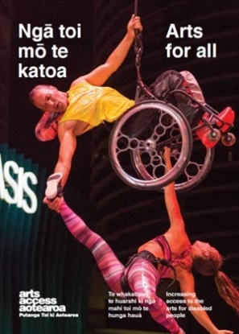
Chamber Music New Zealand’s vision is that “Live chamber music will engage and inspire all New Zealanders as an essential part of life in our unique cultural landscape.” So all aspects of our programming should reflect that engagement.
3. Outline the key steps you took from the policy’s beginning through to its ratification and implementation.
Chamber Music New Zealand knows how to deliver concerts with beautiful music but when we started thinking about delivering these concerts to all sectors of the community, we realised we needed to “up our game”.

Here are some steps we took, and are still taking as we review our accessibility policy:
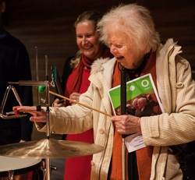
- Engaging with the disabled community: This was the first step in developing our accessibility policy. For example, we talked to Ann Bain of Blind Citizens New Zealand about access needs for blind patrons. It’s about learning firsthand what the barriers to accessing our concerts and venues are, and finding out how to incorporate their requirements into our policy.
- Building networks and relationships: We’ve had a lot of support from Arts Access Aotearoa. We’ve also built relationships with teachers, audio describers, universities, music therapists, community groups, artists and venues. The knowledge we gained from all these connections fed into the accessible policy.
- Staff buy-in: It’s important that all staff are involved from the outset of the process and kept up-to-date with progress. Invite their feedback and support.
- Board engagement: Ensure your board is aware and supportive of the process at an early stage. Your accessibility policy should inform your strategic plan, which includes goals, quantifiable targets and KPIs.
- Ratification: The final step is getting the policy ratified by your board of trustees.
4. How did you overcome your main challenges?
Overcoming the challenges is a work in progress. It’s really important to have your yearly goals mapped out and to make them realistic and achievable.
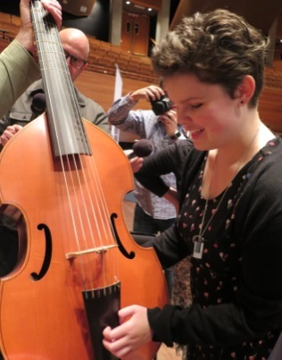
- National reach: The main challenge for Chamber Music New Zealand is that we’re a national organisation. We have to be mindful that any policy changes are instigated and followed through across the whole of New Zealand.
- Consistency of approach: It can be hard to change the status quo and get everyone to embrace the idea that being accessible is a lot more than ticking a box. So many people and places are involved: contracted concert managers, regional presenters and volunteers, all working to bring concerts and events to their communities in vastly different venues.
- Communication: getting the message across to all staff, contractors and volunteers can be a challenge but it’s incredibly important. We all need to be “singing from the same songsheet” and clear, consistent communication can really help. There are many small changes that can be instigated once everyone is informed and engaged: for example, having venue accessibility information on the website and offering large-print programmes.
- Funding: Your organisation’s annual budget setting should include an allocation of money for accessible activities. You may need to seek sponsors or grants – made easier if you have robust systems (e.g. an accessible policy) in place.
5. What’s the difference between an accessibility policy and an action plan?
An accessibility policy provides the framework we need to develop an action plan. Both documents support each other. When we look at our yearly programming and update our action plan, we’re always referring to the policy. They’re symbiotic!
Review your accessible policy annually to ensure it remains relevant to the community, your strategic plan and programmes. Action plans are the nuts and bolts – the fun stuff. Make them realistic and keep them short and snappy.
6. What are some of the accessible projects in Chamber Music New Zealand’s 2016 action plan?
By July 2016, we had already presented three audio described concerts as part of the 2016 Kaleidoscopes Concert Season. For the rest of the year, planning is well underway for two relaxed performances with associated workshops in Hawke’s Bay and Christchurch in September and October.

We’ve just completed a very successful Matariki event, bringing together a number of cultural groups, performers and arts partners to achieve this project. We’re also working on the Chamber Music New Zealand website to include “In the community” activities in an accessible format.
As part of our strategic plan, we’re looking at achievable targets for 2017 and beyond, including partnerships to achieve these goals.

- Involve all staff and members of your board. Everyone should be on board and prepared to implement any changes.
- Seek help and ask the relevant community groups loads of questions.
- Follow accepted templates and guidelines. There’s great information and examples on Arts Access Aotearoa’s website.
- Be realistic around expectations when you’re writing both the policy and action plan. Set achievable goals and realistic dates for review.

For more information:

Chamber Music New Zealand

T: +64 4 384 6133 E: admin@chambermusic.co.nz W: chambermusic.co.nz
Arts For All is an Arts Access Aotearoa/Creative New Zealand partnership programme. It aims to encourage arts organisations, venues and producers to improve access to Deaf and disabled audiences. Download the guide at artsaccess.org.nz or call 04 802 4349 for more information.

