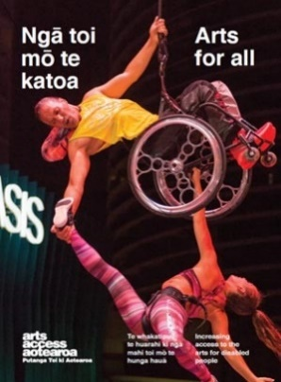
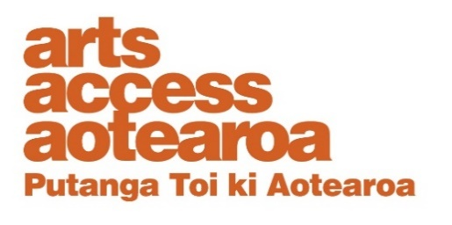
Q & A INSIGHT: ARTS FOR ALL
Developing an accessibility policy
Why is it important for your organisation to have an accessibility policy?
Pascale Parenteau, Education, Community and Accessibility Manager, Royal New Zealand Ballet, talks to Arts Access Aotearoa about what was involved in developing an accessibility policy for the national ballet company.
1. Background: about the Royal New Zealand Ballet
The Royal New Zealand Ballet is a national company of dancers, performing an eclectic repertoire of different choreographic styles – from 19th century classics to 21st century contemporary works.
Our aim is to present dance of outstanding quality. The company includes dancers and staff from New Zealand and overseas. We want to constantly push boundaries and stretch the limits of possibility so that we can take the art of classical ballet in new directions.
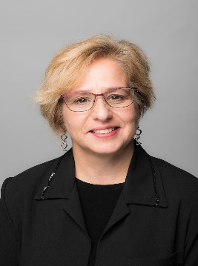
RNZB was formed in 1953 by Danish Royal Ballet Principal Dancer Poul Gnatt and has been housed in Wellington’s St James Theatre since 1998. It is currently in temporary premises and will return to the theatre in 2022 when the seismic strengthening is completed.
We were awarded the Arts Access Creative New Zealand Arts For All Award at Te Putanga Toi Arts Access Awards 2019. This award acknowledged our leadership and commitment to building new audiences by making ballet accessible to diverse audiences, including blind and low vision patrons, Deaf people, children in low-decile schools, and prisoners.
We’re a member of Arts Access Aotearoa’s Arts For All Wellington Network.

2. What motivated you to develop an accessibility policy?
I came to this work out of my own personal experience with disability: I’m the mother of a disabled child. Because of my child, I’ve always thought about ways to integrate my passion for the arts with making the arts accessible to everyone.

In 2014, after four months in my role as Education Manager for RNZB, I attended my first Arts For All Wellington Network meeting. I was so impressed by what I heard that I made it my mission to try and convince the Executive Director, Artistic Director and the senior directors team that accessibility was something worth doing.

My tactic was to approach accessibility as an audience development initiative – a way to reach more customers. I set up a meeting between RNZB and Arts Access Aotearoa’s Executive Director, Richard Benge.

Everyone at the meeting agreed it was a good idea but we’re a busy touring company. It was clear to me that if we wanted to make any progress, we needed an accessibility champion to make things happen – and that champion was me. So I set to work drafting an accessibility and inclusion policy for the company.

Three years after I first attended the Arts For All meeting, the RNZB’s “Accessibility Strategic Commitment” was signed off by the board.

The other reason I was keen to get an accessibility policy was to ensure that I wasn’t seen as the “champion” – the only one in the company committed to accessibility and inclusion. Now that the company has a policy, I know that if I left my role the work would continue regardless.

I might be small but I’m like a rottweiler. When I have a bone, I do not let go! And this is just the beginning. The next stage is to focus on participation so that anyone who wants to dance can do so.

3. Outline the key steps you took from the policy’s beginning through to its ratification and implementation.
I realised early on that before I could write an accessibility policy, I needed to figure out the how, who and when questions.
- Drafting an accessibility policy: I drafted an accessibility policy based on my research, and then circulated it throughout the organisation, incorporating suggestions for improvement, editing and rewriting it until everyone was satisfied.
- Engaging with the disabled community: Throughout the process, I engaged with people in the Deaf and disabled communities to ensure they were happy with my approach and proposal.
- Staff and board engagement: I kept the board and staff aware of the progress from an early stage, inviting their feedback, ideas and support.
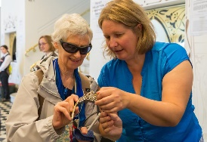
- Collaborations: I looked at other organisations and how we could collaborate to share resources and ideas. For example, we now collaborate with Audio Described Aotearoa for audio description, Deaf Aotearoa for sign language tours, and the Vodafone Events Centre in Manukau for relaxed performances.
- Action plan: I looked at what we were already doing, and how we could adapt and improve on that. This formed a basic action plan: for example, we were offering free tours of our home in the St James Theatre to the public, and so I included an NZSL interpreter and welcomed Deaf people to join the tour.
- Ratifying the policy: Six months later, I presented the document to the RNZB board at one of its meetings for ratification. It was a good feeling!
- And finally: you need to review your policy every couple of years to ensure it stays relevant.
4. What are some of the main challenges implementing an accessibility policy?
- Funding: An organisation’s annual budget setting should include an allocation of money for accessible activities. However, applying for grants and seeking sponsorship creates more work for staff. On the upside, when funders see we’re reaching more communities they’re more inclined to give us more funding.
- Staff: It’s another demand on staff because additional people are needed to deliver the events. However, the more the staff get to witness these events, the more they see the benefits and want to be involved.
- National reach: RNZB is a national organisation, which means we have to be mindful that any policy changes are instigated and followed through across the whole of New Zealand.
- Communication: Getting message across to all staff, contractors and volunteers can be a challenge but it’s incredibly important. We all need to be on the same page and clear, consistent communication can really help.
5.What’s the difference between an accessibility policy and an action plan?
An accessibility policy provides the framework we need to develop an action plan. Both documents support each other. When we look at our yearly programming and update our action plan, we’re always referring to the policy. They’re symbiotic!
Review your accessible policy regularly to ensure it remains relevant to the community, your strategic plan and programmes. Action plans are the nuts and bolts – the fun stuff. Make them realistic,a keep them short and snappy, and always ensure they’re implementing the policy.
6. Pascale’s tips for organisations wishing to develop and implement an accessibility policy
- Design your accessibility policy and action plan in consultation with Deaf and disabled people. It’s all about what they need – not what you think they need.
- Talk to Arts Access Aotearoa staff and seek advice if you feel you need it.
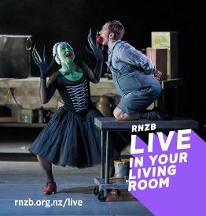
- Don’t lose sight of your main objective: to become more accessible and inclusive for all people in New Zealand, including people who have limited access and experience barriers to participation.
- Think outside the box. Don’t be afraid to do things differently.
- Be patient and take it step by step. Gradual changes are often the best.
- Don’t reinvent the wheel. Start from what you already have to offer.
- Involve everyone in your organisation and give them a feeling of ownership.
- Document everything. It’s not enough to deliver the events and activities. Get evidence (photos, video footage, surveys, media clippings) that it has a social and community value.
- Be courageous. Be bold.
- And remember, everyone can develop an accessibility policy and action plan with careful planning, and large doses of diplomacy, persuasion, wisdom and patience.
One of my favourite quotes is “The task of the leader is to get their people from where they are to where they have not been”. A robust accessibility policy will take your organisation to new places.
For more information
Pascale Parenteau
Royal New Zealand Ballet
T: 021 678 521 E: pascale@rnzb.org.nz W: www.rnzb.org.nz

Arts For All is an Arts Access Aotearoa/Creative New Zealand partnership programme. It aims to encourage arts organisations, venues and producers to improve access to Deaf and disabled audiences. Download the guide at artsaccess.org.nz or call 04 802 4349 for more information.

