Arts For All survey:
how accessible are
New Zealand’s arts
organisations and venues?

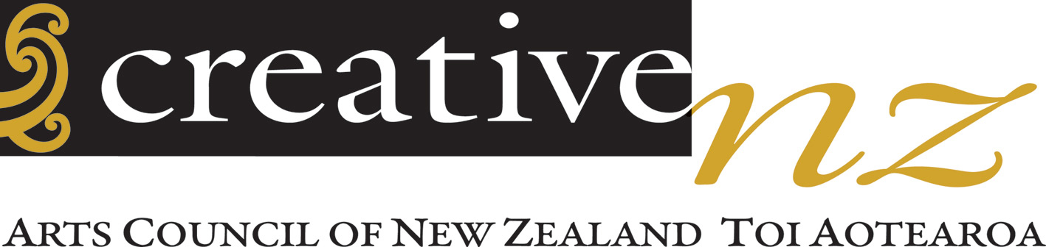
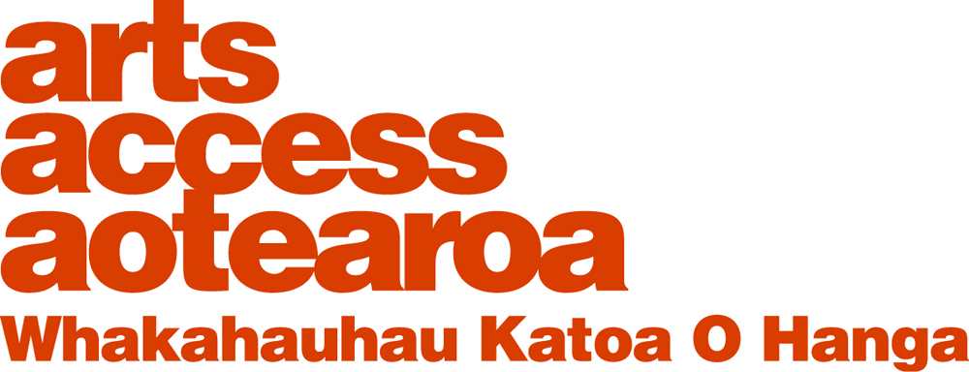

Acknowledgements

This research was funded through Creative New Zealand’s Audience and Market Development programme.

The research project team consisted of Gemma Williamson (project coordinator), Richard Benge, Pippa Sanderson and Iona McNaughton, at Arts Access Aotearoa, and Stewart Sexton from AbilityDis Consulting.

Arts Access Aotearoa would like to acknowledge and thank Helen Bartle from Creative New Zealand for her support with this project and her commitment that all people in New Zealand have access to the arts.

Valuable guidance has been provided by Lisa Starr, of Proof Research, in the development of the online survey.

Minnie Baragwanath and the team at Be Accessible have provided advice and support through the development of the visit checklist.

Arts Access Aotearoa would like to thank the participants from arts organisations around New Zealand who volunteered their time to complete the online survey and to meet with the research team to discuss their accessibility.

Contents
Executive summary 4
Background 4
Key findings 5
Summary of key findings 10
1. Introduction 13
2. Methodology
2.1 Aims 13
2.2 Internet survey 13
2.3 Site visits 15
2.4 Structure of this report 17
- Demographics
  - Internet survey respondent demographics 19
  - Visit respondent demographics 20
4. Attitudes and staff training
4.1 Internet survey responses 22
4.2 Site visit responses 24
4.3 Summary and discussion 26
5. Building access
5.1 Internet survey responses 27
5.2 Site visit responses 27
5.3 Summary and discussion 31
6. Language of disability
6.1 Internet survey responses 33
6.2 Site visit responses 35
6.3 Summary and discussion 38
7. Services
7.1 Internet survey responses 40
7.2 Site visit responses 41
7.3 Summary and discussion 43
8. Policy
8.1 Internet survey responses 45
8.2 Site visit responses 46
8.3 Summary and discussion 47
9. Programming
9.1 Internet survey responses 48
9.2 Site visit responses 49
9.3 Summary and discussion 49
10. Other findings
10.1 Internet survey responses 51
10.2 Site visit responses 53
10.3 Summary and discussion 54
Appendices
- Online survey respondents 55
- Organisations visited 56
Executive summary

Background

Research commissioned by Creative New Zealand in 2008 shows that most New Zealanders (86%) are involved in the arts, either as audience members or active participants. For many people, attending arts events is a straightforward process: they buy tickets, drive to the venue and go to a show without a great deal of planning required.

In 2009, Creative New Zealand and Arts Access Aotearoa published Arts for All: Opening doors to disabled people. This publication provides a practical guide for arts organisations and artists wanting to become more accessible and build new audiences. This publication has also inspired a programme of engagement with arts organisations and local councils.

People that have a disability often have to overcome a number of barriers to attending arts events. This base line research was commissioned by Creative New Zealand and has the following desired outcomes:

- Organisations have a greater understanding of the barriers facing disabled audiences
- Organisations overcome barriers facing disabled audiences
- Awareness of disability issues is raised in the sector
- Action stimulates positive changes to CNZ’s diversity policy
- Action stimulates changes to funding criteria – minimum standards for audience access.

This research involved an online survey, completed by 41 arts organisations, a 70% response rate. Furthermore, 16 visits were made to arts organisations around New Zealand where a checklist was completed on the accessibility of the arts organisation’s building; an in-depth interview was conducted with one or more staff members around their organisation’s wider accessibility; and the accessibility of the organisation’s publications and website was considered.

During these visits, Arts Access Aotearoa was able to build relationships and provide information to organisations in a report on:
- Practical ways their arts organisation can begin to develop their audience to include more disabled people
- What needs to be done to make their buildings and services accessible.

Key findings

The results of the online survey and site visits indicate that most arts organisations in New Zealand are accessible in the way that people with disabilities are able to enter the building, access basic amenities and participate in an event.

The results of the research indicate key areas where organisations could be supported by Creative New Zealand and Arts Access Aotearoa to improve accessibility. These are:

- To develop overarching access policies and action plans, ensuring that all staff are involved and committed to ensuring access for disabled people
- To build the confidence of all staff members in supporting people with access requirements, by providing access and disability awareness training
- To provide support and advice on continual improvement to building access, so that physical access is further improved for disabled patrons and therefore all patrons
- To further support arts organisations to enhance the services they currently provide to disabled people, as well as developing new services with consultation and engagement from disabled communities
- To engage with arts organisations on the development of targeted pricing and schemes that support disabled people to attend events
- To encourage and support arts organisations to programme works, by and about, disabled people where they meet standards of artistic merit.

The research also demonstrates that arts organisations in New Zealand are not currently marketing their accessibility specifically to disabled people. The provision of information and support to ensure that communications, advertisements and publications meet accessible guidelines and include international symbols of access is a key area of development. Furthermore, most arts organisations do not have fully accessible websites and can be supported to further improve the accessibility of these.

Attitudes and staff training
Through both the survey and the site visits, Arts Access Aotearoa identified an enthusiasm and awareness, by arts organisations, of the need to ensure access to their events and exhibitions for disabled people. It was clear that New Zealand arts organisations are beginning to take steps to improve their access and build diverse audiences.

The findings indicate that currently a low number (26.8%, Internet survey) of arts organisations have provided staff with disability awareness training. 61% of arts organisations indicated that receiving training on access awareness and disability awareness would help them better assist disabled people. Developing a programme of disability awareness and access awareness training would assist staff to build the skills, tools and knowledge needed to confidently support people with disabilities.

Through the arts organisations surveyed, it was identified that there is currently a limited knowledge of New Zealand Sign Language (NZSL) by staff. Over two-thirds of arts organisations outlined that their staff did not have any knowledge of NZSL. This skill is very important when communicating with members of the Deaf community.

When visiting arts organisations, it was at times difficult to identify staff members. Although three-quarters of arts organisations provide a uniform for staff, only 10% of arts organisations require staff to wear a large-print name badge. If staff were to wear a large print name badge and a uniform, this would ensure that disabled patrons, and all other patrons, could clearly identify who could respond to questions and provide them with support.

The findings indicate that arts organisations visited believe that their staff had a high awareness about the accessible and, importantly, the inaccessible features of their buildings. Two thirds of organisations visited had one person responsible for access, whereas 31.7% of respondents to the survey had one person responsible for access. It is important that, in addition to an overarching organisational policy, organisations have a person, or small team, responsible for ensuring the accessibility of their organisation.

Building access
Overall, all non-office based arts organisations visited were accessible to disabled people and provided the minimum requirements of the building code. However, during the visits we identified areas to improve basic access for disabled patrons for all arts organisations to better meet their needs.

The findings indicate that signage is a key area for improvement across most arts organisations. Only 33.3% of visited organisations had signage that was clear, 42.9% signage that was legible and half of arts organisations have signage that is consistent throughout the building. There were a number of common themes throughout the arts organisations that made these signs difficult to access including: glare, inadequate contrast, small font size and a lack of signage to indicate key amenities.

All arts organisations visited had accessible parking onsite, or nearby, and all have an accessible entrance. Two organisations provided access through a side entrance.

Reducing the number of trip hazards and adequately lighting hazards were identified as a key area for improvement within arts organisations, particularly galleries. Arts organisations need to be aware of the importance of providing clear pathways for people with visual impairments by removing trip hazards (i.e. water bottles, pot plants). Furthermore, it is important to outline changes in gradient with the use of contrasting tape and to ensure that all glass doors and windows have hazard markings. Reducing trip hazards is beneficial for all patrons.

The findings indicate that up skilling staff on emergency procedures is required for a number of arts organisations. Across the arts organisations, not all staff were trained in evacuation procedures and two arts organisations needed to develop an accessible evacuation plan in consultation with the fire department. Furthermore, two arts organisations visited had some emergency exits that were not accessible.

Language of disability
Marketing and communication were the key areas where arts organisations can be supported to better market their existing services and accessibility of buildings to disabled communities and groups. Most organisations visited had not considered advertising their accessibility, or the benefits of this, to develop new audiences. Only 18.2% of arts organisations visited currently advertise that they are accessible.

The findings indicate that a small number of arts organisations visited currently have promotional materials that meet clear accessible print guidelines and only 19.5% of arts organisations surveyed display international symbols of access on promotional materials.

Positively, the research identifies that arts organisations utilise a variety of means to communicate with audiences and to ticket patrons, including disabled patrons. This enables people with different impairments and/or preferences to be able to access information about the organisation and service in a way that is accessible to them.

The findings outline that organisations need to be supported to develop relationships with disability groups. 61.5% of arts organisations have developed relationships with disability groups and individuals. These relationships have been formed to assist them to develop services. Engagement with disabled groups is an area for growth and development, as these relationships can be utilised to market services and events, improve access to facilities and develop events that communities and individuals are interested in attending.

The research outlined that the organisations visited could improve the accessibility of their websites. A small percentage of websites (18.8%) met accessibility guidelines but all had accessible elements. However, organisations demonstrated a willingness to improve their websites and were taking steps to improve their accessibility. This is an area where organisations can be further supported by Arts Access Aotearoa and Creative New Zealand.

Services
The findings outlined that the pricing of tickets was an area for improvement, and organisations were willing to improve this issue. One of the major barriers to people with disabilities attending arts events is cost. Of the respondents to the survey, only 29.2% currently provide discounted tickets prices to people with disabilities and/or their (assistant) companions. Of those online survey respondents that do not currently provide reduced pricing, three-quarters would consider doing so. Of the arts organisations visited, all would consider providing a companion card-type discount scheme.

Providing targeted services for people with disabilities can be expensive for arts organisations. Considering this, it is encouraging to note a number of arts organisations have nevertheless provided audio description to audiences with a visual impairment. More of the organisations visited (37.5%), than those surveyed (19.5%), had provided audio described performances. A large number of arts organisations also provide hearing loops, with 100% of visited organisations providing a hearing loop.

Almost two-thirds of arts organisations currently provide outreach programmes to diverse communities. Developing outreach programmes for disabled people is a huge area of potential development to arts organisations, who could further develop their existing outreach programmes to reach disabled people, particularly those with learning difficulties.

Policy
Developing an accessibility policy is a key area of improvement for New Zealand arts organisations and will be a focus of Creative New Zealand and Arts Access Aotearoa’s work in 2012. A policy or action plan is recommended for all arts organisations to begin their organisational journey towards providing access to people with disabilities. Developing a formalised policy or action plan demonstrates an organisational commitment to improving accessibility.

There are currently a low number of arts organisations that have formalised an accessibility policy (5%, internet survey; 7.7%, visit) or action plan (15.4%, visit). Organisations are beginning to develop these as they become aware of this need. This area is a work in progress.

Organisations outlined a number of barriers to developing accessibility policies and action plans, including:

- Performances occur in other public buildings that they hire
- Reliant on the policies of the venues they use
- Time
- Funding
- Awareness.

Programming
Through the course of the visits, programming works by or about disabled people was not identified as a priority for arts organisations. Most of these organisations indicated that they program works on their individual merit, which fits within principles of inclusion. Despite this, a considerable number of organisations have programmed work by disabled artists within their programme.

Findings outline that all of the arts organisations visited currently programme matinee performances. This is a potential area for development, as matinee performances are popular with people with disabilities. Furthermore, performances at a matinee time are also ideal for including services, such as touch tours and talks, targeted to specific audiences.

Other findings
Respondents to the online survey were questioned about their knowledge and use of the Arts for All publication checklist. Only 40% of arts organisations were aware of the checklist. 37.5% of respondents that are aware of the checklist use the checklist, and 37.5% of respondents are not sure if they use the checklist. These findings indicate that more awareness needs to be raised around the availability of this publication and checklists, which can be used as a tool to improve access to arts organisations. It could also indicate that the implementation of accessibility is operational. This emphasises the need for an organisational commitment and awareness to accessibility through the development of a policy or action plan.

All arts organisations surveyed were provided the opportunity to indicate which areas, if any, they were interested in learning more about and improving. The findings show that three-quarters of surveyed organisations were interested in being contacted about different options to improve services to disabled patrons. Almost half of all organisations were seeking information about accessibility policies and improving language and communications and 40% of arts organisations were interested in receiving information about disability awareness training.

A quarter of arts organisations currently evaluate audience growth of disabled audiences. Most organisations indicated that this was something they would consider doing in the future, when they were actively taking steps to develop their disabled audience.

All arts organisations indicated their agreement to share the findings of the visit in a way that it would assist a disabled person to visit their arts organisation.

Summary of key findings

Attitudes and staff training
- 100% of arts organisations that completed the internet survey outlined their staff would assist disabled people when required
- 70.7% of arts organisations had staff with no knowledge of communicating with NZSL
- 26.8% of respondents to the internet survey detailed that staff in their arts organisations have received disability awareness training
- 31.7% of respondents to the internet survey had a staff member responsible for accessibility, whereas 66.7% of arts organisations visited have one person responsible for accessibility
- 61% of internet survey respondents outlined that staff training would help them to better assist disabled people
- 87.5% of arts organisations visited were aware of the inaccessible and accessible features of their building
- 58% of arts organisations visited employ a disabled person.

Building access
- 100% of arts organisations detailed that all of their public spaces were accessible
- 37.5% of arts organisations visited have all areas that have even and stable lighting
- 27.2% of arts organisations visited have pathways that are all clear of trip hazards
- 27.3% of arts organisations visited have all hazards well marked
- 36.4% of arts organisations ensured that all their hazards were well lit
- One arts organisation visited has an accessibility map
- 66.7% of arts organisations visited had clear visual signage to indicate the location of an accessible toilet
- Three of the arts organisations provided an accessible toilet backstage
- 14.3% of arts organisations that provided a lift had clear signage to indicate the location of the lift
- None of the arts organisations visited had a lift that provided audio information
- 50% of arts organisations visited have hazard markings on all glass doors and 20% of arts organisations have hazard markings on all glass windows
- 33.3% of arts organisations visited have all signage that is clear, 42.9% have all signage that is legible and 50% have all signage that is consistent through the building
- 75% of arts organisations displayed rows in a large clear way and 25% displayed seat numbers in a large clear way
- 80% of arts organisations visited have all emergency exits that are accessible to all
- 40% of the organisations visited have visual warnings and 60% provide audio warnings in an emergency
- 81.8% of arts organisations visited have an accessible evacuation plan and 77.8% have trained staff in evacuating disabled patrons.

Language of disability
- 22% of respondents to the online survey stated that their publicity material are easy to read, with the option to provide in a larger font
- 19.5% of arts organisations surveyed display international symbols of access on promotional materials
- 17.1% of respondents to the online survey use accessible print guidelines
- 5% of arts organisations surveyed use disability awareness language
- 48.8% of arts organisations that responded to the survey include information about access in their publicity material
- 18.2% of arts organisations visited currently advertise that their building is accessible
- 16.7% of arts organisations visited currently provide an access guide for disabled patrons
- 61.5% of arts organisations visited have developed relationships with disability groups
- 80% of the arts organisations visited, that ticketed via an external ticketing agency, were aware of the accessibility of their ticketing agency
- 14.3% of the arts organisations visited, that we obtained promotional material from, had promotional material that followed clear accessible print guidelines
- 28.6% of arts organisations visited displayed international symbols of access on their print materials
- 18.8% of arts organisations visited have websites that meet accessibility guidelines.

Services
- 51.2% of arts organisations surveyed do not currently provide discounted ticket prices to disabled people and their companions
- 73.9% of respondents who do not currently provide discounted ticket prices would consider providing discounted tickets to disabled patrons
- 39% of respondents to the internet survey provide hearing loops for audience members with a hearing impairment
- 25% of arts organisations visited currently provide reduced ticketing prices for disabled patrons and 100% would consider becoming a member of a companion-type scheme
- 60% of arts organisations visited provide outreach programmes to diverse communities
- 37.5% of arts organisations visited have provided audio description to people with visual impairments
- 50% of arts organisations visited have used a Sign Language interpreter in the past
- 100% of theatres and venues visited have hearing augmentation systems, primarily hearing loops.

Policy
- 5% of arts organisations surveyed have developed an accessibility policy and 10% of respondents to the survey are in the process of developing an accessibility policy
- 7% of arts organisations who responded to the survey have an overarching policy (e.g., Council policy)
- 15.4% of arts organisations visited have a formalised action plan and 7.7% have a formalised policy
- 23.1% of arts organisations visited are in the process of developing an action plan and 23.1% are in the process of developing a policy.

Programming
- 27.5% of arts organisations surveyed outlined that their programming included disability-related work and 36.4% of these arts organisations had hosted the Touch Compass Dance Company
- 60% of arts organisations visited have programmed work by disabled artists or mixed-ability companies
- 20% of arts organisations visited have programmed work about or portraying a person with a disability
- 100% of arts organisations visited have included matinee performances in their programming.

Other findings
- 40% of respondents to the online survey were aware of the Arts for All publication checklist
- Of the respondents that were aware of the checklist, 37.5% of the respondents use the checklist
- 73.3% of arts organisations surveyed are interested in being contacted by Arts Access Aotearoa about different options to improve services to disabled patrons, 46.7% to develop accessibility policies and improve language and communications. 40% are interested in being contacted about receiving disability awareness training
- 27.3% of arts organisations visited currently evaluate audience growth for people with disabilities
- 100% of the arts organisations visited were in agreement to share the findings to the visit.

1. Introduction

There is a dearth of research in New Zealand on the level of accessibility that arts organisations currently provide, which enables them to be accessible for audiences with disabilities.

Creative New Zealand, through the Market and Audience development programme, have commissioned this research and awareness raising as part of its work around understanding diversity

The results of the survey will provide a picture of what is currently being done to ensure accessibility and the areas where more support needs to be provided to further develop this audience.

2. Methodology

2.1 Aims

People who have a disability often have to overcome a number of barriers to attending arts events. This base line research has the following desired outcomes:
- Organisations have a greater understanding of the barriers facing disabled audiences
- Organisations overcome barriers facing disabled audiences
- Awareness of disability issues is raised in the sector
- Action stimulates positive changes to CNZ’s diversity policy
- Action stimulates changes to funding criteria – minimum standards for audience access.

The research consisted of two key phases: an internet survey and on site visits to selected arts organisations.

2.2 Internet survey

Survey design
The internet survey was developed as a base line survey which would enable an identification of existing accessibility practice for arts organisations in New Zealand. The survey was developed in consultation with Lisa Starr, of Proof Research New Zealand.

The survey collected basic demographic information, including name, organisation, city/town, email address and role within the organisation. Participants were identified as this survey was not anonymous.

Where two respondents from a single organisation completed the survey, the second respondent was screened out of the final analysis.

Recipients were asked questions about staff attitudes towards people with a disability and access to their buildings. They were also asked questions relating to the accessibility of their communications, ticketing and marketing and the services available for people with a disability.

Recipients were asked about any policies they have in place regarding accessibility and hosting of patrons with a disability and whether their programming included disability-related work. They were also asked about their awareness of the Arts for All checklists and their interest in being contacted about specific areas of accessibility.

Survey recruitment
The online survey link was emailed to the Chief Executive, or person in a similar role, from key arts organisations, as requested by Creative New Zealand. Two cover letters were sent, one for Christchurch-based organisations and one for other arts organisations. A full list of arts organisations that were sent the survey are detailed in appendix one.

Survey administration
Potential respondents were provided with information about the survey by email. They were able to choose whether they responded to the survey, or not, and could also forward the survey link on to a staff member.

After completing the survey, a page was displayed that thanked participants for their time and then linked them to the Arts for All page on the Arts Access Aotearoa website.

The internet survey was hosted on SurveyMonkey, a secure online survey company. The survey was administered by Arts Access Aotearoa staff.

Reminder emails were sent to arts organisations at weekly intervals while the survey was live. Follow-up phone calls were made to each of the expected respondents that had not yet completed the survey, the week prior to the survey’s close.

The collated data was downloaded directly from a password-protected SurveyMonkey account and stored on a secure computer.

Limitations of the survey
Although the aim was for each Chief Executive, or person from a similar role to respond, it was not possible to ensure that the link was not forwarded on to a designated staff member. This was mitigated by a question asking respondents to identify their role within an organisation.

A limitation of the survey is that, due to the nature and size of some of the arts organisations, the person responding, regardless of their role, may not have been fully aware of all aspects of accessibility in their arts organisation. Although they may have sought assistance from their colleagues to respond, this is not declared within the survey.

In addition to this, although Creative New Zealand identified a diverse sample of arts organisations to complete the survey, as responding to the survey was something possible respondents could opt out of, the sample was likely to not be as balanced or diverse as expected.

The survey also relied on self-reported information and there is no way to ensure the truthfulness of responses. This is an issue for all survey research of this nature.

  - Site visits

Visit design
The qualitative survey was developed as a three-part approach to complement the online survey. The three-part approach involved:
- A checklist – considering primarily building access which was collected during site visits made by Arts Access Aotearoa staff
- A questionnaire - face-to-face and follow-up phone interviews were conducted for more in-depth information about current practice and future projects planned to ensure accessibility
- A research component - the accessibility of the website and publications were reviewed.

The checklist and questionnaire were adapted from the Arts for All publication checklists. The qualitative survey was peer-reviewed by Be Accessible, the Disability Resource Centre in Auckland and Creative New Zealand.

Prior to each site visit, the online survey had been completed by the arts organisations that were visited.

Questions included information about:
- Building access
- Attitudes and staff training
- Language of disability
- Services
- Policy
- Programming.

During the visits to arts organisations, Arts Access Aotearoa staff were also able to build relationships and provide information on:
- Practical ways the arts organisation could begin to develop their audience to include more disabled people
- Actions and changes to ensure their buildings and services are accessible to disabled people.

This information was provided in informal discussion and also through individual reports provided to each of these organisations.

Visit recruitment
The arts organisations visited for the qualitative component were identified by Creative New Zealand and are detailed in appendix 2.
The arts organisations were based in Auckland, Dunedin, Hamilton, New Plymouth and Dunedin.

Visit administration
Arts organisations were sent an email from Arts Access Aotearoa outlining that they had been selected to receive a visit and what the visit would entail.

Arts Access Aotearoa staff responded to any questions about the purpose of the site visit and arranged a time for the visit. If a response was not received within one week, reminder emails were sent and then follow-up phone calls were made.

Visits were conducted by Stewart Sexton, Accessibility Advisor for Arts Access Aotearoa and Owner of AbilityDis Consulting. Accompanying Stewart on each visit was an Arts Access Aotearoa staff member.

Following the site visit, the documentation was completed by the two staff members that conducted the visit, where possible. The responses to each question were entered into an Excel spreadsheet for analysis and review.

Limitations of the visits
The availability of arts organisation staff (both for visits and follow-up phone calls) was a limitation of this research for two reasons.

Firstly, in some arts organisations, certain aspects of accessibility are the domain of certain staff (e.g., marketing), and other areas of accessibility for other staff (e.g., front of house). Often, all staff members with a role in developing the organisation’s accessibility were not available to participate in the interviews; therefore, the respondent may not have been fully aware of each aspect of accessibility for their arts organisation and/or been able to respond to the question. This limitation was mitigated, where possible, by follow-up phone calls and emails to staff members following the face-to-face meeting.

Secondly, not all data was able to be collected on the day and some individuals from organisations were unable to be contacted following the visits. Due to this limitation there are a number of gaps within the data collected from the arts organisations. Where this is the case, percentages are calculated from the actual collected data (e.g., if there are 14 responses, the total percentage is based out of a total of 14). The total number of applicable responses are indicated by the percentage followed by (N=X, T=X). N indicates the number that makes up the percentage. T indicates the total number of applicable responses, therefore the total to calculate the percentage.

The total (T) is also influenced by the diversity of arts organisations. As questions are not all relevant to each type of arts organisation, as indicated below, this influences the total of the respondents (T).

The diversity of the arts organisations was a limitation to the research. Each of the organisations had different experiences, suppliers and situations. This meant that many questions were not relevant to all arts organisations and required judgement calls to be made by the interviewers.

Included in the visits were office-based/touring arts organisations. Some of these organisations were not visited by the public in their offices (e.g., no open days or box offices); therefore all questions on building access were not relevant to them. Furthermore, a number of the questions in the questionnaire related to areas managed by venues such as: seating, services and ticketing. Where the questions were not applicable, the office-based/touring arts organisations are represented in the N/A category which is not included when calculating percentages.

Included in the visits were galleries/museums. Questions regarding services, such as providing trained guides or headsets, were only relevant to galleries and museums. Some of the galleries did not have an auditorium, therefore seating-related questions were not applicable. Ticketing questions were not relevant to the galleries and museums that were visited. Where questions were not applicable, the galleries and museums are represented in the N/A category which is not included when calculating percentages.

Included in the visits were venues. Some of the venues were available for hire, therefore questions related to programming and the provision of services were not applicable to them. Where the questions were not applicable, they are represented in the N/A category which is not included when calculating percentages.

Another limitation was the unwillingness of an organisation to be involved in the visit process. This resulted in an adjustment to the sample.

With the recent Christchurch earthquakes, we were unable to visit arts organisations based in Christchurch. They are currently focused on their survival and rebuilding.

As with the online survey, this interview component of the research also relied on self-reported information and there is no way to ensure the truthfulness of responses.

  - Structure of this report

The results of the research are presented in the following chapters:
- Attitudes and staff training (chapter 4)
- Building Access (chapter 5)
- Language of disability (chapter 6)
- Services (chapter 7)
- Policy (chapter 8)
- Programming (Chapter 9)
- Other findings (Chapter 10)

Each chapter begins with a review of online survey responses followed by the results and information obtained from the site visits. Each chapter concludes with a discussion of the key findings from that section.

3. Demographics

  - Internet survey respondent demographics

A total of 45 respondents responded to questions in the internet survey. After screening out two responses from two organisations that each had two staff members who completed the survey, as well as screening out two respondents where organisations had not completed any questions beyond the demographics, the remaining sample was 41.

Note that one of the respondents had completed to question 23 and another responded completed on behalf of another arts organisation, that they were also Chief Executive of, not the organisation that was sent the link. These responses remain in the sample.

Table 1.1 details the regional location of survey respondents.

Table 1.1 – Respondents by region

Region | Number of actual respondents (T=41) | Percentage of actual respondents by region (%)
Auckland | 16 | 39.03
Canterbury | 4 | 9.8
Hawkes Bay | 0 | 0
Manuwatu-Whanganui | 1 | 2.5
Otago | 3 | 7.3
Taranaki | 1 | 2.5
Waikato | 2 | 4.9
Wellington including Wairarapa | 14 | 34.2
Total | 41 | 100.2

Table 1.2 outlines what types of arts organisation were surveyed.

Table 1.2 – Type of arts organisation

Region | Number sent survey link | Number of actual respondents | % of actual respondents (T=41)
Gallery/Museum/Artspace | 12 | 11 | 26.9
Touring | 21 | 14 | 34.2
Venue | 15 | 11 | 26.9
Festival | 9 | 4 | 9.8
Other | 1 | 1 | 2.5
Total | 58 | 41 | 100.3
Figure 1.3 details the actual response rate of the types of arts organisations that were sent the survey link.

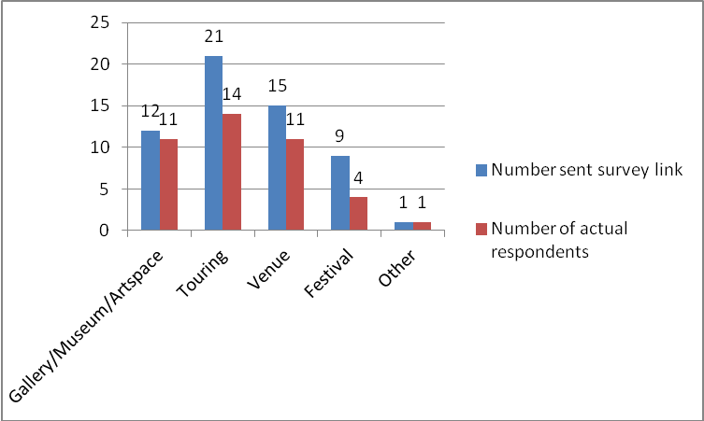
Figure 1.3 – Response rate

Figure 1.4 details the role within the arts organisation of the survey respondents.

Figure 1.4 – Role of respondents
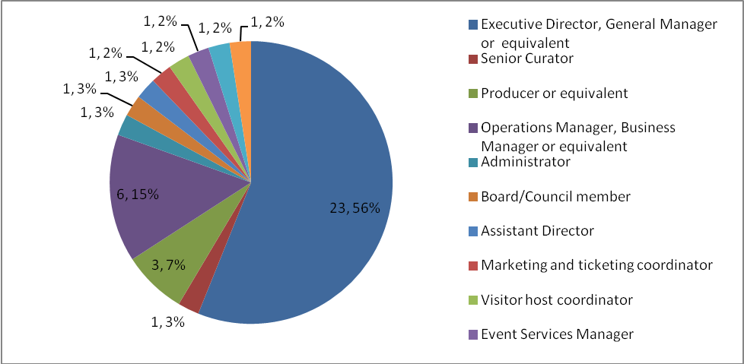
3.2 Visit respondent demographics

A total of 16 arts organisations were visited by Arts Access Aotearoa.

Table 1.5 details the region in which the arts organisations visited were based.

Table 1.5 – Regional location of arts organisations

Region | Number of respondents  (T=16) | Percentage of respondents (%)
Auckland | 5 | 31.3
Otago | 3 | 18.8
Taranaki | 1 | 6.3
Waikato | 1 | 6.3
Wellington including Wairarapa | 6 | 37.5
Total | 16 | 100.2

Table 1.6 details the type of arts organisations that were visited by Arts Access Aotearoa.

Table 1.6 – Type of arts organisation

Region | Number of visited organisations (T=16) | Percentage of actual respondents (%)
Gallery/Museum/Artspace | 5 | 31.3
Touring | 5 | 31.3
Venue | 6 | 37.5
Total | 16 | 100.1

4. Attitudes and staff training

  - Internet survey responses

All respondents outlined that 100% (N=41, T=41) of their staff would assist disabled people when required.

Where applicable to the organisation, 43.9% (N=19, T=41) of respondents outlined that their Front of House staff were “very good” at understanding the requirements of disabled patrons.

Where applicable to their organisation, the respondents rated the majority of Box Office staff (24.4%; N=10, T=41), Marketing staff (36.6%; N=15, T=41) and other admin staff (41.5%; N=17, T=41) as having a “good” understanding of the requirements of disabled patrons.

Within the organisations surveyed, respondents outlined that staff had limited knowledge of New Zealand Sign Language (NZSL):
- 2.4% (N=1, T=41) of respondents have a staff member able to use NZSL,
- 19.5% (N=8, T=41) have some knowledge of communicating with NZSL,
- 70.7% (N=29, T=41) had none
- 7.4% (N=3, T=41) are not aware of whether staff can communicate with NZSL.

Figure 2.1 outlines the organisations that have provided disability awareness training for their staff.

Figure 2.1 Organisations that have provided disability awareness training

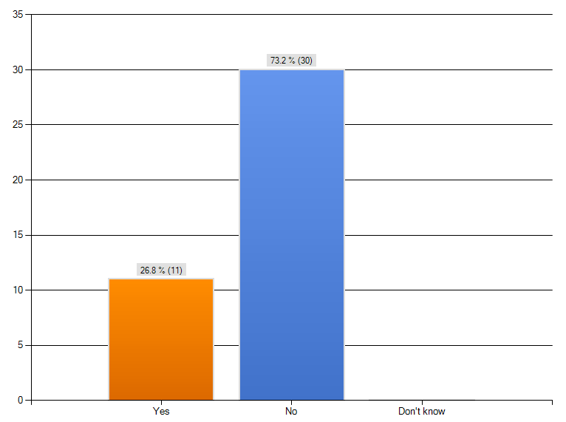

Respondents were asked whether they had one staff member assigned to assisting disabled people access the building. 31.7% (N=13, T=41) of respondents had a staff member assigned to accessibility. 58.5% (N=24, T=41) of respondents did not and 9.8% (N=4, T=41) did not know.

Figure 2.2 details the organisations that have one person responsible for access.

Figure 2.2 Organisations that have one person responsible for access

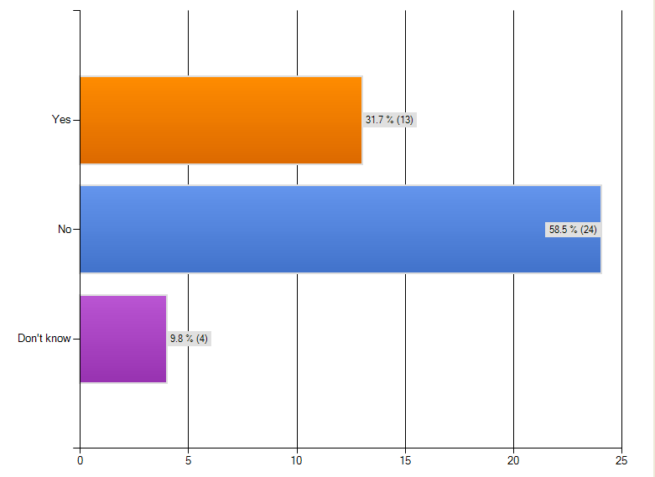

Figure 2.3 details the areas where arts organisations would like assistance to further assist disabled people.

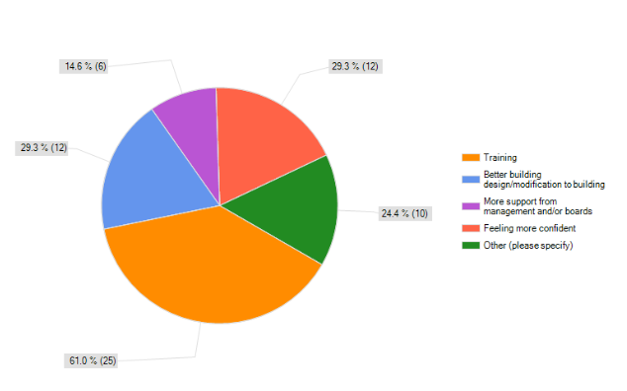
Figure 2.3 Suggestions that would help arts organisations better assist disabled people
In the “other” category, some of the respondents made the following comments:

“We are a tiny organisation and really rely on our venue partners to take care of audience / customer experience / service. We do try to brief them on our audiences and trouble shoot as required. We also respond to people that contact us directly with issues about access etc.”

“Increased knowledge and awareness”

“Easy and effortless messages about contemporary practice and expectations”

“Better understanding the communities requirements”

“More awareness & training are always useful!”

  - Site visit responses

Figure 2.4 outlines the number of organisations where staff have received access awareness training or disability awareness training

Figure 2.4 Organisations that have provided staff with disability awareness training and/or access awareness training
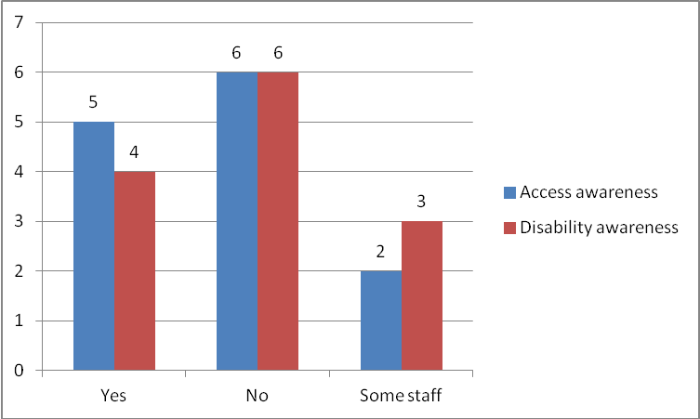

72.7% (N=8, T=11) of organisations provide a uniform for staff. Through the course of the visits, it was observed that although some arts organisations often provided name badges for staff, only 10% (N=1, T=10) provided a large print name badge.

The organisations that were able to control the customer experience outlined different ways they host disabled people through their experience at their venue or gallery. Some of the ways of hosting disabled people are detailed as follows:
- Box office Manager looks after the disabled person or designated person who had received awareness training. FOH/Box office/Stage Manager have briefings (venue)
- Front of House staff support people with disabilities, on arrival, on a case-by-case basis (gallery)
- They would sit down for a chat, have a coffee and talk through the different subscription options and shows (Touring with a box office)
- There is a flexible, one point of contact approach to hosting disabled patrons (venue).

87.5% (N=7, T=8) of arts organisations were aware of the inaccessible and accessible features of their building.

66.7% (N=8, T=12) of arts organisations have one person responsible for accessibility within the organisation.

Figure 2.5 outlines the arts organisations that employ a disabled person.

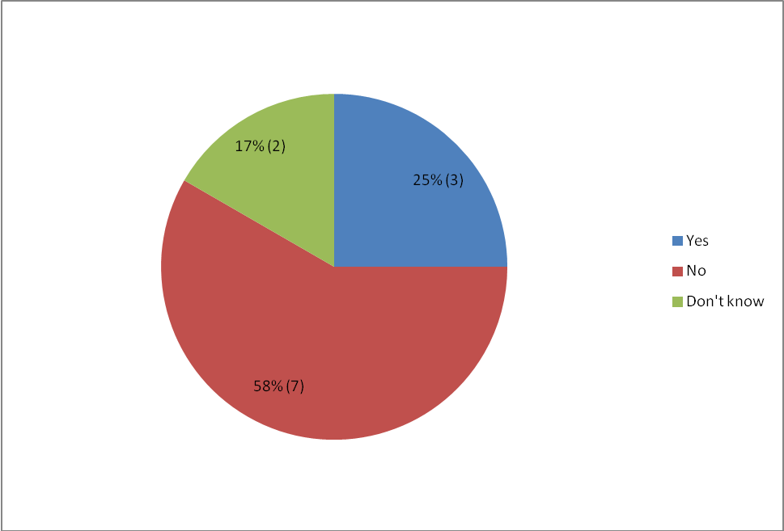
Figure 2.5 Arts organisations that employ a disabled person

Of the organisations that employ disabled people, their roles are:
- wardrobe mistress
- general assistant
- sign tour guide
- artist.

Of the staff members employed, all have hearing impairments.

Only one organisation could see a problem with employing a person with a disability, due to the quirks of the building in which they are based.
4.3 Summary and discussion

All organisations detailed a willingness from staff to assist disabled people, which is positive.

Within arts organisations visited, there was enthusiasm and an awareness of the need to develop ongoing training programmes around disability awareness and access awareness. This is supported with 61% of respondents to the online survey outlining that providing training on access awareness and disability awareness would assist staff to build the skills to better support people with disabilities.

Developing training programmes would provide staff with the tools, knowledge and confidence to better support disabled people. This is a key area where Creative New Zealand and Arts Access Aotearoa could work to ensure that these programmes are available for arts organisations.

Another area where training could be improved is around knowledge of NZSL. Over two-thirds of arts organisations had no knowledge of NZSL. Basic communication skills with NZSL can be really beneficial for communication with the Deaf community and can be easily accessed through sign-language taster courses.

Three-quarters of arts organisations provide a uniform for staff, but only a small percentage (10%) of the organisations provide a low-cost large print name badge. These tools can support all patrons to identify whom they can ask for support.

There was a high awareness from staff about the accessible and, importantly, the inaccessible features of their buildings. Awareness of this information is key when staff are hosting disabled people as it ensures that staff are aware of any potential hazards and can tell patrons.

67% of arts organisations visited had one person responsible for the accessibility of their organisation whereas only 31.7% of arts organisations who responded to the online survey had a person responsible for access. More awareness can be raised about the importance of having one person, or a team of people, responsible for access.

5. Building access

  - Internet survey responses

Table 3.1 details the ways that organisations with a venue are currently providing access to their buildings/venues/offices for people with a disability.

The responses of the 14 (34.2%) organisations that identified themselves as non-venue based arts organisations are not included in this sample.

Table 3.1 Ways that organisations are providing access to people with disabilities

 | Number of organisations that provide the service(T=27) | Percentage of respondents (%)
Visible signage | 21 | 77.8
Textured floor tiles | 1 | 3.7
Handrails | 27 | 100
High-contrast edge of stairs | 11 | 40.7
Accessible toilets | 22 | 81.5
Wide doors | 22 | 81.5
Ramps | 16 | 59.3

Note: Although a number of organisations do not have ramps, they’ve detailed in the “other” section in the internet survey that they maintain a lift.

In the “other” option of the internet survey, one organisation has outlined that the office they rent does not have access for a people with a disability.

  - Site visit responses

100% (N=14, T=14) of arts organisations detailed that all of the public spaces in their building are accessible.

42.9% (N=6, T=14) of arts organisations have direct access to an accessible car park on site. Of the arts organisations that did not have an accessible car park on site, all had accessible car parks within walking distance.

100% (N=14, T=14) have an accessible entrance to the building.

Of these arts organisations with accessible entrances:
- Two (14.3%, T=14) have venues that require access via a side entrance
- Two (14.3%, T=14) have entrances that are on a slight slope
- Two (14.3%, T=14) have accessible entrances that need a door left open or assistance with the door to ensure they are accessible.

Figure 3.1 details the arts organisations with pathways clear of trip hazards and the degree to which these pathways are clear.

Figure 3.1 Pathways clear of trip hazards

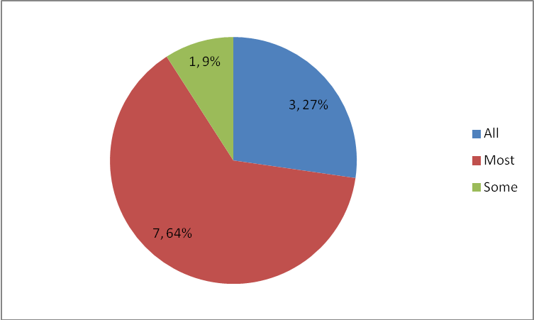

27.3% (N=3, T=11) of arts organisations have all hazards well marked. 63.6% (N=7, T=11) of arts organisations have most hazards well marked.

Figure 3.2 outlines the arts organisations that have even and stable lighting throughout their galleries, venues and offices.

Figure 3.2 Arts organisations that have even and stable lighting and to what degree

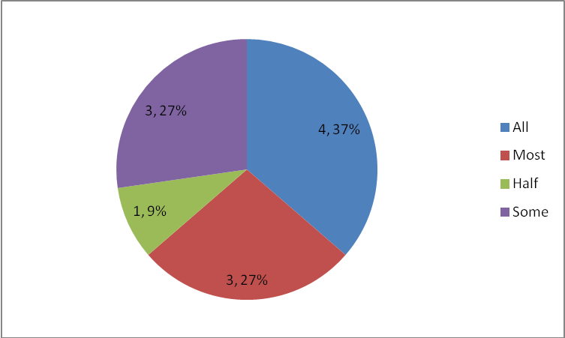

36.4% (N=4, T=11) of arts organisations ensured that all their hazards were well lit, 27.3% (N=3, T=11) had most of their hazards well lit, one (9.1%, T=11) arts organisation had half of its hazards well lit and 27.3% (N=3, T=11) had some hazards well lit.

Throughout the visits, some of the following hazards were identified:
- Edges of glass cabinets requiring hazard markings
- Dark poles and other unmarked hazards in the centre of gallery floors
- Pot plants, water bottles and other hazards in pathways
- Wires on the floor that required colour-contrasting tape
- Ramps and steps requiring contrasting tape to indicate they are there.

Figure 3.3 details whether organisations have hazard markings on windows and doors and to what degree. 50% (N=4, T=8) of arts organisations have hazard markings on all glass doors and 20% of arts organisations (N=1, T=5) have hazard markings on all glass windows.

Figure 3.3 Hazard markings

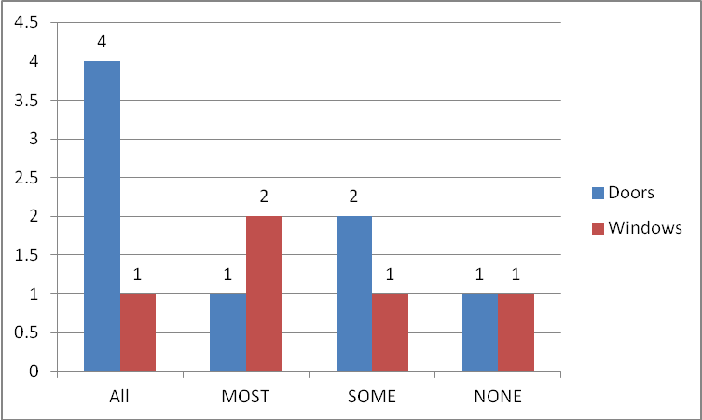

A number of arts organisations required hazard markings on glass doors and windows in public spaces to ensure that people with visual impairments can identify the outside from the inside of the building. This is a priority area.

One (11.1%, T=9) arts organisation has an accessibility map that supports people with access requirements to plan and support their journey throughout the venue. This organisation needs to update this map. One (11.1%, T=9) is planning to develop an accessibility map in the future.

Two arts organisations had rugs that ‘tracked’ in their entranceways. These are difficult to wheel over for a wheelchair user.

91.7% (N=11, T=12) of arts organisations provided direct access to an accessible toilet. The organisation that did not was able to provide access to a toilet on the ground floor on request.

66.7% (N=8, T=12) of arts organisations visited had clear visual signage to indicate an accessible toilet. Of the 33.3% (N=4, T=12) of the arts organisations did not have clear visual signage due to the height of the signage, the lack of signage, or the colour contrast of the signage.

Three of the arts organisations provided an accessible toilet backstage, which would enable these organisations to programme work by disabled artists and mixed ability companies.

14.3% (N=1, T=7) of arts organisations that provided a lift had clear signage to indicate the location of the lift. This is an area for improvement.

None of the arts organisations visited had a lift that provided audio information. Providing this information would assist people with visual impairments to identify which floor they are on.

Table 3.4 outlines the organisations that have clear and legible signage, and the frequency of this signage, throughout the building

Figure 3.4 Signage provided by arts organisations

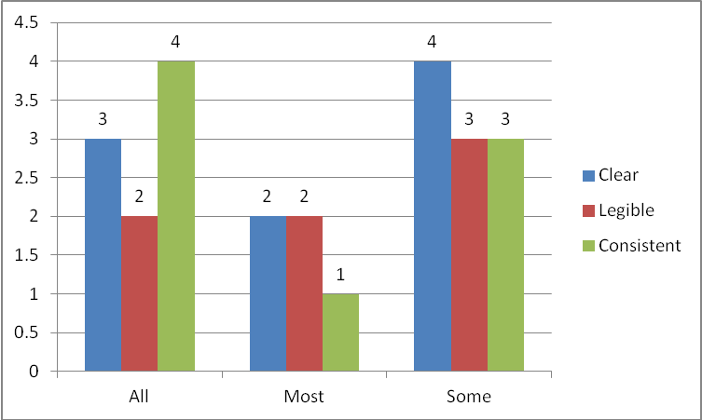

Signage and lighting were areas that needed attention and improvement by arts organisations. Some of the issues identified were:
- Glare on signs
- Inadequate signage
- No signs to indicate pathways throughout the building
- No signs to indicate the location of theatres
- Size of font signage too small
- Inadequate contrast of signage against background
- Not using international symbols of access
- Exhibition panels inconsistent and difficult to read.

Another area for improvement is signage within theatres and auditoriums. Of the organisations that displayed row numbers, 75% (N=3, T=4) of arts organisations displayed these in a large clear way. However, only 25% (N=1, T=4) of venues with theatres and auditoriums displayed seat numbers in a large, clear way.

80% (N=8, T=10) of arts organisations have all emergency exits that are accessible for all. Those two organisations that do not (N=2, T=10) do have one or more accessible exits.

100% (N=11, T=11) have clearly marked emergency exits. 40% (N=4, T=10) of the organisations have visual warnings and 60% (N=6, T=10) of arts organisations provide audio warnings in an emergency.

81.8% (N=9, T=11) of arts organisations have an accessible evacuation plan and 77.8% (N=7, T=9) have trained staff in evacuating disabled patrons. One arts organisation has an Evac-chair, to evacuate people with mobility from upper levels, and two organisations were considering the purchase of an Evac-chair.

5.3 Summary and discussion

Overall, all non-office based arts organisations visited were accessible to disabled people and provided the minimum requirements of the building code. All disabled people would be able to enter these buildings, access basic amenities and attend an event.

However, during the visits we identified areas to improve basic access for disabled patrons to better meet their needs. Many of these areas are beyond what is possible for the arts organisations to provide, in terms of resourcing and time; therefore, we’ve focused on key basic (low cost) areas for improvement below.

Signage was a key area for improvement across all arts organisations. 77.8% of respondents to the internet survey had visual signage in their arts organisations, but when visiting organisation we found that this was an area that could be improved to better support all patrons.

33.3% of arts organisations have all signage that is clear, 42.9% have all signage that is legible and 50% have all signage that is consistent throughout the building. Only 14.3% of arts organisations that provided a lift had clear signage to indicate the location of the lift for those patrons unable to navigate the stairs.

The key issues, across many arts organisations, with signage were:
- Glare on signs
- Inadequate signage
- Size of signage too small
- Inadequate contrast of signage against background
- Not using international symbols of access
- Exhibition panels inconsistent and difficult to read.

42.9% of arts organisations have direct access to an accessible car park on site. Those organisations that do not, all have accessible car parks within walking distance. Through the visits, we noted that a number of organisations could engage with council to enable the development of an accessible car park on site or closer to the venue.

Although all arts organisations visited have an accessible entrance, two organisations provide access through venues via a side entrance where the disabled people are publicly visible by the audience. This could draw attention to a disabled person and it is important that staff members are aware of this to mitigate any issues with people accessing these entrances.

None of the arts organisations visited had a lift that provided audio information. Providing this information would assist people with visual impairments to identify which floor they are on.

Hazards were a key area for improvement within arts organisations, particularly galleries posing a risk to all patrons. Arts organisations need to be aware of the importance of ensuring clear pathways for people with visual impairments by removing trip hazards (i.e. water bottles, pot plants). Furthermore organisations can outline changes in gradient with colour contrasting tape or a similar tool.

Furthermore, 50% of arts organisations have hazard markings on all glass doors and 20% of arts organisations have hazard markings on all glass windows. Glass can be a hazard for people with visual impairments, who may be unable to differentiate the inside and outside of the building. Information about the importance of hazard markings needs to be disseminated to arts organisations, as this is a health and safety issue.

Lighting was another area of improvement for galleries, who need to be aware of the importance of ensuring adequate and even lighting for people with visual impairments to reduce hazards and improve visibility.

85.1% of arts organisations surveyed had an accessible toilet. 100% of arts organisations visited had an accessible toilet, although one did not provide direct access to this. Of the organisations visited, 33.3% of these organisations could improve the signage to indicate the location of the accessible toilet.

An area identified for improvement with arts organisations visited was around emergency exits and procedures. Two of the arts organisations visited had emergency exits that were not all accessible for people with disabilities and 77.8% have staff trained in evacuating disabled people. Two arts organisations needed to develop an accessible evacuation plan.

Although all buildings were accessible, improving building access for disabled people will be a continual work in progress for all arts organisations.

6. Language of disability

6.1 Internet survey responses

22% (N=9, T=41) of respondents stated that their publicity material is easy to read, with the option to provide in a larger font. 68.3% (N=28, T=41) of respondents do not provide easy to read publicity with the option to provide in a larger font.

56.1% (N=23, T=41) of respondents consider their publicity material to be written in plain language that is easy to read for a person with a learning difficulty.

Figure 4.1 details the use of international access symbols in publicity material

Figure 4.1 International access symbols used in publicity material
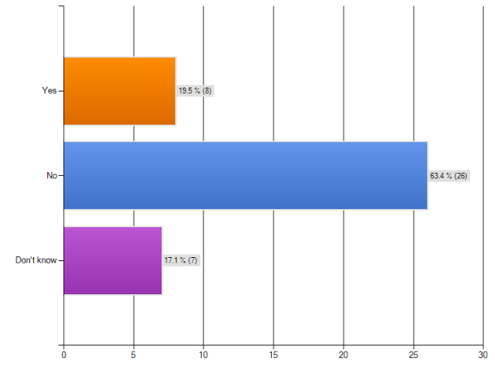

17.1% (N=7, T=41) of organisations use accessible print guidelines, 36.5% (N=15, T=41) do not use accessible print guidelines and 46.3% (N=15, T=41) don’t know whether they use accessible print guidelines.

Figure 4.2 details the arts organisations that use disability awareness language in the description of their services in reference to disabled people.

Figure 4.2 Organisations that use disability awareness language
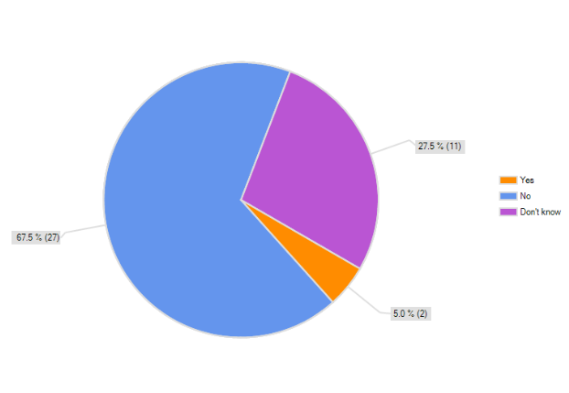

Figure 4.3 details the organisations that include information about access in their publicity material which may include: website, media releases, e-newsletters, advertising, flyers, etc.

Figure 4.3 Organisations that include information about access in their publicity material
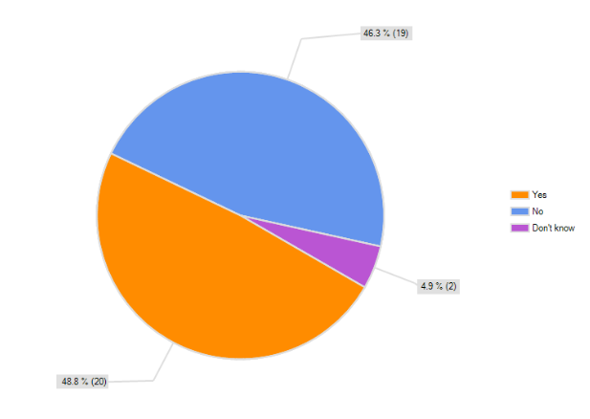

6.2 Site visit responses

During one visit, a staff member used the term wheelchair-bound and another arts organisation indicated their accessible toilet with “Disabled” sign, but overall we noted that staff used appropriate language to describe a person with a disability.

One arts organisation detailed that more information about language to use when describing and communicating with disabled people would be useful to build staff confidence.

18.2% (N=2, T=11) of arts organisations currently advertise that their building is accessible. These organisations advertised this via Facebook and websites.

Overall, it was very clear that most arts organisations had not considered the benefits of advertising their accessibility and specifically marketing to disabled audiences.

Organisations that currently communicate with disabled patrons outlined that they communicate with them in the following ways:
- Signed tour once a year
- Via specific programmes
- Marketing plan
- Same as to the general public
- E-news
- Database of subscribers
- Promo material
- Ads in the paper
- Radio
- Online and social media.

Table 4.4 details the ways that arts organisations communicate with disabled people.

Table 4.4 Ways arts organisations communicate with disabled people

Method of communication | Number of organisations that communicate with the method | Percentage of respondents (%)
Large Print (T=12) | 3 | 25
Audio Tape or CD (T=9) | 3 | 33.3
Braille (T=12) | 1 | 8.3
Plain English (T=6) | 3 | 50
Word document via email (T=12) | 2 | 16.7
Website (T=11) | 9 | 81.8
Print version of audio material (T=9) | 1 | 12.5
Captioning of audio visual material (T=9) | 3 | 33.3
16.7% (N=2, T=12) of arts organisations provide an access guide for disabled patrons.

61.5% (N=8, T=13) of arts organisations engage with disability groups. A number of organisations outlined that they engaged with disability groups when providing particular services, e.g., audio described performances.

The groups these organisations engage include:
- The blind community
- Probus
- Veteran SC’s
- Association of Blind Citizens
- Deaf community
- Arts for All network
- Arts Access Aotearoa
- Royal New Zealand Foundation for the Blind
- Phillip Patston
- CCDSA.

Some of the organisations that did not currently engage with disabled communities shared that they:
- Like the idea of joint ventures
- Have a list of things to do, but haven’t yet touched base with these communities.

Figure 4.6 details the options available to book tickets with the arts organisations.

Figure 4.6 Ticketing options provided by arts organisations

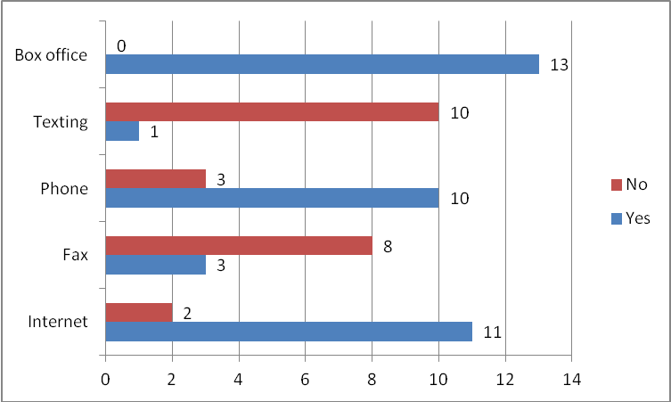

80% (N=4, T=5) of the arts organisations that ticketed via an external ticketing agency were aware of the accessibility of their ticketing agency. One of the arts organisations has a representative from their organisation that trains staff at their external agencies. Another arts organisation detailed that they had been in negotiations with ticketing agencies for 15 years, and the accessibility of these agencies was an ongoing issue for them.

Two of the arts organisations currently have access to Tessitura, a database that allows them to collect information on patron’s preferences, as well as other profiling information, that assists them to support disabled people. The capabilities of this database allow them to evaluate the success of any marketing to disabled communities. Another organisation is currently in the process of installing Tessitura.

Few organisations currently actively engage with disabled communities and individuals when holding public meetings, advisory groups, market research, formal and informal consultations or any audience/community consultative process. None of the organisations visited have systematic processes in place to ensure that disabled people are included in all consultative process.

14.3% (N=1, T=7) of the arts organisations visited, that we obtained promotional material from, had promotional material that followed clear accessible print guidelines. 28.6% (N=2, T=7) displayed international symbols of access on their print materials.

18.8% (N=3, T=16) of arts organisations have websites that meet accessibility guidelines. One arts organisation adhered to World Wide Web Consortium (W3C) guidelines.

Of the arts organisations that do not have websites that meet accessibility guidelines, all have taken steps towards improving their accessibility and have accessible elements of their websites.

Some of the key areas identified where improvement could be made across many arts organisations were:
- Ensuring that all text on the website is high-contrast, to assist people with visual impairments or who are colour blind to access the website
- Ensure that PDF’s on the website for download are in an accessible PDF format for screen readers used by people with visual impairments or provided in a Word format
- Captions added to images on the website which can be read by screen readers, supporting people with visual impairments to understand what is happening in the image
- Add international symbols of access to the front page of the website
- An accessibility page is added to the website, and accessible from the front page, showing information to enhance the experience of disabled patrons. This could include such things as:
- Location of accessible parks and other transportation
- Information about accessing each venue
- Information on accessible and inaccessible features of the venues
- Facilities and services provided for people with impairments
- Seating options
- Informing patrons of possible loud noises or strobe lighting that may affect a patron.

6.3 Summary and discussion

Marketing and communications was the key area where arts organisations can be supported to better market their existing services and accessibility of buildings to disabled communities and groups. Most organisations visited had not considered advertising their accessibility, or the benefits of marketing this to develop new audiences. Only 18.2% of arts organisations visited currently advertise that they are accessible.

An area for development is the provision of accessible promotional materials. 14.3% of the arts organisations visited, that we obtained promotional material from, had promotional material that followed clear accessible print guidelines. Furthermore, 19.5% of respondents to the survey, and 28.6% of organisations visited, currently display international symbols of access on their promotional materials. This is a simple, low cost and effective way for arts organisations to promote their accessibility to the wider community. More information needs to be provided to arts organisations about the benefits of including the international symbols of access on all promotional materials.

Although only 5% of organisations surveyed outlined that they use disability awareness language, during the visits we noted that staff at most organisations referred to people with disabilities in a respectful way. Information about disability awareness language could be provided to staff as part of disability awareness training.

Positively, arts organisations use a variety of means to communicate with audiences, including disabled patrons. This enables people with different impairments and/or different preferences to be able to access information about the organisation and service in a way that is accessible to them.

16.7% of organisations visited provide an access guide so patrons get the information they need prior to attending the performance, exhibition or other arts event. This is an area of development for other arts organisations that are interested in developing diverse audiences.

61.5% of arts organisations engaged have developed relationships with disability groups and individuals, to assist them to develop services. This is an area for growth and development as these relationships can be utilised to market services and events, improve access to facilities and develop events the communities are interested in attending.

All of the arts organisations visited provided two or more ticketing options to all patrons, ensuring that disabled people have different options when booking in case their disability prevents them from booking in a particular way. Furthermore, of the organisations that utilised an external ticketing agency, there was a high level of understanding about the accessibility of their ticketing agencies. The accessibility of their ticketing agencies was signalled as an ongoing problem for many arts organisations.

The overall accessibility of websites was low with 18.8% of arts organisations having websites that meet accessibility guidelines. On the other hand, all organisations had accessible elements of their websites and were taking steps to improve the accessibility of their website, something that may take time. Some of the key areas identified for improvement across most arts organisation were:
- High-contrast text
- PDFs to be accessible or documents to also be provided in Word format
- Captions added to images
- Add international symbols of access to the front page of the website
- An accessibility page is added to the website, accessible from the front page.

In the future, following targeted marketing and promotion of services and accessibility to disabled audiences, three of the arts organisations are in a position to be able to measure audience growth through existing Tessitura databases.

Overall, marketing and communications is a key area where arts organisations require support to begin to market their services and building access, ensuring that disabled audiences know they are able to attend events. In turn, this could ensure a new audience regularly attending events or exhibitions.

7. Services

7.1 Internet survey responses

Figure 5.1 outlines the number of organisations that offer discounted tickets to people with disabilities or their companions. N/A is for those organisations that do not provide ticketing.

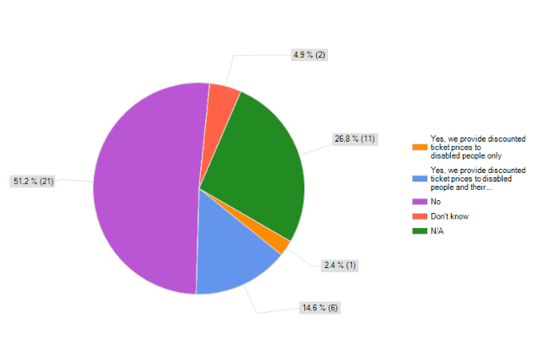
Figure 5.1 Organisations that offer discounted tickets to people with disabilities
Of the organisations that responded “no” or “don’t know” to this question, 73.9% (N=17, T=23) of these organisations would consider providing discounted tickets to disabled patrons and 35.3% (N=6, T=23) do not know.

7.3% (N=3, T=41) of respondents provide tactile opportunities for visually impaired people and 19.5% (N=8, T=41) of respondents provide audio-description of events for visually impaired people, including pre-recorded tapes or a trained guide. 39% (N=16, T=41) of respondents provide hearing loops for audience members with a hearing impairment.

Figure 5.2 outlines the number of organisations that provide accessible programmes and events for Deaf patrons.

Figure 5.2 Accessible programmes and events for Deaf visitors
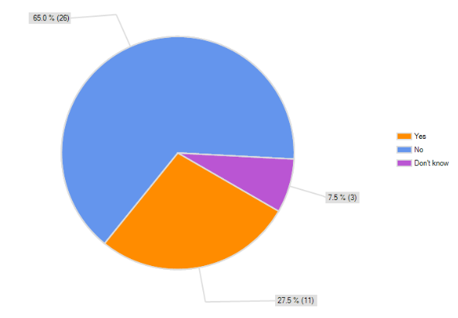
7.2 Site visit responses

25% (N=2, T=8) of arts organisations currently provide reduced ticketing prices for disabled patrons. 62.5% (N=5, T=8) do not provide reduced prices for disabled patrons and one arts organisation is dependant on promoters to approve all ticketing prices.

Those organisations that provide reduced ticketing prices for disabled patrons offer the following schemes:
- One ticket free if you book in advance (for a companion)
- A discounted ticket.

Two organisations detailed that where patrons are unable to choose their seat, and are required to sit in an ‘A’ reserve area, tickets are provided at the ‘C’ reserve rate.

100% (N=8, T=8) of arts organisations that provide ticketing detailed that they would consider becoming a member of a companion-type scheme.

Organisations raised some concerns around this including:
- The administration of this scheme
- The need to resolve fundamental problems around pricing
- Ensuring that the scheme is marketed correctly.

60% (N=6, T=10) of arts organisations visited provide outreach programmes to diverse communities. Only one organisation currently provides these to disabled audiences.

Table 5.3 details the services that can be provided to people with visual impairments and the number of arts organisations that have provided these in the past.

Table 5.3 Arts organisations that provide services to people with visual impairments

Service | Number or organisations that provide/have provided the service | Percentage(%) of organisations that have provided the service
Touch tours (T=12) | 7 | 58.3
Models(T=7) | 2 | 28.6
Raised images(T=7) | 2 | 28.6
Braille text panels (T=4) | 1 | 25
Audio description (T=16) | 6 | 37.5
Pre-recorded tapes (T=5) | 3 | 60
Headsets(T=5) | 3 | 60
A trained guide (T=5) | 5 | 100

Where arts organisations detailed that they provide pre-recorded tapes or headsets, these were provided in the past and are not currently provided. Generally arts organisations had stopped using them because they weren’t very popular or people had difficulty using them.

50% (N=6, T=12) of arts organisations visited have used a Sign Language interpreter in the past. Three organisations are interested in organising signed tours, one outlined that price was a barrier to providing Sign Language tours and events.

For the organisations that have provided a Sign Language interpreter, these have been provided for:
- Deaf awareness week (Gallery)
- As part of regular exhibition talks (2 x Galleries)
- To accompany a play (Theatre)
- To accompany an event at The Edge, with their SIGNAL programme (Touring company).

The other organisation that has provided Sign Language interpreters for events is The Edge, which runs the SIGNAL programme; providing audio description and Sign Language performances to The Edge venues in Auckland.

An arts organisation detailed that a barrier to providing signed or audio described events was the development aspect of the project. To provide signed events or audio described performances, they would need to train interpreters or audio describers to interpret a specific art form. These individuals would also need to have a background in theatre.

100% (T=7, T=7) of theatres and venues have hearing augmentation systems, primarily hearing loops.

Some of the organisations that have multiple venues are not able to provide hearing loops for each room or theatre. Three of the touring companies detailed that some venues they used had hearing loops, but this was not consistent across the venues they hired.

Representatives of three arts organisations providing hearing augmentation systems were unaware whether these systems were regularly serviced and maintained.

One venue detailed that they were unable to use their hearing loop, as it was plagued with ongoing problems.

A gallery had recently purchased a front-row-to-go system to provide hearing augmentation for attendees at events.

One of The Edge’s venues has the Jardine room, also known as the “crying room.” This is for mothers with babies who need to leave a performance, and can also be utilised for people with learning difficulties who may need to take some time out from a performance. People in this room can still view the event. As far as we are aware, this is the only room of its type in the country, although Q theatre could easily create a similar room with its television channel.

7.3 Summary and discussion

One of the major barriers to people with disabilities attending events is the financial cost. Of the respondents to the survey, only 29.2% currently provide discounted tickets prices to people with disabilities and/or their companions. Of those respondents that do not currently provide reduced pricing, three-quarters would consider providing this.

Of the organisations visited, 25% currently provide reduced ticketing prices for disabled patrons. Enabling disabled people and companions to attend events can allow new people to attend an event, and grow a new audience. Arts Access Aotearoa and Creative New Zealand can provide additional information to these arts organisations about the benefits of, and the development of, pricing schemes for disabled people.

Organisations visited were interested in providing a companion card-type scheme. All arts organisations visited, that provide ticketing, would consider becoming a member of a similar scheme. Organisations raised some concerns about the scheme including: administration, pricing and marketing. This is an area where further research and development can be conducted and further information provided to arts organisations.

Of the organisations surveyed, 19.5% have provided audio description to audiences with a visual impairment, whereas 37.5% of those visited have provided audio description. 39.5% of online survey respondents provide hearing loops for audience members with a hearing impairment and 100% of theatres and venues visited provide a hearing loop. All galleries visited were able to provide a trained guide to visitors to the gallery.

27.5% of online survey respondents provide services to deaf patrons and 50% of arts organisations have provided a Sign Language interpreter at an event.

60% of arts organisations visited provide outreach programmes to diverse communities. This is a huge area of potential development for these organisations that could further develop these programmes to reach disabled people, in particular people with learning difficulties.

There are some excellent examples of ‘going beyond expectations’ for accessibility for disabled people with some stand-out examples:
- The development of the SIGNAL programme and the Jardine room by The Edge
- Q Theatre, who have one of the world’s only accessible areas for lighting technicians and have the ability to seat a large number of wheelchair users with it’s flexiform seating
- Training of staff as Audio Describers by Fortune Theatre as well as their commitment to providing a free ticket to the companion of a disabled patron
- Dunedin Public Art Gallery purchasing a “Front-row-to-go system.”

8. Policy

  - Internet survey responses

Figure 6.1 outlines whether the organisations have any formal policies relating to accessibility.

Figure 6.1 Accessibility policies
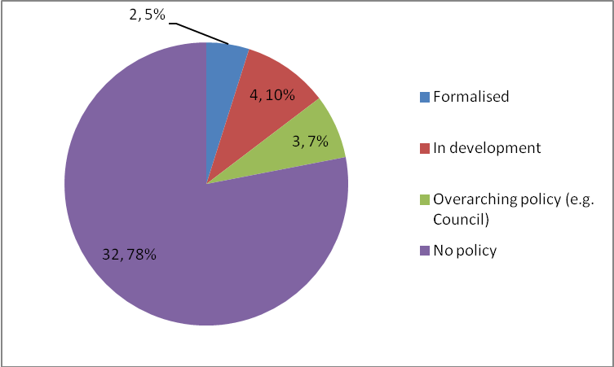

The responses collected for this question were open-ended. As a result of this, it is apparent that a number of organisations do not understand what an accessibility policy is and have listed a range of the services that they provide to people with a disability. Some organisations outlined that they have procedures in place for supporting people with accessibility requirements, but do not have a formalised policy.

Below are some of the comments from organisations relating to policies they have in place regarding accessibility and the hosting of disabled patrons, members or visitors:

“We don't have a policy as our performances occur in other public buildings where a number of these issues are pre-determined for us.”

“A broad understanding that if disabled people enter the gallery staff are to make a special effort be as hospitable as possible.”

“We don't have a formal policy. We have a staff of three people. We rely on the venues we use to provide hearing loops and access for support. We do offer wheelchair and companion seats in line with the policies of venues we use”

“We're in a process of developing a policy document for (our organisation) in line with the best practice guidelines documented in the Arts for All report.”

“We have no written policy but our standard practice is to offer support and assistance to any disabled people attending our concerts, including making special audience spaces available for them in venues for wheelchairs, and ensuring they have access to buildings where concerts are held.”

“Council has an accessibility policy/ies (either legacy Manukau City Council or new Auckland Council)”

“We have no strict policies in place; however we are in the process of developing this. We use major concert venues in 10 main centres throughout the country, where there is the expectation of at least a minimum level of accessibility for disabled patrons. They are hosted according to their needs; however we could definitely train and inform staff at each venue about hosting requirements for disabled patrons.”

“We have a basic accessibility policy that addresses how we can encourage accessibility at the venues we hire and how staff can promote accessibility in the arts as part of the company kaupapa”

“None at the moment - but we are in the process of formulating a policy - but have got a bit stuck!”

“No formal policy in place, however we aim to make the theatre as physically accessible as is practical, and programme a large variety of works that have relevance to a wide range of communities across Wellington. Our staff are encouraged and trained to understand the limitations we have around accessibility and to communicate them effectively to our patrons.”

  - Site visit responses

Figure 6.2 Organisations that have developed an accessibility action plan or policy and the progress of this development.

Figure 6.2 Development of accessibility policies and action plans
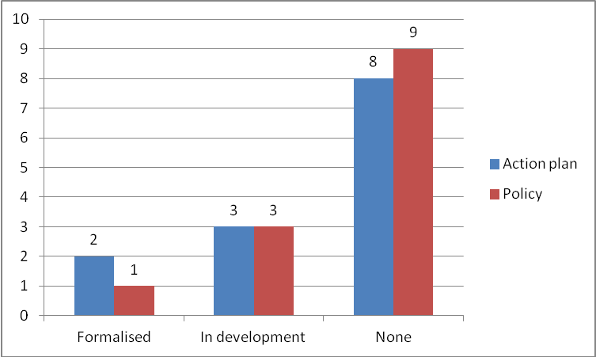

Organisations outlined the following barriers to developing a policy or action plan:
- Time (x4)
- Venues
- Funding (x2)
- Resourcing
- Hadn’t considered it
- Awareness.

Of the organisations that have developed, or are in the process of developing, a policy their motivations for developing this were:
- They don’t like missed or wasted opportunities, there is a lot of potential
- They had attended Arts Access Aotearoa Arts for All forums and interest groups.

Five of the organisations currently that have developed, or are in the process of developing, a policy or action plan have a dedicated staff member assigned to the project.

8.3 Summary and discussion

The development of an accessibility policy or action plan is recommended for all organisations to begin their organisational journey towards providing access to people with disabilities. This is currently an area of improvement where more awareness needs to be raised within arts organisations.

Although there is currently a low number of arts organisations who have formalised a policy or action plan, organisations are beginning to develop these as they become aware of this. The development of an action plan or policy requires resources.

5% of arts organisations surveyed currently have a formalised accessibility policy and 7.7% of arts organisations visited have a formalised accessibility policy. 10% of arts organisations surveyed and 23.1% of visited organisations are in the process of developing a policy.

15.4% of visited arts organisations have a formalised action plan and 23.1% are in the process of developing an action plan.

Organisations detailed a number of barriers to developing accessibility policies and action plans, including:
- Performances occur in other public buildings
- Reliant on the policies of the venues they use
- Time
- Funding
- Awareness.

9. Programming

  - Internet survey responses

Figure 7.1 outlines the percentage of arts organisations that include disability-related work within their programming. 27.5% (N=11, T=40) of arts organisations outlined that their programming included disability-related work.

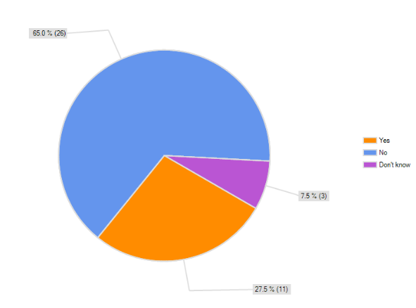
Figure 7.1 Organisations with programmes that include disability related work

Respondents who selected “yes” to the question about including disability-related work were asked to specify more information about their disability-related work. Of the 11 respondents that answered “yes”, 4 (36.4%) had hosted the Touch Compass Dance Company. Another organisation had consulted with them.

Other respondents outlined that their programming had included:
- Interacting Disability Arts Theatre
- Community groups with disabled artists
- Exhibitions about disability
- Productions made for or by various disability communities including the physically disabled and Deaf communities
- Works from people of mixed-ability.

Comments from organisations about the disability-related work they provide included:

“From time to time we have had works by people of mixed ability. Our decisions are based on the work rather than the makers.”

“Past productions made for or by various disabled communities, including the physically disabled and deaf communities over the past year. We would always consider programming works about or for the wider disabled community.”

  - Site visit responses

60% (N=6, T=10) of arts organisations have programmed work by disabled artists or mixed-ability companies. The works programmed include:
- Outsider art exhibitions (x 2)
- Exhibitions by trained artists with a disability
- Performances by Touch Compass ( x 2)
- IHC art awards.

One of the arts organisations had programmed six different exhibitions by disabled or other marginalised artists.

Visited organisations were asked what their experience was of programming these works and two organisations noted:
- An outsider art exhibition was hugely popular
- It was a learning curve that enabled the organisation to check that all systems work.

20% (N=2, T=10) of arts organisations have programmed work about or portraying a person with a disability. These works were:
- Katydid, a play about a person with cerebral palsy
- Element, a play portraying a person with a disability.

Organisations were asked what barriers there were to programming works by disabled artists or about disabled artists. Some of the responses were:
- Disability isn’t a programming thrust
- No barriers – work is judged by artistic merit

100% (N=11, T=11) have included matinee performances in their programming. Feedback on organisations around matinee performances included:
- Want to further develop this strand
- Looking to call these accessible (e.g., no lock-out)
- Programming matinees are dependant on the show and the size of the theatre.

  - Summary and discussion

Throughout these visits, programming was not identified as a priority for arts organisations. Most organisations outlined that they program works on their individual merit, which fits within principles of inclusion. A number of arts organisations have programmed works by disabled artists or about disability.

27.5% of arts organisations surveyed included disability-related work in their programming. It was not specified whether that was by disabled people or about disabled people. Almost a third of these arts organisations had hosted the Touch Compass Dance Company.

A surprising number (60%) of arts organisations visited have programmed work by disabled artists or mixed-ability companies, whereas works about disability have only been programmed by 20% of organisations visited.

100% of the arts organisations visited programme matinee performances. This is an area for development, as matinee performances are popular with people with disabilities and are generally more relaxed. These performances are also ideal for including services, such as touch tours and talks, targeted to specific audiences.

- Other findings

  - Internet survey responses

40% (N=16, T=40) of respondents were aware of the Arts for All publication checklist, 47.5% (N=19, T=40) were not aware of the Arts for All publication checklist and 12.5% (N=5, T=40) did not know.

Of those respondents that were aware of the accessibility checklist, 37.5% (N=6, T=16) of the respondents use the checklist, 37.5% (N=6, T=16) of the respondents are not sure whether they use the accessibility checklist and 25% (N=4, T=16) do not use the accessibility checklist.

Figure 8.1 details the areas of accessibility that arts organisations would like to be contacted about by Arts Access Aotearoa. This was an optional choice and 30 arts organisations responded to this question.

Figure 8.1 Arts organisations would be interested in being contacted about the following
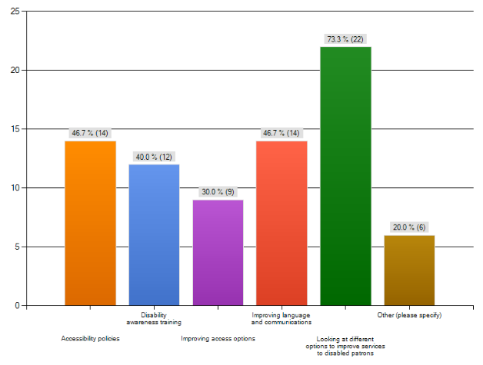
Where “other” was selected, the organisations outlined the following areas where they would like support:

“I know I am overstating it but we are a tiny organization with limited resources. We are very happy to do what we can with those resources but do have to consider what we can achieve with what we have.”

“Touring - 3rd party venues.”

“Our Audience Development Director attends Arts Access meetings and we are aware of the help and advice available through this excellent organisation.”

“It’s really our concert venues that needs to be dealing with these issues primarily”

“We are currently in the process of fundraising for our new venue. Once our bid for funding has been successful this information would be most helpful.”

“Proper guidelines for heritage buildings with limited options for improving disability accessibility without large expenditure.”

The survey provided an optional section where respondents could provide further comments. A number of the responses from this question are detailed below:

“We are to a large extent tied by the facilities offered at the public venues where our performances occur. Usually mobility and sight-impaired people don't have a problem, but hearing-impaired people may struggle.”

“There are currently plans to improve access to the front of the building as currently disabled ramp access is at the side of the building.”

“We are a service organisation and as such have a limited number of people visiting our offices. We know the vast majority of people we deal with and are therefore aware of any special needs and make arrangements accordingly. A lot of the questions had no relevance for us at all.”

“Massive Company is a very small organisation (two full time staff), therefore we have not had the resources to invest into disability awareness programmes.”

“We are a small facility within a very large Council organisation and this comes with its own challenges/limitations. Although Council has key policies in place, often we find that we lack resources ‘on the ground’ and are very stretched to offer more than what is already in place”

“I am encouraging both our Front of House Manager and Facilities Manager to attend upcoming Arts Access workshops to discuss accessibility issues and to pass on their advice to the upper management team as we review and develop an Accessibility Policy Plan for the theatre.”

“We are still on our journey of improving access to all but are really grateful for the support of both Creative NZ and Arts Access Aotearoa. We are looking at adding plain language descriptions as well as looking at audio options. Have just brought our own Frontrow to Go so have it on site all of the time instead of having to borrow from the Council!”

“We are primarily a venue for hire, as such pricing of events and the events themselves are subject to promoter wishes. The venues are in the main accessible but not fully to all parts.”

10.2 Site visit responses

27.3% (N=3, T=11) of arts organisations visited currently evaluate audience growth for people with disabilities. Of those that did, one analyses this information through Tessitura, and another evaluates this with:
- Evaluation forms
- Interviews
- Surveys
- Anecdotal
- An access visitor database.

Of those arts organisations that do not currently evaluate audience growth, some detailed that this was planned but they currently:
- Had more to learn
- Were not consciously providing a service
- Would do following the development of a policy.

100% (N=12, T=12) of the arts organisations visited were in agreement to share the findings to the visit. One organisation noted that they would like to check the results for accuracy, if this information was to be made public.

Arts organisations were asked for suggestions about how Arts Access Aotearoa and Creative New Zealand could further support them to improve their accessibility. Suggestions were:
- Provide a mystery shopper experience
- Ongoing communication and planning for 2012
- Invite to Arts for All network
- Action plan/policy and staff training
- Disability awareness training
- Networking
- Expert advice and support with a new building project
- Invite to join regional Arts for All network
- Not at this stage. Funding reliant
- Feedback on the perception of people with disabilities
- Be great for Arts Access Aotearoa to host introduction tours of different arts organisations such as theatres, venues, touring groups for disability organisations and their clients so people could be more familiar with what is out there and how it works.
- Welcomed the opportunity for the visit
- Sharing information

  - Summary and discussion

Respondents to the online survey were asked questions relating to the Arts for All publication checklist. Only 40% of arts organisations were aware of the checklist, which indicates that more awareness needs to be raised around the availability of this publication and checklists and how these can be used as a tool to improve access to buildings.

Whilst 37.5% of respondents were aware of the checklist or use the checklist, 37.5% of respondents are not sure if they use the checklist. This could indicate that the implementation of accessibility is operational, but it also emphasises the need for an organisational commitment and awareness to accessibility through the development of a policy or action plan.

All arts organisations were provided the opportunity to indicate any, or none, of the areas that they were interested in learning more about and improving. Three-quarters of surveyed organisations were interested in being contacted about different options to improve services to disabled patrons. Almost half of all organisations were seeking additional information about accessibility policies and improving language and communications and 40% were interested in receiving information about disability awareness training.

As this section was optional, the large number of respondents indicated an awareness of the need to make their organisations accessible as well as an interest in receiving information about how they can do so.

A quarter of arts organisations currently evaluate audience growth of disabled audiences, but most organisations indicated that this was something they would consider in the future, when they were actively taking steps to develop their disabled audience.

All arts organisations indicated their agreement to share, in the future, the findings of the visit in a way that it would assist the end user to visit their gallery, venue or arts organisation. One organisation, rightfully, noted that they would like to check this information prior to it being publicised to ensure its accuracy.

Appendices

Appendix one: Arts organisations that were emailed the Arts for All survey

Arts on Tour New Zealand
Artspace
Auckland Art Gallery
Auckland Philharmonia Orchestra
Auckland Theatre Company
Auckland Writers and Readers Festival
BATS Theatre
Black Grace Trust
The Body Festival
Capital E
Centrepoint Theatre
Chamber Music New Zealand
Choirs Aotearoa New Zealand Trust
Christchurch Art Gallery
Christchurch Arts Festival Trust
Christchurch Symphony Orchestra
Christchurch Writers Festival
Circa Theatre
City Gallery Wellington
The Court Theatre
Downstage Theatre
The Dowse Art Museum
Dunedin Fringe Arts Trust
Dunedin Public Art Gallery
The Edge
Footnote Dance Company
Fortune Theatre
Fuel Festival/Hamilton Gardens Art festival
Govett-Brewster Art Gallery
Hamilton City Theatres
Indian Ink Theatre Company
Isaac Theatre Royal
Kahurangi Maori Dance Trust
Maidment Theatre
Mangere Arts Centre
Massive Company
MIC Toi Rerehiko Charitable Trust
NBR NZ Opera
New Zealand Book Council
New Zealand International Comedy Festival
New Zealand International Comedy Festival
New Zealand String Quartet
New Zealand Symphony Orchestra
Objectspace
The Physics Room
Q Theatre
Regent Theatre
Royal New Zealand Ballet
Silo Theatre
Southern Sinfonia
St James and the Opera House
Taki Rua Productions
TAPAC
Tautai Contemporary Pacific Arts Trust
Tempo
Toi Maori Aotearoa
Touch Compass Dance Trust
Vector Wellington Orchestra

Apendix two: Arts organisations that were visited by Arts Access Aotearoa

Auckland Art Gallery
Auckland Theatre Company
Choirs Aotearoa
Circa Theatre
Downstage
The Dowse
Dunedin Public Art Gallery
The Edge
Fortune Theatre
Govett-Brewster Gallery
Hamilton City Theatres
NBR NZ Opera
Q Theatre
Royal New Zealand Ballet
Southern Sinfonia
Wellington City Gallery

New Zealanders and the Arts: Attitudes, attendance and participation in 2008

