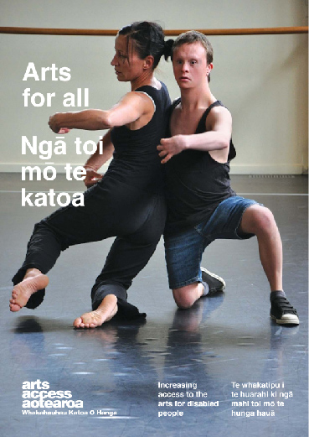
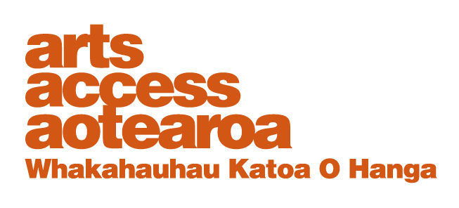
Q & A: ARTS FOR ALL
Sign interpreting theatre
New Zealand Sign Language interpreter Saran Goldie-Anderson talks to Arts Access Aotearoa about the multiple skills required to sign interpret theatre.
1. Background: About Saran Goldie-Anderson

My background in the arts goes back to learning tap, ballet and jazz dance and music as a child. My cousin was born in 2005 and had meningitis, which resulted in her deafness. As New Zealand Sign Language was to become her first language, I decided to learn it as my second language.

At 17, I went to Victoria University in Wellington to study NZSL and took some papers. I then went to Auckland for three years to study the NZSL Diploma course at AUT.

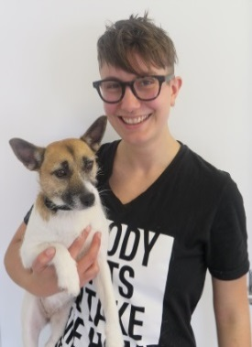
After that, I returned home to Wellington. Through the Deaf Studies Research Unit at Victoria University and some scholarship funding, I undertook postgraduate study in NZSL Interpreting and Translation with Macquarie University in Sydney. The postgraduate course was a challenging and fascinating two years. I learned a huge amount about both my profession and academia, including research and video annotation, and watching videos frame by frame and analysing every detail – including eye blinks.

As someone who had ADHD and left school quite young, I’m really proud of my achievements in higher study, NZSL, and now professionally. I’ve worked with Odd Socks Productions since 2010 and we’ve provided consultation and opportunities for theatre companies and individuals to learn about interpreted theatre. I’ve interpreted many brilliant theatre productions.

2. What are the key differences between sign interpreting a meeting and theatre?
Meetings are generally unscripted, apart from things like presentations and prepared speeches, so interpreters are limited in what they can prepare in advance of the meeting. Interpreters follow strict ethics to ensure the interpretation, which is happening in real time, is accurate and unbiased, and everything being communicated is said and understood clearly.

In meetings, there’s a slight lag between someone speaking English or Māori (or any other language) and the translation into NZSL. That’s because there’s some linguistic problem-solving to consider. The interpreter has to listen to the message and understand it, translate it and provide the interpretation, while still listening to or watching the next part of the message.

With a theatre production, an interpreter usually works closely with the script, cast and director in advance so the interpretation simultaneously matches the lines and the action on stage.

There are also the characters’ attitudes and tone to consider, which may be communicated by body language and facial expressions, and the style of the production as a whole.
A formal and literary script will require a different style of NZSL to a comedic, poetic or storytelling text. This is all expressed in gestures, lip patterns and facial movements. So a sign interpreter of theatre needs to learn the whole script by heart and adapt all these things to fit with each production.

3. How do you prepare for sign interpreting a performance?
I read the script in advance and sometimes watch a video or listen to audio, and attend rehearsals. The script needs to be translated – and this takes time – as I need to consider the best way of interpreting each line.

I work closely with a Deaf advisor – ideally someone whose first language is NZSL – throughout the process, making sure the translation is clear, appropriate and makes sense.

Attending rehearsals is really important. A theatre production is about so much more than just the words that are spoken. All the actors bring their own physical and emotional interpretation to the text as well, and this needs to be reflected in the interpreter's performance.

There are many layers of meaning within a production and during the rehearsal stage, the translation often changes and adapts even more.

Sometimes, I sign a production by myself and sometimes I do it with one other interpreter. As interpreters, we essentially have to act all of the characters in the play and allow for stylistic differences between productions.

The best interpretations always allow enough time for this translation process and for close, respectful collaborative work.

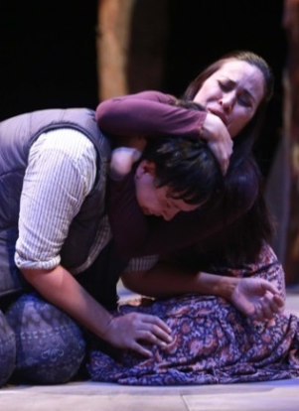
4. You sign interpreted Nancy Brunning’s play, Hikoi, which has eight characters. What’s involved in representing each character?
Initially, this production was meant to have two interpreters but it ended up being just me. This was a big challenge but a very exciting one, especially as there were five teenage characters among the eight characters. I had to physically match the difference between characters as well as their styles of speech and emotions.

Mimicking an actor’s slumped or upright posture, frequent gestures or characteristic facial expressions helps make it clear to the audience which character is speaking.

It’s also important to look in the same direction as the actor who is speaking so that visually, it’s not too confusing for the Deaf audience. Sometimes I can’t see the actor myself so it’s vital to know the script and stage movement by heart and mirror each actor’s movements really well.

5. Tell us about signing in te reo Māori.
NZSL is a language in its own right. It’s not just a word-for-word translation of English or Māori. Because it is a native language of New Zealand, it includes vocabulary to express Māori concepts that don't always have a direct English equivalent: for example, there’s a sign for the concept of “mana”.
Someone whose first language is NZSL might have either English or te reo Māori (or both) as their second language. When a play script is written to include English and te reo Māori and then interpreted into NZSL, that performance of the play is trilingual – using all three languages of Aotearoa.

6. Describe three key challenges of interpreting theatre and how they can be overcome.
- The biggest challenge is people’s preconceptions of how it works. It’s much more than just turning up to a show on the night and interpreting one word at a time as the actors speak. This can be easily overcome by having conversations early enough in the production process.
- Expressing all the layers of meaning within each production in a creative, nuanced way can be a challenge. It’s great fun for everyone if enough time is allowed for interpreters to work closely with the director and actors and Deaf advisor; interpret and memorise the script; and attend rehearsals.
- Another challenge is making sure the interpreter is visible and well-lit so their expressions and signs can be seen. Again, this can be easily and well-managed by having the interpreter involved at an early enough stage in the process.
7. What should venues or companies consider before booking a sign interpreted performance?
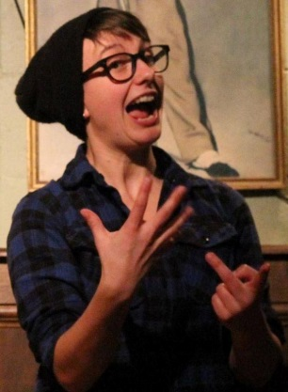
- Ask the question “Why?” Is it because this production has an important message? Because you want to engage people in a different way? Or because it’s been requested by people who wouldn’t come to the production otherwise? Knowing the reasons and possible benefits helps ensure the production is interpreted in an effective way for all audiences.
- Consider the rehearsal process. Do you have the space in the rehearsal process to work with interpreters to ensure it’s an enjoyable process and performance for everyone involved in the production? Are the director and actors willing to become involved?
- Consider whether everyone is on board. Is there a willingness to work positively, provide the script in advance and be flexible? Will interpretation add something to the show? Usually, the answer is yes!
8. What is your dream show to interpret? Why?
Personally in theatre, I like new stuff, interesting stuff, hard stuff. But it’s not about me. In the end, it’s about what Deaf people want to see and have access to. I might completely dislike the political view or angle within a play but that’s irrelevant. It is far more important to ensure everyone who wants to access that play is able to.

That said and because I’m also a dancer, one of my dreams is to be choreographed as a part of the show or play and have a full part in the performance vision of the show.

I’m involved in some exciting discussions about new projects with both Deaf and hearing groups at the moment so watch this space.

For more information
Saran Goldie-Anderson
T: 027404 3135
E: oddsocks.nz@gmail.com

