{Insert Business Logo}

How to use this form

This is a two part form.

Section One is used to capture information on an accident resulting in an injury.

Section Two is used to capture an incident, which has not resulted in an injury (but could have under different circumstances).

In the event of an accident or injury, please take immediate action to address the situation.

Once the immediate urgency has passed, please complete EITHER section one or section two of the form

NOTE: In the event of a serious harm accident, Worksafe must be provided with Section One of the report form within 5 working days (this is a legal requirement).

Definitions

- Accident – an accident is an event that results in harm or personal injury including all illnesses and diseases that could or have affected employees, visitors, contractors, suppliers and tradespeople hosted or otherwise engaged by Tourism New Zealand.

- Serious harm accident- means death, or permanent loss of bodily function, or temporary severe loss of bodily function or amputation or burns requiring specialist referral, or loss of consciousness, or acute illness from absorption, inhalation or indigestion of any substance, or any harm that leads to hospitalisation for 48 hours or more.

- Incident – an incident is an event that in different circumstances could have caused harm or a personal injury, including all illnesses and diseases that could affect employees, visitors, contractors, suppliers and tradespeople hosted or otherwise engaged by Tourism New Zealand.

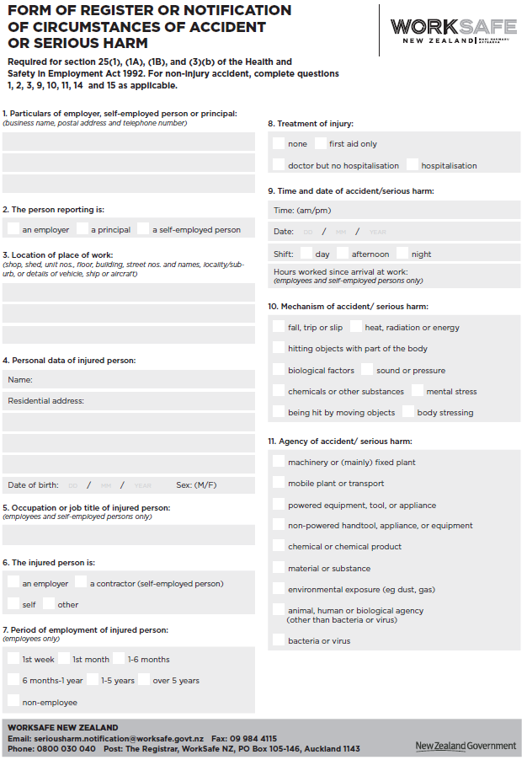
SECTION ONE – ACCIDENT REPORT
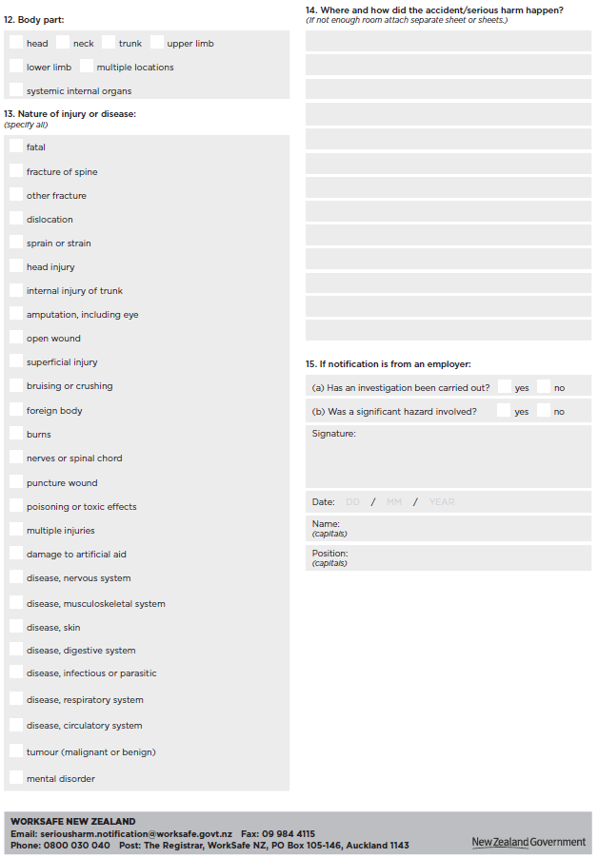
SECTION TWO - INCIDENT REPORT

Please complete the following sections to record and report an incident which has occurred. This incident will not have resulted in an injury

Details of person involved or who observed the incident (to be completed by person injured / involved if possible):

Person Completing Report: ___________________________ Date: _________________
Person(s) Involved: ___________________________________________________________________

Incident Details

Date of Event: ___________________________ Location of Event: _________________
Time of Event: ___________________________
Other people who witnessed
the incident: ___________________________________________________________________
___________________________________________________________________
___________________________________________________________________

and their contact details: ___________________________________________________________________
___________________________________________________________________
___________________________________________________________________

Description of Incident (Describe what occurred and sequence of events):
_______________________________________________________________________________________
_______________________________________________________________________________________
_______________________________________________________________________________________
_______________________________________________________________________________________ _______________________________________________________________________________________

If more space is required please use the back of this sheet

Was incident caused by an unsafe act (activity or movement) or an unsafe condition e.g., machinery or weather? Please explain:
_______________________________________________________________________________________
_______________________________________________________________________________________
_______________________________________________________________________________________
_______________________________________________________________________________________
_______________________________________________________________________________________

Could the incident be avoided? If so how?
_______________________________________________________________________________________
_______________________________________________________________________________________
_______________________________________________________________________________________
_______________________________________________________________________________________
_______________________________________________________________________________________

Signature of Employee: _____________________________ Date: _________________

