Upper Limb Assessment & Treatment Guides

1: Bilateral Upper Limb Movement Training

Introduction / Background / Purpose
Bilateral movement training promotes functional recovery of the impaired limb by using both the intact limb and the impaired limb simultaneously. Bilateral training (BT) comprises repetitive practice of identical bilateral arm movements in symmetrical or alternating patterns e.g. carrying two cups as opposed to bi-manual training where both limbs perform different movements.
BT is based on studies of the inter-limb coordination in healthy adults and it is proposed that the bilateral movement training can promote the functional recovery of the impaired limb by exploiting the coupling effect between the upper limbs.
During the symmetric and bilateral movement of the limbs, what is happening inside the brain is that the intact hemisphere interacts with the damaged hemisphere promoting neural plasticity and cortical repair such that this type of brain stimulation might result in improved therapy result.
Traditionally, bilateral arm training was performed by linking both hands together so that the less-affected limb facilitated passive movement of the affected limb. Bilateral arm training is suitable for use as an adjunct to other upper limb interventions and should involve repetitive movement during performance of novel, functional tasks.

Variations of bilateral arm training now include:
- Bilateral Isokinematic Training (spatiotemporally identical active movements performed during functional tasks)
- Bilateral arm training with rhythmic auditory cueing
- Bilateral training with use of mechanical or robotic devices to drive passive or active movement of the affected limb
- Bilateral training with functional tasks and objects
- Bilateral training with video games
- Bilateral training with FES stimulation.
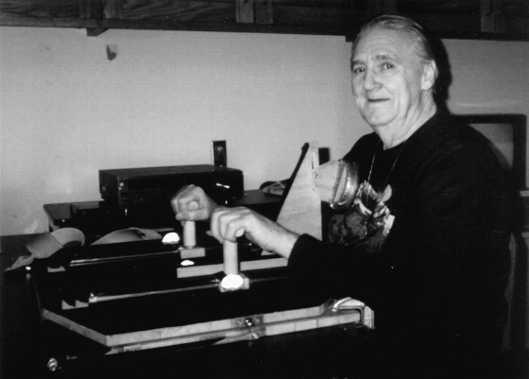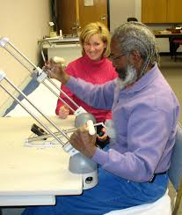

Competencies required

Therapist
- Experience in performing upper limb outcome measure
- Knowledge of the rational of BT use
- Ability to identify appropriate tasks to address motor deficits using this technique
- Manual handling skills to facilitate and assist task practice where required
- Ability to provide feedback, coaching, modelling and encouragement during task performance
- To have received training in the use of technology or mechanical devices as used in specific modes of BT

Client
- Has the cognitive capacity to understand the rationale for the treatment, and
- Consents to the treatment and its regime.

Whanau
- Need to be educated around the rationale and delivery of the protocol if to be completed at home.

Equipment required
The equipment required depends on the mode of bilateral training e.g. with the use of FES. If therapists are using special equipment other than day to day objects they must ensure they have received adequate training in its use.

Procedure
Specific treatment procedures will depend on the type of (BT) especially if FES or mechanical, robotic or gaming devices are used. Therefore additional training may be required by the therapist.
BT can be done in a small group or on an individual basis as long the client has a good understanding of their exercises and there is a degree of monitoring by a trained therapist. If a high degree of manual feedback is required one to one treatment is preferable.

Inclusion / Exclusion Criteria
Bilateral arm training is suitable for use as an adjunct to other upper limb interventions and should involve repetitive movement during performance of novel, functional tasks.
Clients can be included if they are able to participate in an exercise plan and follow instructions. Issues such as pain, cognitive or communication impairments will need to be assessed for their potential impact on the success of the approach.
There are no specific exclusions for Bilateral training techniques however it is not recommended for use with clients with Visual Spatial Hemi Inattention (VSHI). VSHI is the result of a dysfunction of inter-hemisphere allocation of attention following right sided stroke. Following damage there is a pathological hyperactivity that results in a non-opposed biased attentional allocation to the right hemi-field. This is at the cost of the attention that should be directed to the left side. This response is very strong due to a failure of inhibitory mechanism that balances attention into both hemispheres. The issue is an imbalance of the brain directing attention to the unaffected side. Any activities directed to the unaffected (good side) including bilateral activities will worsen the VSHI.

Precautions
Any presence of subluxation, pain, sensory or cognitive impairment that could lead to possible harm if a client is unsupervised whilst engaging in BT.

Evidence
Evidence for Bilateral Training is not yet conclusive as a lot is still yet to be learnt about the neural correlates of bilateral training to understand the different modes of bilateral training and the optimal way to deliver it. Further large scale Randomised Control Trials are recommended.
The use of mechanical and robotic devices in conjunction with Bilateral Training is growing and has commercial as well as therapeutic interests. Initial clinical results are not yet of such calibre to clearly determine effect attributed to bilateral training alone. More research is required with the development of training protocols and guidance around dose intensity.
The use of Bilateral training in conjunction with FES however shows promising results as well as robotic studies that can control movement orientation and quality and deliver high dose movement repetitions.
Therefore therapists need to still use their clinical reasoning when using BT and research recommendations for specific techniques and modes of delivery in conjunction with the client’s baseline of movement and ability to follow instruction.
Videos
www.youtube.com/watch?v=eHBRwMcfFhA
http://bilateralarmtraining.weebly.com/examples-of-bat.html

References
Brackenridge, Jacob, et al. "A Review of Rehabilitation Devices to Promote Upper Limb Function Following Stroke." Neuroscience and Biomedical Engineering 4.1 (2016): 25-42.
Chan, Marko Ka-leung, Raymond Kai-yu Tong, and Kenneth Yiu-kwan Chung. "Bilateral upper limb training with functional electric stimulation in patients with chronic stroke." Neurorehabilitation and Neural Repair 23.4 (2009): 357-365.
Choo, P. L., et al. "The neural correlates of bilateral upper limb training after stroke: a systematic review." Physiotherapy 101 (2015): e248.
Choo, Pei Ling, et al. "Correlations between arm motor behavior and brain function following bilateral arm training after stroke: a systematic review." Brain and behavior 5.12 (2015).
Kim, Hyunchul, et al. "Kinematic data analysis for post-stroke patients following bilateral versus unilateral rehabilitation with an upper limb wearable robotic system." IEEE Transactions on Neural Systems and Rehabilitation Engineering 21.2 (2013): 153-164.
Simkins, Matt, et al. "Robotic unilateral and bilateral upper-limb movement training for stroke survivors afflicted by chronic hemiparesis." Rehabilitation Robotics (ICORR), 2013 IEEE International Conference on. IEEE, 2013.
Simkins, Matt, et al. "Upper limb bilateral symmetric training with robotic assistance and clinical outcomes for stroke: a pilot study." International Journal of Intelligent Computing and Cybernetics 9.1 (2016): 83-104.
Stewart, Kim C., James H. Cauraugh, and Jeffery J. Summers. "Bilateral movement training and stroke rehabilitation: a systematic review and meta-analysis." Journal of the neurological sciences 244.1 (2006): 89-95.
Stinear JW, “Rhythmic bilateral movement training modulates corticomotor excitability and enhances upper limb motoricity poststroke: A pilot study,” J. Clin. Neurophys., vol. 21, pp. 124–131, 2004.
Summers, Jeffery J., et al. "Bilateral and unilateral movement training on upper limb function in chronic stroke patients: a TMS study." Journal of the neurological sciences 252.1 (2007): 76-82.
van Delden, A(Lex) EQ, et al. "Unilateral and bilateral upper-limb training interventions after stroke have similar effects on bimanual coupling strength." Neurorehabilitation and neural repair 29.3 (2015): 255-267.
van Delden, A. Lex EQ, et al. "Unilateral versus bilateral upper limb training after stroke." Stroke (2013): STROKEAHA-113.
Waller, Sandy McCombe, et al. "Sequencing bilateral and unilateral task-oriented training versus task oriented training alone to improve arm function in individuals with chronic stroke." BMC neurology 14.1 (2014): 236.

