Upper Limb Assessment & Treatment Guides

3. Constraint Induced Movement Therapy

Introduction / Background / Purpose
Constraint induced therapy (CIMT) was designed by Edward Taub a behavioural neuroscientist for the use with clients following CVA presenting with chronic movement problems one year post CVA who have an underlying baseline level of movement but do not initiate the use of it due to inattention and learned non-use.

The unaffected limb is restrained or disabled by the use of bandaging or application of a padded mitten or resting splint etc., in order to direct attention to the affected limb. This approach aims to maximise and restore motor function in the affected upper limb by minimising learned non-use and building on existing upper limb movement through completion of unilateral functional tasks.
CIMT uses a repetitive task orientated training approach that uses shaping and task practice.

Competencies required
Therapist
- Experience in performing upper limb outcome measure
- Knowledge of the rationale of CIMT use
- Ability to identify appropriate tasks to address motor deficits using this technique
- Manual handling skills to facilitate and assist task practice where required
- Knowledge of behaviour aspects of learned non-use
- Ability to provide feedback, coaching, modelling and encouragement during task performance.

Client
- Has the cognitive capacity to understand the rationale for the treatment
- Consents to the treatment and its regime
- Has the behavioural traits to adhere to the CIMT program.

Whanau
- Need to be educated around the rationale and delivery of the protocol and agreement re support contracts – (see later for behavioural compliance).

Equipment required
The primary equipment required is access to a mitt restraint to deter the use of the non-affected upper limb.
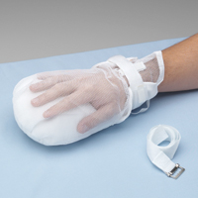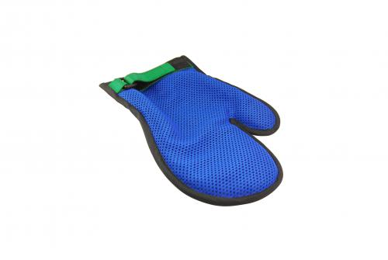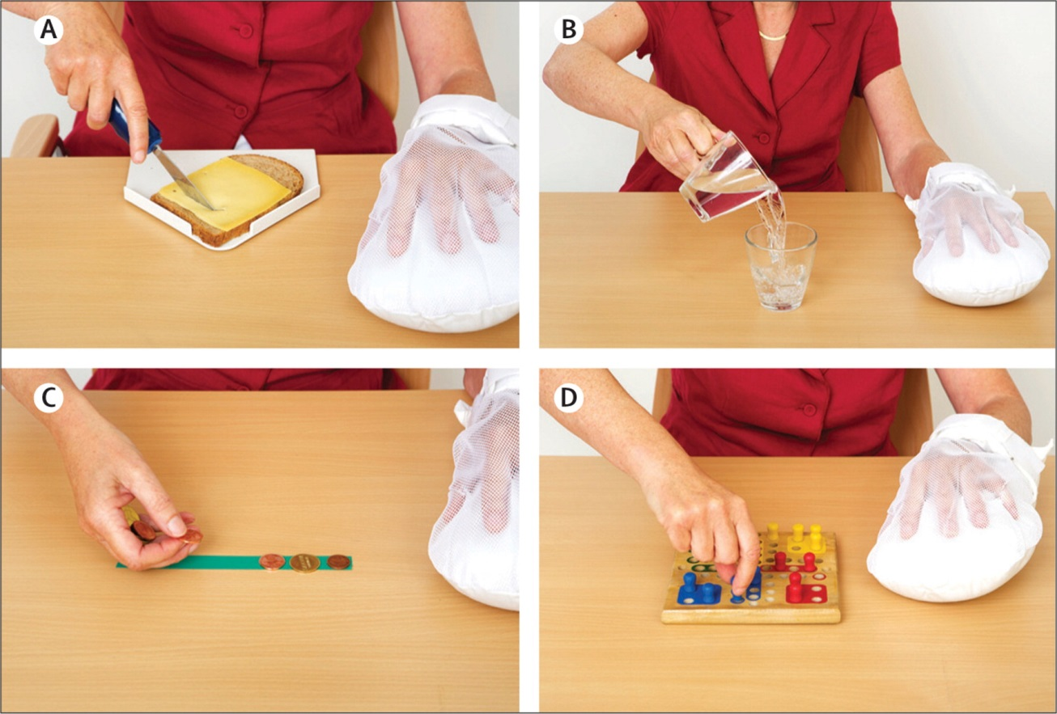

Inclusion / Exclusion Criteria
Minimum inclusion criteria:
- No pre morbid UL injury
- Ability to extend at least 20 degrees at wrist and 10 degrees at the finger joints in at least 2 fingers
- Persistent hemiparesis
- Neurologically stable with no issues of Spasticity
- Ability to walk independently

Exclusion criteria:
- Severe dysphasia or cognitive deficits
- Behavioural responses or attitudes that will compromise their ability to follow the protocol

Precautions
- Forced use when the minimum standard of movement is not present, consideration of any associated pain or injury

Procedure
After ensuring that your client is a suitable candidate for trial of CIMT then selection of the full or modified protocol is required. CIMT has evolved over the last three decades however most of the original treatment elements have remained as the standard procedure.
Full protocol
Original protocol
- Use of the restraint for 90% of waking hours
OR
- 6 hours of restraint per day of the unaffected upper limb for a period of 2-3 weeks

Higher functioning clients can be benefit from:
- 3 hours per day over 2-3 weeks.
- Receive up to 6 hours therapy daily with rest breaks for 5 days a week.

Clients are allowed to remove the constraint during certain activities where safety or independence would have been compromised.

Modified Protocol
- 30 mins of PT 3 times a week for 10
- 30 mins of O.T 3 times a week for 10 weeks
- constraint to be worn 5 hours a day at times identified as involving frequent upper limb use.
Task Training
Training method is approached in small steps of increasing difficulty. Therapy gradually increases to having the patient perform functional tasks.
Training may consist of:
- group activities
- Exercises with a focus on domestic activities (e.g. use of jars, eating utensils, pegs) handicrafts and games
- Activity selection based on sensori-motor capacity.
Therapist provides:
- feedback
- hands on facilitation as required, and
- promotes the avoidance of associated proximal movements and inhibition of inappropriate muscle contraction and synergistic movement patterns.
Videos
https://www.youtube.com/watch?v=YBFf1x29NvA
https://www.youtube.com/watch?v=Ze9j-IeTy8Q
https://www.youtube.com/watch?v=PLwZu3uMXqE
Recommended components to promote success of skill transfer and behavioural strategies:
- Daily administration of the motor activity log
- Home diary and home skill assignments
- Daily schedule
- Behavioural contract for client
- Behavioural contract for care giver
- Problem Solving to overcome apparent barriers to the use of the affected upper limb in real word situations.

Recommend reading for further instruction on the above see:
Morris,D.M, Taub,E & Mark,V.W (2006) Constrain Induced Movement Therapy : Characterising the intervention Protocol . EuraMedicophys (42):257-68 available at www.uab.edu/citherapy/images/CIT_training

Evidence
The following is a summarised opinion from the 2009 Cochrane systematic review of 19 studies around the use of CIMT.
Authors’ conclusions:
CIMT is a multifaceted intervention: the restriction to the normal limb is accompanied by a certain amount of exercise of the appropriate quality. It is associated with a moderate reduction in disability assessed at the end of the treatment period. However, for disability measured some months after the end of treatment, there was no evidence of persisting benefit. Further randomised trials, with larger sample sizes and longer follow up, are justified.

Plain language summary:
Constraint-induced movement therapy (CIMT) is a type of rehabilitation therapy in which the patient is obliged to use the paralysed arm. The normal arm and hand are prevented from moving with a glove and a special arm rest. We found 19 studies involving 619 participants, which assessed whether CIMT could reduce disability in stroke patients with a paralysed arm. Patients were included in the studies if they had good potential for recovery but tended not to use the arm. At the end of the treatment period, compared with exercise without constraint, CIMT improved the patient’s ability to manage activities of daily living, but there was no evidence that this improvement was maintained over the next six months. Further larger trials to assess whether CIMT provides lasting benefit are justified.

Sirtori V, Corbetta D, Moja L, et al. (2009). Constraint-induced movement therapy for upper extremities in stroke patients. Cochrane Database Syst Rev, Issue 4, CD004433.

Information for Patients / Families / Whanau
- See CIMT for families handout
- See CIMT consent form
References
Blanton,S & Wolf,S.L. An application of upper extremity constraint induced movement therapy in patient with sub acute stroke. Physical Therapy, 1999, 97, 847-853

Gordon, A. M. (2011) Bimanual training and constraint- induced movement therapy in children with hemiplegic cerebral palsy .Neurorehabilitation and Neural Repair vol 25no.8 692-702.

Dromerick AW, Lang CE, Birkenmeier RL, et al. (2009). Very early constraint-induced movement during stroke rehabilitation (VECTORS): A single-center RCT. Neurology, 73(3), 195–201.

Page et al. Modified constraint induced therapy in sub acute stroke: a case report. Archives of physical medicine and rehabilitation. 2002; 83: 286-290

Pollock et al (2014) Interventions for improving upper limb function after stroke. Cochrane Database of systematic reviews. Issue 11, Art no.:CD010820.

Sirtori V, Corbetta D, Moja L, et al. (2009). Constraint-induced movement therapy for upper extremities in stroke patients. Cochrane Database Syst Rev, Issue 4, CD004433.

Taub, E & Uswatte,G. A new approach to treatment and measurement in Physical rehabilitation: Constraint Induced (CI) Movement Therapy. In R.G.Frank and T.R Elliot (Eds) Handbook of rehabilitation psychology. Washington DC: American Psychological Association

Wu, C. et al (2011) Randomised trial of distributed constraint Induced therapy versus bilateral arm training for the rehabilitation of upper limb motor control and function after stroke. Neurorehabilitation and Neural Repair vol 25,no 2.130-139

Wu, C. et al (2012) Pilot trial of distributed constrain induced therapy with trunk restraint to improve post stroke reach to grasp and trunk kinematics. Neurorehabilitation and Neural Repair. Vol 26 no: 3 247-255.

