Upper Limb Assessment & Treatment Guides

4: Firm Support Devices Post Stroke

Introduction / Background / Purpose
An early, consistent approach to management of a hemiplegic upper limb can be vital in preventing structural damage to the shoulder joint, and improving outcomes for stroke patients. The National Stroke Foundation (2010) identifies that prevention of contracture and subluxation may help to prevent shoulder pain. One method to achieve this is by utilising firm support devices, such as slings when a patient is ambulating / transferring and arm troughs and tables when a patient is seated.

Competencies required
Clinician: knowledge of slings and firm support devices available to them
Patient: Cognitive ability to utilise slings / trays if they are to be independent. Educated regarding the use of slings / support devices.
Whanau: Educated regarding the use of slings / support devices and manual handling to support their family member.

Equipment required
- Slings
- Firm Support devices

Procedure
Slings:
Slings provide Temporary support to the arm in situations where support cannot otherwise be given. Examples of these times are:
• During all transfers (including hoist transfers)
• While the patient is mobilising
• While the patient is in the shower
• While practising standing tasks in therapy.

At all other times the patient’s upper limb should be supported using a firm supportive device such as a table tray, arm trough or pillows.
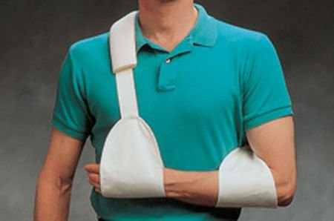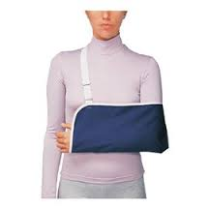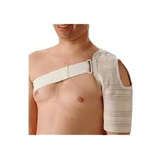

Firm Support Devices:
In order to avoid gravitational forces pulling on the hemiplegic upper limb, and to facilitate improved positioning and use of the upper limb, hemiplegic upper limbs should be supported using a firm supportive device whenever the patient is sitting out of bed.
The patient should be encouraged to have their arm positioned out away from their bodies instead of across their laps, to prevent shortening of the soft tissues in front of their shoulder.

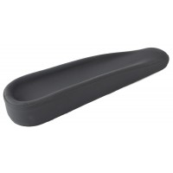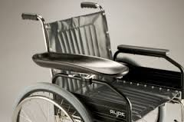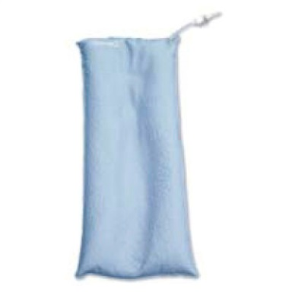

Inclusion / Exclusion Criteria

Slings:
Slings should be used when the patient has insufficient muscular return around the shoulder joint to protect the shoulder from injury.
A patient may also require a sling for periods through the day if they are at an unusually high risk of injury the arm due to poor sensation, and/or have severe perceptual problems.
Alternately, patients who are at high risk of developing oedema in their hand may require a sling while mobilising even if they have good recovery around their shoulder.

Precautions
Prolonged use of a sling to support the patient’s upper limb is discouraged because:
- Muscles and other soft tissues in the upper limb will become shortened, especially in the shoulder internal rotators, adductors, biceps, wrist and finger flexors and forearm pronators. This is linked with the development of shoulder pain.
- The patient is prevented from using any active return they may have in their upper limb, and is stopped from using it a functional way.
- The patient may learn disuse of their upper limb.
- The patient may develop a distorted body image.

Evidence
There is evidence to suggest that devices such as table trays, triangular slings and arm troughs provide immediate reduction of shoulder subluxation. This reduction is not maintained on the removal of the device (Ada et al, 2005).
The National Stroke Foundation (Australia) 2017 guidelines recommend that firm supportive devices may be used in patients with severe upper limb weakness that are at risk of developing shoulder subluxation, and may be used for patients who have already developed a shoulder subluxation (National Stroke Foundation (Australia) Guidelines, 2017).

Information for Patients / Families / Whanau
See stroke foundation positioning for left and right hemiplegia.
References:
Ada, L., Foongchomcheay, A., Canning, C. G. (2005). Supportive devices for preventing and treating subluxation of the shoulder after stroke. Stroke, 36(8), 1818-1819.
Dieruf K. et al (2005) Archives of Physical Medicine and Rehabilitation. Volume 86, Issue 12 , Pages 2324-2329.
New Zealand Clinical Guidelines for Stroke Management 2010
Turner- Stokes L., Jackson (2002) Shoulder pain after stroke: a review of the evidence base to inform the development of an integrated care pathway. Clinical Rehabilitation 16:276-298
Snels et al (2002) Treating patients with hemiplegic shoulder pain. American Journal of Physical Medicine and Rehabilitation: 81:150-60
Zorowitz, R.D., Hughes, M.B, Idank, D, Ikai, T, Johnston, M.V, (1996) Shoulder pain and subluxation after stroke: Correlation or coincidence?. American Journal of Occupational Therapy Vol 50.No3

