Functional Electrical Stimulation (FES)
Information for Patients and Families

What is FES?
FES is a treatment used to produce a muscle contraction. A range of different machines are available that use a small current to produce the muscle contraction via surface electrodes.

How does it work?
Surface electrodes are placed on the skin – usually over the muscle and also over the nerve i.e. where the nerve enters the muscle. A small current makes the muscle contract. The current stimulates the nerve. The FES provides the ‘impulse’ that would usually come from the brain but is not working following damage. FES helps when the muscle has some ability to contract, even if very weak, but it does not make the muscle start working again.

Why do we use FES?
It is used to help strengthen weak muscles. FES can assist the muscle to contract and often enables more practise than a person trying themselves alone. FES can help with re-training particular movements e.g. extending your wrist. It can be used to help stabilise a joint e.g. a sub-luxed shoulder. FES can also be used to practise specific activities e.g. opening your hand as you reach for a cup.

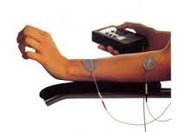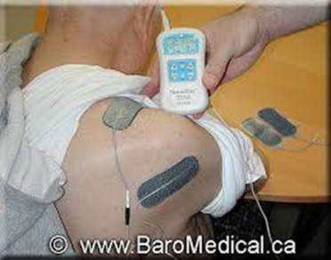

Who do we use FES with?
FES is used for a range of neurological conditions where patients have some muscle weakness or stiffness. Typically these include: stroke, Parkinson’s disease, multiple sclerosis and spinal injuries.

Who cannot use FES?
There are some situations and conditions in which FES cannot be used e.g. if you have a pacemaker; open or infected skin; metal implants, over your neck, over your abdomen (if pregnant), are allergic to the electrodes, etc. Your therapist will discuss these and others with you before using FES.

Are there any side effects?
The main potential side effect is a rash on the skin under the electrodes. After FES treatment a mild rash can appear but if it quickly disappears, this is not of concern. Most electrodes are self-adhesive, hypoallergenic and only for single patient use. Occasionally patients develop a persistent rash or blisters and therefore treatment would need to cease.

Further questions?
If you have any concerns or issues about FES please contact your therapist.
Your therapist is: ………………................. phone/email: ……………………………..

