Upper Limb Assessment & Treatment Guides

5: Functional Electrical Stimulation (FES)

Introduction / Background / Purpose
Electrical Stimulation (ES) is a means of producing a muscle contraction via electrical stimulation. The electrical stimulation is applied by skin surface electrodes. Stimulation is via the nerve not the muscle. Key muscle groups can be activated e.g. anterior deltoid, triceps and wrist extensors.
Electrical Stimulation can be used for:
- muscle strengthening e.g. wrist extensors
- functional rehabilitation e.g. reach and grasp/release. When used functionally ES can be referred to as Functional Electrical Stimulation (FES)
- shoulder subluxation e.g. there is some evidence if used early ES can help prevent subluxation
- to decrease oedema
- to decrease spasticity
- as a ‘neurosplint’ substituting for an orthosis. When used in this way ES can be referred to as Neuro Muscular Electrical Stimulation (NMES)

Although there are a range of terms used for electrical stimulation, in New Zealand, ‘FES’ is often used instead of ES or NMES.
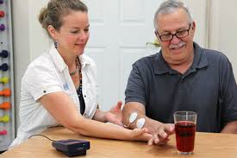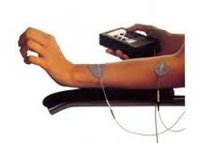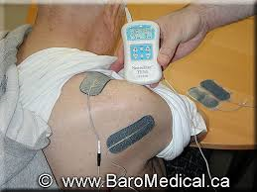

There are some specialist forms of FES e.g. EMG activated electrical stimulation, where ES is triggered by the electrodes detecting the patients attempt to contract the muscle. More recent developments include wireless ES machines that activate muscles in sequence to facilitate grasp/release e.g. Bioness H200. In addition, FES can also be used in conjunction with ‘dynamic’ splints such as Saeboglove to promote functional use.

Competencies required
- FES should only be applied by experienced staff to ensure effective and safe use
- Knowledge of contra-indications and precautions
- Knowledge of the particular FES machine and its parameters
- Following an initial trials by the therapist, rehabilitation assistants can be delegated to continue treatment. Some clients/carers may also be able to use FES independently, following adequate training.

Equipment required
FES machines – a variety of products are available e.g. (see below)
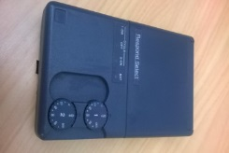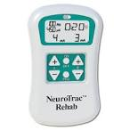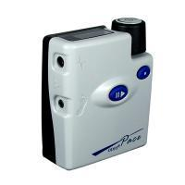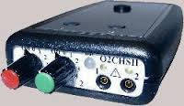
Parameters: (e.g. pulse width/duration, frequency, amplitude, waveform, etc.)

Parameters vary from machine to machine. For a brief overview of parameters see:
Use of Electrical Stimulation following stroke. A quick reference Guide. August ’14
https://www.ssahpf.scot/wp-content/uploads/2015/11/electrical-stimulation-consensus-statement-ssahpf-pdf-2.pdf

Accessory controls:
Hand switch: the therapist controls the on/off time
Foot switch: the patient’s movement controls the on/off time (not applicable to upper limb)

Electrode pads:
A range of electrode pads are available. These can be hypo-allergenic, self-adhesive or non-adhesive. Self-adhesive Non adhesive
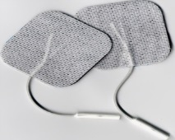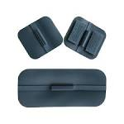

If using non-adhesive pads you will also need ultrasound gel and micropore tape. These pads can be cleaned and re-used with different clients. Self-adhesive pads can be re-used but only for a single client.

Leads:
The black or white lead is the active (+) electrode. It is usually placed on or near the motor point. The red lead is the indifferent (-) electrode. It is usually placed distally to the motor point, on the ‘muscle bulk’.

Procedure
- Gain consent from patient (and/or carer)
- Check contra-indications/precautions
- Explain the purpose of the treatment, the set-up of the machine, the correct placement of the electrodes and any possible risks/side effects e.g. skin irritation. Also discuss when to cease treatment and contact the therapist regarding any adverse effects or concerns
- Check skin is intact in the area the electrodes are to be placed
- Clean skin with alcohol wipes e.g. to remove moisturizer, etc. You may also need to shave the skin to improve contact
- Position electrodes
- Check the electrode position is correct i.e. that the movement required occurs as the intensity is increased. Reposition the electrodes as needed - it may take several attempts to ensure the best contraction is achieved
- Increase the intensity slowly, and ONLY during the ‘on’ phase
- Encourage the client to work with the movement elicited and/or exercise prescribed
- Turn the machine off before removing the electrodes
- Check the skin for any irritation from the electrodes.

Inclusion / Exclusion Criteria
Inclusion - Patients with upper limb muscle weakness and reduced functional use post stroke; patients with flaccid shoulder muscles.
Exclusion - patients who are unable to give consent, have severe cognitive deficits, pain, spasticity or anxiety.
Contraindications Precautions
Pacemaker in situ Electrode allergies
Poor skin condition Chronic oedema
Uncontrolled epilepsy Reduced sensation
Acute DVT Cognitive impairment
Active infection including cancers Pregnancy
Fracture Implants e.g. metal
Pregnancy (over abdomen/trunk) High level spinal injuries
Stimulation over neck (carotid sinus, phrenic nerve) Peripheral vascular disease

Caution is advised as different guidelines include different conditions in the contra-indication and precaution lists. There are few studies to confirm the recommendations.

Evidence
Scottish Stroke Allied Health Professions forum. Use of Electrical Stimulation following stroke. A consensus statement. August ’14 www.chss.org.uk/ssahpf/ecs-statement.pdf

Practice notes:
http://www.physio-pedia.com/Electrical_Stimulation_-_Its_role_in_upper_limb_recovery_post-stroke

Howlett, Owen A. et al. 2015. Functional Electrical Stimulation improves activity after stroke: a systematic review with meta-analysis. Arch Phys Med & Rehabil 96(5):934-43

Gu, P. and J. Ran (2016). Electrical stimulation for Hemiplegic shoulder function: A systematic review and meta-analysis of 15 randomised controlled trials. Arch Phys Med & Rehabil 97(9):1588-1594

Alon, G., Levitt, A.F.&McCarthy, P.A. 2007. Functional electrical stimulation enhancement of upper extremity functional recovery during stroke rehabilitation: a pilot study. Neurorehabil Neural Repair 21 207-215.

Mangold, S., Schuster, C., Keller, T. et al. 2009. Motor training of upper extremity with functional electrical stimulation in early stroke rehabilitation. Neurorehabil Neural Repair 23 184-190.

Powell, J., Pandyan, A.D., Granat, M. et al. 1999. Electrical stimulation of wrist extensors in post stroke hemiplegia. Stroke 30 1384-1389.

Delitto A, Robinson AJ. Electrical stimulation of muscle: Techniques and Applications. IN: Snyder-Mackler L and Robinson AJ, Clinical Electrophysiology, Electrotherapy and Electrophysiologic Testing, 1st Edition. Williams & Wilkins: Baltimore. Chapter 4, 1989.

de Kroon JR, IJzerman MJ, Lankhorst GJ, Zilvold G. Electrical stimulation of the upper limb in stroke: stimulation of the extensors of the hand vs. alternate stimulation of flexors and extensors. American Journal of Physical Medicine and Rehabilitation 83(8):592-600, 2004.

Robinson AJ & Snyder-Mackler L, Clinical Electrophysiology, Electrotherapy and Electrophysiologic Testing, 3rd Edition. Philadelphia: Wolters Kluwer Health/Lippincott Williams & Wilkins,Chapters 6 & 7, 2008.

Chan M.K.-L., Tong R.K.-Y., Chung K.Y.-K. Bilateral upper limb training with functional electric stimulation in patients with chronic stroke. Neurorehabilitation and Neural Repair. 23 (4) (pp 357-365), 2009.

Popovic M.B., Popovic D.B., Schwirtlich L., Sinkjaer T. Functional Electrical Therapy (FET): Clinical Trial in Chronic Hemiplegic Subjects. Neuromodulation. 7(2):133-140, 2004.

Information for Patients / Families / Whanau
Information sheet: Functional Electrical Stimulation (see attached doc)
Functional electrical stimulation for the hemiplegic shoulder – information of patients and families
http://www.strokengine.ca/patient-info/functional-electrical-stimulation-upper-extremity-info/

