Information for patients / families

Task specific training

What is task specific training?
Task specific training is a type of exercise treatment involving repeated practise with your affected arm/hand. However, rather than practising the movements alone e.g. moving your wrist up and down, you repeatedly practise different activities, whole tasks, that involve moving your wrist up and down.

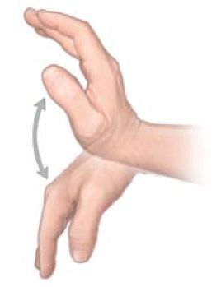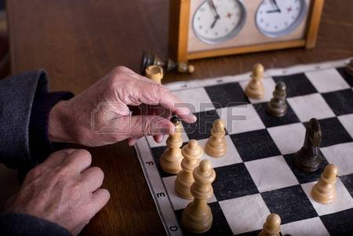

How does it work?
Research has shown that practising something you want to be able to do, or that you enjoy, helps the brain by increasing motivation and interest. Whenever you learn something new or change how you do something, practise will help. This also applies after a stroke.

Why do we use task specific training?
It is a method of treatment helps patients to keep practising many repetitions by doing activities they feel challenged to try.

Who do we use task specific training with?
This type of training can be used by many stroke patients while in hospital or at home. However, it is most beneficial to those with some recovery of movement who are able to move their arm/hand actively.

Who cannot use task specific training?
Some patients are too tired or can’t concentrate enough to do this type of training as it requires lots of repetitions. Other patients do not have enough movement in their arm/hand. Your therapist will be able to advise you if the treatment is suitable for you.

Are there any side effects?
There are not likely to be any side effects from this treatment. Your arm or hand may feel tired from the increased exercise but it should not be painful.

Further questions?
If you have any concerns or issues about Task Specific Training please contact your therapist.
Your therapist is: ………………................................
phone/email:…………………………………………

