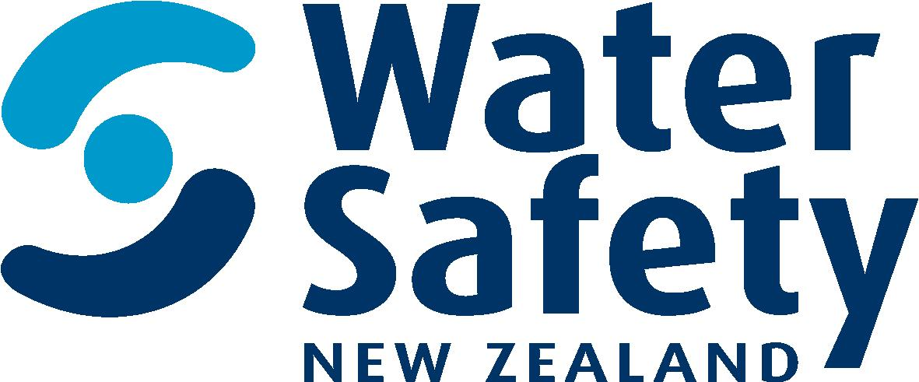

Marketing coordinator

Water Safety New Zealand

Position Description

february 2019

Position Description

Job title: Marketing Coordinator

Reports to: Strategic Partnerships and Marketing Manager

Direct reports: None

Group: Strategic Partnerships and Marketing

Background
We are an island nation with some of the most magnificent waterways in the world. Our ocean, coasts, beaches, lakes and rivers help define us and reflect the people we have become. Water is life and in New Zealand, it’s our way of life. Experiences in, on or around the water are part of what we do and what makes us Kiwi. But sadly, preventable drownings and non-fatal incidents are all too common.

We are the leadership body which advocates for, represents and supports the water safety sector to reduce the drowning toll and water related injury in New Zealand. We educate for the wellbeing of all New Zealanders.

Our Purpose
To lead a step change in New Zealand so people don’t drown.

Our Vision
By 2025 more people in New Zealand respect the water and have the skills, knowledge and awareness to enjoy it safely.

Our Values

Ambitious: To make a difference we need to be exceptional. We punch above our weight and keep striving to be better. We face a complex problem and are problem solvers. We aim high and look to continuously improve.

Focused: We have one cause and don’t get distracted. We only do things that demonstrably increase safety in, on and around the water. We prioritise with the big picture at the heart of all our decision making and activity. We lead with trusted authority.

Innovative: We try different things and keep learning because things will always change. We take creative measures based on evidence to make bold decisions. We keep things fresh and engaging and we seek to grow the capability of our members and partners.

Inspiring: We are story tellers. We encourage, reinforce, stay forward looking and specify our messages in ways that draw people towards us and what we have to say. If we challenge, we do so positively. We’re an optimistic group tackling a tough challenge.

Giving: We’re in the caring business. We care about people and their prospects. So a generous and curious disposition is vital. We won’t judge. It’s also crucial to our team dynamic, we work under pressure and need to be supportive of each other.

Position purpose

The Marketing Coordinator will form part of the Strategic Partnerships and Marketing team and play an integral part in delivering our Marketing objectives, based on a desire to be more externally focussed. A heavy emphasis on interpreting plain writing into engaging, marketing focused content is required.

As an evidence-based organisation, the role will interpret data, insights and research to form creative and innovative marketing initiatives that make a difference.

The role will facilitate both internal and external marketing opportunities from ideas and concepts into the delivery of initiatives and campaigns. There is an emphasis on social marketing in order to influence and change behaviour to improve drowning outcomes for all New Zealanders and visitors.

WSNZ will invest in public awareness campaigns, initiatives and programmes which are enduring and lead to measurable knowledge, attitude and behaviour change. The Marketing Coordinator will actively promote our existing programmes and develop new opportunities as we lead, advocate and educate for the wellbeing of all people in New Zealand.

Principle Responsibilities and Accountabilities

- contribute to the development and implementation of the Marketing strategy
- writing and responding to marketing briefs
- working with creative, production, water safety sector and corporate partners and team to deliver marketing campaigns, projects, presentations and reports
- contributing to the development and implementation of the Content strategy
- conceptualising and writing engaging content for creative initiatives, campaigns, programmes and projects
- support communications partners and team to publish content in various formats – both graphically and written
- develop content and resources for websites
- working with data partners and team to write up insights and translate into easy to understand, informative and engaging copy
- working with research partners and team to write up evaluation of marketing and social marketing campaigns, programmes and projects
- writing marketing campaign and media post analysis and evaluation reports and presentations

Relationships:

Internal | External
Manager Strategic Partnerships and Communications | WSNZ Members
Fundraiser | Water Safety Sector Partners
WSNZ Office Team, incl. WSNZ CE | Programme Delivery Partners
Communications and Media Lead | External Agencies – eg. FCB
 | Sport NZ / ACC
Knowledge, Skills and Experience

Required;

- marketing or advertising experience or relevant qualification
- excellent use of grammar and spelling
- strong creative writing skills
- outgoing with strong relationship skills
- committed user of social media and online technology
- organizational, problem solving and critical thinking skills
- respectful inter-personal communications skills
- ability to interpret complex information and/or plain English into engaging, marketing focused content
- ability to plan, manage and prioritise multiple tasks to meet deadlines
- commitment to improving the well-being of people in New Zealand through education
- innovation management - is good at bringing the creative ideas of self and others to market; has good judgement about which creative ideas and suggestions will work; has a sense about managing the creative process of others; can facilitate effective brainstorming
- interpersonal savvy - relates well to all kinds of people, up, down, and sideways, inside and outside the organisation; builds appropriate rapport; builds constructive and effective relationships

Desirable;

- interest in photography and video
- interest in developing resilient communities through recreation and sport
- experience or interest in water-based activities and water safety
- knowledge of tikanga and te reo Māori.

Ability to;

- be compassionate - genuinely cares about people; is concerned about their work and non-work problems; is available and ready to help; demonstrates real empathy
- create - comes up with a lot of new and unique ideas; tends to be seen as original and value-added in brainstorming settings.
- manage diversity - manages all kinds and classes of people equitably; deals effectively with all races, nationalities, cultures, disabilities, ages and both sexes; supports equal and fair treatment and opportunity for all
- organise - can marshal resources (people, funding, material, support) to get things done; can orchestrate multiple activities at once to accomplish a goal; uses resources effectively
- set priorities - spends his/her time and the time of others on what’s important; quickly zeros in on the critical few and puts the trivial many aside; can quickly sense what will help or hinder accomplishing a goal; eliminates roadblocks; creates focus
- understand others - understands why groups do what they do and how to motivate them
- manage vision and purpose - communicates a compelling and inspired vision or sense of core purpose; talks beyond today; talks about possibilities; is optimistic; can inspire and motivate others

