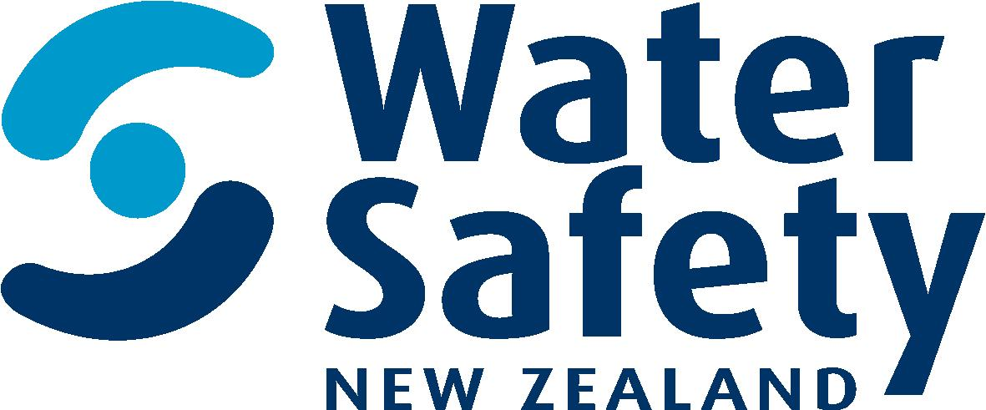

Policy and research advisor

Water Safety New Zealand

Position Description

february 2019

Position Description

Job title: Policy and Research Advisor

Reports to: Capability and Investment Manager

Direct reports: None

Group: Capability and Investment

Background
We are an island nation with some of the most magnificent waterways in the world. Our ocean, coasts, beaches, lakes and rivers help define us and reflect the people we have become. Water is life and in New Zealand, it’s our way of life. Experiences in, on or around the water are part of what we do and what makes us Kiwi. But sadly, preventable drownings and non-fatal incidents are all too common.

We are the leadership body which advocates for, represents and supports the water safety sector to reduce the drowning toll and water related injury in New Zealand. We educate for the wellbeing of all New Zealanders.

Our Purpose
To lead a step change in New Zealand so people don’t drown

Our Vision
By 2025 more people in New Zealand respect the water and have the skills, knowledge and awareness to enjoy it safely.

Our Values

Ambitious: To make a difference we need to be exceptional. We punch above our weight and keep striving to be better. We face a complex problem and are problem solvers. We aim high and look to continuously improve.

Focused: We have one cause and don’t get distracted. We only do things that demonstrably increase safety in, on and around the water. We prioritise with the big picture at the heart of all our decision making and activity. We lead with trusted authority.

Innovative: We try different things and keep learning because things will always change. We take creative measures based on evidence to make bold decisions. We keep things fresh and engaging and we seek to grow the capability of our members and partners.

Inspiring: We are story tellers. We encourage, reinforce, stay forward looking and specify our messages in ways that draw people towards us and what we have to say. If we challenge, we do so positively. We’re an optimistic group tackling a tough challenge.

Giving: We’re in the caring business. We care about people and their prospects. So a generous and curious disposition is vital. We won’t judge. It’s also crucial to our team dynamic, we work under pressure and need to be supportive of each other.

Position purpose

As the water safety sector leadership organisation WSNZ represents the sector through its policy advice and advocacy activities, as well as helping address sector knowledge needs through the sponsorship and funding of research.

The role of the Policy and Research Advisor is to provide advice to the leadership of WSNZ on;
- Policy and advocacy positions on key issues for WSNZ and the sector
- Sector research priorities and research funding
- Compliance with, and impact of, current and proposed legislative changes

The Advisor will also support the Manager Capability and Investment in their advocacy work and relationships with central and local Government agencies, and the refresh and implementation of WSNZ’s Māori strategy.

Principle Responsibilities/Accountabilities

Policy advice and support

- Initial preparation of policy advice on external issues, potential advocacy positions, submissions and implementation of the Water Safety Sector Strategy
- Policy support to Manager: Capability and Investment on relationship management and assist with the preparation of policy papers, media reports and presentations
- Maintaining effective relationships with policy stakeholders, including designing and contributing to member and sector consultation processes
- Lead the development of reactive policy advice and provide general policy support on stakeholder engagement
- Assist the manager to identify emerging issues and trends or changes in factors which may impact on the sector
- Provide advice on the design, implementation and review of organisation and sector policies
- Contribute to the implementation of WSNZ’s Māori strategy and other key organisational strategies and policies

Research advice and support

- Make available research, advice, market intelligence and evidence on water safety to WSNZ, sector members, the wider sector and the New Zealand public
- Provide advice on national and international drowning prevention research programmes and results
- Participate in sector groups, and advise on opportunities, to develop research priorities for drowning prevention in New Zealand
- Advise on funding opportunities for drowning prevention research and contribute to the development of WSNZ funding mechanisms for research and academic scholarships

Compliance activity

- Monitoring proposed legislative changes for impact on WSNZ operations and those of sector partners
- Develop the annual legislative compliance report for the CE
- Advise on the design, implementation and review of WSNZ’s internal policies

Management and Business Support

- Undertake projects, produce reports and other information as directed
- Represent WSNZ at meetings and events as required
- Utilise evidence and apply robust analytical processes in forming advice
- Participate as a collaborative team member and contribute to joint projects
- Work collaboratively with other WSNZ staff and members of sector organisations

Relationships:

Internal | External
Manager Capability and Investment | Cross Sector Reference Group
Chief Executive | Water safety sector members
Manager Strategic Partnerships and Communication | Sector member’s organisations
Database and Information Advisor | Sport NZ and ACC
Fundraising Co-ordinator | Other Government departments
WSNZ Office Team, including Accountant

Knowledge, Skills and Experience

Required;

- at least two years’ experience in policy development, analysis and review
- an understanding of, or experience in advising on research needs and programmes
- excellent organisational, problem solving and critical thinking skills
- good inter-personal communication skills and an ability to present complex information so it is easily understood by non-technical staff
- strong written communications and oral presentation skills
- ability to plan, manage, and prioritise multiple tasks to meet deadlines

Desirable;

- a knowledge of state sector policy-making processes and the machinery of Government
- knowledge of and interest in the sport and recreation, and/or public safety sector(s)
- knowledge of or an interest in water-based activities and water safety, particularly education
- knowledge of WSNZ’s role and responsibilities as an NGO contracted to a Crown Agent and an awareness of the wider social and political context in which WSNZ operates
- knowledge of tikanga and te reo Māori
- a relevant tertiary qualification

Demonstrated by;

- decision quality - makes good decisions in a timely manner based upon a mixture of analysis, wisdom, experience, and judgment
- functional/technical skills - has the functional and technical knowledge and skills to do the job at a high level of accomplishment
- organisational agility - knowledgeable about how organisations work; knows how to get things done both through formal channels and the informal network; understands the cultures of organisations
- interpersonal savvy - relates well to all kinds of people, up, down, and sideways, inside and outside the organisation; builds appropriate rapport; builds constructive and effective relationships; uses diplomacy and tact; can diffuse even high-tension situations comfortably

Ability to;

- be compassionate - genuinely cares about people; is concerned about their work and non-work problems; is available and ready to help; demonstrates real empathy
- manage diversity - manages all kinds and classes of people equitably; deals effectively with all races, nationalities, cultures, disabilities, ages and both sexes; supports equal and fair treatment and opportunity for all
- inform - provides the information people need to know to do their jobs; provides individuals information so that they can make accurate decisions; is timely with information
- set priorities - spends his/her time and the time of others on what’s important; quickly zeros in on the critical few and puts the trivial many aside; can quickly sense what will help or hinder accomplishing a goal; eliminates roadblocks; creates focus
- understand others - understands why groups do what they do and how to motivate them
- manage vision and purpose - communicates a compelling and inspired vision or sense of core purpose; talks beyond today; talks about possibilities; is optimistic; can inspire and motivate others

