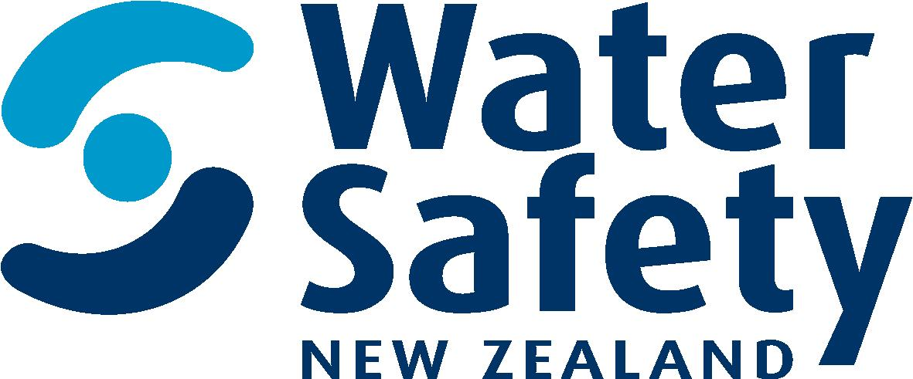

Programmes manager

Water Safety New Zealand

Position Description

february 2019

Position Description

Job title: Programmes Manager

Reports to: Capability and Investment Manager

Direct reports: None

Group: Capability and Investment

Background
We are an island nation with some of the most magnificent waterways in the world. Our ocean, coasts, beaches, lakes and rivers help define us and reflect the people we have become. Water is life and in New Zealand, it’s our way of life. Experiences in, on or around the water are part of what we do and what makes us Kiwi. But sadly, preventable drownings and non-fatal incidents are all too common.

We are the leadership body which advocates for, represents and supports the water safety sector to reduce the drowning toll and water related injury in New Zealand. We educate for the wellbeing of all New Zealanders.

Our Purpose
To lead a step change in New Zealand so people don’t drown

Our Vision
By 2025 more people in New Zealand respect the water and have the skills, knowledge and awareness to enjoy it safely.

Our Values

Ambitious: To make a difference we need to be exceptional. We punch above our weight and keep striving to be better. We face a complex problem and are problem solvers. We aim high and look to continuously improve.

Focused: We have one cause and don’t get distracted. We only do things that demonstrably increase safety in, on and around the water. We prioritise with the big picture at the heart of all our decision making and activity. We lead with trusted authority.

Innovative: We try different things and keep learning because things will always change. We take creative measures based on evidence to make bold decisions. We keep things fresh and engaging and we seek to grow the capability of our members and partners.

Inspiring: We are story tellers. We encourage, reinforce, stay forward looking and specify our messages in ways that draw people towards us and what we have to say. If we challenge, we do so positively. We’re an optimistic group tackling a tough challenge.

Giving: We’re in the caring business. We care about people and their prospects. So a generous and curious disposition is vital. We won’t judge. It’s also crucial to our team dynamic, we work under pressure and need to be supportive of each other.

Position purpose

The Programmes Manager is responsible for WSNZ’s funding programme coordination, communications and relationship management. They will be the key contact point for WSNZ funded partners and for WSNZ senior management team regarding WSNZ’s funding programmes.

WSNZ is currently developing several regional water safety strategies that will create new partnerships and delivery relationships in regions with high drowning rates. The Manager Programmes and Partnerships will help implement these strategies by identifying potential regional delivery partners and programmes.

WSNZ has also designated a small group of organisations that provide the core infrastructure and programmes of the NZ water safety sector as National Infrastructure Agencies (NIAs). The purpose of these designations is to allow WSNZ to provide greater certainty on its funding and to support their capability development. The Programmes Manager will facilitate the development of annual NIA funding agreements and support WSNZ’s CE engagement with NIAs.

Then Manager Programmes and Partnerships will deputise for the Manager: Capability and Investment when required and will generally provide management advice and support on an as-needed basis.

Principle Responsibilities

Funding round management
- Project manage WSNZ’s annual funding programme including the receipt and assessment of applications; contract management; and accountability reporting.

Relationship management
- Maintain effective relationships with key funded partners and stakeholders, including: National Infrastructure Agencies and local government organisations. This includes initial liaison with potential partners in selected regions.

Monitoring and evaluation
- Develop monitoring and evaluation processes to evaluate the effectiveness of, and satisfaction with, WSNZ-funded programmes, and their compliance with contracted objectives.

Management and Business Support

- Provide high-quality advice and support to WSNZ decision-makers and support the Manager Capability and Investment to achieve organisational goals.
- Provide information and advice to other staff on WSNZ-funded programmes and partners.

Additional Accountabilities

Funding round management
- Project manage WSNZ’s annual funding round process including the;
  - development of project plan and milestone timeline
  - drafting and distribution of the investment prospectus and application forms
  - collation and assessment of funding applications
  - drafting and dispatch of letters and funding contracts to applicants

- Project manage the accountability reporting process around WSNZ’s annual funding round;
  - drafting and dispatch of reporting template
  - checking and collating information provided and following-up any queries
  - ensuring all reports received by deadline
  - analysing data provided to calculate WSFL reach figures

- Project manage any ad hoc funding contracts agreed with organisations outside the WSNZ annual funding round, including;
- drafting and dispatch of funding contracts and correspondence

- Manage the receipt and payment of invoices from funded partners including;
- handling any queries from partners
- liaising with Financial Controller on payments and following up on outstanding invoices

- Help partners implement WSNZ-funded initiatives and plan projects effectively by;
- helping solve problems and managing financial aspects of contracts

- Contribute to the development of new WSNZ funded programmes and advise on their implementation

Relationship management
- Maintain effective working relationships with funded partners, including;
  - Drowning Prevention Fund recipients;
  - Māori providers;
  - regional strategy partners, including Regional Preferred Providers

- Supporting Chief Executive and Manager: Capability and Investment to maintain effective relationships with funded partners and key stakeholders, including:
- National Infrastructure Organisations
- Local Government organisations
- Central Government agencies

- Communicating with and recruiting prospective partners by:
- promoting WSNZ products and services and assisting potential partners with access to WSNZ funding
- visiting prospective partners and attending networking events as required

Monitoring and evaluation
- Create a framework for the monitoring and evaluation of WSNZ-funded programmes;
- data collection and analysis
- developing feedback methods
- identification of capacity needs

- Provide assessments of the effectiveness and efficiency of WSNZ funded programs, both new and established;
- developing and monitoring key performance indicators (KPI’s) for funded programmes
- providing high quality reports of program quality and user satisfaction

- Provide advice on the accountability and capability of current and prospective funded partners;
- ensuring contracts are carried out according to agreed terms
- reviewing the quality and accuracy of accountability information provided and following up on missing information
- assessing the capability of partners to deliver contracted outputs

Management and Business Support
- Undertake projects, produce reports and other information as directed;
- providing material for Quarterly Updates, Annual Reports and other corporate publications/web pages
- represent WSNZ at meetings and events as required
- participate as a collaborative team member and contribute to joint projects

Relationships:

Internal | External
Manager Capability and Investment | Programme Delivery Partners
Manager Strategic Partnerships and Communications | Water Safety Sector Members
Fundraising Co-ordinator | Funding providers
Accountant
WSNZ Office Team, incl. WSNZ CE

Knowledge, Skills and Experience

Required;

- experience in contract administration and management and a familiarity with public funding processes
- experience in managing relationships and adopting customer-oriented approaches
- excellent organisational, problem solving and critical thinking skills
- good inter-personal skills and an ability to negotiate
- strong written and oral communications, including presentation skills
- ability to plan, manage, and prioritise multiple tasks to meet deadlines
- ability to work with numbers and utilise these to underpin decisions and advice
Desirable;

- knowledge of or an interest in water-based activities and water safety, particularly education
- knowledge of and interest in the sport and recreation, and/or public safety sector(s)
- able to analyse and interpret data
- knowledge of tikanga and te reo Māori
- knowledge of WSNZ’s role and responsibilities as an NGO monitored by a Crown Agent and an awareness of the wider social and political context in which WSNZ operates
- a relevant tertiary qualification

Demonstrated by;

- process management - good at figuring out the processes necessary to get things done; knows how to organise people and activities; knows what to measure and how to measure it; can simplify complex processes
- organisational agility - knowledgeable about how organisations work; knows how to get things done both through formal channels and the informal network; understands the cultures of organisations
- managing and measuring work - clearly assigns responsibility for tasks and decisions; sets clear objectives and measures; monitors process, progress, and results; designs feedback loops into work
- functional/technical skills - has the functional and technical knowledge and skills to do the job at a high level of accomplishment
- interpersonal savvy - relates well to all kinds of people, up, down, and sideways, inside and outside the organisation; builds appropriate rapport; builds constructive and effective relationships; uses diplomacy and tact; can diffuse even high-tension situations comfortably

Ability to;

- be compassionate - genuinely cares about people; is concerned about their work and non-work problems; is available and ready to help; demonstrates real empathy
- manage diversity - manages all kinds and classes of people equitably; deals effectively with all races, nationalities, cultures, disabilities, ages and both sexes; supports equal and fair treatment and opportunity for all
- inform - provides the information people need to know to do their jobs; provides individuals information so that they can make accurate decisions; is timely with information
- organise - can marshal resources (people, funding, material, support) to get things done; can orchestrate multiple activities at once to accomplish a goal; uses resources effectively
- set priorities - spends his/her time and the time of others on what’s important; quickly zeros in on the critical few and puts the trivial many aside; can quickly sense what will help or hinder accomplishing a goal; eliminates roadblocks; creates focus
- understand others - understands why groups do what they do and how to motivate them
- manage vision and purpose - communicates a compelling and inspired vision or sense of core purpose; talks beyond today; talks about possibilities; is optimistic; can inspire and motivate others

